# Reef Talk . Group success

# Zonta Club of the Whitsundays July – August 2024

# How busy have we been !!!!

[This Photo](https://pngimg.com/download/38651) by Unknown Author is licensed under [CC BY-NC](https://creativecommons.org/licenses/by-nc/3.0/)

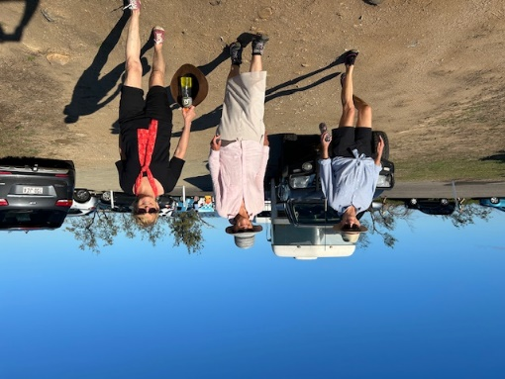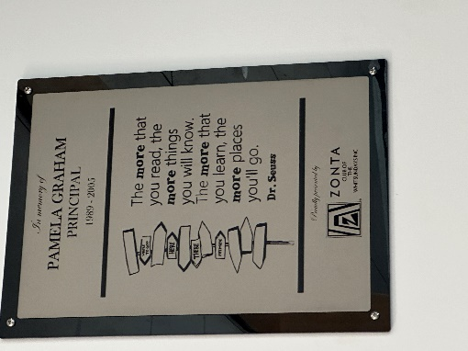

**President**

What a busy time it has been. The 66th Zonta convention, our July BBQ, helping with the triathlon Socializing with John Denver and Morning melodies, the reef festival street march, the lighthouse walk and finishing with trivia at the library on 30 August. All of this together with Board meetings and General meetings has kept me very busy and enjoying every minute.

The combination of pursuing our projects in team efforts and ensuring that we have fun as well is the focus of our Club.

With more activities, birthing kits and 16 days of activism coming up together with managing our scholarships and bursaries will keep us busy for the rest of the year.

Thank you everyone for being involved and volunteering in all our projects. We do make a difference in our community.

**Marlene Reiffel 0407 288 244**

**Zonta International's 66th Convention,**

**27-30 June 2024 in Brisbane, Australia.**

This was amazing, over 1700 people from all around the world gathered in Brisbane to celebrate Zonta, elections and vote for the new international Committee. Listen to some amazing speakers of projects they have carried out and how some have overcome many adversities to achieve amazing outcomes.

The costumes from many countries were varied and wonderful to see. The cultures, colours., and designs throughout the week were amazing.

The street walk of at least 1500 Zontians everyone wearing orange was a fantastic sight. The whole weekend was uplifting, informative and the inspiring.

I was with the Burdekin and cairns ladies and had a lot of fun and it was great to see Maxine’s orange ladies proudly displayed in the centre of Brisbane.

**Marlene**

**Membership report – July/August 2024**

Our new scarves have arrived and are available to members. Thank you, Shelagh, for all your sewing. It was a big job.

The number of new guests coming to our Zonta meetings is wonderful and encouraging. Congratulations to our Zontians who have bought them along and thank you to the friends of Zonta who love to come when they are in town. Spreading the word and talking to friends and neighbours is one of the best ways to encourage new members.

Our new scarves have arrived and are available for all existing and new members. They are very smart, and we received a lot of compliments from the attendees Area 5 conference.

We have continued in having our badge draw each month (so remember to wear your badge) and we still have our small library each month.

Please note that if you bring a guest to the general meetings, they still need to be catered for, and it is asked that they too pay $30 toward the catering. More importantly, if you OR your guest cannot attend, please notify Dawn Green by the Tuesday morning prior to said meeting so the caterers can

be notified.

Paying for over – catering, eats into our hard-earned fund raising.

**Jo - Director membership**

**Service Committee –**

**Carole Lindsay**

**Reef festival Saturday 3 August 2024**

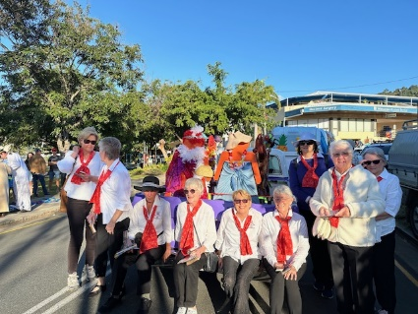What a wonderful day. We all arrived , looking fantastic in our uniforms and our new scarves, outstanding.

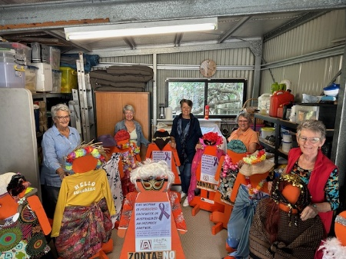Thanks to Paul and his Ute we were able to decorate our orange ladies who looked splendid on the day, riding high in the Ute in all their finery and we looked pretty good walking behind with our banner and handing out brochures and bookmarks to the public.

In fact, we were so good we won first prize of $300 in the not-for-profit category. Well done everyone.

Following the parade twenty of us gathered at the pub to have a social celebration of the day, enjoyed by everyone.

Special mention and thank you to our guests Anne and Helen who walked with us.

**Zonta BBQ**

Our next Zonta BBQ has been booked for Saturday 7 September

Thank you everyone for volunteering for the roster. It is your valuable time, but I know that the socialising with the public and ourselves is always enjoyable and how quickly the time flies,

**We have ordered 400 birthing kits for this year. Thank you, Betty who has volunteered to cut the plastic, in readiness for the packing.

Would four members please volunteer to help me with the project which will only entail a few hours of preparation and a few hours at both schools.

We will be discussing appropriate dates with the school in the coming weeks

**Social Events**

**Movies and shows**

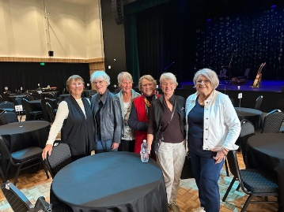A number of our Zontians attended the Proserpine Entertainment Centre (PEC) for

* + John Denver – starring Darren Coggan
  + Morning melodies – A farewell to Doris Day with Melinda Schneider

Both mornings were very entertaining, and everyone went for lunch at the Metro Pub after the morning melodies.

The next morning melodies is on 3rd October with “Livvy and Pete” Helpmann award winner Michael Griffiths and acclaimed cabaret darling Amelia Ryan celebrate the songbooks of Aussie icons Olivia Newton-John and Peter Allen.

Several Zontians have already booked, and you can book directly through the PEC. Closer to the date we will see if we can car share and decide if we want to do lunch after.

**Triathlon Sunday 28 July**

The Whitsunday Triathlon Club invited any Club to volunteer to assist with their Airlie Beach Triathlon Day.

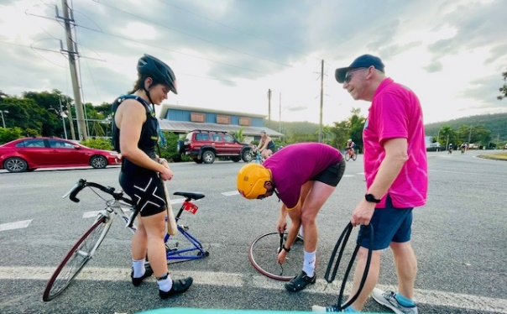We responded quickly and 10 Zontians got up early on Sunday morning to be at our check points by 6.00 am. Despite midges, and grumpy car drivers we did a great job, and the race finished without incident. The competitors waved and acknowledged us, and Nicki even had to help change a flat tyre. All in all, a great morning finishing up at Garuda Café for coffee and breakfast for some.

And to top it up the Club earned $1000 for our assistance!!!!!!!!

**Lighthouse Walk**

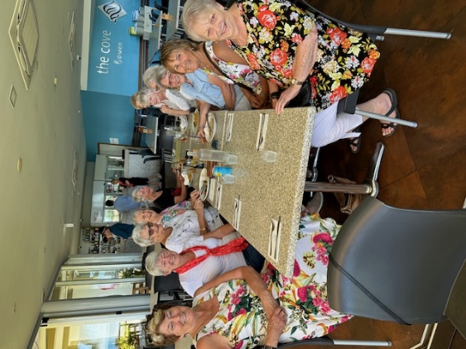Thanks to Jo’s wonderful organisation lots of our Zontians embraced the invitation to do the Bown Lighthouse walk, which only happens once or twice a year. We fortified ourselves with food and drink at the Cove restaurant and the started our adventurous walk across the sea to the island with several hundred other excited walkers.

We navigated the soft spots, holes, coral bits and wonderful red starfish with water up to our knees and a bit higher on a few occasions before scrambling up the hill to the lighthouse. It had great views especially seeing the line of people stretching from the mainland to the lighthouse. Several intrepid Zontians climbed the ladder up into the lighthouse and then we had to hurry back to the mainland to beat the tide.

A great day, enjoyed by all.

**Derby Day**

Yes, it is on again.

LaTabella has given us an amazing rate for lunch and possibly champers. Our committee have held their first meeting, and the organising is well under way.

As usual we are asking everyone to bring something for our raffles to the value of about $15 giving you plenty of time to watch out for any amazing specials at the shops.

If you know any businesses that would like to donate a prize to the day, please follow up and let the Committee know.

See our brochure attached

**What’s been happening:**

* Roz welcomed her new grandson
* Janice is snatching some time to go sailing
* Meleeta had another amazing trip motorcycling through the north of India.
* Carol is off on a month’s holiday driving through Queensland
* Jo Is off to visit her family in Brisbane

**Vale**

Our thoughts and condolences are with Helen following the passing of her much-loved sister, Susan on 7 August 2024.

**Advocacy**

:

* + 16 Days of Activism against Gender-Based Violence 2024 Nov 25, 2024, Dec 10, 2024
  + our **Zonta says NO** sign will be prominently displayed on the billboard on Airlie Hill
  + **orange ladies will be**  around town outside shop, pubs, and clubs during this time.
  + **Our Orange ladies** are receiving a makeover by Maxine and Kevin ,
  + Toilet posters for the back doors of toilet cubicle at community facilities, sporting fields, pubs, and clubs is progressing.
  + Discreet information cards with emergency phone numbers for support with Domestic and Family Violence and Sexual Assault. Being checked that phone numbers are correct and do we need to print more
  + Scholarships and school bursaries – the committee has prepared the fliers, and they should be with schools in the coming week

**Donation to AFADU**

On behalf of myself and our AFADU Board and all the children at the LIrhanzo Children’s Village, thank you for agreeing to sponsor Phiona’s Hairdressing Apprenticeship. Phiona had her 21st Birthday Party on the 6th Feb 1922 so she is now 23.

Phiona’s previous sponsors dropped away when they retired so THANK YOU for covering this particular sponsorship. It came as a total surprise, means a lot to me on so many levels and I am so grateful. For Phiona, being able to learn to be a Hairdresser, is a dream come true. She was not an academic child, however, it’s no wonder when you look at the dramas that she, Adonia and Noctula went through. Life is tough in Africa!

I will keep you posted on her progress and ask Ezelle, to pass on to Lucia, a little about ZONTA. She will be thrilled.

My sincere thanks again to my wonderful ZONTA club.

Pammie Harrison

**Donation to Cannonvale Primary School**

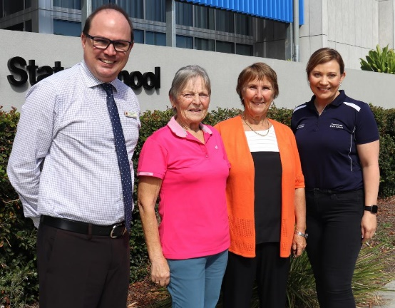During the week I had the absolute pleasure of meeting the wonderful ladies from Zonta.  Zonta have been an outstanding support towards the Whitsunday Community and continue to provide ongoing support for Cannonvale State School.    Not only does Zonta sponsor our awards at our end of year celebrations, but they also regularly donate a substantial amount of funds to our school to support families who may need financial assistance with uniforms, excursions, school levies etc.  Zonta have been involved with our school for quite a long time and it was a true honour to hear their journey with Cannonvale SS.  Thank you to the wonderful ladies at Zonta for their ongoing support of both our school and our community.

**The History of our library project**

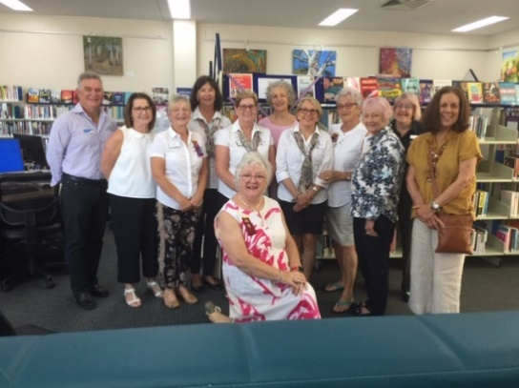

The Zonta Section at the Cannonvale Library is a project of our Club that's been going in some shape for many years. I don't know when it began but it is well before my time. Seemed to fall off for a while but the Club and the library were keen to re-instate, so a couple of years ago we decided to use some of the Club's fund-raising monies to purchase new books for the section and to add to this on an annual basis.

In 2022 we provided more than 40 new books and another 30 or so in 2023. The section now looks quite large and is well used. There is a wide range of topics and authors, although we’ve mostly bought books by women authors, with women characters. There is some non-fiction (even a couple of cookbooks) and lots of good quality fiction.

We decided not to do much in the "self-help" area as that was pretty well covered by the library and also to avoid topics that may go out of style quickly (diets for example).

The draft list of books was compiled from members recommendations, various catalogues from independent book sellers and also some of the literary prize lists. I liked to UK Women Authors Prize - but sometimes the books are quite hard reads!

Then I put the list to the Librarian for their input - do they already have too many copies, though not to be suitable, too old. Mostly they are very grateful to have new titles for the shelves.

We wanted the audience to be as wide as possible but to aim for good quality literature that would have some life on the shelf.

Funding is from the Club's fund-raising account. I buy from BigW (always the cheapest but don't often have the titles), Booktopia (in receivership now), Amazon maybe. There are a number of good independents online. Costs have gone up lately - so say if books are now $30 - $35 each and you wanted to start with 30 - that's about $1000.

I know the library wants to take a number of the Zonta Section titles off the shelf now as they are getting a bit old or not popular - so I am in the midst of getting new list together.

On another note, the Club designed and purchased Zonta bookmarks last year as a bit of PR. These have been very popular - and are displayed in the library to be taken home by anyone borrowing a book. We also got some Zonta labels printed - with logo and "donated by" included and put one of these on the inside cover or first page.

**Janice**

**The beginning of Zonta Club of the Whitsundays**

**– a memory from Beth. Member of Zonta club of Townsville club**

We in Townsville Club have just had our 40th birthday celebrations and I was talking to Lyn Agnew about our connection to your club. As you probably know Townsville was your sponsoring club.  I have this photo of our member May McPhail handing   over a cheque which may have been from her Sky Dive.

I came down to your charter dinner with Ann Leathwick who was the Area Director at the time and a member of Townsville and May McPhail.aying that the reason for her jump was the formation of the Whitsunday club.  Apparently, she had told the organizers that if they got the numbers up, she would jump!

I’m sure your archivist would like to have these bits of history.

Please tell the lady (Maxine) who made your Birthday cake that her ‘40th’ for Townsville was again on display.

I’ve attached a picture of our cake.  The quote was $150, and we thought homemade cakes would just as easily mark the occasion and wouldn’t cost as much!   They went down well. Pink ones are red velvet, and the bottom ones GF.

Cheers

Beth Snewin

Zonta Club of Townsville

## **Pause for Thought**



“*Pause for thought” is a replacement for the invocation. The nominated member gives a five-minute talk on any project of Zonta International or issue that has relevance to Zonta*.

**Women have strengths that amaze - Read by Corrie at our August meeting**

Women have strengths that amaze

They carry children they carry hardship, many carry burdens, yet they hold faith, happiness and joy

They smile when they want to cry

They volunteer for good causes. They are senators, educators, childcare workers, executives, attorneys, truck drivers’ pilots, stay at home mums and your neighbours

They can wipe a tear and cover a cut and pat you on the shoulder at the same time.

They can lend a shoulder to cry on and ear to listen and a voice to make suggestions

Their heart breaks when a friend dies, they have sorrow at the loss of a family member, yet they are strong when they think that there is no strength left. They round up energy even when they are tired.

Women do more than give birth, they bring peace and hope, they give compassion and ideals, they give moral support to their family and friends.

They weep with joy when their children excel and cheer when loved ones get awards.

Women want to grow into the best person they can be

They want to touch you in a way that will make you share your goodness with others.

The beauty of a women is not the clothes she wears, the figure she carries, or the way she combs her hair, true beaty is reflected in the soul

The beauty of women must be seen from her eyes because that is the doorway to her heart, the place where love resides. The heart and strength of a women makes the world spin!!!

There is a quote by Elisabeth Kubler (Cubler-Ross) that best sums it up

***Women are like stained glass windows***

***They sparkle and shine when the sun is out***

***But when darkness sets in***

***Their true beauty is revealed only***

***If their light is within***

**Schedule of speakers**

September Lauren

October Judy /Jo

November Meleeta



***Thoughts on Equality***

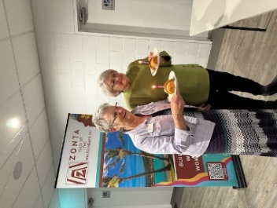 One’s life has value so long as one attributes value to the life of others, by means of love, friendship, indignation and compassion.” — *Simone De Beauvoir*

**BIRTHDAYS**

**Happy birthday to you……**

**July –** Shelagh & Dawn

**August**, Betty Margaret, Pammie, Betty,and visitor Nat



***Dates to remember:***

* ***Bunnings BBQ Saturday 7 September 2024***
* ***Next meeting 19 September***
* ***Derby Day 2 November 2024***
* ***Birthing Kits October/ November***
* ***16 Days of Activism Nov 25, 2024, Dec 10, 2024***
* ***Christmas party Saturday 7 December- Pammie’s house***
* ***IWD 9 March 2025***

***Regular Dates***

* ***Knitting group April to Nov last Monday of the month at 10.00 am.***

***Carol 0417 619 098***

***Editor September 2024***

***Marlene Reiffel***