Dear members and friends
oct/nov
2017
Zonta
Southern Gold Coast
Tweed

SS
Soursss
Newsletter

PRESIDENTS REPORT
Well a little bit quieter this month after a busy previous few months. Lots of activities planned by our sister clubs in the next couple of months so lets get out there and support them in their efforts just as we like to have their support when we have a special event planned. We still have lots of enquiries about joining our Club but sadly no new members as yet. Will keep trying with a big focus on our friends of Zonta group which is well over 100 people. Will be going back to them over the next couple of months and attempting to get some sign ups. Might be good to investigate what the road blocks are for these people who are obviously committed to Womens issues but are reluctant to take the next step, or maybe some have just moved on to other things. Attracting and retaining new members has to remain our passion, because with new members we can just do so much more to raise funds and commit to what we all care about in the year ahead.

SANCTUARY REFUGE VISIT

I had a visit to the Sanctuary this week to deliver some things and had the opportunity to just sit in the outdoor area and have a chat to Simone and some of the women and children there. I felt it was very worthwhile for us all. The place is looking so much more organised and you can definitely see the light at the end of the tunnel now. As we know Simone is an extraordinary person and it was good just to see her stop for a moment and sit. I explained to her that I am unable to do much physically at the moment and she said ‘What is needed sometimes is just to look after the children while mum has a a break or just chat to the women about ordinary things.” This was good to hear and when I thought about it, it made perfect sense. As you know chatting is something I do very well. I think we will all find our niche as to what we can do to help. Building will not go on forever and finally it will all be finished but we can all find a way to support in whatever way makes us happy if we just think about it. We also discussed fund raising, food, needs of the refuge and how to work in collaboration for the greater good.

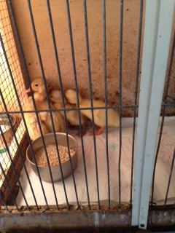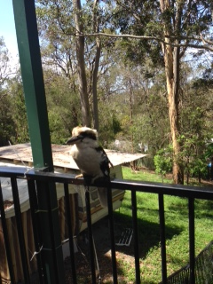

Ducklings they bred at the Sanctuary

ART FRAMING

Visited Cheap as Chips framing in Burleigh to collect our amazing crystal art and they did not disappoint. They have done such a good job and for such a discounted price. The lovely Bianca posted a great comment about Zonta on their facebook site, except the way it was written made it sound like I was International President! Sorry Sonja. I promise I have no aspirations for the job. Ha Ha. Your boots would be very hard to fill.
I am making some enquiries about where we can display the art to get the most exposure we can. More at next meeting.

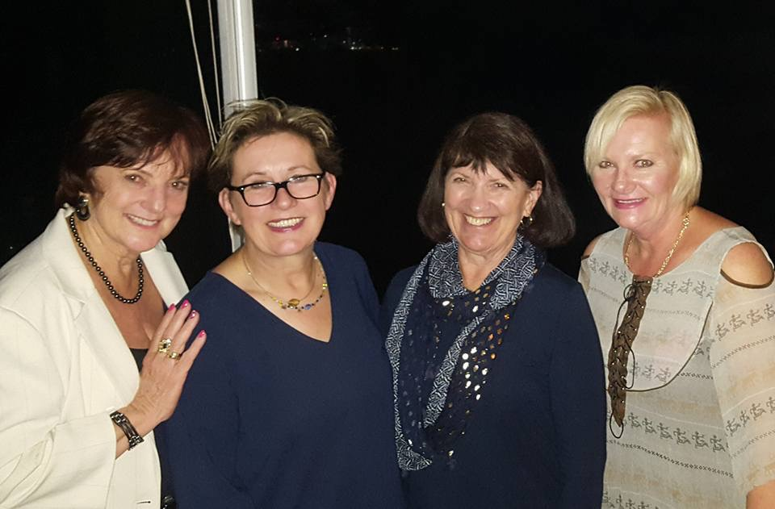
Lesley-Anne, Ute Scholtz, Pauline and Kaye having some GC fun

SANCTUARY VISIT 2
Carole and Rosemary managed to have a visit to the Sanctuary to help out with jobs and were given task of tidying the back veranda. A very challenging area as it had been used for storage and was not able to be used for anything else. As we know this is a great space under cover for children and women to have some time out, so now it looks a lot more tidy and comfortable. Big thanks to you both . The Zonta plaque has now been presented to Simone and put into place in our sponsored room. Photo will be taken at next visit. We will discuss at next meeting what our plans are for the women and children around Christmas.

FEATURED BIOGRAPHY - ROSEMARY MASLEN
In order to know a little more about each other I intend to ask each member to write a short story about themselves as it is good to know where we have been, where our skills lie and perhaps even where we might need a bit of extra support.

Thanks Rosemary

SAVE THE DATE

NOVEMBER 19TH Final meeting of year and assembling of Care Packs at Louises house . Order in for lunch.
15 Dundee Dve. Banora Point 1130 QLD time, 1230 NSW. No meeting on the 20th.

- NOVEMBER 22nd Zonta Says No Walk 6kms - Brisbane [see email]

- NOVEMBER 25TH Bunnings Barbeque fund-raiser at Nerang. 0700 to 1600. New helpers call Rhonda 0431843430

- NOVEMBER 28TH Breakfast with Rosie Batty – Brisbane [see email]

- DECEMBER 10TH 3PM Christmas Party at Rhonda house for members, partners and friends. Come along for a Merry Old Time!
58b Renfrew Dve Highland Park. RSVP 3rd December. Ph 0431843430. Bring Secret
Santa for you and a friend.

- JANUARY 15th 2018 Meeting and planning night. South Tweed Bowls Club 6 for 6.30 Qld. Time

- JANUARY 21ST 2018 Amelia Earhart Brunch at Brisbane Golf Club Yeerongpilly
Zonta Club of Brisbane South. Would we like to send a GC contingent?

