
June 2007

Zonta Club of
West Moreton Inc.
Inside this Issue
1 | From the President
2 | Zonta Events  Reminders
3 | Committee Reports
4 | Member and Other News
Our Club Website:
http://westmoreton.
zontadistrict24.org/

Our Club Email:
westmoretonzonta@yahoo.com.au
Zonta Club of West Moreton Inc.
PO Box 505
Ipswich Q 4305
Club No. 0900 District 24 Area 6


From the President

Dear Zontians,

I am look toward the Zonta year ahead with energy and enthusiasm…

Our Changeover Dinner was a lovely and successful evening. I would especially like to thank Dorinda Baar, Leonie Peasey, Alison McGrath, Gaye Anderson, Area Director Ans Van Erp and Mayor Paul Pissale for their unique contributions to making the night a special one. It was also memorable for me to be inducted as president on the evening that Joie Dwyer was honoured for her contributions to our club, the community and to Zonta International over the past 27 years. We look forward to catching up with Joie at future events!

Congratulations to all of the new and returning office bearers and committee chairpersons. I look forward to working with each of you!

The Heritage Homes tour planning is coming along nicely with Bev Johnston and Pam Lane organising the day with the assistance of a very diligent committee. The tickets have sold quickly and an additional home has been added to the line up. Well done!

Thank you to Marie Kavanagh and Ann Matyear for organising the upcoming knitting day on the 24th of June to make jumpers for Aboriginal babies for distribution within

Australia. It will make for an excellent opportunity for fellowship whilst helping those in need. I hope to see you there!

At the June meeting we will be discussing some possible options for the allocation of the proceeds from the Heritage Homes Tour and the Raffle. We are currently gathering information about Hannah’s House (a support service in Ipswich for girls aged 15-18) and the mental health needs of women in Ipswich through Jacaranda Clubhouse, and I will also be liaising with Rachel Nolan regarding other worthy community organisations or projects, which could benefit from the support of our club which are consistent with “Advancing the Status of Women”.

Tina and Maria have been working hard on the raffle and have some exciting updates for our next meeting!!

We have several members currently on special leave due to family, study and work commitments. We wish you all well and look forward to your return to Zonta.

I understand that the Programme Committee is organising a fun evening for our July meeting with an “Antarctica” theme. Stay tuned…

Warm regards,
Amy

JUNE
MEETING DETAILS

Monday 25 June 2007
6.15pm for 6.45pm
at the Ipswich Club

Business Meeting

Toast: Dorinda Baar
Grace: Leonie Peasey

IMPORTANT
please phone
Robyn Hargreaves
32889804

if

- apologies
- any special dietary requests
(e.g. a vegetarian meal)

before
7.15 am Friday 22
June

REMINDER: If apologies are not received by stipulated time of the meeting week, you are required to pay for the cost of the dinner. The Treasurer will send you an invoice.
REMINDER: If it is an ordinary night you only need to phone if you are NOT coming to the meeting … but if it is a guest night then ALL members should phone to indicate whether they are coming or not.

Zonta’s Jazz Tracks evening on Saturday 14 May went off well. Lovely weather, excellent venue, good music, food and friends proved once again that these are the essential ingredients for a great evening. The night was attended by 110 people and although it will not raise a great deal of money it did give an opportunity to trial this venue and the general consensus was that it was an excellent venue with lovely atmosphere and a great sound box. My thanks to everyone involved in setting up and then unsetting the venue. A special thanks to Leonie for her work in organising the venue and artists….Pam Lane

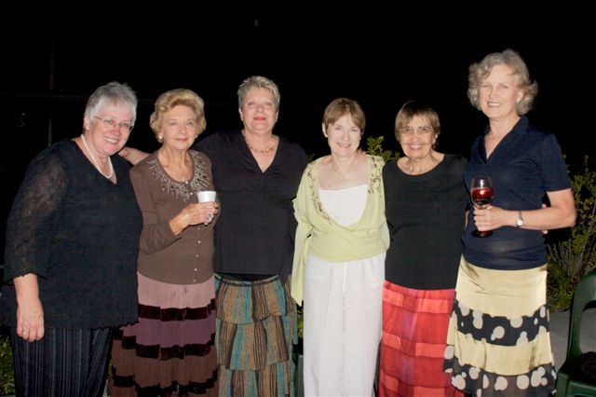

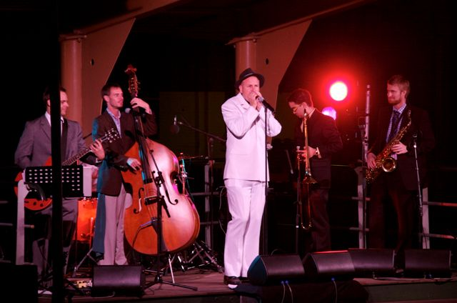

UPCOMING ZONTA EVENTS

July Meeting

Our July meeting will be themed as
Christmas In July

The meeting will be held at The Workshops Rail Museum Refreshment Room on the 23 July 2007. Partners are most welcome!

Heritage Homes
of Ipswich 2007 Tour

Sunday 22 July 2007
9.00 am to 3.30 pm

Places limited.
To book or for more information
Contact Bev Johnston
38123390
0409343886

Arias at Sunset

Date: 27 October 2007

Committee Reports

United Nations Committee

As chair of the United Nations Committee, I welcome working with Eirys, Vicki, Gillian, and Karen. We have not yet met, but will following the June meeting. This is a happy coincidence, in that I have been interested in the United Nations since school, and I am a United Nations support member.

The work of the United Nations for the advancement of women has been seminal to the improving position of women in the world, through both specific gender agencies, and in the larger field of human rights. It is also a great forum for the dissemination of ideas about the contribution of women to society. The most recent convention formulated is that of Consent to Marriage, Minium Age for Marriage, and Registration of Marriages.

We here take for granted our right to marry when we wish, and whom we wish. This is a fundamental human right. Currently, we know of child marriage, forced marriage, and not to forget, genital mutilation. All of these practices can flourish in societies where the position (and disposition) of women is being directed in a patriarchal society, where women are “managed”, and kept silent by men.

As Chair of the Committee, I welcome the opportunity, with other committee members, to research and disseminate appropriate information about UN activity, particularly as it applies to the position of women. Input from Zontians who are not members of this committee is always welcome.

Kate Kunzelmann
Chair, United Nations Committee

The Status of Women Committee

The Status of Women Committee has been formed but has not yet met. It will do so before the July Zonta meeting.

Marie Kavanagh - Chair

Extracts from Amy’s Changeover Speech

I would like to thank each of you for coming tonight. I can honestly say that joining Zonta is one of the best things I have done since moving to Australia. There are many reasons for this. The most important of which is because Zonta has provided me with a network of dynamic, supportive and like-minded women who share a common desire—to work towards improving women’s interests on a local, national and global scale. I have been very fortunate to have been in the club while Gaye, Gillian and Leonie were
President. They have led our club with enthusiasm, conviction and their own unique style. I hope to do the same….

I’ve had a chance to think about the year ahead and would encourage us to focus our efforts on the following:

  - Strengthen mentoring and collaboration within the club—particularly as many relatively newer members have accepted leadership roles and will look to others for guidance and support (myself included!)
  - Consolidate our membership—what I mean by this is to help each member find their place in our club, and to continue to maintain a cohesive group, whilst maintaining our traditions and being guided by the wisdom of our more experienced members
  - Maintain momentum—regarding our current service and fundraising projects
  - Encouraging each of you to be proactive—with your ideas and suggestions regarding improving our clubs and working on projects
  - Finally, I encourage each of you to be “detectives” this year—helping to identify women’s interests and organisations most in need of our service and fundraising efforts, and I will be guided by your input

So, what am I looking forward to? Collaborating with an excellent board and simply having a FUN and PRODUCTIVE year with all of you…Amy Mullens
Member and Other News

Recently Dorinda and Amy competed in a Masters Swimming Carnival at Nerang, and Jenny M and Amy also attended a 3-day yoga retreat in the Northern NSW hinterland!

Pam van de Hoef’s beloved mother-in-law, Vonnie Waters, passed away recently after a 6 month struggle with cancer. Mt Olivet provided wonderful care at the end. Our sincere condolences to Pam, Mark and family.

Birthdays
Birthday organisers ….
3rd quarter – Kath Everett
(July August September)
4th quarter – Pat Evatt
(October November December)

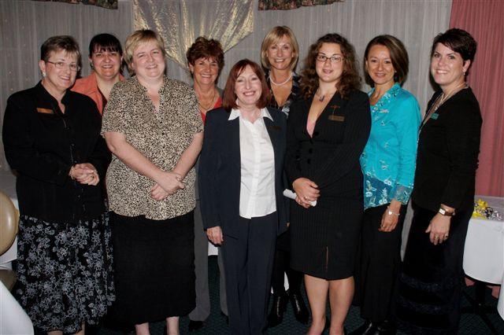

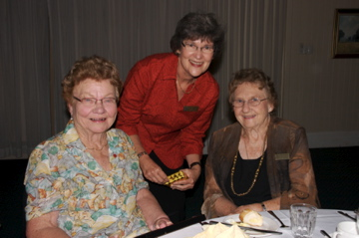

KICKZ
Knit (for) Indigenous (and other) Cool Kids (with) Zonta

Can you help?
The university students of SIFE UQ and the Zonta Club of West Moreton are proud to announce the KICKZ program. The aim is to knit jumpers and beanies for indigenous babies and other young children in the community requiring warm clothes for winter.

What can you do to help?
Knit, wrap, pack, help serve lunch. You do not have to be able to knit to attend but there will be those who will assist you to learn.

What to bring?
Yourself and any friends who would like to join us. Plenty of good cheer and community spirit. Size 4.5 or 5 knitting needles if you have them.

Where and when?
Sunday 24 June
10.30 am -2.30 pm
Rooms 116/117 Bldg 12 UQ Campus (follow the signs)

What will be provided?
Lunch, tea and coffee. (If you would like to bring a plate please do). Wool, knitting needles, patterns, wrapping paper. In house music and movie.

Contact:
Marie Kavanagh 0402 640597
Anne Matyear 0427 645 976

An exciting time ahead for Joc and John Steele. They are travelling first of all to Ireland for the wedding of their son Michael and then off backpacking through Europe.

Maria and Charles Stevenson will be leaving Ipswich on the 30th June to join Joc and John in Ireland for the wedding celebrations. They will then be travelling to Spain to enjoy some fun in the sun at Barcelona. (Some people have all the luck.)

Past member Margaret Boulter has not been idle of late (not that she ever would be) but she too has been busily knitting baby jumpers. Her group of friends have reached the grant total of 44.

Margaret Llewellyn is heading to Sydney to help her daughter Angela settle into her new unit. Plenty of packing and unpacking ahead. Mums are really indispensable aren’t they?

Marie Kavanagh and Pam Smallwood are both proud and delighted new grandparents. Pam’s daughter Ainsley gave birth to a son Cillian Lincoln in Melbourne on 14th May weighing 8lb 3ozs and Marie’s daughter Anita had her second daughter Paige Sienna at the Mater Hospital in Brisbane on 6th June. Paige weighed 7lb 11ozs.

Marie leaves her job at the Ipswich Campus on the 8th July and starts at the University of Southern Queensland in Toowoomba on the 9th July. She is presently enjoying numerous farewell functions and experiencing the niceties that come with them. Both the Ipswich Campus and the St Lucia Campus have hosted functions in Marie’s honour.

