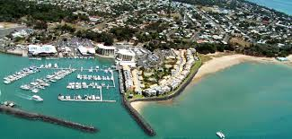
Hervey Bay Marina
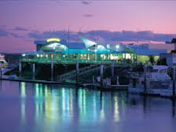
Hervey bay Boat club by night
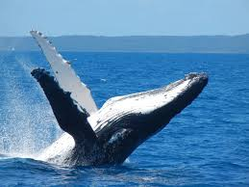
Hervey Bay Humpback Whale
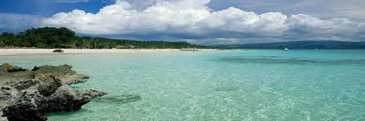
Fraser Island a short boat trip from Hervey Bay

