# Reef Talk .



# Zonta Club of the Whitsundays November/December 2020



or is licensed under [CC BY](https://creativecommons.org/licenses/by/3.0/)

[This Photo](https://pngimg.com/download/38651) by Unknown Author is licensed under [CC BY-NC](https://creativecommons.org/licenses/by-nc/3.0/)

**Report from our President – Mez**

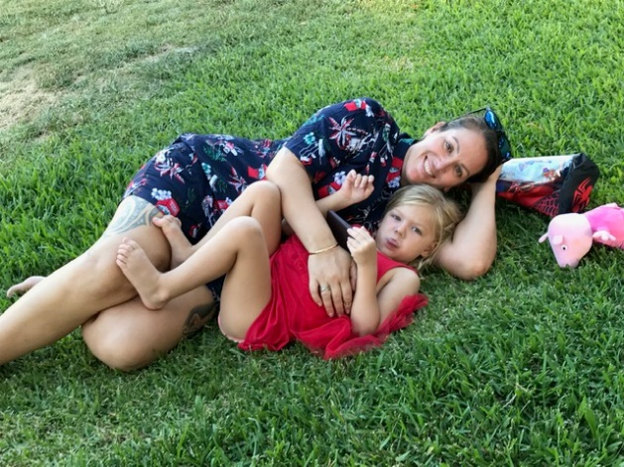

Figure A very relaxed Mez at our Christmas party

What an amazing 6 months we have had!!!

Even though Covid has kept us down, we've had a fantastic time  - Bunnings Sausage Sizzles, throwing a Derby Day, getting everyone ready for Christmas making Pamper Packs for deserving families through Whitsunday Counselling and Support, arranging our Adopt-A-Family pack for the Whitsunday Neighbourhood Centre for a beautiful Woman with two teenage children,  getting our Orange ladies out for the 16 days of Activism around not only Airlie and Cannonvale - but Proserpine as well!

We welcomed our first new member for the year, and we also have one transferring into our club... IWD planning is well underway, and we're all so excited for the theme "Choose to Challenge. A challenged world is an alert world. And from challenge comes change. So, choose Challenge!"

I cannot wait for the next 6 months, so take this time out to relax, have a fantastic Christmas with your families and loved ones, and I will see you all again in January. XXX Mez

**Members report – December**

I would like to welcome Wendy Herndon to the Zonta Club of Whitsundays. It was a pleasure to induct her at the November meeting.

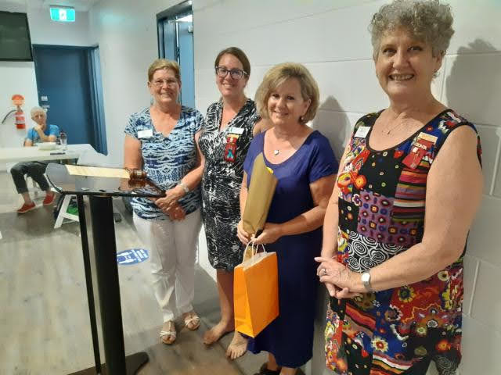

I have several White Zonta Shirts that have been donated to the club. I will bring them to our next General meeting (January 21st) if anyone is interested.

I hope everyone has a fantastic holiday season and look forward to seeing you all next year.

Cheers Judy Brown (Membership Director)

**Christmas Party 2020**

**Picnic in the park**

Our inaugural Zonta Christmas picnic was a great get together and a wonderful way to celebrate the year that was and look forward to 2021. It was just so relaxing with everyone bringing along everything and a chance to really get into our “fellowship” and have a chance to mix.  There was plenty of laughter, mingling and strangely one thing of note there seemed to be a lot of Thermos’ and flasks??  To all that were there we agreed a lovely way to complete a busy year and worthwhile exploring again for next Christmas.

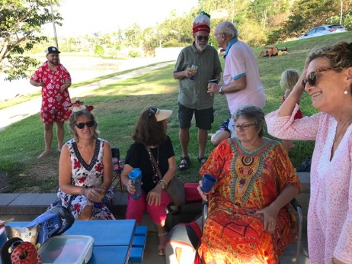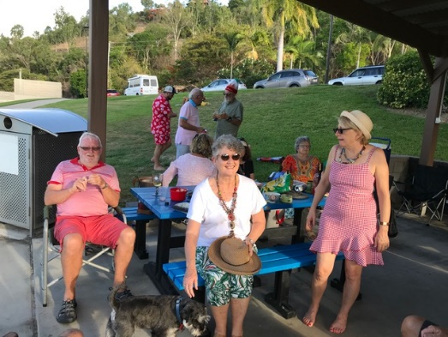

Wishing everyone a very Merry Christmas and a Happy New Year to all our fellow Zontians and partners!

**Service Committee –**

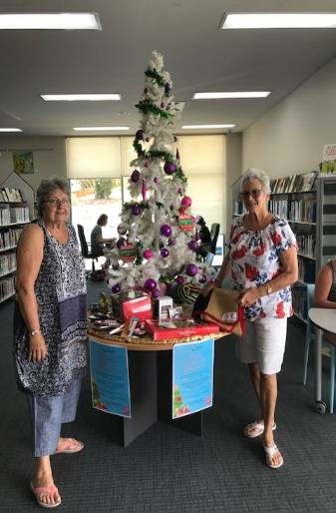

* Shopping is in progress for the 10 Pamper Packs to be delivered to Whitsunday Counselling & Support.
* We have nearly finished getting vouchers for a family for “The Adopt a Family Appeal” & will supply them to the Neighbourhood Centre in the next week.
* We have delivered 3 Blankets & numerous children’s gifts to The Mayors Appeal at the library. These gifts were provided from Laura’s home by her sister in law & obviously they were originally intended to be for Laura’s grandchildren. It was a great feeling to be donating these little things on behalf of Laura.
* We have just delivered 12 Blankets to Counselling & Support Refuge with 3-4 of them being for the children & family special rooms that we Zontians are helping to furnish within the Counselling Building. All the blankets have the Zonta label on them & were made by Zontians & Friends of Zonta.

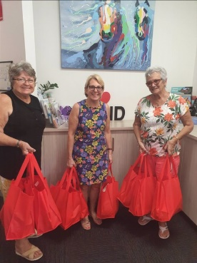

* During the year, the knitting group have supplied numerous blankets to The Nursing home, Proserpine Hospital, Whitsunday Counselling & Meals on Wheels.
* The group will resume in April once the weather is cooler.

**Pamper Packs** We finished the pamper packs & delivered the 10 Christmas bags for the Counselling Service.

* **International Women’s Day 6 March 2021**.  We have booked the Coral Sea Marina Hotel and have found some amazing speakers for the day. The IWD Committee are working hard to ensure this will be a sensational day. Watch this space as we put the programme together ‘

**Zonta BBQ ‘s with Bunnings**

**Sausage Tasting** –There has been some friendly controversy over whose sausages we should use for Bunnings BBQ so we thought it would be a bit of fun if we had a sausage tasting We all received a plate with four tasting on it. It was part of our sumptuous dinner provided by the Zonta Board members to compliment the selection of sausages.

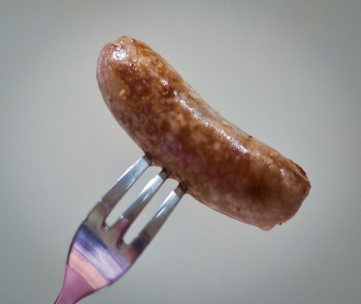

[This Photo](https://en.wikipedia.org/wiki/Newmarket_sausage) by Unknown Author is licensed under [CC BY-SA](https://creativecommons.org/licenses/by-sa/3.0/)

* Marlene presented the following paper.

1. Woollies 24 pack @ $9.00 = $0.37 to 100 sausages cost $37
2. Coles 24 pack @ $9.00 = $0.37 100 sausages cost $37
3. Master butcher 150 @ 145.08 = $0.96 100 sausages cost $96
4. IGA Proserpine 18 @$8.00 = $0.44 therefore 100 sausages cost $44.00

* Difference between highest and lowest per 100 sausages is **$59**.00 per hundred
* We normally sell a minimum of 300 sausages = **$177 per BBQ day**
* In a normal year we do about 5 BBQ’s so the different in profit between master’s and Coles is s a minimum **of $885** per year based on 5 BBQ. Sometimes we get more.

**Notes**

* Voluntary duties including rostering shopping, set up and pack down additional washing and cleaning of equipment from time to time and rostering takes about up to 1 ½ days. A lot of work for our members.

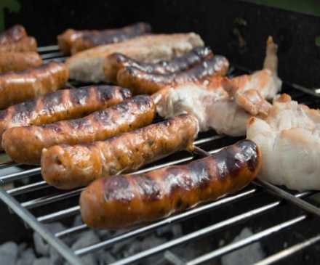

[This Photo](http://www.freeimageslive.co.uk/free_stock_image/bbq-3-jpg) by Unknown Author is licensed under [CC BY](https://creativecommons.org/licenses/by/3.0/)

* We should support our local small businesses like Master Butchers and IGA Proserpine, however Coles and Woollies also employ a lot of local people, many of whom are women and girls. They are also part of our community
* After adding onion, sauce often two and include bread Is the difference in taste worth the loss of profit

**Option**

Buy some sausages from Master Butcher say 60 and the rest from the results of our taste tests.

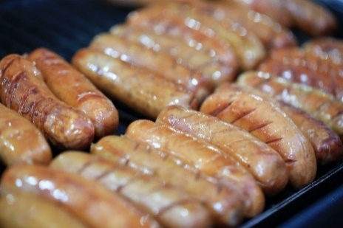

**Results of blind tasting**

The result of the blind tasting was master’s sausages came out as No 1 and Coles followed 2nd followed by IGA and lastly Woolworths.

The members were asked to vote on what sausages we should purchase for our BBQ’S.

**A formal vote was passed in favour of using only master’s sausages.**

Approval was also given for all volunteers on the day to be provided with one free sausage in bread with sauce and a drink.

**Advocacy**

**Found a Committee.**

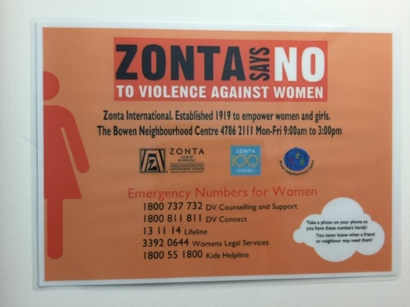

**Lauren, Noelene, Helen, Wendy, and congratulations to all who committed to this group**

I saw an orange lady on the hill. She really stands out.

Our Orange Ladies are up around town and in Proserpine.

The Committee has done a fantastic job and I thank them very much for the dedication to get these out. The Orange Ladies come down this week at the end of November and before we use again will need some work on them.

I would also like to thank the businesses who allowed us to put them up in and around their stores.

**Did anyone discuss this idea**??……. The Zonta Club of Bowen has put these signs up around Bowen. This was on the toilet door at the picture theatre. I thought this was a great idea and maybe the **new** committee might like to consider further.

**Dianne Trueman on 0408353450**

**PROSERPINE STATE HIGH SCHOOL BURSARY RECIPIENT FOR 2020**

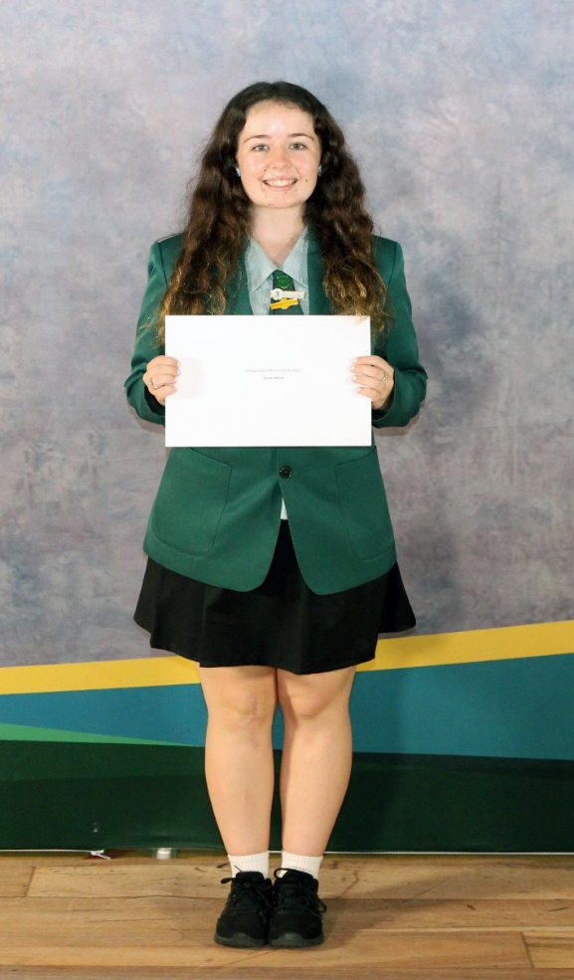

The recipient of our Club’s bursary for 2020 is Sarah Milne.

Sarah is the Proserpine High School Vice-Captain. She has participated in preparing the birthing kits and volunteers at Whitsunday Dance Connection as a dance teacher. Sarah has overcome her own learning difficulties to be an inspiration for other girls in a similar situation.

In the future, Sarah hopes to inspire women that diversity is important and not an obstacle to whatever you want to achieve

Congratulations to Sarah and best wishes for the future.

The Club received the following thank you from the Proserpine High School.

“On behalf of the entire school community, thank you for your very kind sponsorship of our annual Awards Night.  Such generosity from the local community certainly ensures the success of the night.

It is very gratifying to the students to know that their efforts are acknowledged by the community as well as their school.

The school is extremely grateful for the generous response from the community to sponsor our Annual Awards Night and look forward to continuing this partnership with you into the future.

Your support of Proserpine State High School is greatly appreciated.”

## **Pause for Thought**

**Patsy Morgan -meeting 19 November 2020**

**Ruth Bader Ginsburg - 1933-2020**

If ever there was a lady that could have been crowned as the Queen of Zonta then it would have been this lady, Ruth Bader Ginsburg.

She was born in Brooklyn to a devout Jewish family in 1933. Then married and with 2 very small children, she became only 1 of 2 ladies in a class of 500 to be accepted at Harvard Law School.



She became a trailblazer for women’s equality and civil rights.

Ruth went on to become the first female professor at Columbia Law School and she founded the Women’s Rights Project which helped craft the 1st legal case for women’s equality.

Then in 1993 she became only the second Justice in History.

Some of her famous words will forever go down in history to be quoted by all generations to come.

“**Women belong in all places where decisions are being made”.**

“**Fight for the things that you care about but do it in a way that will lead others to join you”.**

**“Women will have achieved true equality when men share with them the responsibility of bringing up the next generation”.**

This year, she died of pancreatic cancer.

So that you get to know a little more of her life and deeds, I would urge you to get onto Netflix and search for the movie “On the basis of Sex”.

Felicity Jones and Armie Hammer play the Ginsburg’s very well indeed and is an awe-inspiring film. I feel it’s on par with ‘Hidden Numbers’.

So, this month’s invocation is to honour Ruth Bader Ginsburg and her women’s equality and to ask you to watch the movie ‘On the basis of Sex”. Thank you.

**Pause for Thought” Schedule of speakers**



“Pause for thought” is a replacement for the invocation. The nominated member gives a five-minute talk on any project of Zonta International or issue that has relevance to Zonta.

General Meeting Speaker Backup Speaker

January Roz Jennings

***Annie is home – but in Lockdown***

***What an amazing time she has had… read all about it***

So

Hi everyone!

Your Captain speaking...

I was in France la Rochelle from the 2nd July working on the boat. Then work ended due to Covid in Sept.  Then I flew to Lisbon Portugal. I sailed to the Portuguese islands of Madeira. Then sailed to Spanish Gran Canaries. Lucky as I got there France and the UK went into serious lock down. These islands did not as very little covid there.

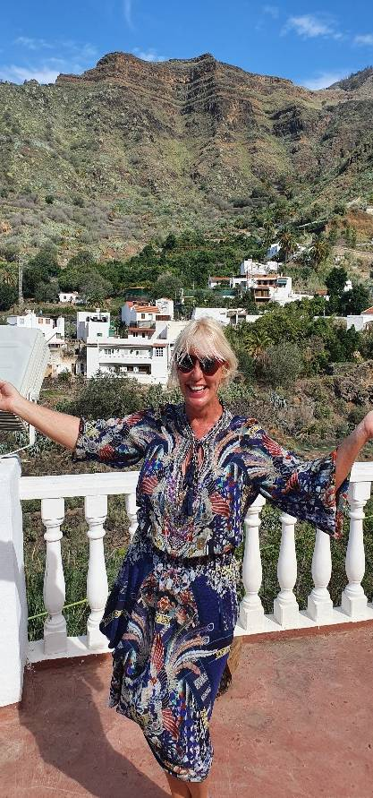

It is also very cold ....in France.

I sailed with people from PJ and Steve’s hometown in the USA, Phoenix. New sailors that appreciated a hand.

I toured and saw the places we sailed to by bus and car.

The airline cancelled twice and the spots to 're book were hard to get. anxiety/jitters as I was departing Paris France 26th no 2020 to Sydney, Australia

I flew with Etihad to Quarantine hotel Sheraton grand Hyde park Sydney

My experience:

I had a covid test before the flight and I was flying solo and feared not getting on the plane till I had my tickets securely in my hand. Once aboard I had a good time eating drinking watching movies.  The attendants are all in masks and full hazmat gear. All passengers wore a mask all flight.

Once you land, you joined a queue to be notified of the upcoming quarantine situation by customs. The airports were empty. No shops open, no lounges and no duty free.

It does feel a little bit militaristic with all the police and army about. The mood is quite gloomy. You will not be able to choose your hotel, your guided out the airport to the bus. The police and army boys load the bags. They put you onto a bus and u wait an hour then you are on your way to a hotel????? Told where only once underway. A policeman boards gives u forms to fill in and then says they are here to help. It took maybe 3 hours or so from de boarding to getting to the hotel.

All the staff I dealt with were extremely friendly and welcoming all the way through. Everyone I spoke with was very friendly, even up to the last military guy who brought me to my room who took the effort to start a conversation with me to ask about my trip. Opened the door with his key, then said u cannot exit the room at all.  Yr. not given a key.

SYDNEY HARBOUR Sheraton Hyde park hotel

Overall, the experience has been fine, like many of us I spent the last few months mentally preparing for the idea of being alone in a hotel room for 2 weeks, reading horror stories about the situation. Maybe it was because my expectations were low but honestly the quarantine has been fine. It is not ideal, but in my opinion, labelling it prison is a bit of a stretch, it is just a reality that we all must deal with right now. The food is pretty good (quality varies from day to day but they give you way too much which is probably a good thing), and the room is quite updated with a bath. As for the rules here, there is no fresh air, and you are not allowed to leave your room for any reason other than an emergency. You can have packages delivered but only a max of 2 times per day. You will have a fridge so keep any unwanted food in there just for peace of mind, so you do not have to stress about going hungry. At this hotel, no microwaves are allowed, and they only provide you with paper plates and plastic cutlery.

The nurses will call your room every day to check up on your symptoms and they have been very friendly and understanding of the situation.

Dealing with the 2 weeks, I’ve a skipping rope bought and exercise bike...use my phone a lot.... I did a COVID test Day 2 and Day 10. Please note that the day you land is Day 0! So, its 15 days.

You are delivered 3 meals a day (7 AM - 9:30 AM, 12 PM - 2 PM, 6 PM - 8 PM) to your door.

Towels and linen given to u at day 7 to change myself.

There are many different experiences around Australia.  Mine is just day 6....and I am out the 12th Dec too late to fly home so another hotel.  Then Hamilton island direct.  Just in time for the ladies’ wine club...then Airlie Beach 14th dec ...  better plan some lunches ladies

Please feel free to reach out to me if you have any questions.

On Sat, 17 Oct 2020, 05:57



***Christmas covid --- It was a month before Christmas***

***Thank you, Patsy, for this contribution***

Like This T’was a month Before  
Christmas 2020⛄🎅🎁🎄  
  
T’was a month before Christmas,  
And all through the town,  
People wore masks,  
That covered their frown.  
  
The frown had begun  
Way back in the Spring,  
When a global pandemic  
Changed everything.  
  
They called it corona,  
But unlike the beer,  
It didn’t bring good times,  
It didn’t bring cheer.  
  
Contagious and deadly,  
This virus spread fast,  
Like a wildfire that starts  
When fuelled by gas.  
  
Airplanes were grounded,  
Travel was banned.  
Borders were closed  
Across air, sea and land.  
  
As the world entered lockdown  
To flatten the curve,  
The economy halted,  
And folks lost their verve.  
  
From March to July  
We rode the first wave,  
People stayed home,  
They tried to behave.  
  
When summer emerged  
The lockdown was lifted.  
But away from caution,  
Many folks drifted.  
  
Now it’s November  
And cases are spiking,  
Wave two has arrived,  
Much to our disliking.  
  
Frontline workers,  
Doctors and nurses,  
Try to save people,  
From riding in hearses.  
It’s true that this year  
Has had sadness a plenty,  
We’ll never forget  
The year 2020.  
  
And just ‘round the corner –

The holiday season,  
But why be merry?  
Is there even one reason?  
  
To decorate the house  
And put up the tree,  
When no one will see it,  
No-one but me.  
  
But outside my window  
The snow gently falls,  
And I think to myself,  
Let’s deck the halls!  
  
So, I gather the ribbon,  
The garland and bows,  
As I play those old carols,  
My happiness grows.  
  
Christmas ain’t cancelled  
And neither is hope.  
If we lean on each other,  
I know we can cope.

***Thoughts on equality***

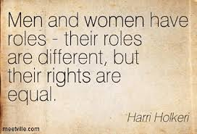

**November Happy Birthday**

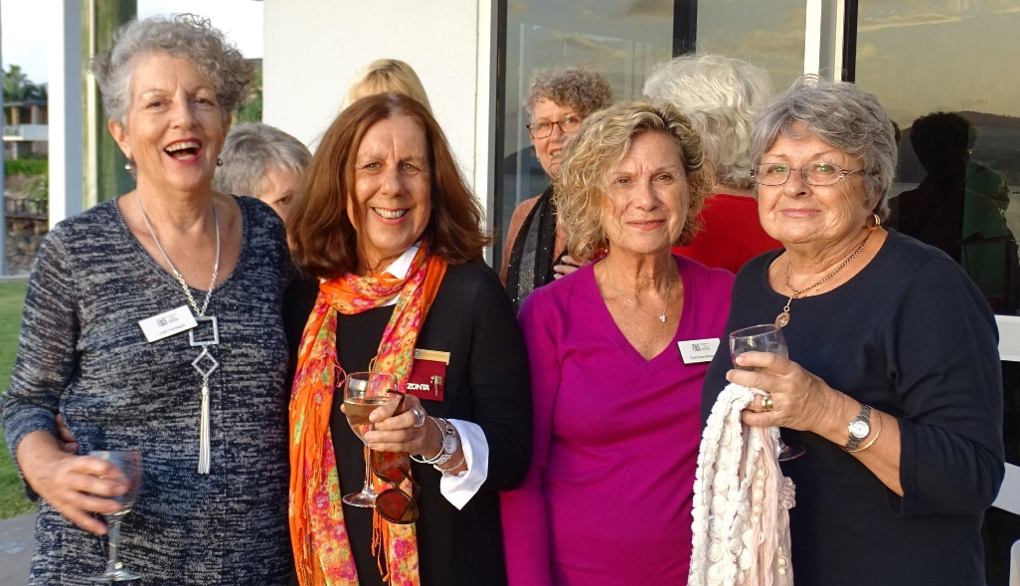

**Roz**



***Christina has contributed this lovely article about end of year dogs***

**End-of-ear 2020**

First, I planned to write about that ‘special’ year 2020, what it meant for me – not going to Switzerland for example. But enough was and will be said about the pandemic. I am so lucky to live where I live – no Covid-19 cases, life practically normal and living on the farm, surrounded by hills, trees, wildlife; my dogs, geese and all my rescue animals: horses, dogs/puppies, cats/kittens, roosters, Muscovy ducks.

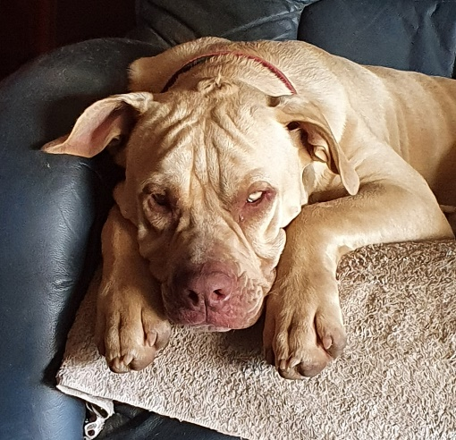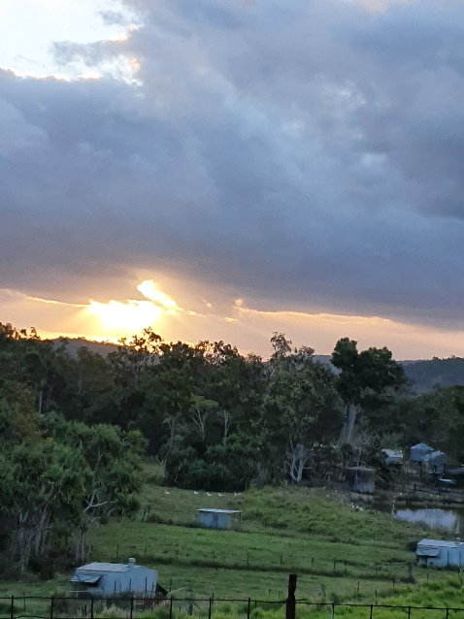

My biggest animal challenge was Boy/Burb/Ragazzo. A young woman watched the 3-months old puppy being abused and saved him, before the abuser could shoot him. I have never seen a puppy that scared. He was shaking from his nose to the tip of his tail; he broke my heart. I promised him that he would never be abused again. After 9 months he still does not like men he does not know, but he loves his dog mates, loves, and trusts me! At 14 months the puppy has grown into a chunky 40 kg young dog (Mastiff/Cane Corso).

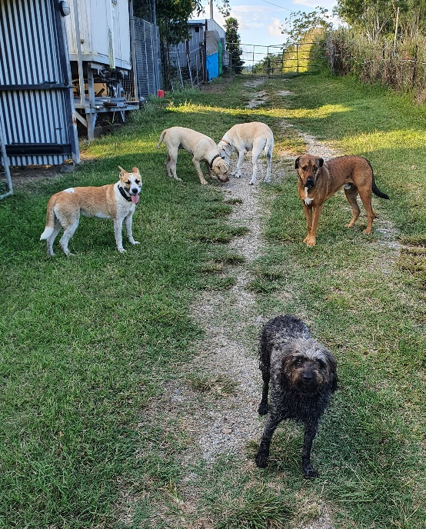

Since February 2019, more than 80 dogs/puppies, more than 100 cats/kittens, 4 horses and 4 roosters passed through my doors. I kept the Muscovy ducks and 2 roosters…

The human challenges are much bigger (see text ‘just a dog’) and, at times, my diplomacy goes out the window, when people discard animals like a pair of shoes. The stories about the owners would fill a couple of books!

My faith in humanity always gets restored by the people in my community: I have such a wonderful network of supporters. Businesses, individuals do fundraisers for Animal Rescue Whitsunday. People I do not know, drop pet food off and donate money. They care and look out for abandoned animals. Everyone knows me; the Animal Rescue Whitsunday posts on Facebook get shared by many. Rescuing dogs, cats and farm animals keeps me busy and focused.

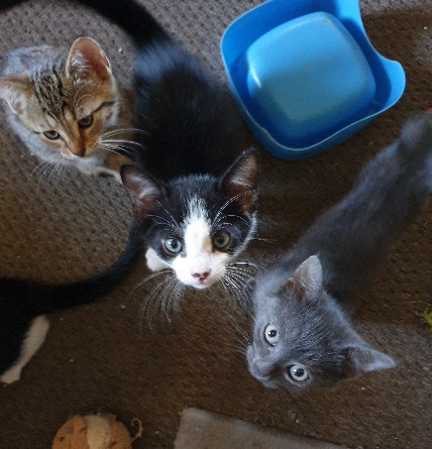

I wish you all a happy 2021. Life will never quite be the same, but the glass is still half full! I want to share the story below because it says it all.

Christina Sis Chrige

JUST A DOG

From time to time, people say "lighten up, it's just a dog" or "that's a lot of money for just a dog." They do not understand the distance travelled, the time spent, or the costs involved for "just a dog." Some of my proudest moments have come from "just a dog." Many hours have passed, and my only company was "just a dog," but I did not once feel slighted.

Some of my saddest moments have been brought about by "just a dog," and in those days of darkness, the gentle touch of "just a dog" gave me comfort and reason to overcome the day.

If you, too, think it is "just a dog," then you will probably understand phrases like "just a friend," "just a sunrise," or "just a promise."

"Just a dog" brings into my life the very essence of friendship, trust, and pure and unbridled joy.

"Just a dog" brings out the compassion and patience that makes me a better person.

Because of "just a dog," I will rise early, take long walks, and look longingly to the future. So, for me and folks like me, it is not "just a dog" but an embodiment of all the hopes and dreams of the future, the fond memories of the past, and the pure joy of the moment.

I hope that someday they can understand that it is not "just a dog," but the thing that gives me humanity and keeps me from being "just a woman." So, the next time you hear the phrase "just a dog," just smile, because they "just don't understand." - Author unknown

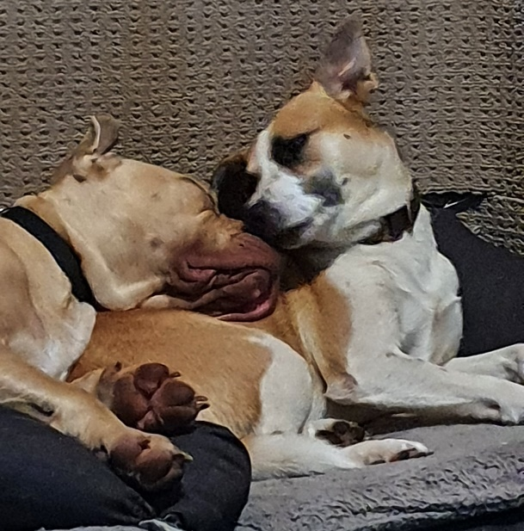

***Dates to remember***

* ***Next meeting 21 January 2021***
* ***6 March 2021 International women day***
* ***Book Club at Kerry Kenyon’s house last Wednesday in the month at 5.00 pm***

***Cath 0419 653 878***

* ***Knitting group April to Nov last Monday of the month at 10.00 am.***

***Carol 0417 619 098***

* ***Sewing Group ad hoc, breast cushions, turbans modesty sheets, virus masks etc***

***Carol 0417 619 098***



[This Photo](https://www.christmasvillageworld.com/2020/02/10/come-il-natale-in-australia/) by Unknown Author is licensed under [CC BY-NC-ND](https://creativecommons.org/licenses/by-nc-nd/3.0/)

***I have thoroughly enjoyed my turn as editor for the newsletter, however it is time to pass it on as I will be away for much of 2021***

***Merry Christmas everyone***

***Editor***

***Marlene Reiffel***

***November/December 2020***