Zonta Club of Hervey Bay Inc International Women’s Day Report 2022
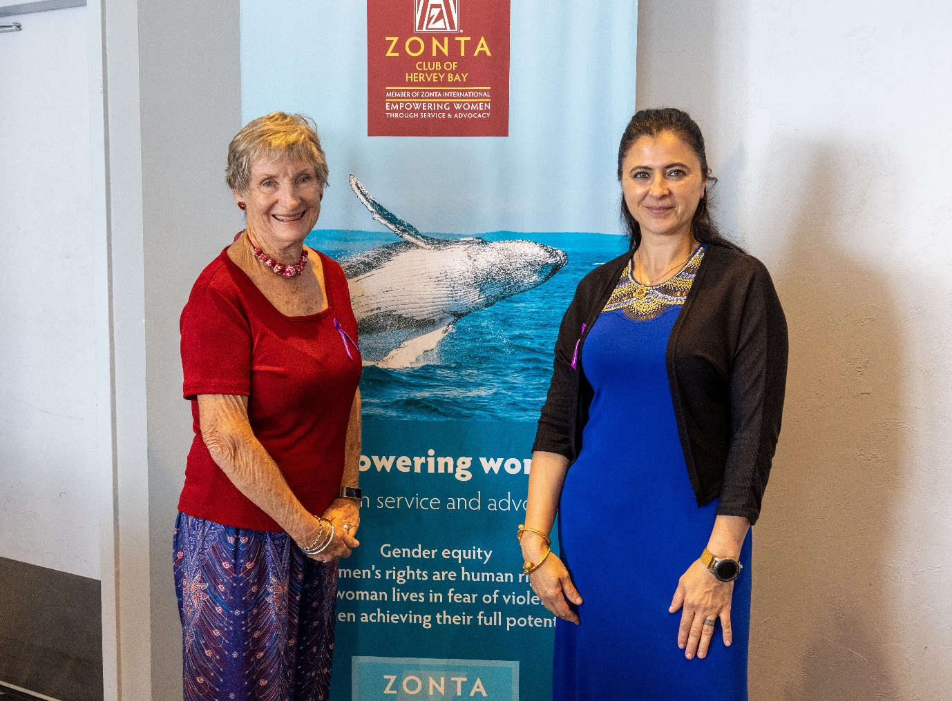
The Zonta Club of Hervey Bay has had a signature event on IWD day for many years and this year was one of the most successful.
Due to generous support from Fraser Coast Regional Council for a high-quality speaker, and to Kingfisher Resort, Bunnings Hervey Bay and De Lorenzo for excellent raffle prizes, the tickets sold out very quickly with the maximum 140 achieved with a long waiting list.
This event attracts high attendance and celebrates the achievements of women. This year we saw a much higher attendance by men, with leadership from council and industry attendees. New organisations, including major employers also joined us, sponsoring tables for their staff to attend.
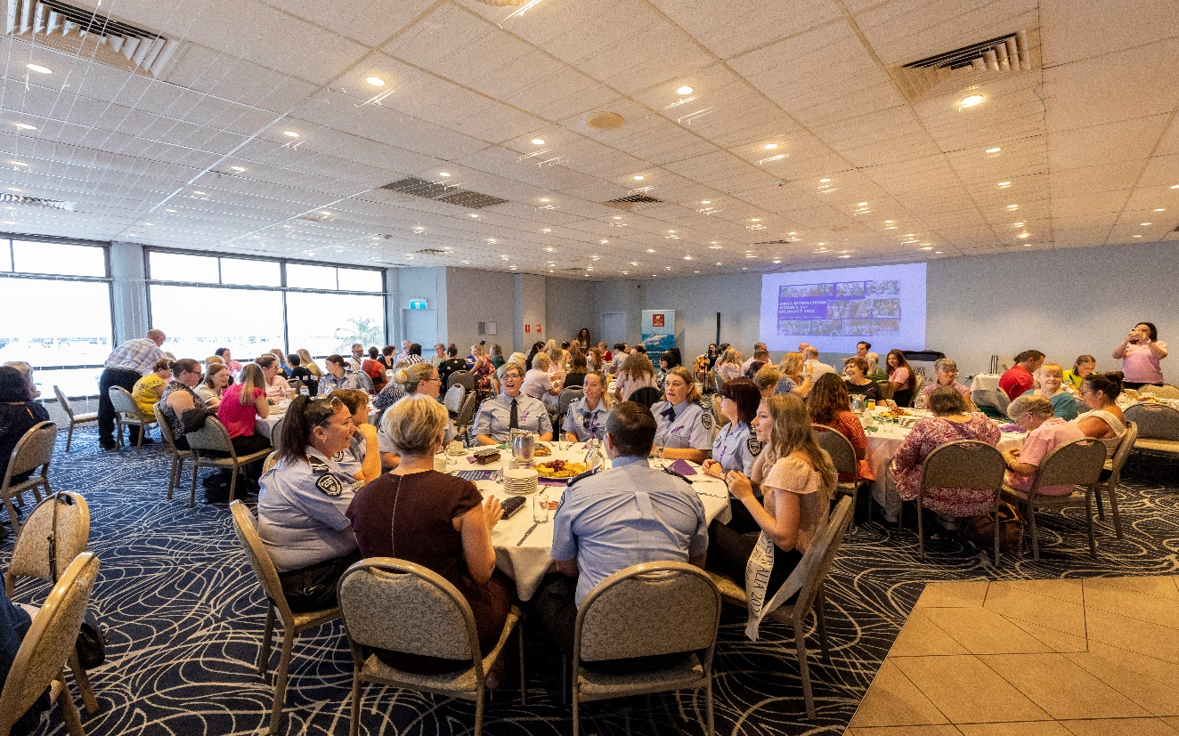
The theme of the early morning breakfast was one of mental attitude in times of challenge. Alicia Wade, gratitude expert, life coach, business mentor, motivational speaker, and author, as well as chair of the advocacy committee was MC for the event and started the morning positively with a welcome to country from Butchella representative Karen Hall. Karen’s speech certainly inspired and educated us as we all felt grateful to be on Butchella land and learning about the roles of Aboriginal women in caring for country and community.
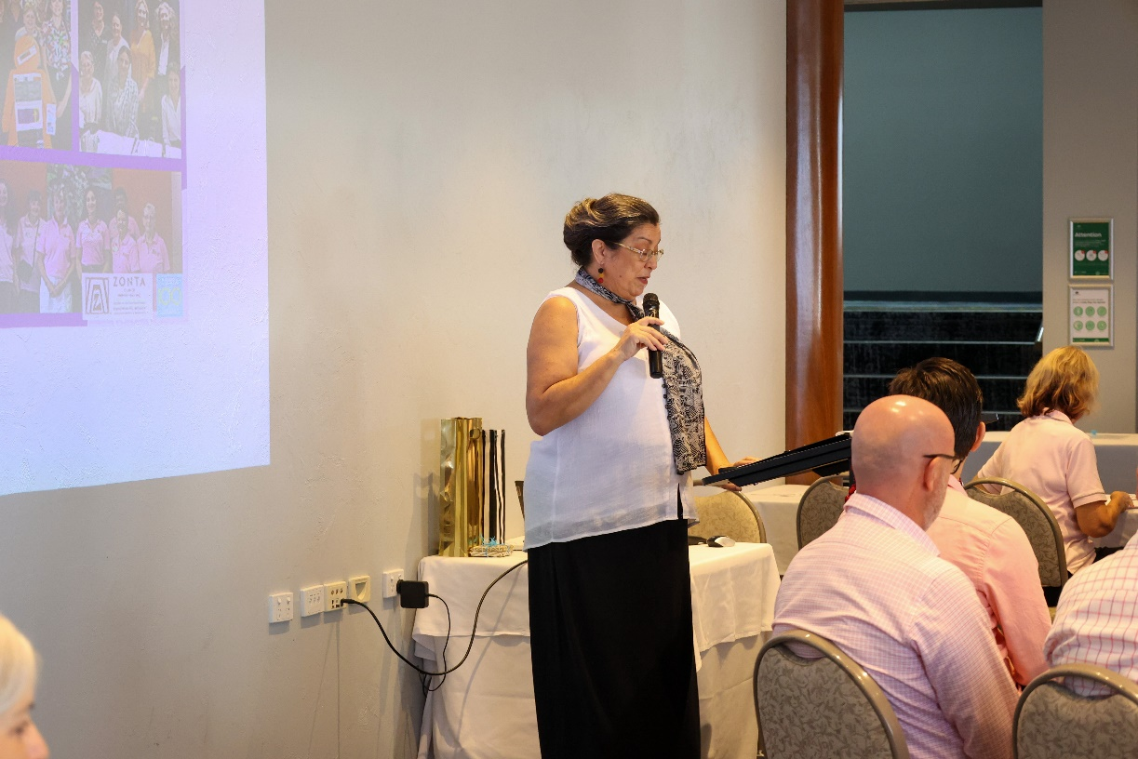
Sara Faraj, Club President, and youngest club president in Zonta, spoke strongly about the importance of speaking up, of having a voice as women. She spoke of personal histories of her family in the middle east, and the progress made over time as well as the challenges we still face across the globe and locally. She concluded strongly with the words ‘when a woman speaks, do not look at your watch.’ Sara will be speaking at the Area 2 meeting in Gladstone, and I am sure will again inspire us.
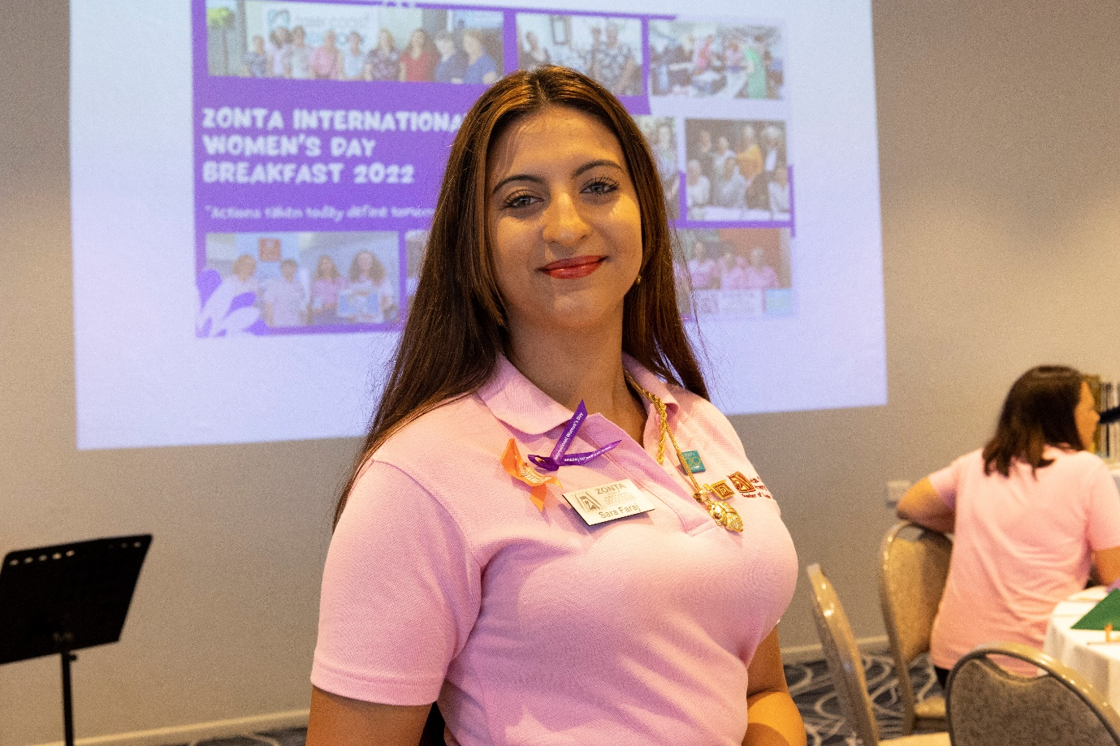
The Fraser Coast Regional Council Mayor, Councillor George Seymour, continued the theme bringing our awareness to how we talk and speak about men and women who work and care for children. His speeches are always insightful and challenge our thinking about what it means to be a woman in our community and inspires us to challenge the assumptions made by men. We are fortunate to have such leadership and support by the mayor and other councillors who attended the morning.
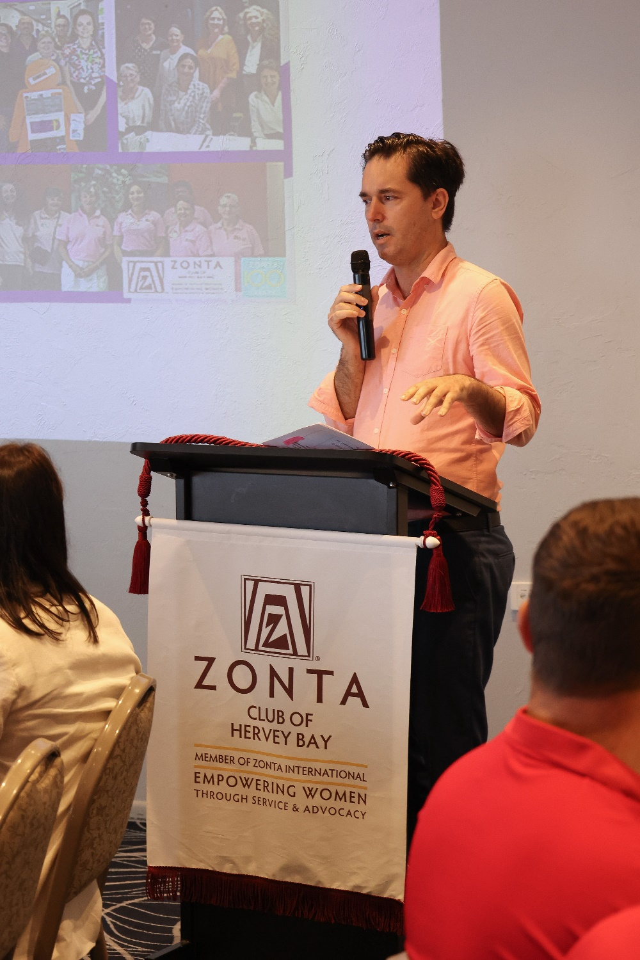
The guest speaker was Jacqui Bell, the youngest ultramarathon runner to compete on all 7 continents. Jacqui’s story of overcoming challenges both mental and physical was inspiring and left the audience in awe of her achievements. Her story was not limited to her journey as an ultra-marathon runner, but challenged us all to follow our goals, dreams, and desires, to have the mental attitude that overcomes barriers to our achievements, to work as a team to achieve goals and to be the best that we can be.
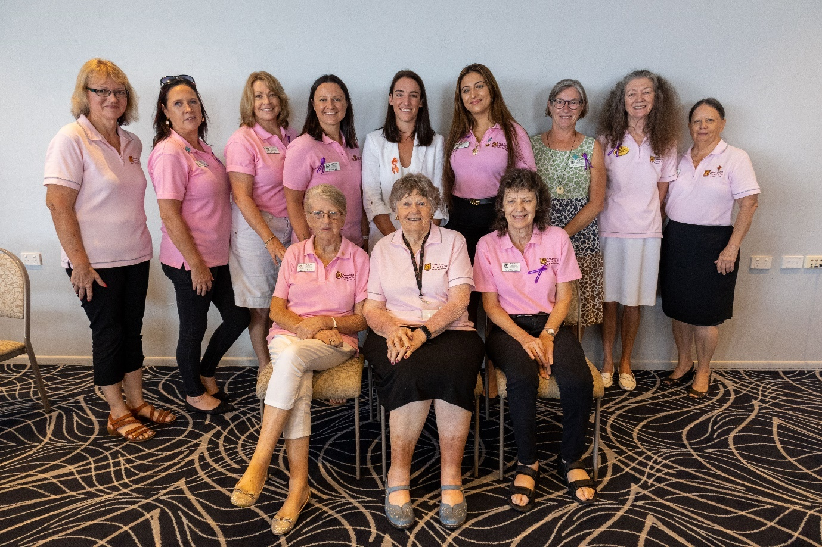
The Hervey Bay Boat Club provided an excellent breakfast and the staff cared for us so well. The raffle prizes were the final excitement before we all left for our work, inspired, grateful and ready to apply the inspiration of the morning to our lives and work in Zonta.

