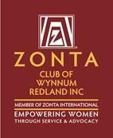The Zonta Club of Wynnum Redland Inc.
ABN: 57025338425
PO Box 132 Capalaba 4157
wynnumredland@zontadistrict22.org
Zonta International District 22, Area 3
C conviction, C commitment, C courage
Find us on Facebook: https://www.facebook.com/Zonta-Club-of-Wynnumhttps://www.facebook.com/Zonta-Club-of-Wynnum-Redland-Inc-240575512649766/Redland-Inc-240575512649766/
March 2021

Details:
The next dinner meeting is 8th March at Fiction Bar, Raby Bay - 6pm for 6:30pm. Cost for the dinner meeting is $30 with payment made electronically to bank account: BSB 633000 Acc 158165050 .
RSVP is NOW with payment and any dietary needs to club treasurer Ros Beveridge (handlyn8@bigpond.com.au).
PLEASE NOTE.
Failure to apologise to Ros before Friday 5pm will be assumed an acceptance and a meal will be provided. So, the cost of this meal will have to be met by the non-attending member as the Club cannot afford to pay any more than the Fiction Bar who bill us on numbers supplied.

President Nicola Redmond
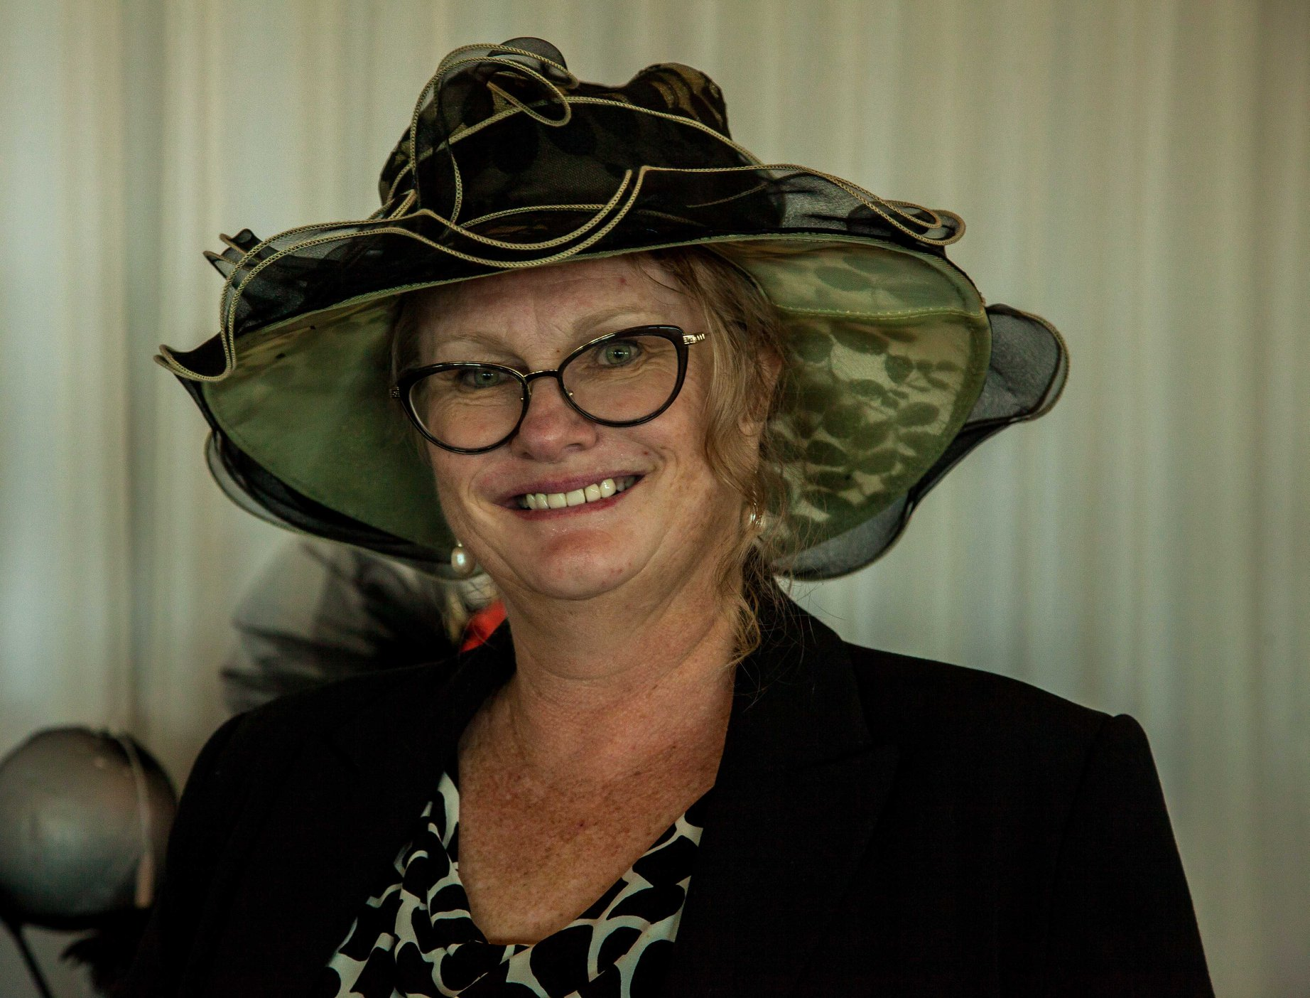
Dinner Meeting February 2021

President Nicole Redmond. Welcomed us to country & paid our respects for local elders, present past and emerging.
Considerable discussion was held regarding establishing a marketing plan. Irene has offered to conduct a workshop on the subject as this is her area of expertise. Further detail will be forthcoming at our March meeting.
Loris gave a brief but informative talk on the District Meeting and that Amelia Erhardt breakfast she attended.
We are planning a breast cushion making event to take place on either 11th or 18th March at Barbara’s home.
Robyn B-R was keen to hear about some hands-on contribution that can involve her senior students. Birthing Kits were mentioned as a possibility.
Carol MacDonald reported back on the “Applying for Grants workshop” that she attended on behalf of the Zonta Club.

Planning Day 2021
General agreement that every member should be on a committee and contribute. Member will be asked at the March meeting to offer their assistance in the formation of sub committees to assist each director.
Membership News Julie Cardiff
Julie welcomed the formation of a marketing plan for Zonta WR and will work with Irene and Michelle to bring this to fruition. A reminder to all club members that IWD dinner is a good way to introduce possible future members to Zonta. We have a potential new member from the staff at Wellington Point High and some other interested parties.

Service News Pat Lavelle
Our IWD dinner was an unqualified success. We filled the Courthouse Restaurant with 104 guests. Our MC extraordinaire, Jenny made everyone feel welcome and kept us all on time. Nicole’s Presidents Address was very friendly and must have impressed our guests with the clear understanding of the plans and goals of the Zonta Club of Wynnum Redland. Margaret’s granddaughter Quinn was a pleasure, both to listen to and in her manner and conversation. Indeed, the young people present, Quinn, Makayla, our YWPA winner, Olivia and Pauline, YWPA applicants and the young people from Wellington Point and Cleveland High were wonderful encouragement in the future.
Therese was our keynote speaker and entertained us all with the ins and outs of the lingerie business. Our full agenda was completed by Irene presenting the YWPA award to Makayla and Wellington Point High.
The final act of the night was to draw the raffle, which was all donated by members and associates, so remember who supports us and offer them your business wherever possible. Of Note: KM Smith Funerals, Ella Bache Cleveland, Finesse spirits, Secrets for Women, Bruce Hutchison L J Hooker and Ross Vasta.
We are currently planning the function/social calendar for 2021. Looking at three or four Functions with a few purely social events to promote club fellowship. 2021 being the 40th anniversary of the Zonta Club of Wynnum Redland Inc we need a suitable celebration all suggestions will be welcomed.
Advocacy
Therese showed a copy of the Zonta says No signage to go into toilets and has undertaken to order club cards. She will liaise with RCC to place these in appropriate positions.

Communication
Michelle arranged the business cards for the club and I have already handed out four today at the RWIB IWD lunch at the Courthouse.

Date Claimers –

8 March Dinner Meeting Fiction Bar

11 March 2021 IWD Breakfast Brisbane East at the Greek Club

May Area Meeting see request attached.

4/5 September District 22 Conference Mackay

Zonta Club of Wynnum Redland Board

President: |  |  | Nicole Redmond nickie1@ozemail.com.au
First Vice President:  Second Vice President: |  |  | Pat Lavelle patjane1@hotmail.com  Julie Cardiff julie@cardifflaw.com.au
Secretary: |  |  | Carol MacDonald caroljmacdonald@icloud.com
Correspondence Secretary: |  |  | Marilyn Smith damj382@hotmail.com
Treasurers: |  |  | Ros Beveridge handlyn8@bigpond.com  Helen Wood helen.wood@firstclassaccounts.com
Board Members: |  |  | Judith Trevan-Hawke pujt@bigpond.com  (ex officio)  Sue Freilich suefreilich@gmail.com  Therese Thorp Secrets4women@bigpond.com  Jennie MacIntosh jennie@kmsmith.com.au  Robyn Smith robynsmith.rs64@gmail.com

Host Club Zonta Club of Brisbane East Inc
When Area 3 meeting 8 May 2020
Venue Will be either at Gold Coast, where we are exploring options at Nerang OR
Brisbane close to Freeway
Program We have Bridget our District Governor updating us on District and ZI, Lyn Agnew Lieutenant Governor on Membership, particularly Add your Voice campaign and Christine D22 Treasurer. We also are exploring a range of guest speakers.
Request If we decide to have it in Brisbane could Brisbane Clubs please canvas whether you would host members from one of our Southern Clubs say for the Friday night ie put them up for the night and perhaps do a joint fellowship evening. My request considers the time it takes for our Zontians in Northern Rivers and Tweed Heads who not only have a considerable drive but any border regulations that may come their way.

