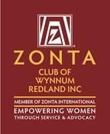The Zonta Club of Wynnum Redland Inc.
ABN: 57025338425
PO Box 132 Capalaba 4157
wynnumredland@zontadistrict22.org
Zonta International District 22, Area 3
C conviction, C commitment, C courage
Find us on Facebook: https://www.facebook.com/Zonta-Club-of-Wynnumhttps://www.facebook.com/Zonta-Club-of-Wynnum-Redland-Inc-240575512649766/Redland-Inc-240575512649766/
June 2021

Details:
The next dinner meeting is 14th June at Fiction Bar, Raby Bay - 6pm for 6:30pm. Cost for the dinner meeting is $30 with payment made electronically to bank account: BSB 633000 Acc 158165050 .
RSVP is Fri 7th May with payment and any dietary needs to club treasurer Helen Wood helen.wood@firstclassaccounts.com
PLEASE NOTE.
Failure to apologise to Ros before Friday 5pm will be assumed an acceptance and a meal will be provided. So, the cost of this meal will have to be met by the non-attending member as the Club cannot afford to pay any more than the Fiction Bar who bill us on numbers supplied.

President Pat Lavelle
President’s Notes
Hello to all members,

Many thanks to all our members once again for pulling off a highly successful Gala lunch a wonderful day and all the guests enjoyed themselves.
l would like to thank Theresa for her excellent MC work for the day great performance well done.

Gail never lets the club down with her extraordinary work with the raffles and table plans thank you and well done.
To have a successful function it takes months of planning and hard work so once again many thanks to Barbara Wills who never lets us down.
Barbara wishing you best wishes for the 10th hope your operation is successful.
We can now look forward to the rest of the year with lots happening mainly our 40th birthday 26th September we can celebrate with pride.
Unfortunately, l will not be with you for the next dinner meeting, Bill is having an eye OP on the 14th June, l have apologised to Helen.
Best Wishes to all. Pat.
Dinner Meeting May 2021
President Nicole Redmond welcomed us to country & paid our respects for local elders, present past and emerging. We then had a brief meeting before closing the May meeting to open the AGM. President Nicola gave her report on the clubs’ activities before asking Judith Trevan-Hawke to take the chair. Judith called on the Nominating committee for their report.
The Nominating Committee, Jo Hieatt, Gail Abbott and Janet Mylne thanked the outgoing Board for their work. Judith Trevan-Hawke-Hawke installed the new Board by naming each member and the position of their appointment, whilst the meeting unanimously voted approval (vote) of each named appointment. Judith presented all the Board with yellow roses, after each person pledged The Zonta pledge.
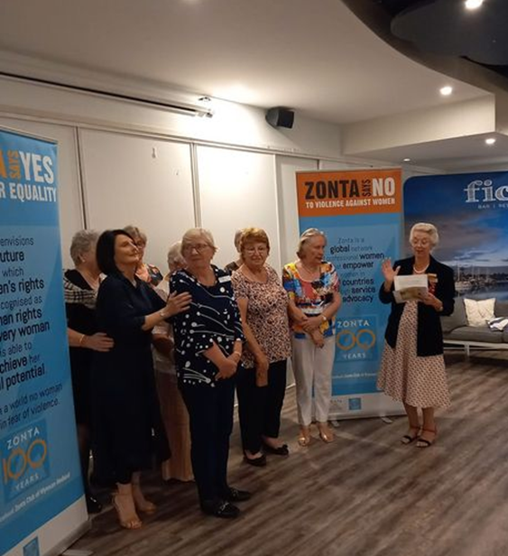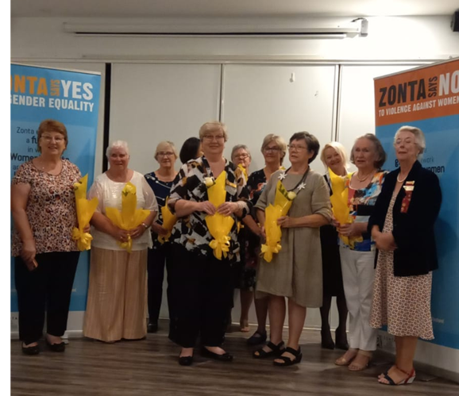
President Pat Lavelle
1st VP Julie Cardiff
2nd VP Robyn Smith
Secretary Carol McDonald
Treasurer Helen Wood
Director Marilyn Smith
Director Therese Thorp
Director Jenny McIntosh
Advisor Judith Trevan-Hawke
On closing Judith Trevan-Hawke declared all nominees are installed.

Membership News Julie Cardiff
After a disappointing loss of members for various reason it was very encouraging to see interest in Zonta at our recent lunch at the RQYS. I would like to develop a regular casual get together on a weekend with the objective of interesting working women who may not understand our mission.
This is a work in progress, and I would be happy to have any advice or/or support those members can offer. Please always be always conscious that you may know a prospective member that you can invite to meet us at a dinner meeting.
Service News Robyn Smith
A day of fun, music and fine food was enjoyed by 104 guests at the RQYS Manly. The theme of Black, White and Red inspired most of the guests to dress in these colours and Julie Cardiff encouraged the ladies to move around the room while Charmaine from Raby Bay Resorts selected the Best Dressed winner. We were entertained by “Mates Rates” a Barbershop Quartet before a great Fashion Parade by Raby Bay Resorts. Zontians Jennie, Jo, Judith and Liz were wonderful models showcasing the Australian Made clothing.
Our Guest Speaker Alan Finegan was wonderfully informative about the forgotten history of Moreton Bay. His talk made so many of the original explorers come to life, some warts and all.
Steve Murphy from LJ Hooker Real Estate Cleveland sponsored not one but three lucky door prizes. So, three lucky ladies won a day trip to North Stradbroke Island with lunch at the Point Lookout Hotel. So happy to report our Founding Member and consistent supporter Phyllis won one of these prizes.
In all a successful day with funds raised to support the clubs work, locally and internationally.
Xmas In July is to be a club fellowship event with numbers restricted to 40.
Mary from the Courthouse has confirmed that we will be operating the Sweeps and Raffles for their Melbourne Cup Luncheon.
Saturday, 26th September to celebrate our 40th Anniversary, is booked in for a High Tea at Ormiston House. (50-70 guests can attend at this time due to COVID restrictions) We would like a strong attendance from past members and will be looking to contact as many as possible soon.
Advocacy News Therese Thorp
It is very important that we, as a club, support the joint initiative of Zonta, Soroptimist, Red Rose Foundation and Redland City Council in the Candle Lighting Ceremony at Walk the Talk on 5th May. Please wear your Zonta T shirts and be at Kyling Corner at 4.45. It was a bit disappointing that due to inclement weather the walk was cancelled. The candle lighting ceremony went ahead in the Fiction Bar and while the Zonta numbers were disappointing those who attended were very noticeable in their orange T shirts.
Zonta Club of Wynnum Redland Board

President Pat Lavelle
1st VP Julie Cardiff
2nd VP Robyn Smith
Secretary Carol McDonald

Treasurer Helen Wood
Director Marilyn Smith
Director Therese Thorp
Director Jenny McIntosh
Advisor Judith Trevan-Hawke
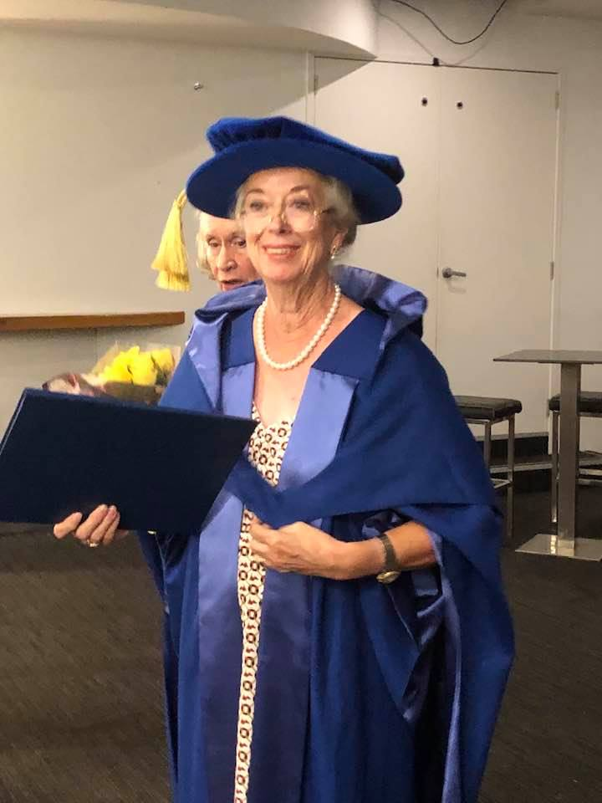 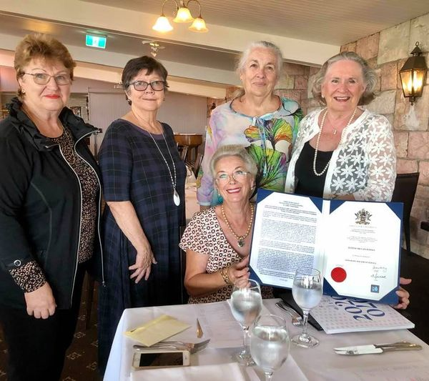 Our Honorary Doctor of Sciences, Judith Trevan-Hawke. Bestowed by James Cook University for Judith’s services in her field of Occupational Therapy. We are very proud of Judith as she has been a tireless worker in our group at Zonta Wynnum Redlands. Some club members celebrated with Judith over lunch at the Courthose Restaurant.
Date Claimers
February | 8th  22nd | Dinner Meeting Fiction Bar  Board Meeting Fiction Bar
March | 4th  8th  11th  29th | IWD Dinner and Presentation of YWPA award Courthouse Restaurant  Dinner Meeting Fiction Bar  Breast Cushion Working Bee  Board Meeting
April | 4th  ^{12th}  18th  26th | Easter Sunday  Dinner Meeting  Quota Changeover  Board Meeting
May | 4th  ^{5th}  10th  ^{31st} | Area 3 Meeting Nerang RSL  Walk The Talk Cleveland See Flyer Attached  Dinner Meeting Fiction Bar  Board Meeting
June | 1st  14th  ^{27th}  ^{28th} | Gala Lunch RQYS  Dinner Meeting Fiction Bar  Trivia Afternoon tea Postponed  Board Meeting
July | 12th  25th | Dinner Meeting  Christmas in July
August | 9th  30th | Dinner Meeting  Board Meeting
September | 4/5th  13th  26th  27th | District Conference Mackay  HouseDinner Meeting  40th Anniversay Ormiston House  Board Meeting
October | 11th  25th | Dinner Meeting  Board Meeting
November | 2nd 8th  ^{29th} | Melbourne Cup Day Courthouse  Dinner Meeting  Board Meeting
December | 11th  13th | Christmas Lunch Little Ships Club  Dinner Meeting

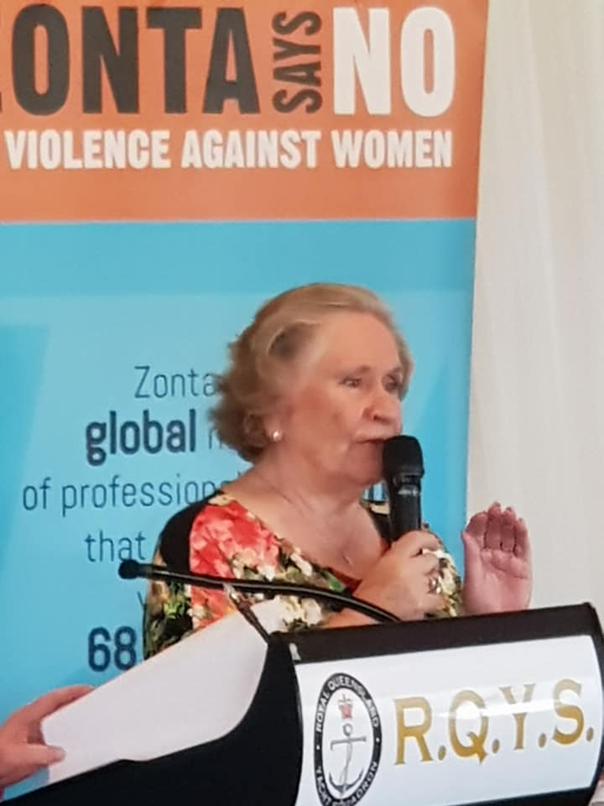

President Pat Welcoming our Guests to the Zonta Black, White and Red Lunch at RQYS Manly

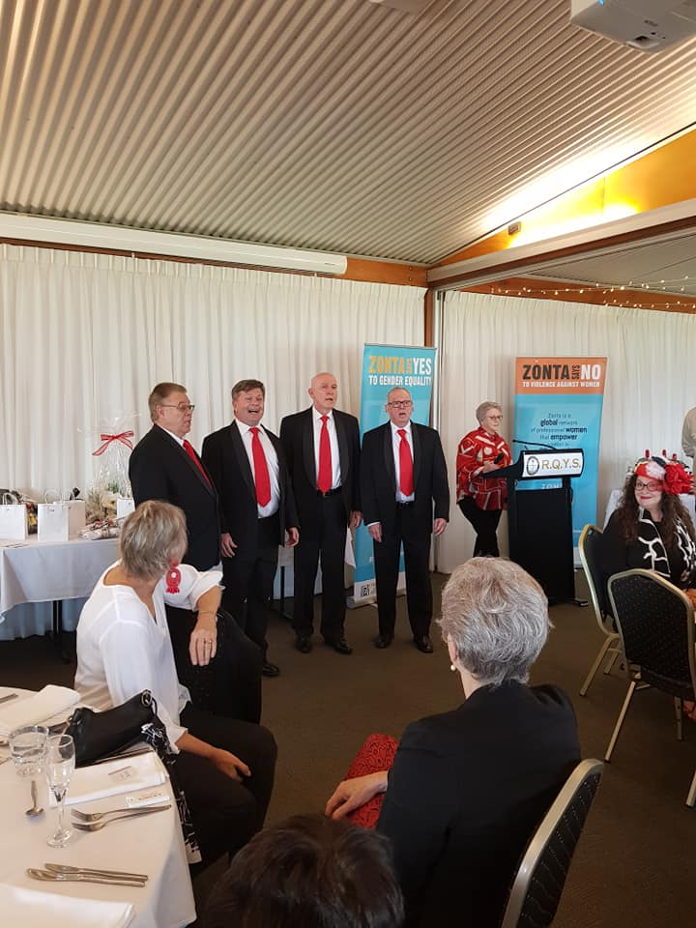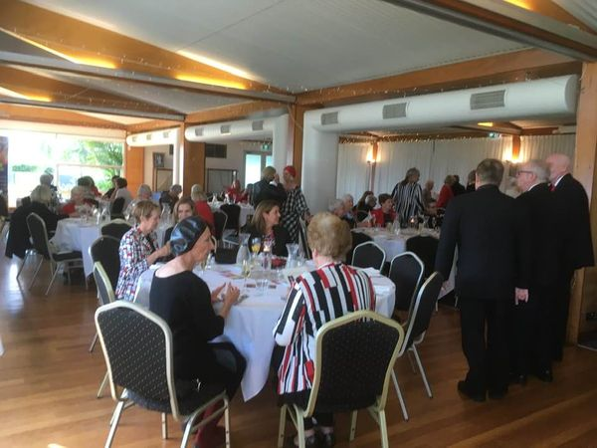

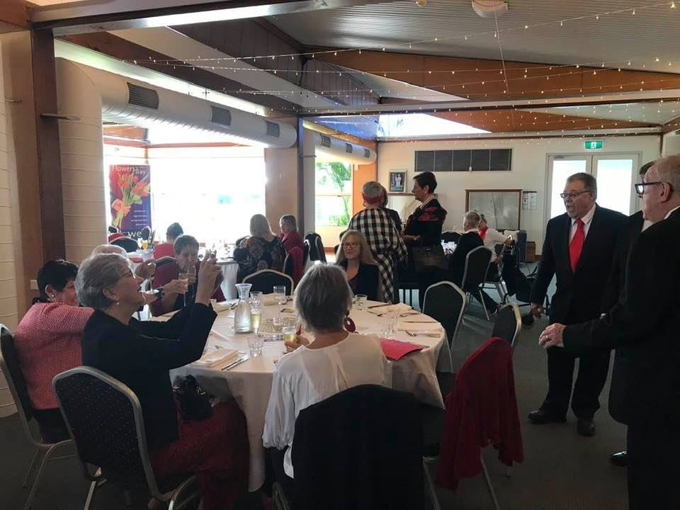

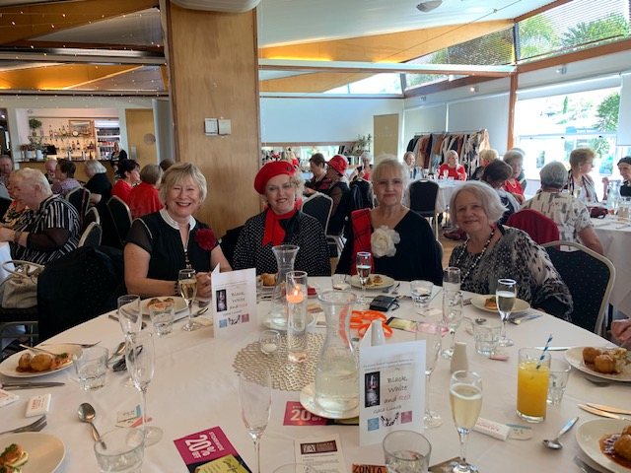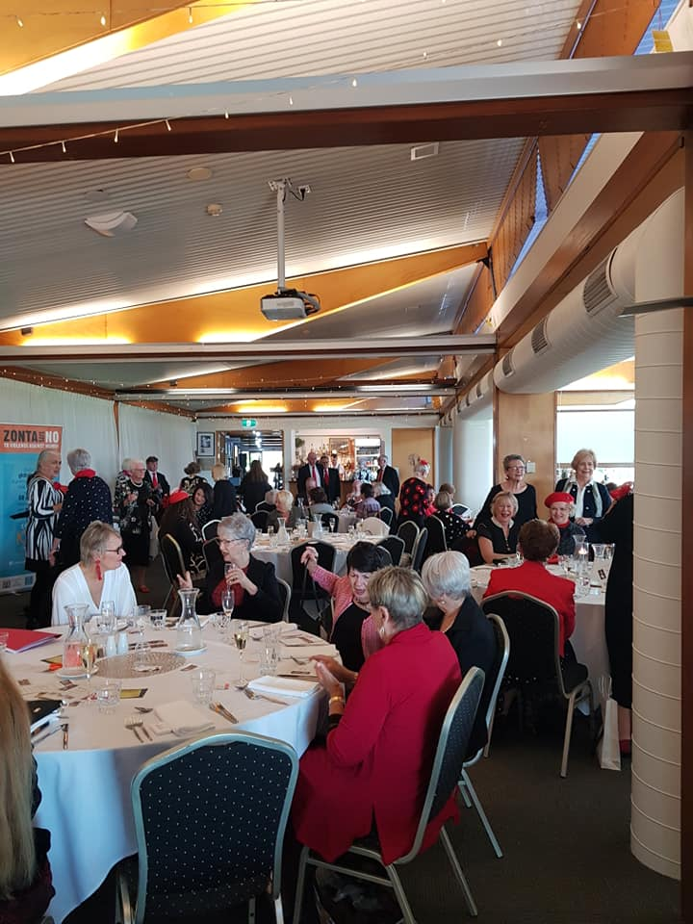
Janet Mylne telling the Zonta International Story
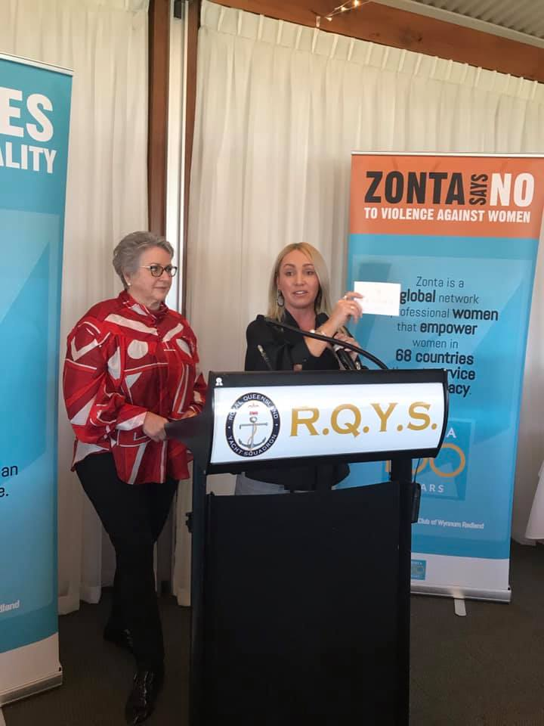
Our MC extoridinaire Therese with Charmaine from Raby Bay Resorts
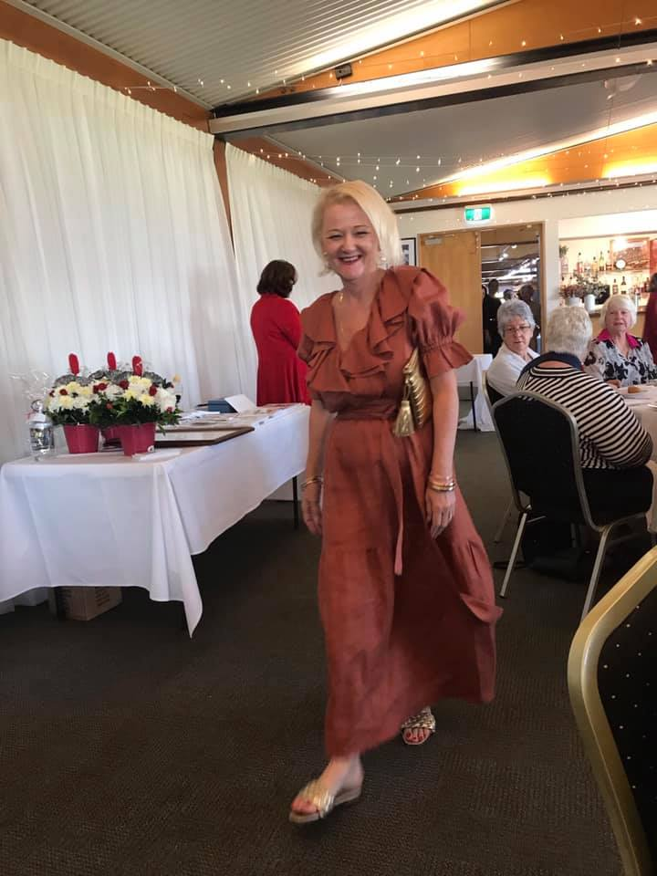
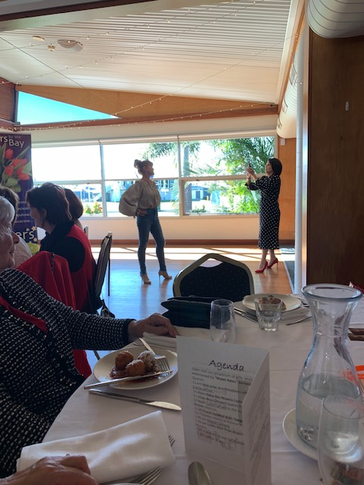
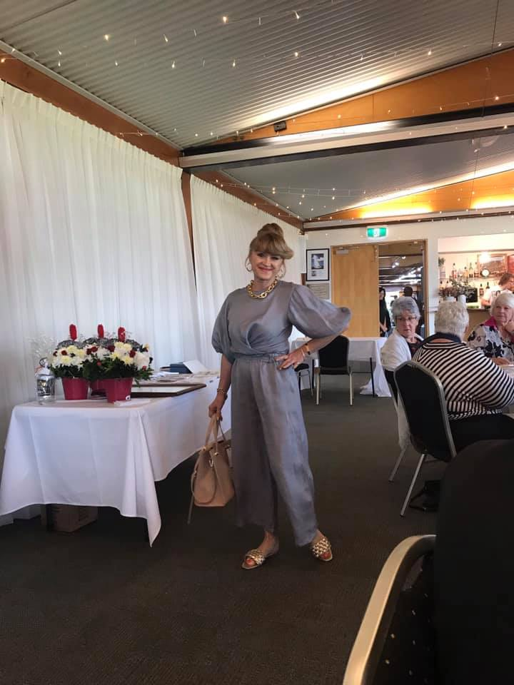
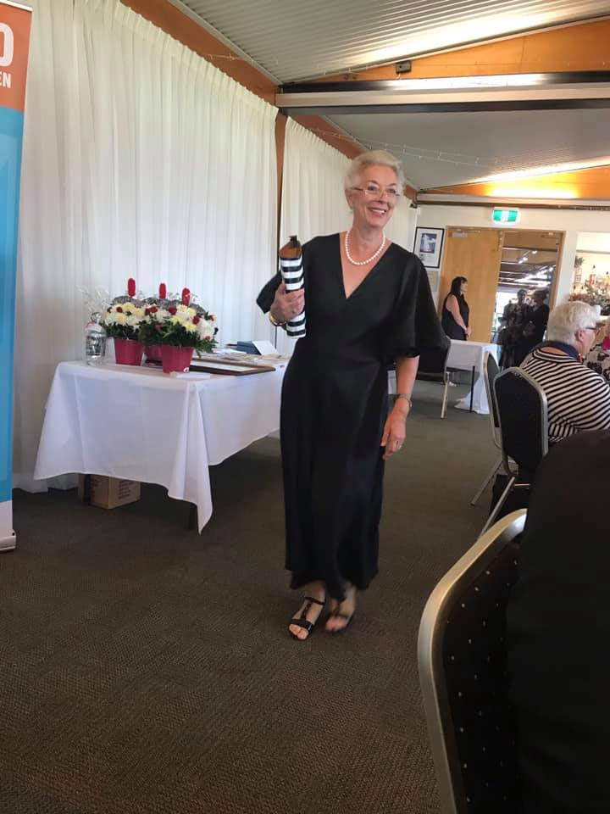
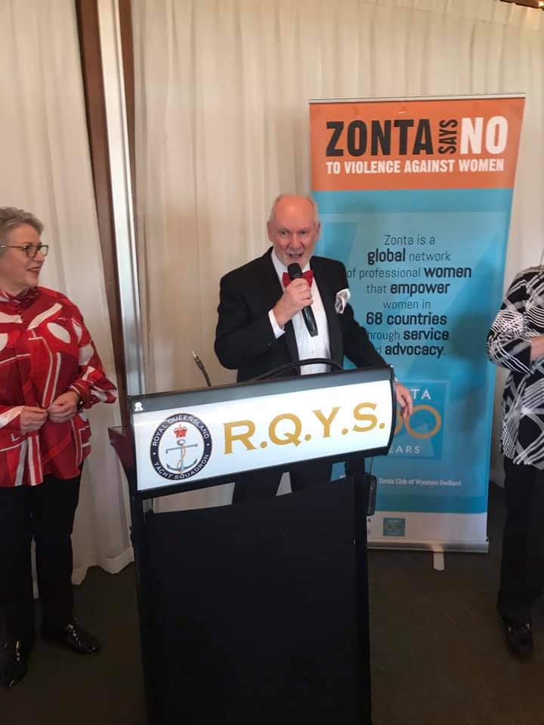
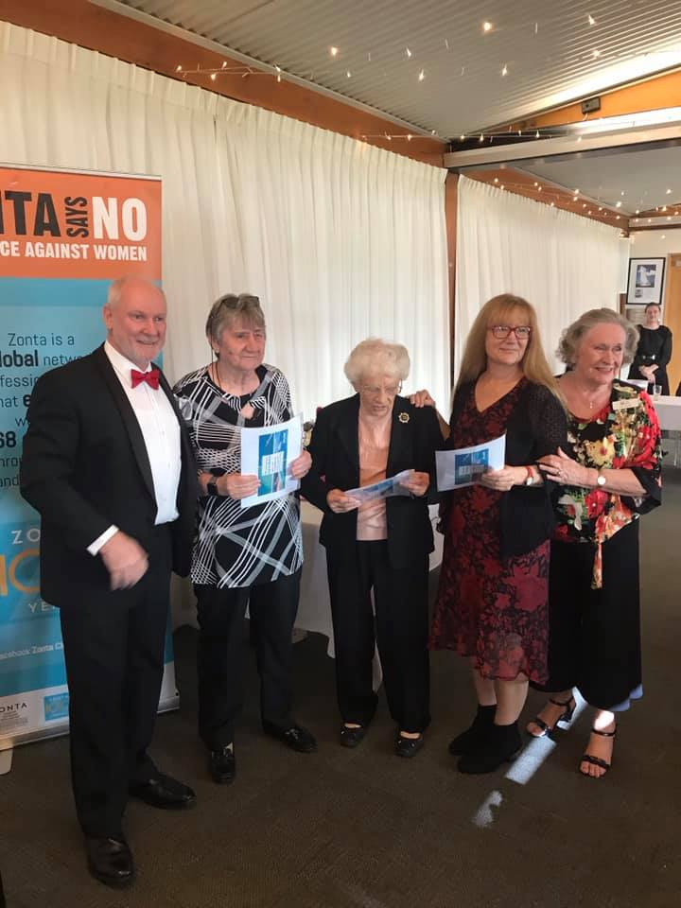
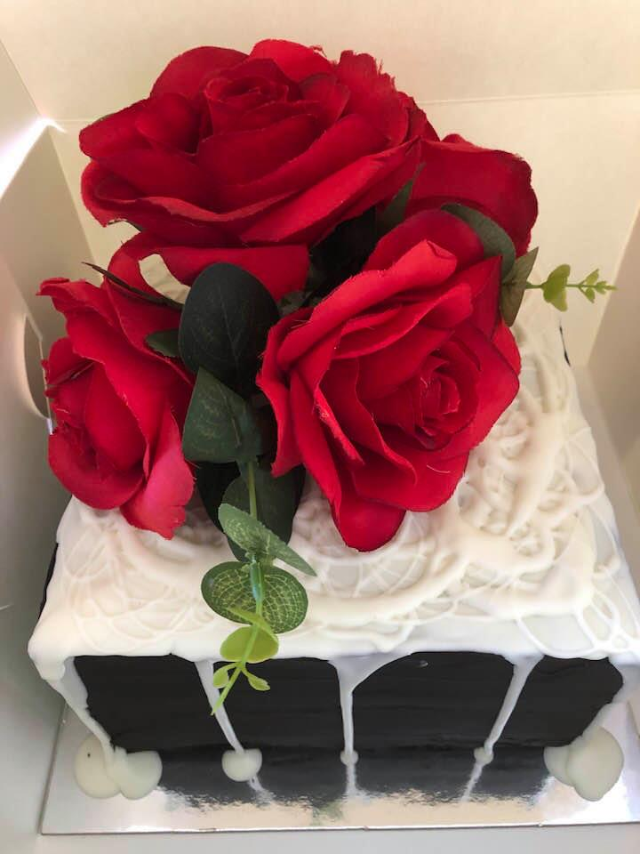
And the Raffle prize of a brownie cake donated by Bayside Brownies was won by our member Carol, just in time for her son’s birthday.

