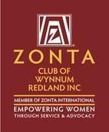
The Zonta Club of Wynnum Redland Inc.
ABN: 57025338425
PO Box 132 Capalaba 4157
wynnumredland@zontadistrict22.org
Zonta International District 22, Area 3
C conviction, C commitment, C courage
Find us on Facebook: https://www.facebook.com/Zonta-Club-of-WynnumRedland-Inc-240575512649766/
July 2021

Details:
The next dinner meeting is 12th July at Fiction Bar, Raby Bay - 6pm for 6:30pm. Cost for the dinner meeting is $30 with payment made electronically to bank account: BSB 633000 Acc 158165050 .
RSVP is Fri 9th July with payment and any dietary needs to club treasurer Helen Wood helen.wood@firstclassaccounts.com
PLEASE NOTE.
Failure to apologise to Helen before Friday 5pm will be assumed an acceptance and a meal will be provided. So, the cost of this meal will have to be met by the non-attending member as the Club cannot afford to pay any more than the Fiction Bar who bill us on numbers supplied.

President Pat Lavelle
President’s Notes
Hello to all members,

My apologies for my absence at the June Meeting, my husband required some specialist surgery which entailed an overnight stay for us both on the other side of town. My thanks to the club members who rallied around and held an excellent meeting. Particular thanks to 2nd Vice President Robyn Smith who filled the chair. Bill is on his way to recovery, thank you to all for the good wishes. I am excited about our guest speaker for the July Meeting. Annette Smith is the recently appointed breast care nurse at Redlands Hospital, and I feel we will be able to assist her patients.
Best Wishes to all. Pat.

Dinner Meeting June 2021

Second Vice President Robyn Smith welcomed us to country & paid our respects for local elders, present past and emerging.
Matters arising, Janet Mylne mentioned that we normally ask the group to pass the minutes of the AGM after the May Meeting, however we have only just received the Audit which the board will review and the minutes will submitted to be passed then at our July meeting. (Helen to distribute the Audit results to all members)
Janet asked Carol to correct the names of this year’s Nominating Committee to read Jo Hieatt, Nicola Redmond and Janet Mylne.
Irene spoke about the forthcoming Conference in Mackay on the 4th -5th September, which all members have been emailed about. So far Angela and Loris will be attending from our group. There is still time to book.
Robyn welcomed Mr Bruce Hutchison to give us a talk about his business as he is one of our consistent Sponsors. Bruce has provided raffle prizes to every function consistently over several years. Bruce spoke about his journey into becoming a Real Estate agent 17 years ago, and the changes over those years as to how properties have been marketed and sold. Robyn thanked Bruce for his informative talk.
Loris gave an informative talk about her life, starting with the story of leaving her native Canada to arriving in Australia.
Loris spoke of her life journey, and her original joining to Zonta in Bundaberg before returning to Canada in 2008. In 2013 Loris decided to come back to Australia and she joined Brisbane East club where she held office as Treasurer. During this time, Loris became involved with a charity called Bodhgaya Development Assoc. Designed to help in India, this charity helps to develop rural schools and medical aid to poor communities, micro financing for women’s groups, skilled training for impoverished villages as well as TB and Health Clinics. Loris went to visit this area in 2017 and she said that she had never seen such terrible poverty. Loris supplied brochures to anyone who was interested.
Loris suggested we might look at other charities if they fitted into the Zonta guidelines. Loris also mentioned that she would like to enquire about whether there's a special room set aside for women while they wait to go into court, in "domestic violence” situations. Janet Mylne said that she would check at the Cleveland Courthouse.

Membership News Julie Cardiff
I would like to develop a regular casual get together on a weekend with the objective of interesting working women who may not understand our mission.
This is a work in progress, and I would be happy to have any advice or/or support those members can offer. Please always be always conscious that you may know a prospective member that you can invite to meet us at a dinner meeting.
Service News Robyn Smith
This month has seen strong interest in Zonta WR from outside sources. Through the District 22 website we were contracted by Annette Smith. Annette has been appointed as the breast care nurse at Redlands Hospital. Annette was urgently seeking breast cushions and thanks to our recent efforts we were able to immediately supply her with ten cushions. Annette is to be our guest speaker at our July dinner meeting.
To replenish our breast cushion supply, the team are meeting at Barbara Wills house on Thursday 8th July, all welcome at 12.30 for a light lunch, a bit of work and some friendly chat.
We were also contacted by Amanda Rampton, School Based Youth Health Nurse; Amanda says;
I wanted to touch base with you and Wynnum and Redland’s Zonta to provide you with an update of our workforce in your district. We are a team of five School Based Youth Health Nurses (SBYHN), who sit in Wynnum/Redlands high schools and provide a primary health care service for students to access support for their health and wellbeing. I would also like to acknowledge the productive working alliance that Wynnum and Redland’s Zonta has previously shared with the School Based Youth Health Nurses. In the past Zonta has been generous to provide professional development in a gender-based violence program called Love Bites, which is then delivered in our schools.
For your information and dissemination to your members, the current Children’s Health QLD Hospital Health Service (CHQHHS), Child and Youth Community Health Service (CYCHS), SBYHNS team in the Wynnum and Redlands state high schools are as follows:
.

We now have a list and contact details for all the school-based nurses in our area. We responded to Amanda asking what we can do to support the young women that they help but are yet to get an answer.
Xmas In July is to be a club fellowship event with numbers restricted to 40. Planning is underway for a sumptuous Christmas lunch of turkey, ham off the bone (Aussie Ham of course!) and roast vegetables. Robyn Smith is going to make a traditional Christmas pud with brandy sauce. All this on Sunday 25th July from 11am at 816 London Road Chandler. Now is the time to book and pay through the Zonta bank account $30 pp please use your name and Xmas as reference so Helen can allocate funds.
Saturday, 26th September to celebrate our 40th Anniversary, is booked in for a High Tea at Ormiston House. (50-70 guests can attend at this time due to COVID restrictions) $45.00pp. We would like a strong attendance from past members and will be looking to contact as many as possible soon.
Mary from the Courthouse has confirmed that we will be operating the Sweeps and Raffles for their Melbourne Cup Luncheon. Lunch $130.00pp.

Advocacy News Therese Thorp
Therese told the group that the publications that Carrol Jackson had distributed were received really well by the public.
Therese asked for help re guidelines in arranging signs at the football grounds
Therese also wanted to thank Janet for her speech at our Gala function, which explained what Zonta WR is about and how we help in the communities both near and far.

Zonta Club of Wynnum Redland Board

President Pat Lavelle
1st VP Julie Cardiff
2nd VP Robyn Smith
Secretary Carol McDonald

Treasurer Helen Wood
Director Marilyn Smith
Director Therese Thorp
Director Jenny McIntosh
Director Loris Neff
Advisor Judith Trevan-Hawke
Date Claimers
February | 8th  22nd | Dinner Meeting Fiction Bar  Board Meeting Fiction Bar
March | 4th  8th  11th  29th | IWD Dinner and Presentation of YWPA award Courthouse Restaurant  Dinner Meeting Fiction Bar  Breast Cushion Working Bee  Board Meeting
April | 4th  ^{12th}  18th  26th | Easter Sunday  Dinner Meeting  Quota Changeover  Board Meeting
May | 4th  ^{5th}  10th  ^{31st} | Area 3 Meeting Nerang RSL  Walk The Talk Cleveland See Flyer Attached  Dinner Meeting Fiction Bar  Board Meeting
June | 1st  14th  ^{27th}  ^{28th} | Gala Lunch RQYS  Dinner Meeting Fiction Bar  Trivia Afternoon tea Postponed  Board Meeting
July | 8th  12th  13th  25th | Breast Cushion Workshop  Dinner Meeting  Beta Sigma Phi Lunch RQYS  Christmas in July
August | 9th  30th | Dinner Meeting  Board Meeting
September | 4/5th  13th  26th  27th | District Conference Mackay  Dinner Meeting  40th Anniversay Ormiston House  Board Meeting
October | 11th  25th | Dinner Meeting  Board Meeting
November | 2nd 8th  ^{29th} | Melbourne Cup Day Courthouse  Dinner Meeting  Board Meeting
December | 11th  13th | Christmas Lunch Little Ships Club  Dinner Meeting

INSPIRATIONAL WOMEN
·
This is Nadia Nadim. She was born in Afghanistan. Her father was murdered by the Taliban when she was 11 years old and her family fled to Denmark on the back of a truck.
Nadia has scored almost 200 goals in professional football and represented the Danish national team 98 times.
She's completed medical school and is studying to become a reconstructive surgeon when her playing days are over.
She speaks 11 languages fluently and is on the Forbes list of Most Powerful Women in International Sports.
If you want to show your daughter a role model, show her Nadia Nadim.... not the Kardashians.

Do you think it’s time to see more ‘unfiltered’ women on the big screen? Kate Winslet suggests that we’re starved for it – and she’s not wrong. In her new series, “Mare of Easttown,” Winslet fought to keep all of her wrinkles, belly, and ‘flaws' onscreen. Now, the actress says that’s why so many people may have connected with her character. “There are clearly no filters. She’s a fully functioning, flawed woman with a body and a face that moves in a way that is synonymous with her age and her life and where she comes from. I think we’re starved of that a bit.”

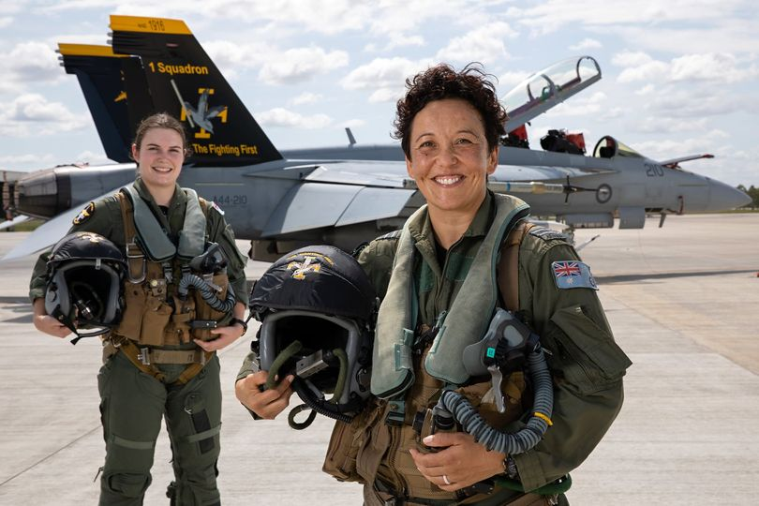

An all-female crew from 1SQN flew a F/A-18F Super Hornet mission on March 8 to mark #InternationalWomensDay.
Weapons System Officer FLTLT Zalie said she was proud to fly as part of the all-female crew & hoped to encourage & empower other women.

