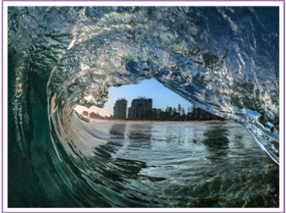

Zonta News

October2020
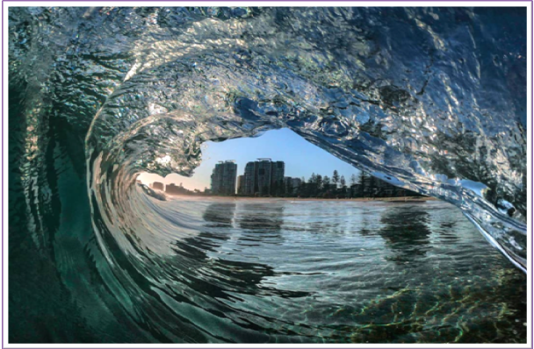
Thought for the month
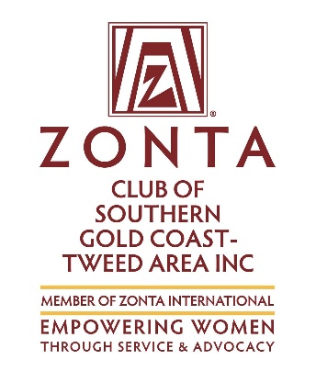Upcoming Events

Dinner Meeting
18th January
6pm for 630pm Time

2

Don’t wait for a light to appear at the end of the tunnel,

Stride down there…………………

And light the bloody thing yourself.

Sara Henderson

PRESIDENTS MESSAGE
Welcome back from the Christmas break and to 2021. I trust you all had a very happy Christmas and New Year and feel refreshed and ready to face the next twelve months.

The next twelve months will probably still have its ups and downs until COVID is completely sorted out.
Just as I write this message my area is in a 3 day lock down, so hopefully I will be at the January 2021 meeting.

We would like your thoughts as to what functions/fun raisers you would like for the 2021 year. If you have
any suggestions, please let them be known on Monday night.
The AGM is not far away. At our January meeting, we will be electing a Nominating Committee. It is the job of the committee to identify appropriate candidates and encourage them to nominate for board positions. What can you do to help our club prosper?

Wishing you all a year of fellowship, good health, and great accomplishments.
I’m certainly looking forward to the year ahead and seeing everyone on the 18th January 2021 – 6:00pm for a 6:30pm Qld Time

Warm regards,

Lesley-Anne

SERVICE REPORTS

No Reports this month, Could I have them monthly please.
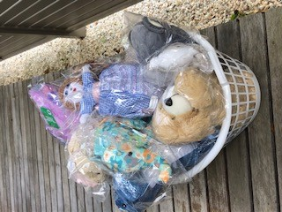

Christmas Toys For Refuge
Member Bio next month Louise Frost

Toys for Refuge
Louise Frost next months member

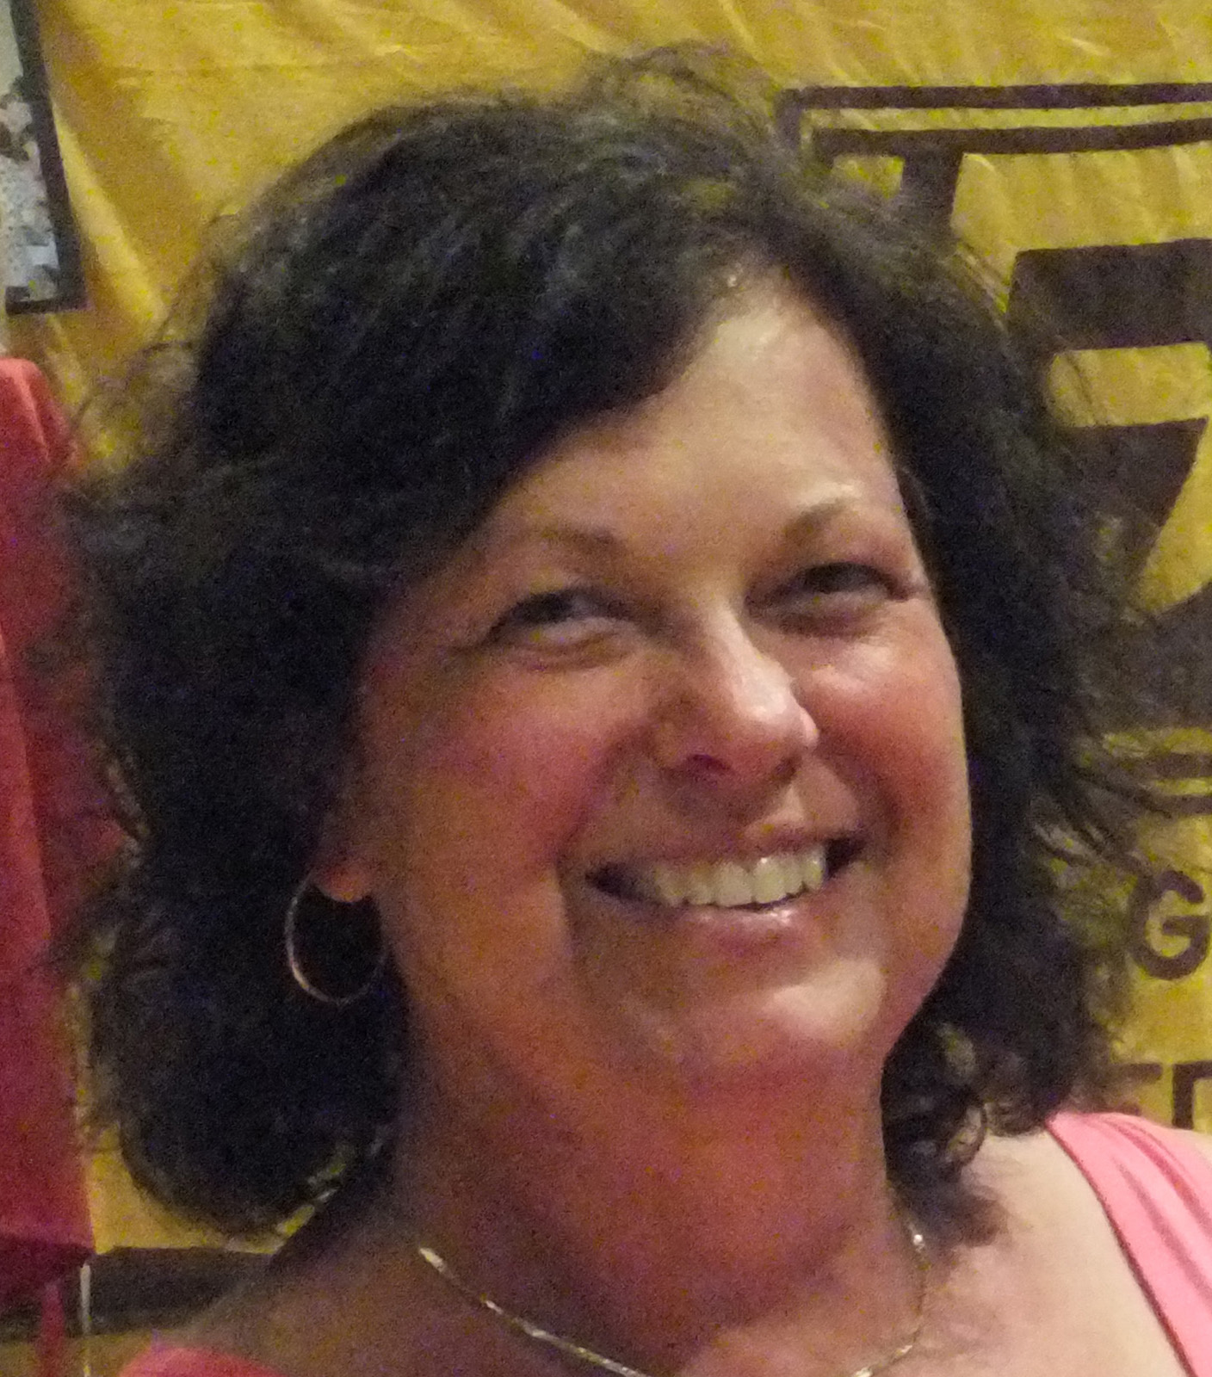

Member of the Month

SUSIE DUNN

I was born at the Toowoomba Base Hospital on the 20th July 1958. I was the fourth & youngest child for Sylvia & Harold.
I attended Primary & Secondary school in Toowoomba at Concordia before starting my nurses training at the ripe old age of 17.
I did my General nurses training at the Toowoomba Base Hospital between 1975 to 1978 before taking a European trip for 9 months travelling through most of Europe & the UK.
I commenced my Midwifery training at the Southport Hospital in 1980 soon after my marriage to Tracy.
We lived in a small duplex in Coolangatta before building our first home at Banora Point.
In 1981 I started work at the Tweed Heads Private Hospital in the wards & then the Theaters before the new Maternity ward was built & opened & I then continued to work as a midwife full time before having our 1st child Kelly in 1986. I returned to work part time when Kel was 4 months old & two years & four months later Sara came along & again I returned to part time work about 4 months after her birth.
Doing my Maternal & Child Health certificate gave me the opportunity to start my current job in Community Health in Tweed Heads. My position involved doing Prenatal Classes, in patient education, baby health clinics, breastfeeding clinics & home visiting new mothers & babies. During my time at Community Health I completed My Lactation Consultancy certificate & a Diploma in Women's Health. On doing my Women's Health I have relieved the Women's Health Nurse in her clinics when needed.
Tracy & I did our first overseas trip together in 2009 on a road trip for 5 weeks through the UK, Scotland & Ireland.
I enjoy walking & did a 14 day trek in Nepal with a girlfriend in 2010 & then another with her along the Great Ocean Road in 2019.
My walking inspired me to attempt a 24 hour walk in 2013 to raise money for Birthing Kits which I did achieve with the fantastic support from the members of our Zonta Club & training from the then owner of my gym.
Tracy & myself are now enjoying our first grandson who has just turned 1 in November & keeps us running when we care for him at times. He is such a delight & so happy & lovable.
I have been a member of Zonta Southern Gold Coast Tweed for almost 10 years now & during that time have enjoyed every moment making new friends & supporting women & girls in developing countries & locally.
Susie

