

Zonta Club of West Moreton Inc

march 2013

Inside this issue

1. Presidents Message

2. Cmtee Reports

3. HIV Domestic

Violence,Rwanda

4. Fraud Squad cntct.

5. Date Claimer

6. More Area Wkshp

snaps

**President’s Message**

Hello Fellow Zontians.  
  
We are nearing the end of the Zonta Year and I hope that all who attended  
the area 4 meeting came away as energised and a great vision of what  
our Zonta International is achieving on the world stage and also  
on District level and Local. Our planning day in June will be lively with all the ideas   
that came out of this meeting.   
  
You will have all received an email from Sandra Venn Brown who is on the   
nominating committee with Maria Stevenson and Diane Maccheroni.  
If our club is to continue to grow and be credible, (remember Visibility and Credibility)  
we need to have new ideas as well as the older members giving   
support and mentoring to newer members. We are all the backbone of this great club  
and please put your name forward or nominate someone who you believe will  
make a difference.   
  
Thank you to the team that ran the International Womens Day. It certainly ran   
smoothly and can I say "on time" and I have received wonderful feedback.   
  
Remember our raffle and please assist Maria in selling. $50.00 per ticket to win $5000 cash.  
  
Look forward to getting together at our next meeting.   
  
Margaret Llewellyn

**Service Committee Report**

Next meeting will be on Tuesday 2nd April at 6.30 pm at Pam Lane,s house.

Kate

**Advocacy Committee Report**

Next meeting will be on Tuesday 19th March at Catherine Pook’s home commencing @ 7.00pm

**Membership Committee Report**

Hello fellow Zontians

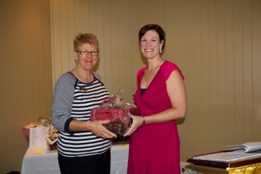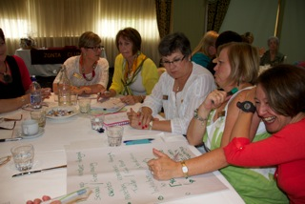What a great Area Workshop we had a couple of weeks ago and I would like to thank you all for giving lots of suggestions for how to increase membership and keep our members keen and engaged. Next meeting, member Catherine Pook will give a brief rundown on the two days from her perspective.  
Visibility & Credibility Planning

Guest Speaker, Shannon Scott

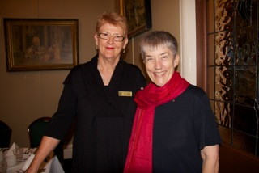

District Governor, Judith Anderson with Area Director, Kath

Next general meeting our guest speaker will be Lorraine Mitchell who is the Student Centre Manager in the English Language Institute at Griffith University. She is involved with International students who come to learn English here and frequently makes trips to overseas. Lorraine's topic is "Dollars and Sense - underneath global education". Please come along to hear Lorraine who will have interesting and up to date information about this area of education in Australia.  
  
As usual we will have a member snapshot from BRONWEN COTTMAN.

Following International Women's Day we have seen a surge of interest from women wishing to join our Zonta Club. We anticipate holding an information night in early May to introduce these interested women, and others to our club. And, hopefully, a number of them will attend meetings in the next couple of months. If you know of anyone who may be interested in joining us, attending a meeting, or the information night please let me know and I will send them a formal invitation.

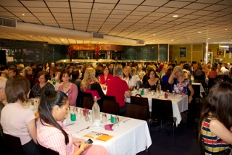Well attended Breakfast

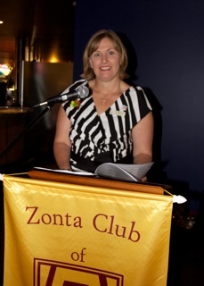

Presentation by Deidre

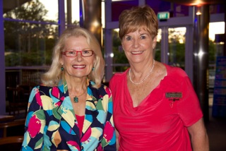

Guest Speaker with Margaret

Last week I sat in on a great teleconference about the District 22 website and how we can use our own website for promotion and advocacy. I will tell you all more at our next general meeting.

Finally, the Nominating Committee has nearly completed its deliberations on the incoming Board for 2013-14 ready for our AGM in April.

Sandra Venn-Brown  
Chair, Membership

**HIV Domestic Violence in Rwanda**

**Multi-sectoral approaches to address**

**intimate partner violence and HIV/AIDS**

Program responses to address violence against women

have also been implemented through sectors other

than health. These include public awareness campaigns,

policy initiatives and advocacy efforts at the global

level and in countries. On the other hand, HIV/AIDS

programs have largely been implemented as health

interventions. A few opportunities where both violence

against women and HIV/AIDS can be synergistically

addressed through multi-sectoral approaches are

described here.

I) ***Public Awareness:*** Mass media and public education

campaigns to raise awareness of violence against

women and HIV/AIDS have been undertaken separately

at the global and country levels. Their impact on

changes at the community level is arguably more limited.

Nonetheless, public awareness campaigns create

an overall favourable environment in which other

activities on violence and HIV/AIDS can be undertaken

by giving visibility to the issues and mobilizing public

and political support. Public education campaigns on

violence against women include UNIFEM’s ‘Picturing

a Life Free of Violence’ campaign, the ‘White Ribbon’

campaign encouraging men to take action on violence

against women, Amnesty International’s ‘Stop Violence

Against Women’ campaign, and the ‘16 Days of Activism’

campaign to end violence against women28,29,30.

II) ***Economic empowerment of women:*** Microfilm

nance and micro-credit interventions to improve

household poverty and women’s access to resources,

opportunities and choices employ a system of group based

lending to enable women to start small businesses.

Evaluation of micro-credit programs suggest that

they empower women by improving their decision-making

in the household and have health benefit ts such

as improved nutrition, child health and contraceptive

use. There is also evidence from a study in Bangladesh that micro-credit interventions may reduce partner violence31. In South Africa, the Intervention with Microfilm

nuance for AIDS and Gender Equity (IMAGE) is being evaluated to assess whether micro-fi nuance activities targeted to poor women combined with participatory

training in violence, gender roles, HIV prevention, sexuality,

and relationships reduce women’s risk for HIV

***Strengthening laws and policies:*** Policies on domestic violence and related gender issues at the

level of international treaties, national laws and legislations,

and institutions play an important role in addressing

violence against women and reducing women’s

vulnerability to HIV/AIDS. At the international level, the

Convention on the Elimination of All forms of Discrimination

Against Women (CEDAW 1979) and the declaration

of the United Nations General Assembly Special

Session on HIV/AIDS (UNGASS 2001) highlight the

importance of violence against women for reducing

HIV transmission and providing treatment and care for

AIDS, and call on governments to develop and monitor

legislations and related programs. Such agreements are

being used to hold signatory governments accountable

for addressing HIV/AIDS and gender equality in their

respective countries through monitoring and advocacy.

At the national level, networks of women’s groups have

pushed for better domestic violence laws and their

enforcement in countries. For example, in Nicaragua,

the Network of Women Against Violence focused its

activities on reforming the justice system by drafting a

domestic violence bill33.

Conclusions and key messages

There is a compelling case to end intimate partner

violence both in its own right as well as to reduce women

and girls vulnerability to HIV/AIDS. The evidence

on the linkages between violence against women and

HIV/AIDS highlights that there are direct and indirect

mechanisms by which the two interact.

• Coercive sex poses a direct biological risk for HIV

infection resulting from vaginal trauma and lacerations;

• Intimate partner violence poses indirect risk for HIV infection in several ways:

- Women with a history of violence may not be able

to negotiate condom use;

Excerpt**. World Health Organization**

Information Bulletin Series, Number **1**

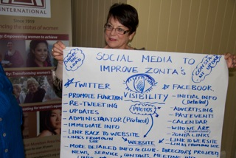

At our last Business Meeting

The guest speaker was

Detective Superintendent Brian J. Hay APM from the Fraud Squad who kindly left his contact details.

Telephone: 3364 4441

Mob.: 0438 264 564

Facsimile: 3364 6549

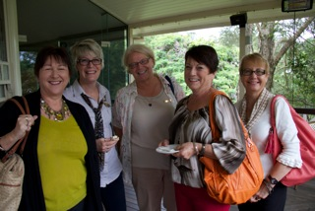Email:

[Hay.BrianJ@police.qld.gov.au](mailto:Hay.BrianJ@police.qld.gov.au)

**Date Claimer**

MONDAY 27 May - changeover dinner at the Ipswich Club - $30 per person and guests are invited. Guest speaker will be Judge Sandy Horneman-Wren

**Don’t forget to sell Raffle Tickets** for details contact Maria Kelly

**More snaps of Area**

**Workshop**

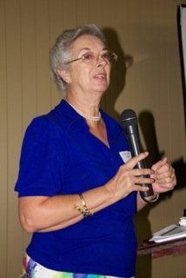

**Next Meeting**

**25th March,**

Please RSVP to Jill Lucht by Friday,22nd March if you are **NOT**

attending, failure to do so will result in an invoice for the meal being issued

**Date Claimer**

**MONDAY 27 May -** changeover dinner at the Ipswich Club - $30 per person and guests are invited.

**Guest** **speaker:**

**Judge**

**Sandy Horneman-Wren**

**Letter from Judith Trevan Hawke**

Dear Robyn and Kath,

What a super venue for the area 4 meeting. The time I had with you on Saturday was really good and I enjoyed catching up with you both, other Zontians and Zonta friends from previous conference and convention!

I was really sad not to be able to stay, but it was the right decision for the family and sometimes we have to sacrifice, even Zonta.

I look forward to meeting you again and continuing to work with you during this biennium I appreciate everyone’s support.

The charming box of goodies was a delight to explore, my husband said can you go back and get more of these biscuits!

Congratulations to your team that worked on the Area meeting and to all who attended, I know it was a very interesting time.

Best wishes

Judith Trevan-Hawke



Which Charter Member Celebrates 40 Years in Business in April?

**Congratulations Gaye**

C:\Users\celebrant\AppData\Local\Microsoft\Windows\Temporary Internet Files\Content.IE5\3AWYV6N0\MC900237324[1].wmf