27 January 2020

ZONTA INTERNATIONAL CENTENNIAL ANNIVERSARY GRANT REPORT

The Zonta Club of Brisbane East Inc was honoured to receive a Zonta Centennial Anniversary grant to fund through its partnering organization the National Association for the Prevention of Child Abuse and Neglect (NAPCAN) addition training of facilitators to conduct the well recognized respectful relationships progam, LOVEBiTES, in additional schools.
LOVEBiTES is based on best practice standards for education programs as recommended by the Federal Government funded Australian Domestic and Family Violence Clearing House and other leading academics in the area of violence against women. It is a Respectful Relationships Education Program for young people aged 15-17 years. It consists of two interactive workshops: one on Relationship Violence, and one on Sex and Relationships, followed by creative workshops and community campaigns. Love Bites is a flexible model with options to use a full day or multi session delivery approach. The program emphasises the importance of a whole-of-school commitment to respectful relationship education.
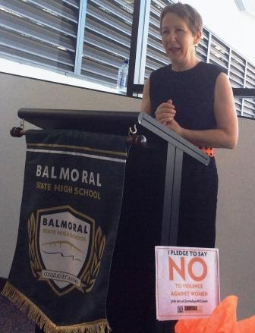 On receipt of the funding of $US5,000 ($A7146) a program was developed to train additional facilitators as well as provide a refresher course from earlier trained facilitators.
The planning with NAPCAN included a breakfast launch of the program at Balmoral State High School on 3 December 2019 which hosted the initial training and refresher program. This was highlighted as an activity during our 2019 Zonta Says No campaign. The program was launched by the then Minister for the Prevention of Family and Domestic Violence, the Honourable Di Farmer MP and attended by the local Councillor, Kara Cook, the then District 22 Governor Sandy Venn Brown and other dignitaries eg senior staff of the Queensland Department of Education and senior representatives from NAPCAN.
This launch was an excellent opportunity to promote Zonta International and our Club as during the speeches many references were made to the service projects at international and local level and the increased awareness of domestic and family violence through the Zonta Says NO Campaign.
Guests heard from our District Governor, the Metropolitan Regional Director of Education and a trainer from NAPCAN.
The two and on-half day training program was conducted on 3rd, 4th and 5th December 2019 and followed by a Refresher program on 6 December for facilitators trained in previous programs.
At the close of each training program the students are given the opportunity to design a creative activity to sum up their learning from the program. This can be in posters, a video or a hip-hop music performance. An example from the 2019 program is below.
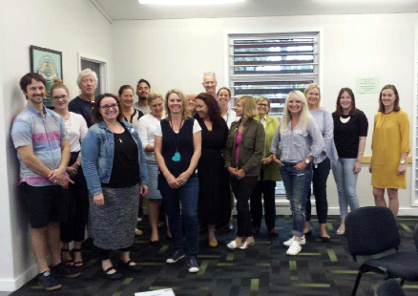A further training program was scheduled for mid 2020 and when publicised was oversubscribed within 2 weeks Because of COVID-19 restrictions this program had to be deferred and rescheduled for 24th, 25th, and 26th November 2020 when restrictions were eased. It was conducted at Yeronga State High School.
The funding provided from the Zonta International Centennial Grant to our partner NAPCAN has now been fully expended. In addition to the Zonta International Grant further financial assistance was received from the Councilor for Morningside, Kara Cook. The Zonta Club of Brisbane East Inc funded the catering costs for each program and in-kind support was received from both Balmoral and Yeronga State High Schools via provision of a free venue for the training and “at cost” catering.
.
Attached is a spreadsheet itemizing Income, Expenditure and the In-Kind contributions showing the funds received from the Zonta International Centennial Grant were fully expended in accordance with our initial application albeit with some delay because of COVID-19.
Again our Club members thank you for this grant which enabled LOVEBiTES, a project of which the Zonta Club of Brisbane East Inc is proud, to be extended each year in to more of our schools

Ros Kinder
President, Zonta Club of Brisbane East Inc

A sample of the posters developed by students as the creative activity at the end of the program.

