In this Newsletter…

President’s Report 2

Committee Reports
- Finance & Fundraising 2
- Status of Women and Service 2
- Organisation and Membership 3
- Public Relations, Communications
and United Nations 3

Club Diary 4

Club & Member’s News & Stories
- Coral Brown’s Kokoda Challenge 5
- New Club Email 8
- Sonshine Sanctuary Update 8

News
- Victorian Women Lawyers v ATO 9
- Amelia Earhart’s Birthday 9

In memory of Joan Ford
- ‘The Wonderful Joan Ford’ by Marilyn Holness 10
- Eulogy delivered by Coral Brown 11


Office Bearers / Board Members
President:
Coral Brown

Vice President:
Diane Hook

Secretary:
Kerri Dick

Treasurer:
Judy Hill

Correspondence Secretary:
Vickie Christie/Annette Collins

Director
Finance & Fundraising:
Lyn Colautti

Director
Status of Women & Service:
Simone Ricketts

Director
Organisation, Membership & Classification:
Diane Hook

Director
Public Relations, Communications & United Nations:
Jackie Leske

Founded in 1919, Zonta International is a global organization of executives and professionals working together to advance the status of women worldwide through service and advocacy. Zonta members volunteer their time, talents and money to local and international service projects, as well as scholarship and award programs aimed at furthering women's education, leadership and youth development.

Happy Birthday to Sandy Miller
(August 25)

Next Dinner Meeting

When | Where | What
Tuesday 5th Aug  6:00 pm | Café Mediterranean | General Dinner Meeting  If you are unable to attend or wish to bring along a guest please contact Jackie Leske by 9:00am Tuesday 4th August on 0402 024 342 or jackqueline@gmail.com. If you do not give your apologies on time you will be expected to pay for your meal.

PRESIDENT’S REPORT

With the end of the financial year it makes you realise just how fast this year is progressing.
It was wonderful that so many members could attend Joan's funeral which was a fitting tribute to her. For those who were not able to make it we have included in this newsletter her eulogy and the poem as penned by Marilyn. I have been talking to the family about the garden and hope to have some more news for the next meeting.
Last Friday Bev Barton and I spoke at the Sonshine Knitters Club. I spoke about Zonta and the work we do and Bev about the Hospice. They were very interested and presented us with a beautiful knitted rug and dolls which we will be able to use as a raffle prize at a forthcoming event.
Coral Brown
President

committee REPORTS

FINANCE & FUNDRAISING REPORT
16 July, Café Mediterranean
Our next proposed premiere movie night is “Australia”. The Caloundra cinema will not take a booking from us at this stage, however we are wait listed and should know more by the middle of August. It would appear that the movie will screen in either November or December of this year.
Marie Pigott and Annette Collins are pursuing leads at the Caloundra RSL in the hope that we can get a reasonable price to host our IWD breakfast in the new function room. Thank you very much to Marie and Annette for your tenacity.
We discussed possible guest speakers for IWD and hope to compile a short list in the next few weeks, ideally at the August general meeting. Our committee thinks it is important to send an invitation out to the chosen guest speaker in the very near future to allow plenty of time to pursue other options if the nominated guest speaker declines the invitation.
If any member has an idea for our IWD guest speaker can you please email the nominee and a short biography to either myself lyncolautti@hotmail.com or jackqueline@gmail.com before the August general meeting. There are some great women featured on the following website: www.wbww.com.au/womenarch.htm
Lyn Colautti
Committee Chair
STATUS OF WOMEN & SERVICE REPORT
Next committee meeting Saturday 2nd August 9am at 30 Pheasant St Buderim.
Simone Ricketts
Committee Chair

committee REPORTS (cONTINUED…)

Organisation, Membership & Classification REPORT
Our Committee held an informative and interesting meeting late last month.
We discussed the possibility of recruiting new members to give our Club greater diversity. Women in male dominated businesses e.g. Car/Tyre companies, engineering, aviation, media.
We also discussed advertising our monthly dinner meetings in the community section of the local newspapers. Weekender, Sunshine Coast Daily, Caloundra Weekly. This would let visiting Zontians know when and where we were meeting. Also having our name published monthly reminds potential new members about Zonta.
Having interesting and sometimes entertaining guest speakers at some of the monthly meetings would entice more women to attend our meetings. We felt that some light heartiness would be uplifting.
I recently read in one of our Zontian magazines that we continue to find that the single best source for new Zontians is current members. Many of us have helped our own Club grow by recommending eligible colleagues and friends for membership and sharing our own experience of Zonta membership with them. Keep up the good work, girls.
Di Hook
Committee Chair

PROGRAMME, PUBLIC RELATIONS & UNITED NATIONS COMMITTEE REPORT
Kawana Hotel, 22 July, 5:45pm
A main focus of the Committee is making the dinner meetings more 'fun' and 'inspiring' while remembering the Zonta objectives. To that end we are looking for speakers and guests who can inspire members and guests with their achievements. Marilyn will be approaching the university to see if they have any suggestions for speakers. The Committee will even consider interviewing or requesting profiles from women for the Newsletter.
The Committee discussed creating a Calendar and theming dinner meetings to dates. The first themed dinner meeting will be the October meeting as October 24 is United Nations Day. More details next month. Other ideas for dinner meetings (included the badge fines and sargeant at arms) may also be implemented at future meetings.
Once we have speakers we need to have a gift to show our appreciation. (the last two Zonta pens donated by Joan Ford were given to Terry and Sue at the last meeting). Desley had some lovely woodturned pens that her partner had made and will speak to him about having some made for us.
The 'New Member Profile' in the Newsletter was very popular - Thanks to Joleen Watson. The Committee hopes to continue that going forward. The Committee would also like to see an 'Existing Member Profile'. Given the length of the Newsletter this month I have decided to leave them out. Nonetheless we would appreciate both new and existing members offering profiles for future newsletters.
Desley and Jackie hope to meet with Jane Cluff shortly to pick up where she left off with the website.
The Committee will meet again on Tuesday 19 August at 5:45pm at the Kawana Hotel.
Jackie Leske
Committee Chair

CLUB DIARY

Upcoming Events & Reminders

When | Where | What
Saturday  2nd August  9:00 am | 30 Pheasant Street, Buderim | Committee Meeting - Status of Women and Service  Committee members who are unable to attend this meeting should advise Simone Ricketts
Tuesday  5th August  6:00 pm | Café Mediterranean  55 Bulcock St, Caloundra | Dinner Meeting  Please remember:  - If your name begins with the letter A, B, C, D, or E please bring a raffle prize along to a dinner meeting between now and December. That way we should have plenty of raffle prizes for the coming months. Raffle prizes can be anything at all but should not cost any more than about $10.00.  - If you are unable to attend or wish to bring along a guest please contact Jackie Leske by 9:00am on Tuesday 5th August on 0402 024 342 or jackqueline@gmail.com. If you do not give your apologies on time you will be expected to pay for your meal.
Tuesday 19th Aug 5:45 pm | Kawana Hotel | Public Relations, Communications and United Nations  Committee members who are unable to attend this meeting should advise Jackie Leske
Wednesday 20th August  6:00 pm | Café Mediterranean  55 Bulcock St, Caloundra | Committee Meeting - Finance & Fundraising  Committee members who are unable to attend this meeting should advise Lyn Colautti
To be advised | To be advised | Organisation & Membership  Committee members who are unable to attend this meeting should advise Di Hook
Thursday  28th August  6:30 pm | ‘Favourites’ Function Room Corbould Park  Pierce Ave, Caloundra | Combined Services Women’s Club Annual Dinner  - ‘Service Squillions’ theme so feel free to wear a fabulous hat or fascinator.  - RSVP by 15th August 2008 to Mary Henzell on 5494 5060 or mjhenzel@optusnet.com.au.
Sunday  16th November  Lunch | Corbould Park  Pierce Ave, Caloundra | Mary Henzell’s Race Day  - More details to be provided shortly.

KOKDA CHALLENGE

I thought that I would briefly share last weekend with you all – yes the Kokoda Challenge!
Fortunately fantastic weather, a full moon and 27hours 58 minutes & 56 seconds (our official time) later we finished. It was the hardest physical thing I have ever done and I don't need to do it again.
The week before saw a team meeting on Monday night where we discussed all the logistics. It was also at this meeting where we realised that Kate Morris (Judy Henzell's daughter) leg had not really improved with a weeks rest and her physio was saying that he didn't think she would be ready to start. We decided just to continue as if we were going.
Friday afternoon saw us loading the car and after extensive physio Kate's leg had improved and we were ready to give it a go. Up at 5am ready to leave at ¼ to 6 and we arrived at the starting point at 6.30 amongst 260 other teams and the Kokoda Kids which numbered 30. The excitement and tension could be felt in the cool morning air as we went about getting our electronic chips and last minute instructions. I should introduce the team – Kate Morris, Katrina Sullivan, me and Melinda Short. We were team 93 – The Caloundra Chicks.
We started in the 25-30 hour section and were eager to be off to the first of the 14 checkpoints that became important milestones as each one passed. Of the 14 checkpoints 5 were supported and we had the privilege of 2 support crews – Annie and Phil ( Kate's sister and brother in law) who supported us the first day and Michael, Lachlan and Connie (Melinda's husband and children) who took over and did the night and the “breakfast” stop. Our plan was to walk though all the minor checkpoints stopping only for a quick loo stop if required. The 5 major stops were where we filled our drink bladders stocked up on our food, changed shoes, socks, ate, strapped feet etc but we wanted to stay at the most 30mins anything under was a bonus.
Initially as you can imagine the pace was slow to begin given that parts of the track were single file and there was so many people, there were a couple of unexpected water crossings due to the rain the Gold Coast had had recently and some parts very slippery and muddy. And, the hills much much harder than we had trained on!
Polly's Kitchen was checkpoint 5 our second supported stop not quite half way and one that most teams make their “dinner” stop however we had decided that given one of the worst hills was to come straight after, and, we wanted to do this in the day light we had a quick stop there pumpkin soup, and after changing our shoes as we knew we were coming into the night and seven creek crossings 17 minutes later we were off again. We made checkpoint 7 our “dinner” stop and by then we were 56 klms along. Minestrone soup went down a treat, we had negotiated all the creeks and were off to the next supported stop checkpoint 10 at Syd Duncan Park which was very exposed and cold. This was our hot chocolate and cake stop a reward for 66klms completed.
.

KOKODA CHALLENGE (CONTIUED…)

Along the way I must say how fantastic all the volunteers and SES people were at each of the checkpoints giving you so much encouragement, And I must explain that you couldn't go through a check point unless your whole team was present, and you were electronically swiped and they checked your name so safety was very important also. For those who wished to watch the web over the weekend you could follow our trek on google earth which showed the progress of all the teams, where you were, your pace expected ETA , it showed how hard the hills were and even showed us coming though the finish line – maybe the way to do it next year!
The views along the way of the Gold Coast, the sunrise over the Gold Coast and the different types of vegetation made it all interesting however I do have to say that most of the time you were just intent on where you were going.
Ckeckpoint 12 our last supported stop was “breakfast” and 17klms to go. The downhills had really started to take their toll and we were all tired but had picked up our pace again and were all conscious of the end. 11.04 am saw us cross the finish line, the 8th womens team to finish and if we had been in the over 50 category we would have been 3rd. Over 66 teams had pulled out either though injury or they just couldn't mentally keep going.
The actual “high” for me didn't come until Monday I must say on the Sunday I was just tired and sore and the full impact hadn't really registered on me. Annette came around with some champers to celebrate but not much of that was drunk, too bed, unfortunately not to sleep but with Monday & Tuesday to recover all was well.
8am Monday morning saw 3 of us walking up and down in the sea at Moffat Beach talking over the event and wondering where each of the teams we had spoken to or played tag with had finished. A restful day, massage Tuesday and finally sleep!
I must say that without our positive support crews it would have been so much harder. I was proud of them all bit in particular Lachlan and Connie, grade7 and 5. They were up happy even with only a couple of hours sleep in between each time we saw them. Lachlan knew he had to fill our water, Connie lots of little jobs and Michael also had everything under control with very little sleep.
The graveyard shift was certainly the hardest!

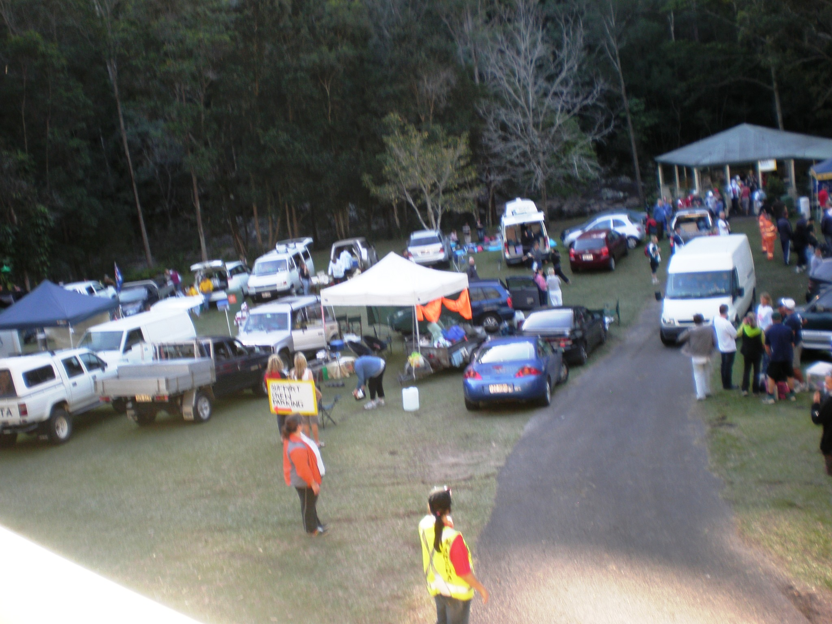
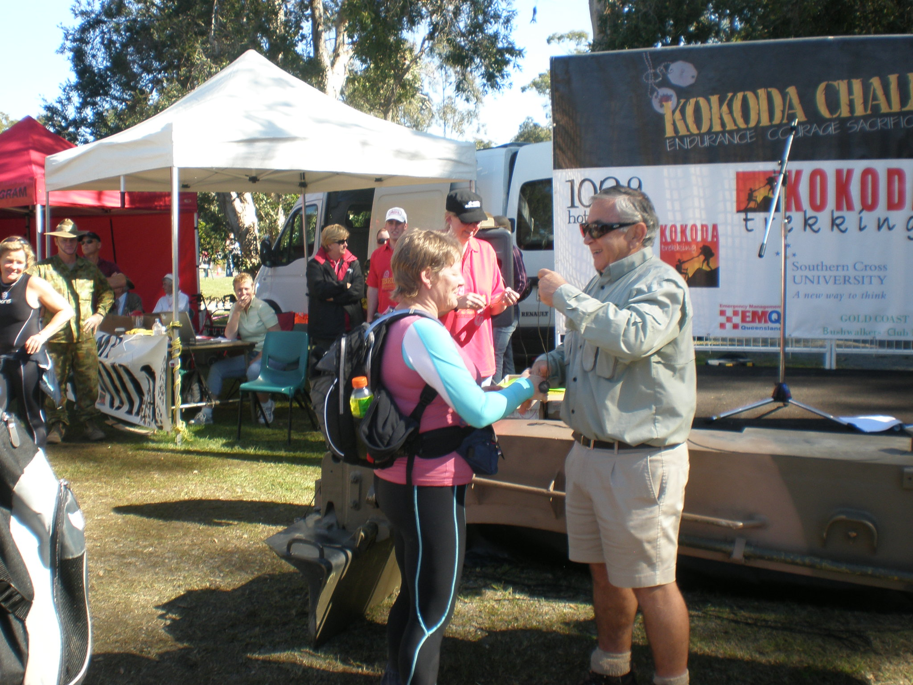

KOKODA CHALLENGE (CONTIUED…)

Also great was to be able to walk with the Kokoda Kids – there were 30 in total and the administrator who had emailed us each week. She explained that the program accepted ½ high achievers and ½ kids who were struggling for what ever reason. There were also some who were in the middle ground who could go either way. They advertise for kids to join the program through schools, counsellors, health workers. The kids then need to apply and be interviewed and commit to the program for 12 months. As well as this 96 km walk they also get to walk the Kokoda Track so a huge experience for them. When we mentioned to Jo that we were the Caloundra Chicks she remembered that we had contributed very well with our fundraising and was very grateful as well as we all were so again thankyou for contributing to our wine sales. We raised $2750.00 with maybe a few more sponsorship cheques still being received.
I hope this has given you a bit of an overview of the weekend and again thanks for your all your support.
Coral Brown

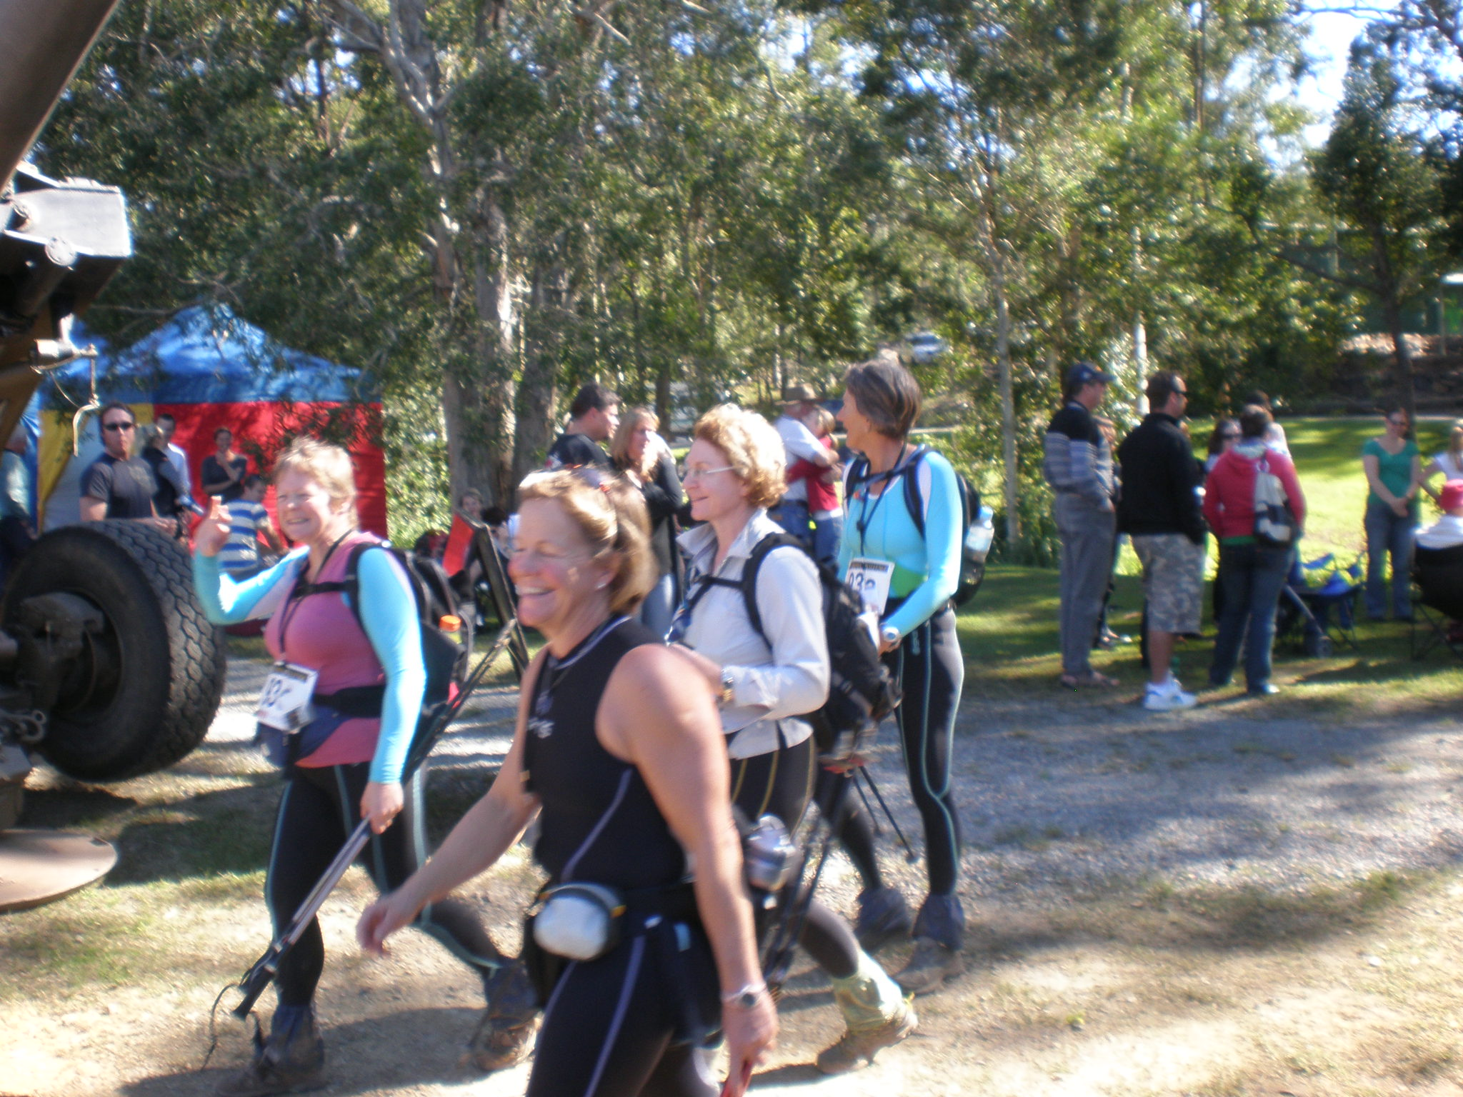

NEW CLUB EMAIL ADDRESS

The Public Relations, Communications and United Nations Committee has set up a club email address.

The club email address has two important functions. Firstly information that is stored can be accessed easily by all members who have access to the internet. Secondly, it enables the club to store emails and other information. If appropriate emails received at the address will be summarised or noted in the newsletter.

Once the Committee gets a website up and running (this is still a way off) the Committee and the Board may need to consider whether these functions are better fulfilled through the website.

In the meantime, members can access the email address by:
- Go to www.gmail.com
- Enter user name zontaclubcaloundra
- Enter password yellowrose

Once logged in you will see the emails. The email address also has provision to store contact details (on the left hand side of the screen), a calendar of events, documents and photographs (all at the very top of the left hand side of the screen). Over time we will look at taking advantage of those functions.

At present the photos of Coral’s team in the Kokoda Challenge that were not able to fit in the newsletter can be viewed by clicking on ‘Photographs’ at the very top of the left hand side of the screen.

Please contact Jackie Leske if you have any questions or troubles. (Mobile 0402 024 342 Home 5485 2564 email jackqueline@gmail.com).

Public Relations, Communications and United Nations Committee

SONSHINE SANCTUARY UPDATE

I delivered the goodies that the Zontians brought to the last meeting for the Sonshine Sanctuary and Cindy and the girls are very grateful for these goods.

It helps to lighten the load on their expenses and all the women and children in the refuge will benefit in some way.

Thank you to all the Zonta members for their help.

Regards Anne Schnell

If members wish to help the Sonshine Sanctuary they can bring items like UHF milk, toilet paper, new knickers, pillows, towels to the next dinner meeting.

news

AMELIA EARHART’S BIRTHDAY - 24 July 1897

Just a note of interest.. did you know July 24th was Amelia Earhart’s birthday(1897). However, Zonta celebrates January 11th as Amelia Earhart Day.

This was the date she became the first woman to fly across the Pacific Ocean, crossing from Honolulu to California…January 11th 1935. Amelia also was the first woman to fly across the Atlantic Ocean, the first woman to fly the Atlantic solo and the first woman to receive the Distinguished Flying Cross, amongst many other aviation achievements.

As a Zontian, Amelia became a role model for the newly emancipated women of her day. She embraced Zonta International and was a member of the Zonta Clubs of Boston, Massachusetts, USA (1928-1930) and New York (1930-1937). We honour her many aviation first achievements and the qualities she displayed that made all of this possible…

Simone Ricketts
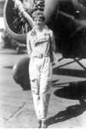

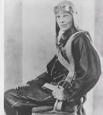

Victorian Women Lawyers v Australian Taxation Office
(from the Australian Financial Review Friday 4 July 2008, by Marsha Jacobs)

Victorian Women Lawyers had two winds in the one case in the Federal Court last week.

Federal Court judge Robert French ruled last Friday that the VWL – which was established to ‘overcome a well-known social deficit, namely the substantial underrepresentation of women in the legal profession, in its upper reaches and in the judiciary’ – was a charity and therefore tax exempt.

This victory against the Australian Taxation Office significantly widens the scope of organisation that might qualify for valuable income tax exemptions.

But VWL also succeeded in having a judge take on judicial notice the disadvantage of female practitioners in the profession.

Judicial notice means that a matter is considered to be ‘common knowledge’ under the Evidence Act and does not need to be proved in court.

Justice French referred in his decision to the ‘longstanding and yet to be overcome differences between the position and participation of women and men in general and in Victoria in particular.

‘The social fact propounded was the historical and persisting disadvantage of women in relation to their participation and career advancement within the legal profession’ Justice French said. ‘At that level of generality there was no dispute. I am prepared to take judicial notice of it.’

VWL convenor Christine Melis said: ‘The court has characterised [females’] disadvantage as a social fact.’

in memory of joan ford

THE WONDERFUL JOAN FORD

She was there at the start, the wonderful Joan Ford
An inaugural member to our club since February 89
Rarely a meeting missed, except for travels abroad.
The years of wisdom seldom told, the gentlest of hearts
Always warm, never cold.

Beneath the quietly spoken voice
A meticulous mind, continued to unfold
Sharp as a tack, the details recalled, with precision and clarity clearly retold.
Always there to lend a hand, on time, in place and ready to roll
Be it breastcare cushions or birthing kits, sausage sizzles or scones with cream
Counting tickets or dollars and coins
Her generosity matched only, by the kindness of her deeds.

A gentle whisper in your ear, encouraging words, maybe praise or “don’t fear”
A kind note in the mail, from Joan it would come
Flowers on the porch, delivered by hand, nothing too much trouble for our Joan
A postcard from a far away port, a short note, not forgotten, nor lost in thought.

An annual tradition for Anzac Day, in Joan’s kitchen each year
We assembled the wreath on Zonta’s behalf
With the same care and precision applied, to all of her tasks.

“Do you have something old?” I asked her one day
For the Queensland Museum’s ‘Old Queensland’ display
Out came a copy of the ‘Golden Jubilee Souvenir” edition of Women’s Weekly
Preserved in it’s splendour displaying the years 1933 to 1983
In pristine condition to join the display.

But along came the needlework, the first piece she’d done
At the ripe old age of 8 or 10
Proudly displaying that meticulous mind yet again,
With the back and the front of those doilies looking exactly the same.

As we remember our Joan my heart sinks to record
That we have lost, not just a member, but a whole lot more
We have lost a gentle lady with the biggest of hearts,
A dedication to others that did not dim with age
Her memory will linger, as we will recall
The many special moments
We have shared, and she has shared, with us all.

As I drive over the bridge bearing her name
I’ll remember with fondness the person I’ll call,
My friend and my mentor
The wonderful Joan Ford.

Marilyn Holness 2008

in memory of joan ford (continued…)

EULOGOY DELIVERED BY CORAL BROWN

My name is Coral Brown and I am the President of the Zonta Club of Caloundra and it is with great sadness that I represent our fellow Zontians here today at the passing of one of our founding members Joan Ford.

There is a poem called the Dash which refers to the date on a tombstone from the beginning to the end. From the joy of birth to the following date which brings tears, but what matters most is how your life is spent in the time between those years and Joan spent those years fully with her family, her connection to so many community events and projects, her love of marjon and more recently her bridge classes. She also extensively travelled with her life time friend and sister in law Judy Henzell.

Last night we dedicated our Zonta meeting to Joan and reflected on what a giant this small and frail women was.

Joan is remembered as a gracious women who was interested in everything and everybody. She was a qualified accountant who in an honorary capacity audited many charitable clubs books for many years.

Although she was a very private person you could rely on her, she worked quietly behind the scene, she was thoughtful, committed, warm and welcoming, always generous with her time and always went that extra mile.

Whilst Joan supported many community organisations, was an ardent church worker, a patron of the Caloundra City School and until a couple of weeks ago was still working 3 days per week I know that Zonta held a special place in her heart.

The Zonta Club of Caloundra was sponsored by the Redcliffe Club of Zonta and celebrates its 20 year anniversary next February. Zonta is a worldwide service organisation that seeks to advance the Status of Women Worldwide.

The founding members were Joan Ford and Judy and Mary Henzell and in speaking with Joan and Judy they didn't really now what they were getting themselves into but the club has grown to now nearly 30 members many of whom are here today.

Over the years Joan held many positions within the club and these were all carrried out in the highest regard. The Club supports both international and many local projects of which Joan has been an integal part.

Joan has also been the Club historian and when our newsletters came by mail there would be a page relevant to what had happened in the club in previous years pertant to that month or celebration.



in memory of joan ford (continued…)

EULOGOY DELIVERED BY CORAL BROWN (continued…)
Joan was also our club photographer and there are many albums all carefully labelled with our hisory in it. Until recently at the beginning of our dinner meetings Joan would always go and greet every member and be sure to sell them a raffle ticket. Joan was interested in every member and considered them her friends.

One member at a dinner meeting happened to mention to Joan that she attended Brisbane Girls Grammar, and from then on each month the news letter from the school would be in her letterbox. Joan never forgot the little things.

Joan would read her Zontain magazine and then bring it to the meeting for new members or prospective members to read. She would be the first to come up to you after a meeting if we were having a fundraising event and voulunteer to get a voucher as a raffle prize or in the event of our International Womens Day breakfasts where we hope each member can sell 10 tickets Joan always sold in excess of 30 such was her commitment, passion and belief.

A couple of years ago 2 members of our club went to Vietnam as part of Project Vietnam and Joan wished them well saying that she wished she was younger and could go to. She was very interested on the work they had achieved upon their return.

As patron of the school, Joan donated a perpetual student bursary for Science. But Joan did not want that bursary to be given to the smartest or the most promising student but for it to go to the struggler who worked hard and had a passion for science and we believe that was a reflection of Joan's philosophy.

Our last fundraiser only a few weeks ago was the movie Sex in the City and driving Joan home from the meeting she said that she didn't think she would be able to sell the tickets to that show and I knew it is was worrying her.

Another member rang a few days later wanting extra tickets so I rang Joan thinking hers would be free but she had sold them all and I think she felt quite proud to have done it.

She even attended the night and when asked if she enjoyed it she said with a twinkle in her eye that she had had some laughs but is was a bit risqué in parts so even when she may have been out of her comfort zone and not well at the time she still would not let us down.

The Ford family have stated no flowers by request and have very generously asked for donations to be forwarded to the Zonta Club. The Symbol of Zonta is a yellow rose and the meeting last night voted to find a suitable venue within the Caloundra area where we can establish a Zonta Garden dedicated to the memory of Joan.

Our vision is a garden with a fountain and seats where the Caloundra Community can go and reflect on the inspiration Joan was to so many and to the many whose lives she so enriched. It was an honor and privilge to have known her.

I will now hand over to Marilyn Holness who is the immediate Past President of Zonta who has penned a poem dedicated to Joan.

