PRESIDENTS REPORT
JANUARY
2018
Zonta
Southern Gold Coast
Tweed

SS
Soursss
Newsletter

Happy New Year EVERYONE !!
What a great year of growth and new ventures within our club during 2017. We have found re- discovered ways to get the profile of Zonta out into the community with a lot of interest from new people about joining. We have started supporting some different projects and have been constantly inspired by the hard work and dedication of people like Simone and Nigel Patterson and all the team at the Sanctuary.
Our year ended on a high note with a very successful fund raiser at Bunnings and a great Christmas party at Louises home. Thanks Louise for making this suggestion and making us all feel welcome. Great big thanks to all members who have supported me from the start of my Presidency and continue to do so. I had big shoes to fill And thanks for overlooking my many mistakes, I hope to get better at this as I go along as I
constantly learn new things about Zonta and how to operate to the best of my ability as your
President. We now have a very exciting 2018 ahead of us, beginning with our planning meeting next Monday. Hope to see you all there dear Zontian sisters.

ASSEMBLY DAY FOR CARE PACKS
All members who were able, gathered for a satisfying and productive day together packing care packs for victims of sexual assault. These packs along with new knickers go to all three public hospitals within our catchment - Tweed, Robina and Gold Coast University Hospital. We managed to put together over 140, containing donated new toiletries, to show someone we will never meet , that we are thinking of them, on what is probably the worst day of their lives. Special thanks must go to Kaye and Andrew for their huge contribution to the cause. This means we can go on
supporting these women into the future [though we wish there was no need for it]
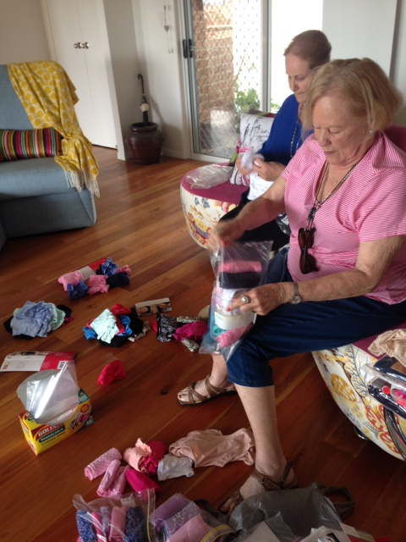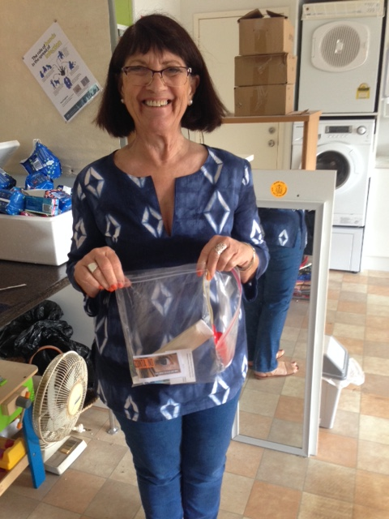

Merle and Kay very busy

Pauline looking pleased

BUNNINGS BARBEQUE
This came out of the blue and big congratulations to all those members and friends who
were able to answer the call. Special thanks to Susie and Louise who were available to set up in the morning and then pack up at the end. These are both big jobs and were done very efficiently and without any hassle. An enjoyable day for us all while raising valuable funds for our projects. Louise realised next day that she had done too much, but we are all constantly learning and will address it next time.

SANCTUARY CHRISTMAS

After much deliberation and suggestions by members it was decided to purchase movie vouchers for the women who live in the Sanctuary to give them a treat for Christmas. It was my pleasure to go to the Sanctuary and deliver the tickets to Simone the week before Christmas. She expressed great thanks on behalf of the women but it was a rushed visit as she was going out to take one of the ladies to a doctors appointment.

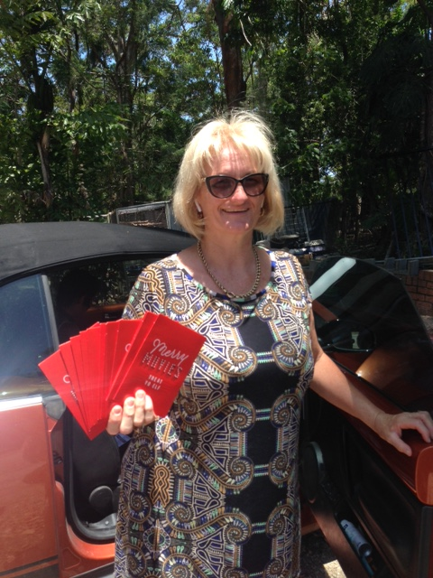

Simone dashing off as usual [with tickets in hand]

CHRISTMAS PARTY
A fun time was had by all at Louise’s house to celebrate the season. Lots of yummy food and drink was consumed [but not too much]. Stealing Santa was a good laugh with no one really willing to steal anyone else’s pressie. Shows that we were all pretty happy with what we got with the
exception of Merle maybe, but she has probably found a use for it by now. It looked just the thing for a lady on her own.
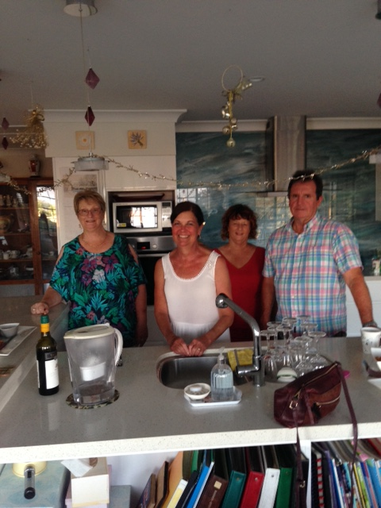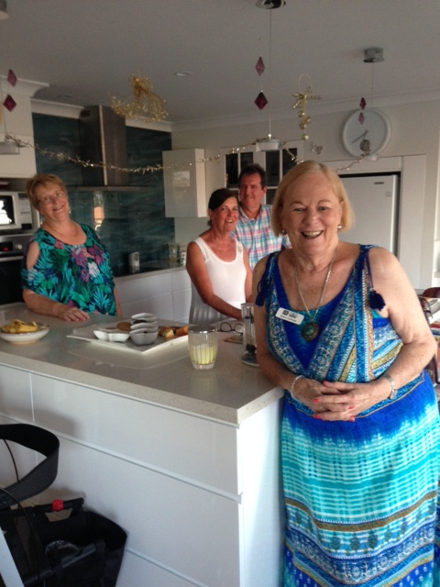

HISTORY OF OUR CLUB
Pauline and Merle are working together to compile the history of our club for the upcoming Centenary Celebrations. It is a big , ongoing job with lots packed into boxes and storage over the years. We really look forward to seeing the finished product in whatever form it may take. Any contributions from past members would be gratefully considered.

SAVE THE DATE

15TH JANUARY DINNER MEETING 6 FOR 6.30 QLD TIME SECRET GARDEN ROOM SOUTH TWEED SPRTS CLUB

21ST JANUARY AMELIA EARHART BRUNCH SEE EMAIL FOR DETAILS

January 2018

