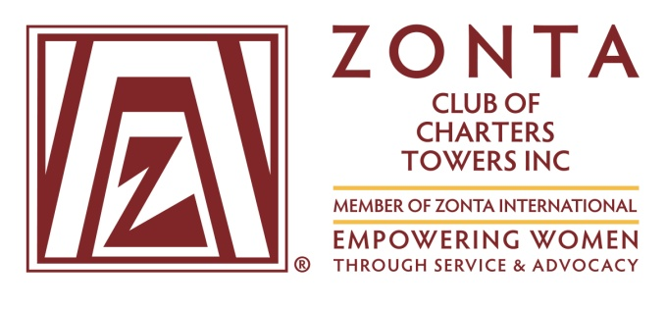

Newsletter : March 2016

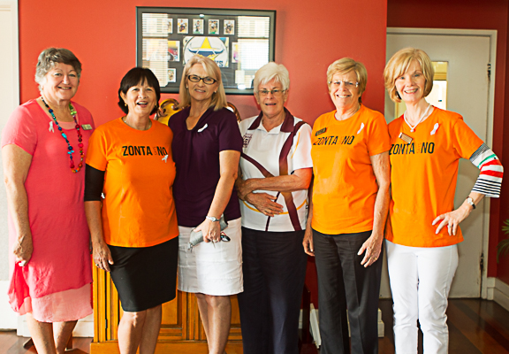
Zonta members (l to r) Robyn Pratt, Sue Farmer, Judy Barnes, Robin Bassingthwaighte, Hilary Grant and Lesley Collins.

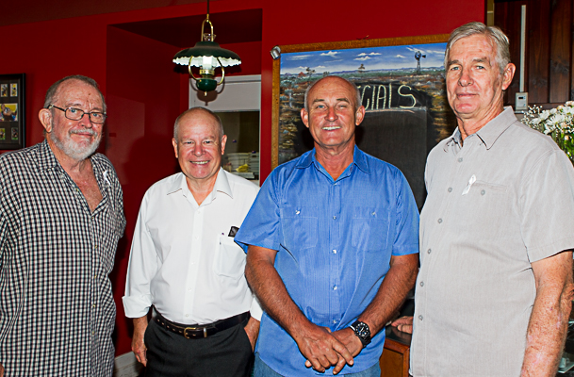
White Ribbon Breakfast guests (l to r) Gary Grant,
Wayne Dixon, Wayne Miller and Ernest Bassingthwaighte.

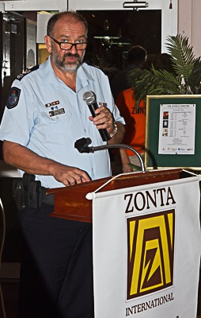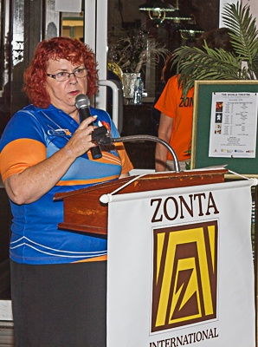
Guest Speakers Snr Sergeant Graham Lohmann,
and Ms Elvene Whitbread, Charters Towers Neighbourhood Centre, address the issue of Domestic violence.

From President Hilary Grant

A first for the Zonta Club of Charters Towers was acknowledging White Ribbon Day on November 25.
A breakfast well supported by community leaders, service clubs and schools was held at Henry’s.
Guest speakers-Elvene Whitbread (Charters Towers Neighbourhood Centre), Sonya Box (Life Without Barriers), Senior Sergeant Graham Lohmann (Charters Towers Police) and Cr Frank Beveridge (Mayor, Charters Towers Regional Council) spoke of the nature of domestic violence and the ongoing problems the victims face in their lives.
Senior Sergeant Lohmann said there had been a sharp increase in domestic violence cases in Charters Towers in recent years.
Up to November 2015, police had prosecuted 81 breaches of domestic violence orders, up from 70 in 2014.
White Ribbon Day originated in Canada in 1991 and is now active in more than 60 countries.
It is the world’s largest male-led movement to end violence against women.
Our thanks to Zontian Corral Clarke for all her efforts in organizing such a successful morning.

WHITE RIBBON -

Vision: All women live in safety free from all forms of men’s violence
Mission: Making women’s safety a man’s issue too…

Zonta’s Overseas Projects

The Zonta International Foundation funds the projects and programs of Zonta International.
Zonta clubs usually donate one-third of the money they raise to the Zonta International Foundation, utilizing the remaining two-thirds in local projects and programs in line with Zonta’s mission and vision.
US $5.1 million will be spent during 2014-16.
Every contribution is critical to empower women and girls worldwide.
Current International Service Funds supported by Charters Towers include Eliminating Obstetric Fistula in Liberia US $600,000 and Delaying Early Marriage in Niger US$1,000,000
In Liberia funds are used to equip hospitals to treat and repair obstetric fistula and to train health care providers in fistula management.
The health and socio economic status of more than 400 women and girls will be improved through surgery and non surgical procedures.
Increased knowledge and awareness of obstetric fistula in targeted communities will contribute to a 25% reduction in the incidence of the condition.
Niger has the highest child marriage prevalence in the world with 76% of girls married by the age of 18 and 36% by the age of 15.
A high proportion of school age girls are not in school and the vast majority of adolescent girls are illiterate.
By the age of 19 the majority of married girls have had children or been pregnant.
The project aims to improve the health of adolescent girls, ensure their access to educational opportunities, protect them from violence and encourage their leadership by providing access to mentors and women leader
These projects will be delivered by agencies of the United Nations.

About Zonta
Zonta International envisions a world in which women’s rights are recognized as human rights and every woman is able to achieve her potential.
The Zonta Club of Charters Towers holds a dinner meeting on the second Thursday of the month at Henry’s Café and Restaurant, 5.30pm for 6pm.
To find out more about Zonta,
Contact Judy Barnes on 0418 188122
or visit the website www.zonta.com
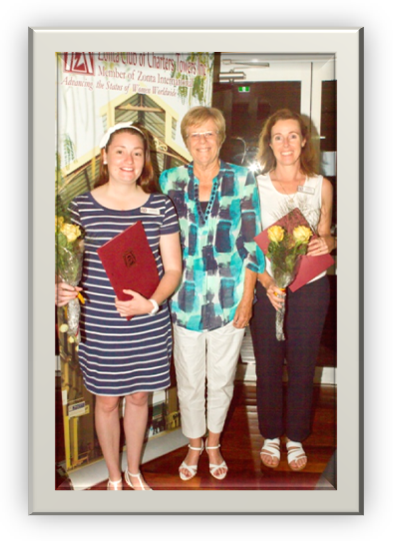
President Hilary Grant welcomes new members Jessie Stewart and Barbara Salisbury above, and Mary Jackson, below.
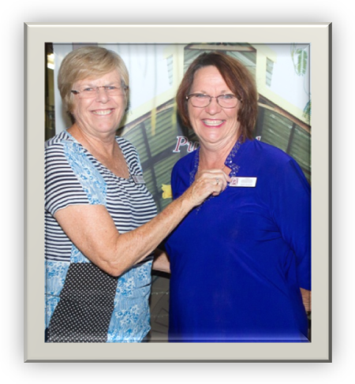
The Yellow Rose
On International Women’s Day each year, the Zonta Club of Charters Towers presents a bunch of yellow roses to a member of our community to acknowledge their service to others.
2007 Lyn Snowdowne (Cancer Council and Lions Club)
2008 Ann Dunn (Lions Club)
2009 Dot Birgan (first and only female mayor of Charters Towers)
2010 Shirley Symes (restoration of the Stock Exchange, reopening of the Don Roderick Gallery)
2011 Meg Ogilvie (St Vincent de Paul Society, Towers Players)
2013 Bev Whalen (Cancer Council)
2014 Lyn Prichard (QCWA, Girl Guides, Charters Towers Show Society)
2015 Val Cragg (Charity Markets, Show Society)
2016 Carole Phillips. Carole was a Dalrymple Shire Councillor (the first woman elected to the Shire Council), a member of the Soroptimist Club, a member of the Charters Towers Neighbourhood Centre Management Committee and is a passionate member of the Bush Curlews Writers Group.
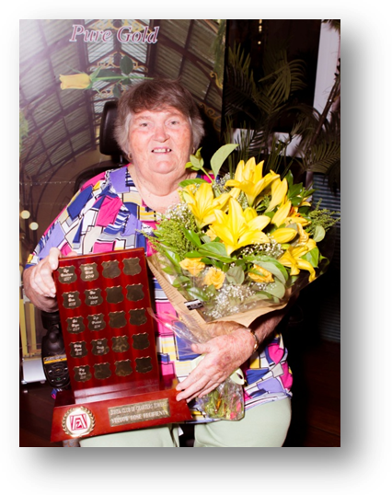
2015 Yellow Rose Recipient Val Cragg

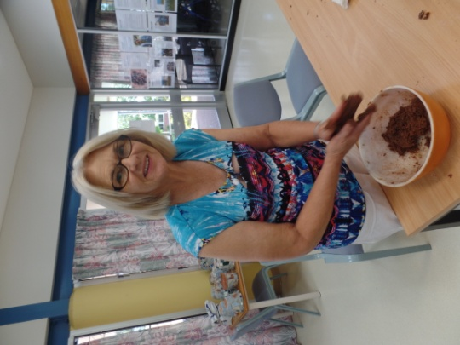
Community Service –Zonta’s Christmas fund raiser –
Judy Barnes and Tania Van Wijk making rum balls.

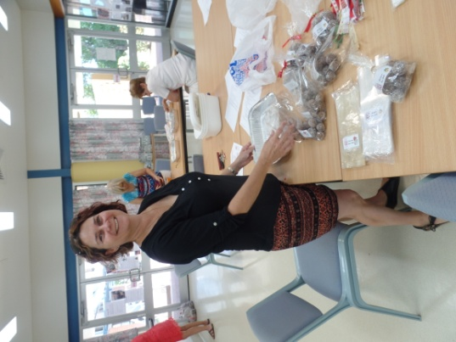

Zonta Calendar

March | Thursday 3 | 5.30pm for 06.00pm | March Meeting at Henry’s
 | Tuesday 8 | evening | International Women’s Day
 | Sunday 27 (Easter Sunday) |  | NO Centenary Park Markets
April | Thursday 14 | 5.30pm for 06.00pm | 2016 Annual General Meeting &  April Meeting at Henry’s  Guest speaker - Kate Hastie re financial management for women
 | Sunday 24 | morning | Coffee & Donut stall, Centenary Park Markets
May | Sunday 8 | morning | Mothers’ Day function – Time and venue to be advised
 | Thursday 12 | 5.30pm for 06.00pm | Continuation of 2016 AGM  May Meeting at Henry’s  Guest Speaker - Frances Williams re 2016 Census
 | Friday 20 | evening | Promoting recognition of Prevention of Family and Domestic Violence Month - “Zonta Says No” at the Cowboys NRL game.
 | Saturday 21  Sunday 22 |  | Area 5 meeting in Townsville:  Host: Townsville Metro Club  Venue: Quest on Eyre, 19 Leichhardt St, North Ward  Theme: ‘Empowering Women'.
 | Sunday 22 | morning | Coffee & Donut stall, Centenary Park Markets
June | Thursday 9 | 5.30pm for 06.00pm | June Meeting at Henry’s – guests -  Newly elected female Councillors
 | Sunday 26 | morning | Coffee & Donut stall, Centenary Park Markets

Saturday 20 February 2016 – Breast Cushion Sewing
- Charters Towers Zonta Club holds two breast cushion sewing days each year, producing approximately 200 breast cushions for use by women recovering from breast cancer surgery.
- The cushions are donated to Dr Sally Mead at the Mater Hospital and The Townsville Hospital
- Donations of cotton fabric are always welcome.
- For further information, please contact
Judy Barnes on 0418 188122 or
Maxine Lockman on 0400 749 669.
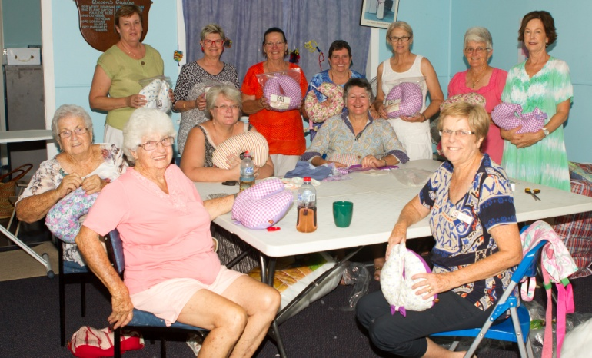
Above - sewers display the finished product
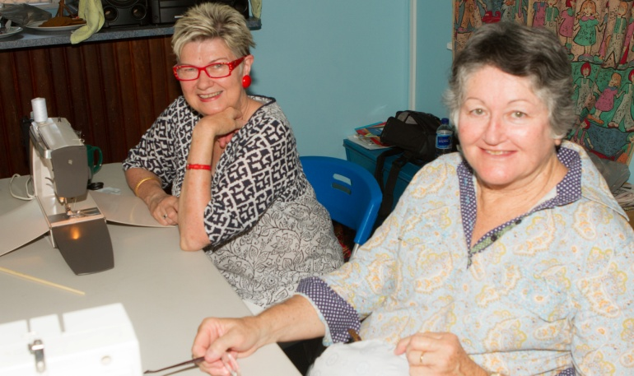
Above – Judy Murphy and Robyn Pratt;
Right – Judy Barnes and
Corral Clarke.

