PRESIDENTS REPORT
FEBRUARY
2018
Zonta
Southern Gold Coast
Tweed

SS
Soursss
Newsletter

What an exciting start to the new year with our first meeting seeing some new faces around our meeting table and all members present looking keen and refreshed for the year ahead. We covered a lot of ground and tried to make sure everyone felt included and heard as we planned our activities for the year. We set up our first working bee date for the year at the Sanctuary, decided to go again with birthing kits this year and considered sponsoring the Paradise Point program for girls again. There was much discussion about accessing a young woman/s who might be doing it tough and need some extra help to continue her education. This will be explored and options considered. As President I am keen to see everyone has a ‘ hands on’ role in our club and I think this is being achieved. We are also really growing as a unified force I think , bringing everyones talents and skills to centre stage as we take on the challenges of fund raising, raising awareness of Zonta and promoting our projects which recognise that womens rights are human rights.

ZONTA INTERNATIONAL WEBSITE

For those who have not had a chance to check it out and are passionate about the fistula project there is a great video on the site talking about the project and why it is so vital to Liberia and its people, not just the women affected and their families. Particularly inspiring was Victoria’s story and how the project has turned her life around and given her the opportunity to set up a small business for herself. Very moving and well worth a look for those who may have missed it.

SANCTUARY WORKING BEE

Another big thank you for all who were able to attend the week following our meeting. Two units were almost finished so we stepped in to lend a hand with some painting. We also got a photo of our placque in position in the mother baby unit which is looking very comfortable.

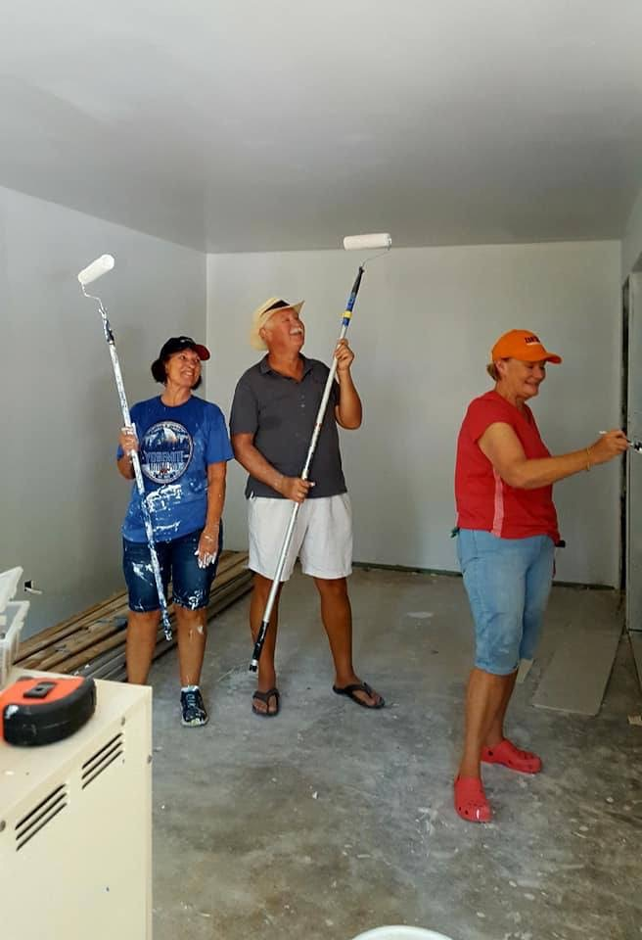

Doing a great job Pauline, Kaye and Andrew. For some reason Andrew looks very clean and tidy compared to the girls?

AMELIA EARHART BRUNCH IN BRISBANE
For those lucky enough to get there we enjoyed some delicious food and very good company on Sunday 21st January celebrating the 83rd anniversary of Amelia Earharts

record breaking flight from Hawaii to California on 11th January 1935. The speaker Caitlyn Stephenson was a very smart, inspiring young woman who has achieved many honours and wonderful success through her hard work and dedication to Avionics. She is passionate about employee development, youth development and promoting women in aviation and engineering. Currently she is Deputy Integration Manager Helicopter Aircrew Training System {HATS} Boeing Defence Australia. Big thanks to Brisbane South for a lovely get together and a perfect speaker for the morning. Rhonda, Pauline, Merle, Carole and Rosemary . Good to catch up

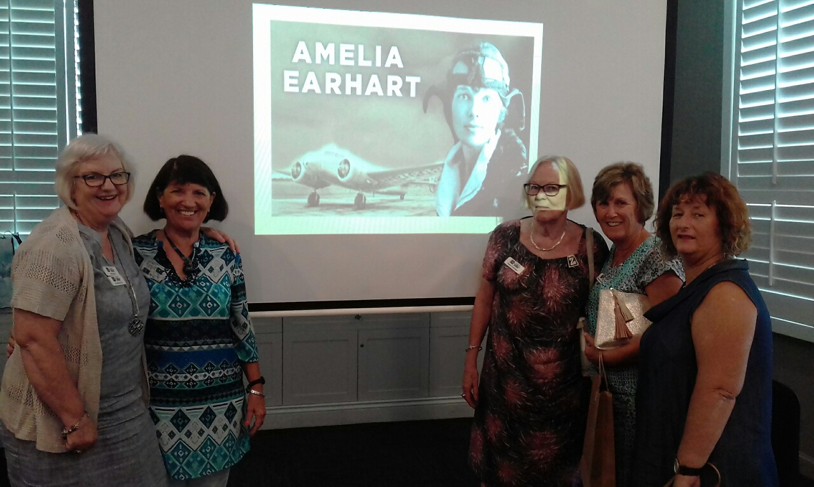

BIRTHING KITS
As President I am very happy to see birthing kits back on the radar. Packing them is always a good day and we know we are saving the lives of mothers and babies in countries we will probably never see, but caring about the welfare of these women is core Zonta business. These lives are just as worthwhile as our own and the least they deserve is to birth their babies in a clean, safe place. We need to also consider that Birthing Kits Australia, who we buy the kits from, provide training to birth assistants to enable them to use the kits hygenically and appropriately. This is also massively important. Giving these women a role while at the same time increasing their satisfaction with what they do knowing they are doing the best they can for mother an baby with very limited resources.
Some discussion around crowd funding this project as it is always well received by supporters and the general public. Watch this space .

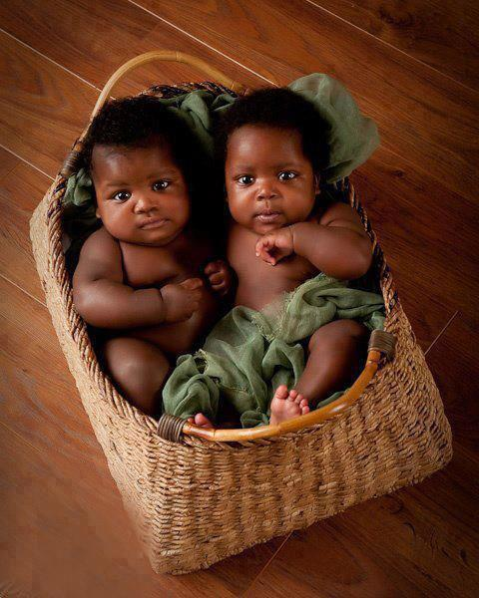

Could not resist sharing this photo, are they not adorable ?

AREA MEETING
Would like to see big contingent from our club to attend this. It is almost local for us and is such a worthwhile event as we all endeavour to learn more about Zonta, what our role is and have some fun with other like minded people. Zontians come from all backgrounds and are all ages, but our comitment to women and children gives us all a common goal to strive for. There is much to be donw

THE STORY OF CAROLE

In thinking about why I chose to join Zonta I immediately thought of my first major milestone, which is the birth of my three, now adult, children. When my children were all under six years old Les, my husband, and I embarked on a 6 month journey around Australia. We travelled into pretty much every corner and our children participated in every aspect of our adventure. My daughter had just started school so we were obligated to maintain some level of schooling. I think it was at this time I really appreciated the importance of the family as a unit. During this time we relied upon each other for learning, for safety, for fun and for care.

On our return I became very involved with my children’s schools and held positions on various P&Cs. I volunteered in classrooms in reading recovery programs, fundraisers, craft days and canteen. The basis of my contribution had always been with the belief that as parents we can help to better resource all children through facilities and opportunities, but to also help in better educating all parts of the community about good parenting.

I now have four grandchildren and see how fortunate they are to have committed and loving parents who would do anything to provide opportunities.
My husband and I are a big part of all their lives and enjoy being part of the milestones they make.

Amongst the many businesses I have owned being an owner of an Early Childhood Centre seems to be the most demanding and fulfilling. Since being in the childcare industry I have used my past skills in business to move forward but also am passionate in making sure that the children are a priority and the families are well looked after. During this time at the childcare centre I have come across some situations where the child is at risk and the mothers are being abused. I have always had a disgust for this behaviour and realise it is a well-kept secret. I have had a privileged life where my husband has only every treated me and our family and with the greatest of respect; he has always taken the attitude that he has to look after us. I just thought this was normal but I have since learnt otherwise and it upsets me greatly as all children have the right to be happy and feel loved. Joining an association helps fight against these attitudes. From the short time I have been a member it appears that Zonta Southern Gold Coast Tweed fund raisers to help in small way to try and make these situations for some people a little better. It gives them a light at the end of a long and complicated tunnel.

Giving back to an organisation like Zonta reminds me of the life I have and the life many should have.

THANKS CAROLE FOR SOME INSIGHT INTO YOUR LIFE AND WHY YOU CHOSE ZONTA

SAVE THE DATE

MONDAY 19th FEBRUARY DINNER MEETING 6 FOR 6.30 QLD TIME SECRET GARDEN ROOM SOUTH TWEED SPORTS CLUB, MUDJUNGBUL Dve TWEED HEADS

ZONTA ROSE DONATION FOR IWD 8THMARCH TO REMEMBER A SPECIAL WOMAN IN YOUR LIFE

SATURDAY APRIL 21ST AREA MEETING 1-3 @ THE CENTRE 82 BRISBANE ST BEAUDESERT

29TH June – 3RD JULY 64TH ZONTA CONVENTION YOKAHAMA JAPAN

