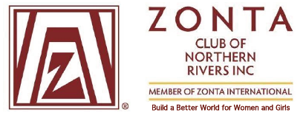

Zonta Club of Northern Rivers Newsletter
November 2022

MEETINGS ARE HELD AT THE ALSTONVILLE BOWLING CLUB @ 6pm Every THIRD Wednesday of the Month
Our last Newsletter in April covered our major fundraising activity for 2022 (the Open Garden) and featured our major 2022 project - providing support for Older Women: and Homelessness, particularly for this age group. We noted at that time (that is, April 2022) that the flooding crisis in the Northern Rivers had worsened the plight of these women and further exacerbated the housing crisis in the region.
Membership
Membership has remained stable throughout the year with 13 active members. Zonta NR offered honorary membership this year to local politicians Janelle Saffin and Catherine Cusack, both of which have been accepted. We also have another new member who will be inducted in January 2023.
Our August meeting welcomed a guest - local Ballina Shire Councillor Simon Chate who came along to learn more about the work of local Zontians.
Club Projects and Activities
Fund Raising

2023 Major Fund Raiser – Open Garden February 2023

Following our successful Open Garden in 2022 another is planned in 2023. This will once again be held at Lyn and Bron’s home at Uralba on the weekend of 11th and 12th February, 2023.

In May our Club received a donation ($1,910) from the Zonta Club of Central Coast to help with our work with older women and flood relief. This added to other monies received from Perth Northern Suburbs Zonta clubs and has been a welcome addition to our project funding.

As mentioned in our previous Newsletter we have also received a grant from Southern Cross Credit Union which funds have been used during 2022.

Zonta NR projects 2022

Older Women's Homelessness and Housing Issues :
Our focus since the floods and the resulting accomodation crisis has been to support the women who are being accommodated in the Wollongbar pods. North Coast Community Housing took over management of the pod village in May 2022 and since that time Zonta NR has assisted in a variety of ways including:
- Purchasing and supplying kitchen, laundry and manchester items to the women- these included a wide variety of items as specified by NCCH as being required by the occupants of the housing project. Thanks to Lynne Shailer, Jeni Binns and Lyndall Smith for purchasing them and arranging delivery.

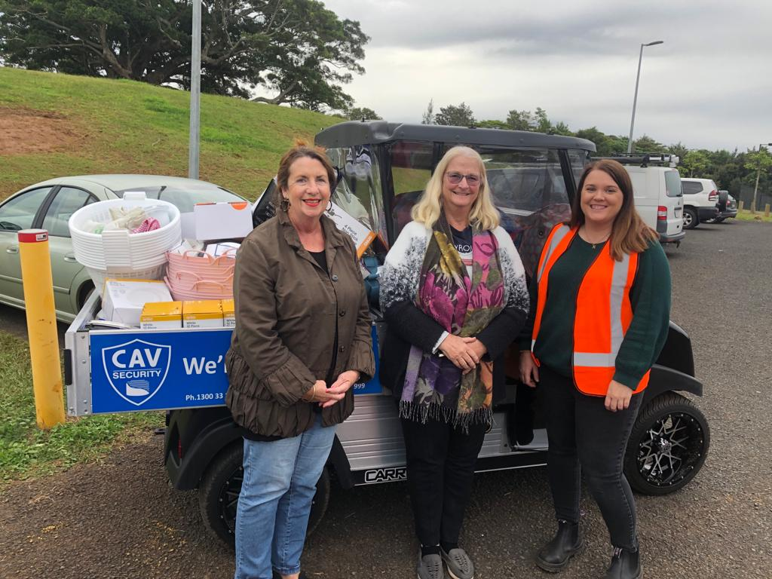

- Attending a high tea at the Wollongbar Pods in August 2022

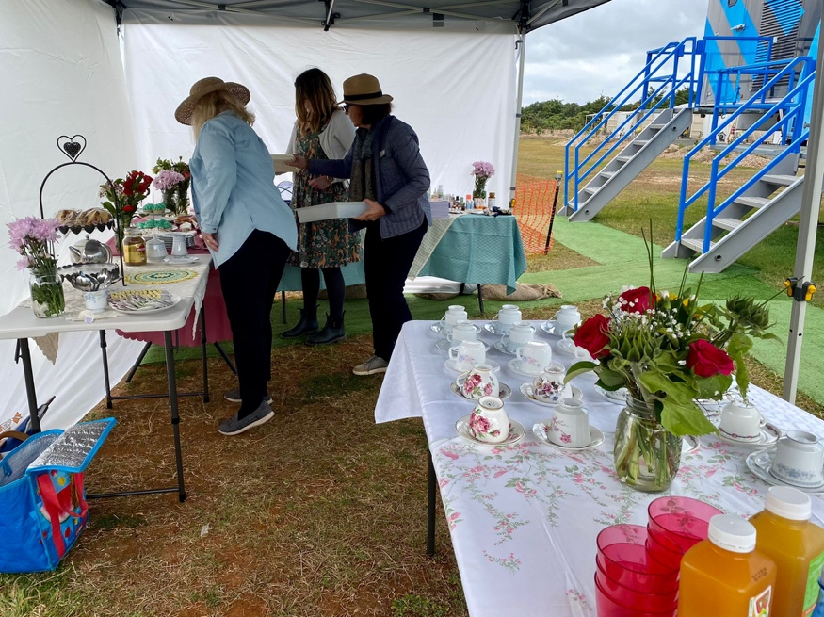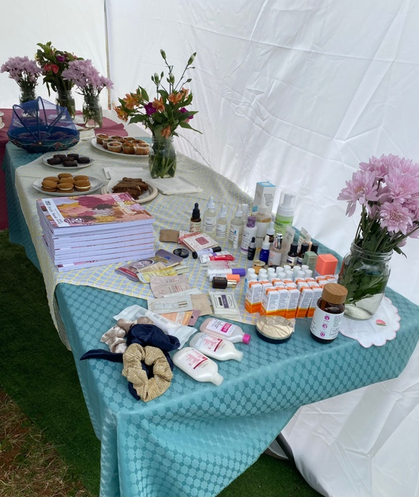

- On 27 October our club provided a cake stall for the Spring Market organised by NCCH at the Wollongbar pod village.

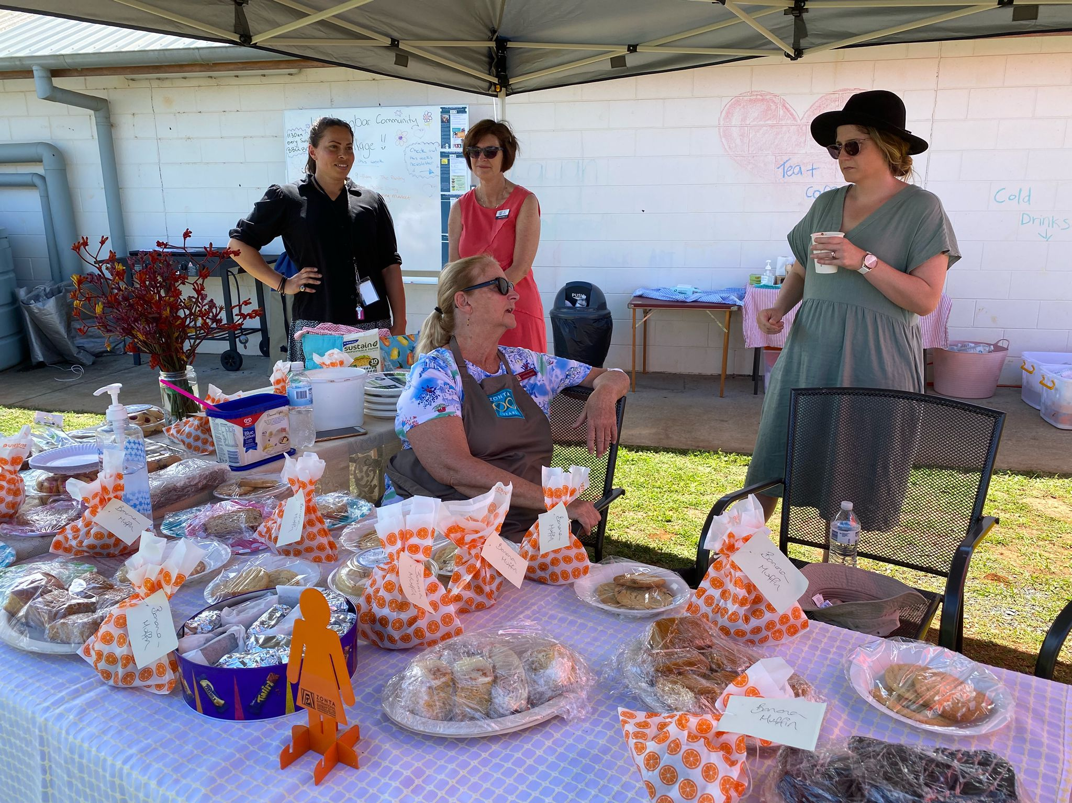

Our ongoing commitment to Other projects continues including:
Zonta NR celebrates Pregnancy & Infant Loss on 15 October each year with a time of quiet reflection at the Memorial Garden at Goonellabah. The Garden is maintained by Zonta members and this year a special thanks to Lyn Crehan and Maggie Cross for their attention to the garden.
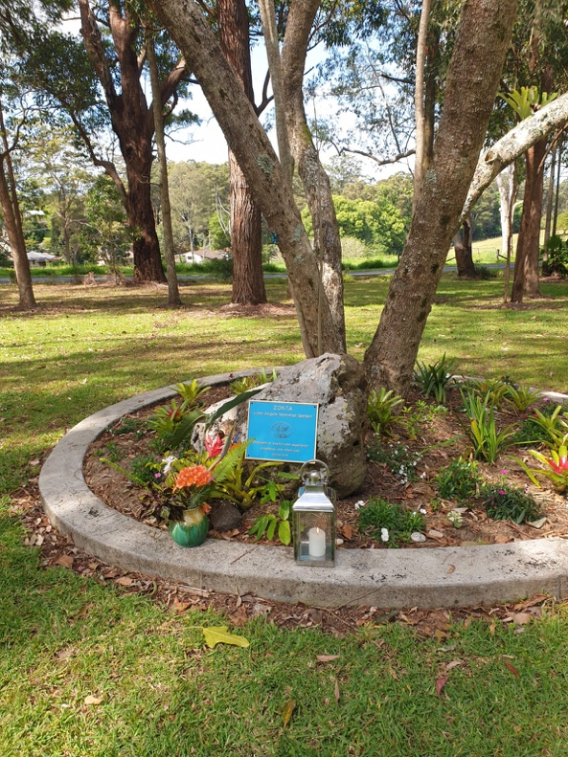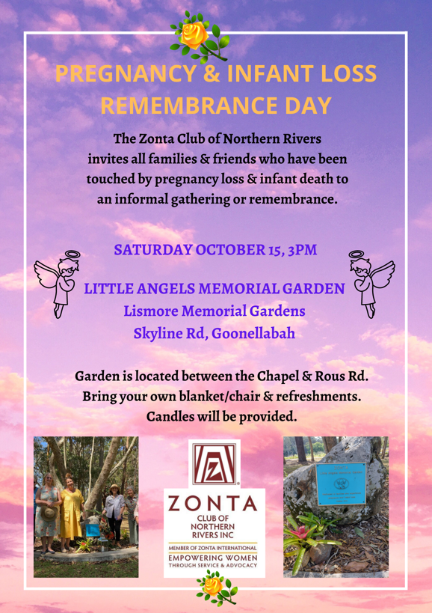

Support for Heartfelt House and Adult Survivors of Sexual Abuse
In June Zonta NR donated $1,000 to Heartfelt House for their ongoing programs focussing on the needs of their individual clients; and a further $600 in August for their next Healing Pathways Program. This is a 10 week group program for women who have survived childhood sexual abuse. The cost of the program is $100 and therefore this donation is a sponsorship for 6 enrolments.

16 Days of activism against gender-based violence

The 16 days of activism against gender-based violence is an annual international campaign that runs from 25 November to 10 December. The theme for 2022 is “UNITE! Activism to end violence against women and girls.”

This year Zonta NR will hang our Orange banner over these 16 days as well as each member placing an Orange Lady at a local business or community hub to promote the message. Planning is well underway with lots of creativity being displayed as we dress our ladies to promote the message to stop violence against women. Zonta NR remains indebted to the Ballina Mens Shed who created the large ladies for us.

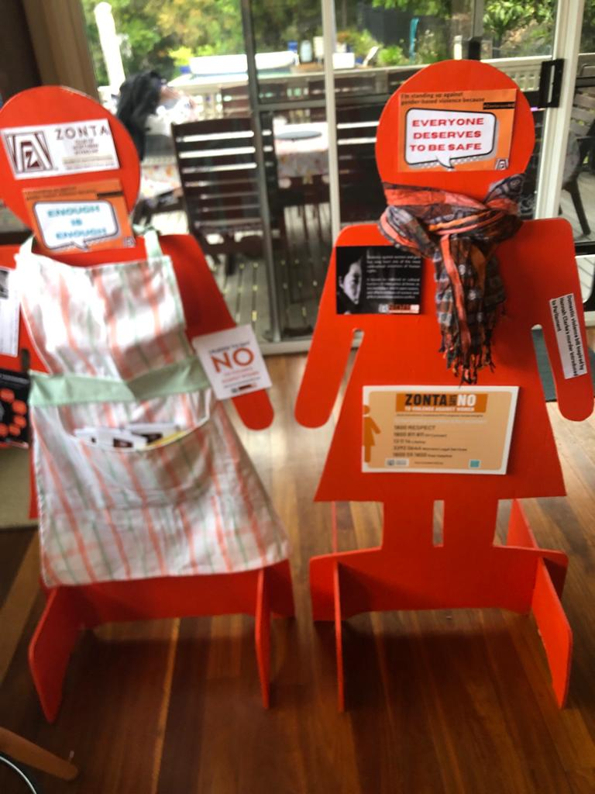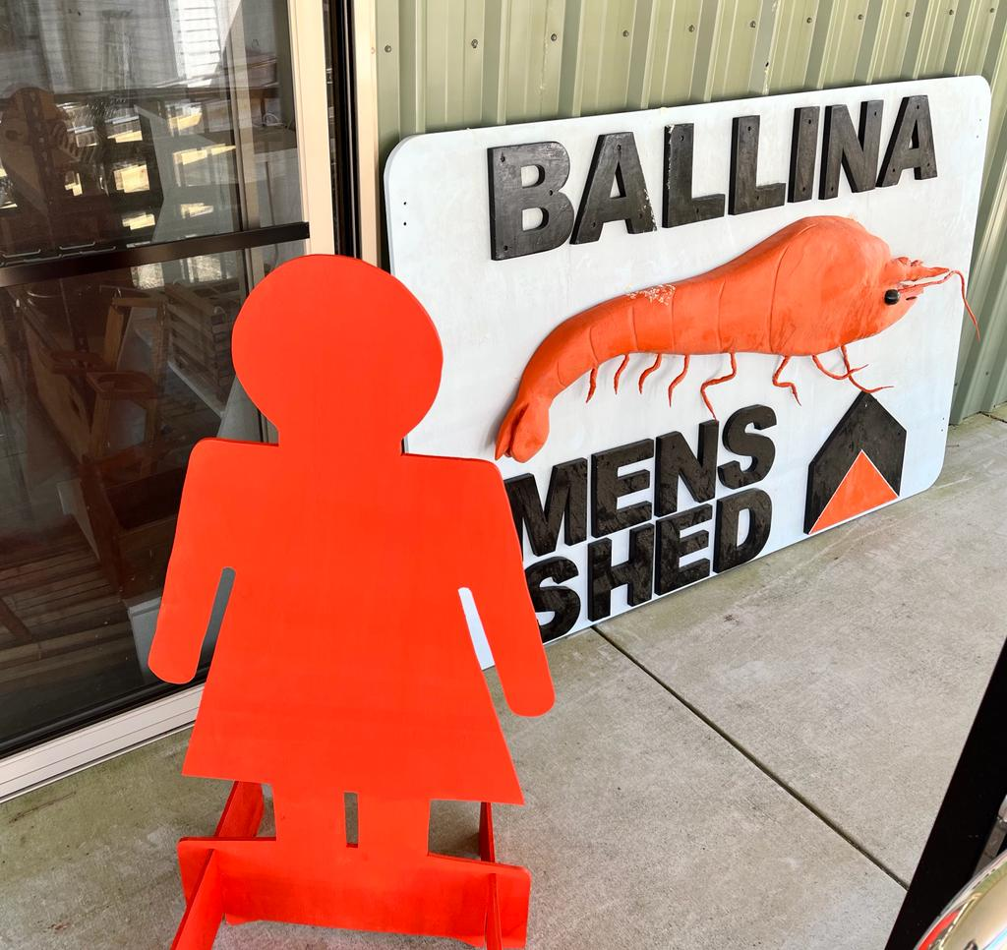

Zonta NR continues to provide financial support to maintain the Stillbirth Room at Lismore base Hospital. An updated photo of the room with a recently donated painting from Naya Lee.
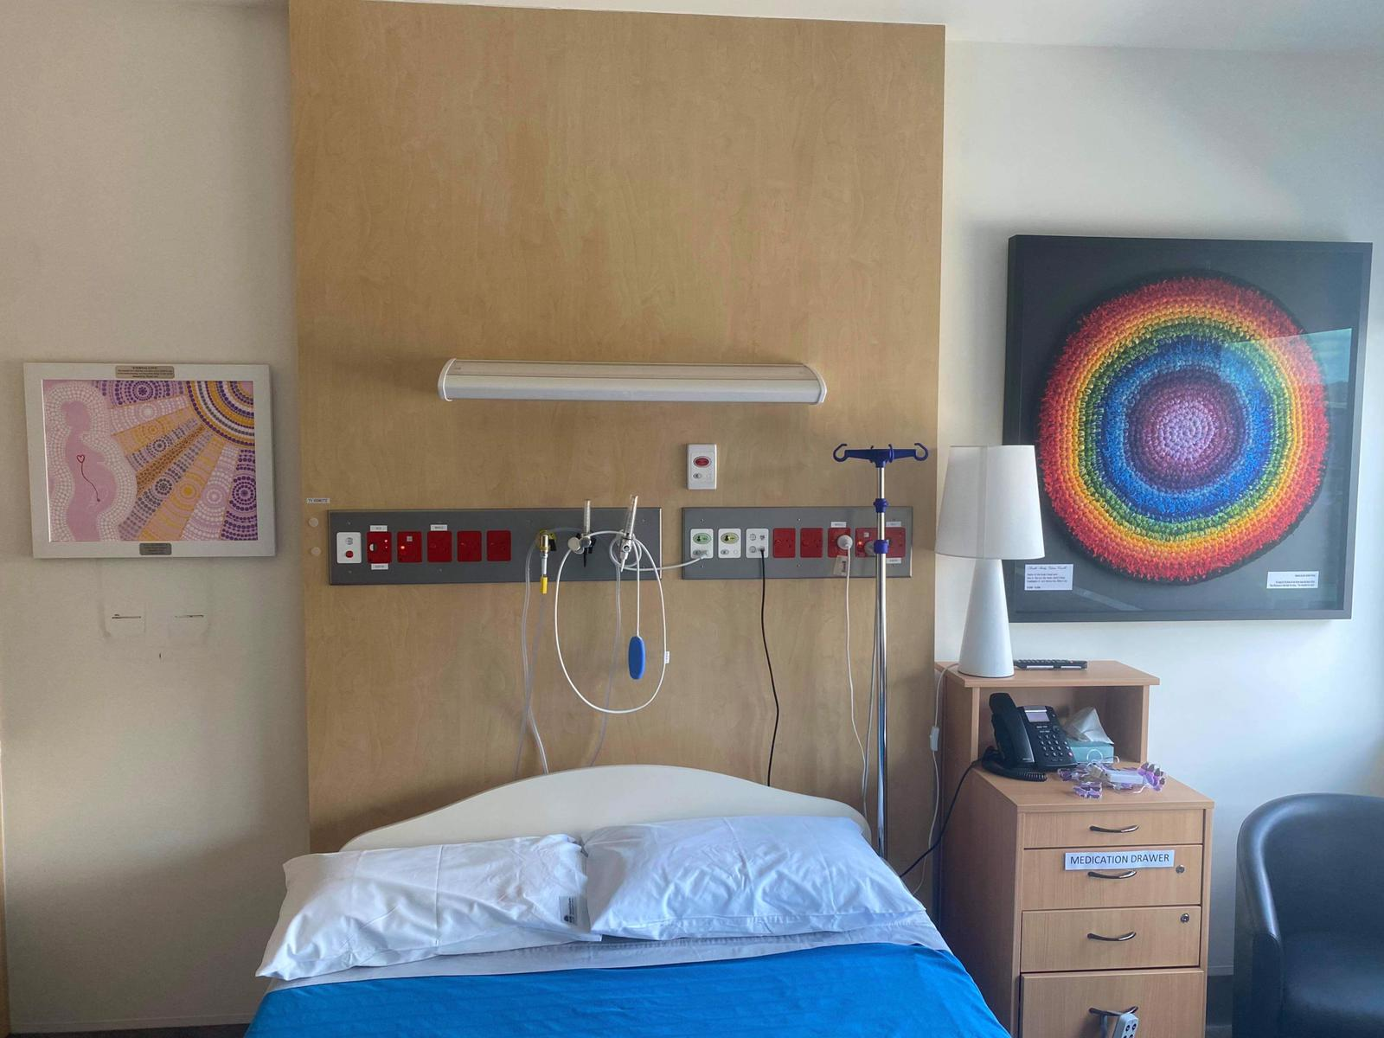

Social Activities of Club
On 29 April some of our club members attended the local Quota Friendship High Tea at Summerland House and were entertained by some interesting speakers. It was a good opportunity to meet other local women, many of whom were our local politicians (Catherine Cusack, Tamara Smith, Sharon Cadwallader) and learn more about Quota’s aims and activities.

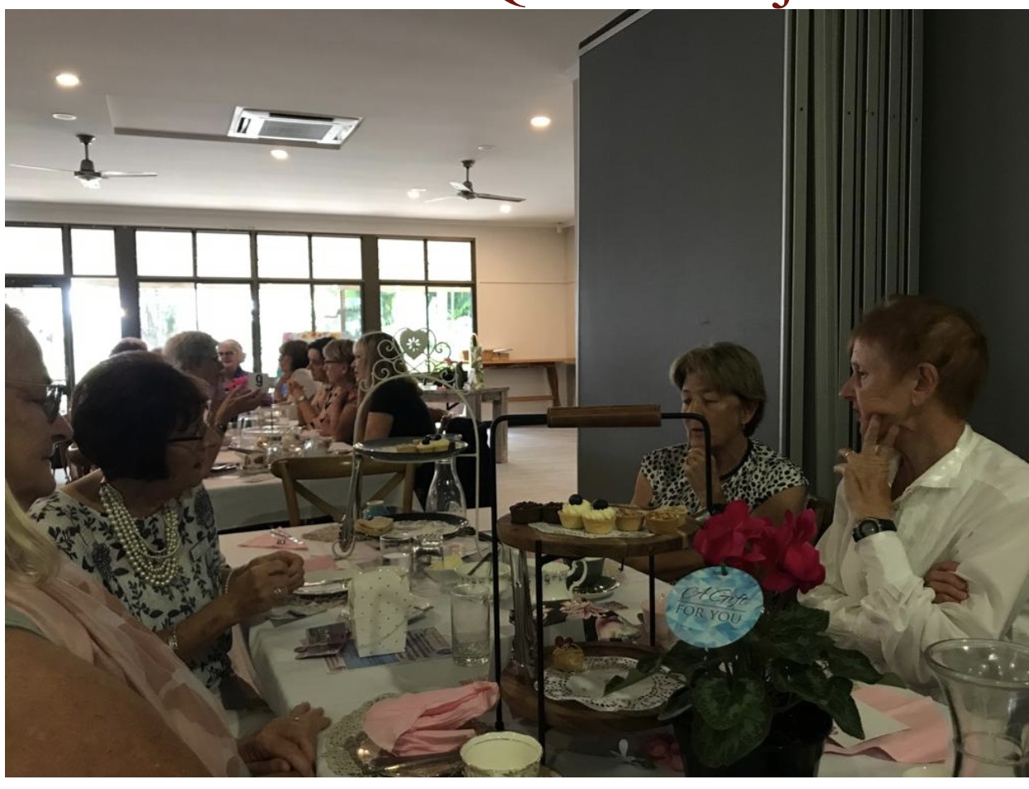

Our club has also had a wedding this year with the marriage of Lyn and Bron in June 2022.

On 6 August this year the Club held a successful though somewhat belated “Christmas in July” function at Bobbi’s home. Many members and their partners attended for a formal sit down lunch to which all contributed.

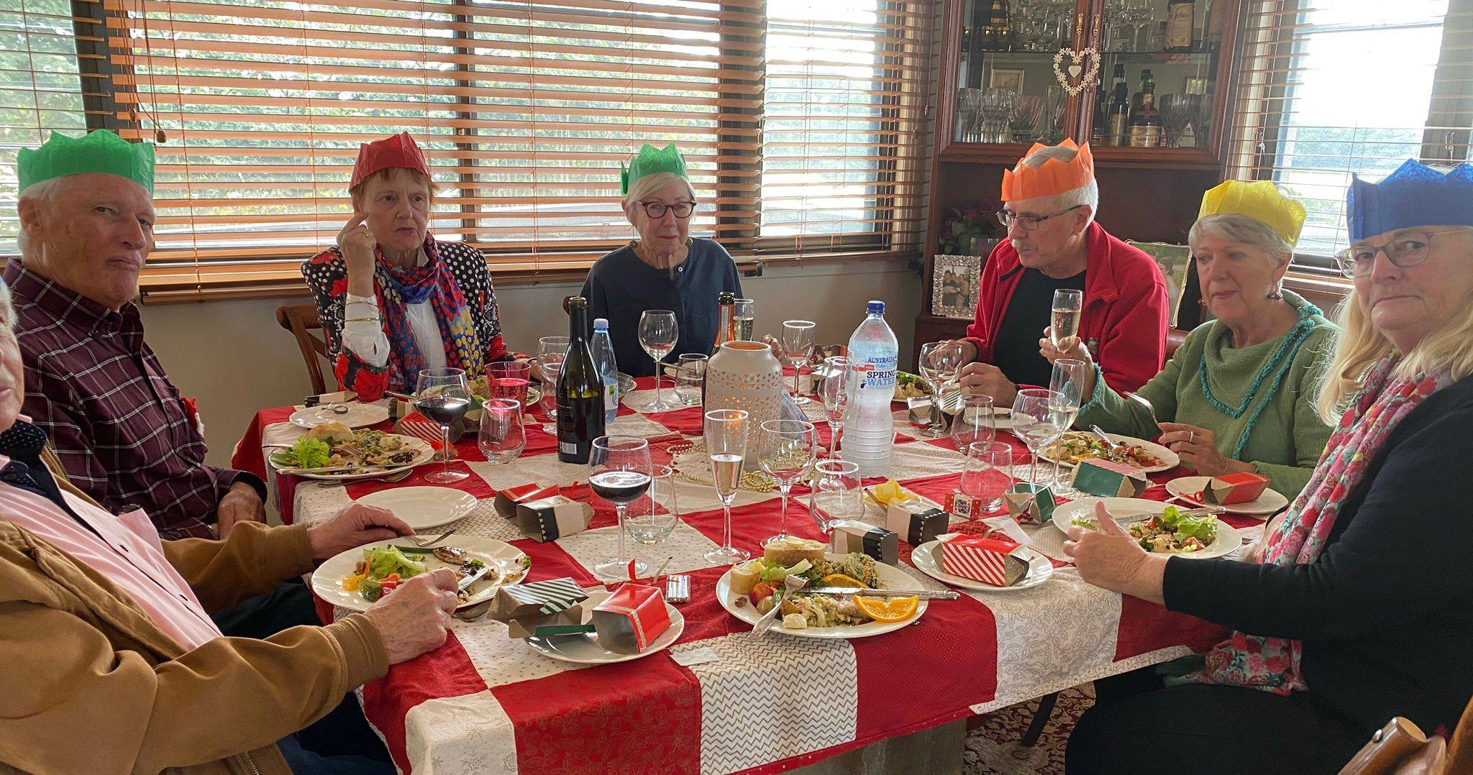

In September our club president Lyndall attended the Husk Distillery at the invitation of the South Tweed Club who were holding a member and non member social day. This has prompted our club to give some further thought to a social function in 2023 that will involve non-members in a similar social and promotional activity.

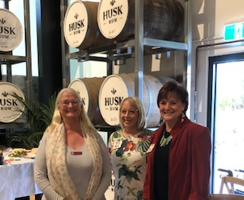
What is happening world wide?

Zonta International (ZI) and its members work at all levels (local, national and international) to improve women’s rights and enable women to achieve their full potential. ZI has four major causes – advocating for gender equality; ending gender based violence;ending child marriage and expanding access to education.

The 2022 ZI projects were unchanged:
Empowering Girls through education in Madagascar
Adolescent girls’ Health and Protection in Peru
Global Program to end child marriage
Empowering gender based violence survivors in PNG and Timor Leste

A focus on child marriage in Australia was raised this year by the Federal Police who identified an increase in forced child marriage in Australia, particularly NSW and Victoria. Forced marriage in a criminal offence in Australia yet young girls are still being “sold” into marriages, some as young as 11 years of age.

In 2022 Zonta NR donated a $800 to International Service Projects. Whilst we would have preferred this go to PNG it was not possible to earmark the donation in this way.

2022 has also seen increased emphasis on human trafficking, a major human rights issue that affects women and girls. The pandemic and political instability have left more women and girls exposed to human trafficking, as traffickers took advantage of the economic hardships these changing economic and social conditions produced. Most women and girls are trafficked for sexual exploitation however some are trafficked for forced labour or other forms of exploitation. In September 2021 ZI issued its new statement on Trafficking in Persons : a Human Rights Issue, calling on all governments to take all appropriate measures, inlcluding legislation, to suppress all forms of trafficking in women and girls.

Diary Dates for remainder of 2022
November 16- Monthly Meeting Alstonville Bowls Club 6pm

Zonta Northern Rivers Board 2021-2022:
President: Lyndall Smith
Vice President: Ellen McGirr
Secretary/Treasurer: Julie Burton
Board Members: Lynne Shailer, Anne Flanagan, Lyn Crehan

