

**Don’t forget…**

**Zonta’sWell Women Workshop**

**Tuesday 17th March 6.30pm,**

**Henry’s Restaurant**

Supportingwomenbusinessownersin

ChartersTowers

* Share your experiences
* Network with local women
* Gain awareness of local supports
* Develop creative coping strategies

***NO COST***

***for local women business owners***

Interactive presentations by Guest Speakers:

* **Jeanie Brook (Frontier Services)**
* **Tamara Hogan**

**(Coach, therapist & author)**

Light supper and gift bags included.

Places are limited!

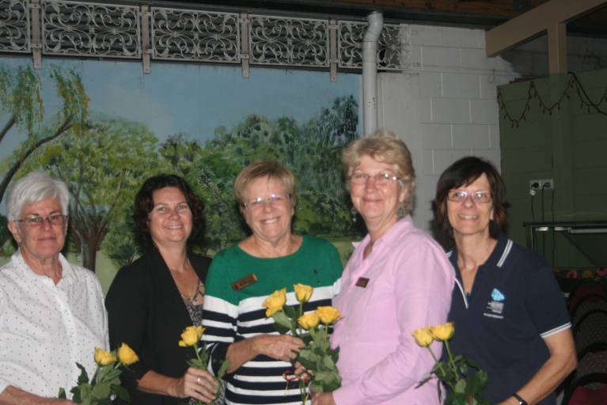

**Zonta Charters Towers Executive** (L to R):

Robin Bassingthwaighte, Treasurer,

Tania Van Wijk, Vice-President,

Hilary Grant, President,

Maxine Lockman, Correspondence Secretary

Bea Harris, Minutes Secretary.

**From the President**

2014 saw the Zonta Club of Charters Towers celebrate its tenth birthday – ten years of helping women locally, nationally and globally through service and advocacy.

We celebrated the milestone in style with a gala dinner at Henry’s Café and Restaurant.

District 22 Governor, Judith Trevan- Hawke (Brisbane) was in attendance, also Area 5 Director, Marie Cameron (Mackay) and representatives from Zonta clubs in Mackay, Townsville, Burdekin and Bowen.

Some projects we take on every year –

* International Women’s Day (with the announcement of the Zonta scholarship winner and Yellow Rose recipient),
* Sewing breast cushions for cancer sufferers,
* Assembling birthing kits for women in Third World countries.

Other projects are one offs and in 2014 we were proud to work with the Neighbourhood Centre on two of their projects – the setting up of a respite unit and the Christmas party for drought stricken farmers and their families.

We furnished one of the bedrooms at the Kernow Centre Respite Unit and provided some of the entertainment (a jumping castle and a bungy run) at the Christmas party.

On the international front, we financially supported Zonta’s projects for the elimination of obstetric fistula in Liberia and the delaying early marriage in Niger.

We are always looking for new fundraising ideas to finance our projects.

Thank you to the executive- Tania Van Wijk (Vice President), Bea Harris (Minutes Secretary), Maxine Lockman (Correspondence Secretary), and Robin Bassingthwaighte (Treasurer) and to the members who havecontributed their time, their enthusiasm, their expertise and their finances to all our projects.

Hilary Grant

PRESIDENT

**International Women’s Day**

**Friday 6 March 2015**



**2014 Projects…..**

In 2014, the club successfully applied for funding for a photocopier through the Queensland Country Credit Union’s Community Grants Scheme.

The photocopier is put to good use running off newsletters, fliers advertising events, minutes and information for new members.

Thank you to Judy Barnes for completing the application and to the Queensland Country Credit Union for their support of their local community.

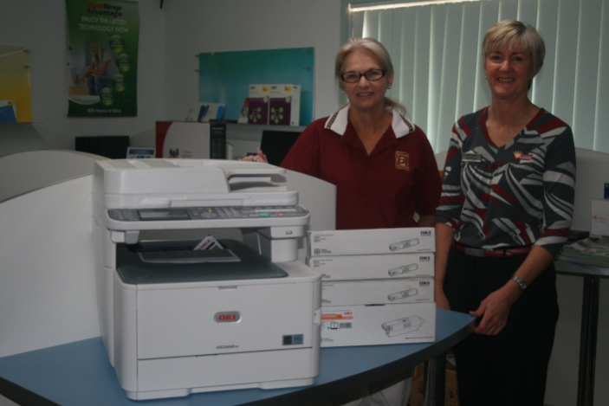

***May is Domestic Violence month***and

Zonta members participated in a march down GillStreet organized by the Charters Towers Neighbourhood Centre -“Keep Our Town Safe”.

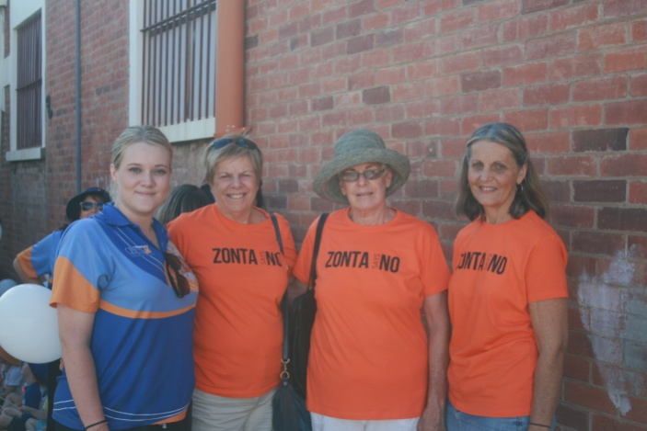

**St Gabriels“Z Club”**

St Gabriels Z club fundraised for two projects in 2014.

They bought and assembled pamper packs for rural women enduring the drought. These packs were distributed by Jeanie Brooks from Frontier Services at the pamper days she ran.

Goodie-bags were donated to the Charters Towers Neighbourhood Centre for children who have to leave home at a moment’s notice due to a violent situation.

The drawstring goodie-bags contained story books, colouring-in books and pencils, cuddly toys, hair ties and ribbons and games suitable for children under ten years of age.

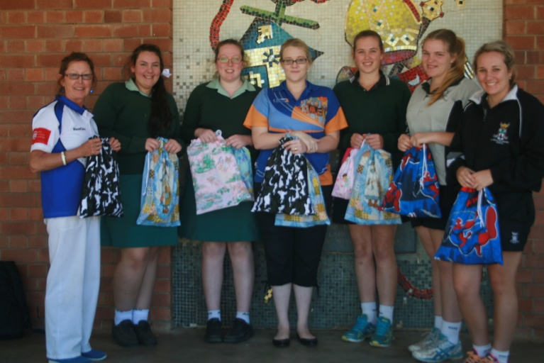

Z Club Members with goodie bags

for the

Charters Towers Neighbourhood Centre



**2014 ZontaHigher Education Award**

2014 Higher Education winner Kirsty Healing grew up on Warrawee Station, Charters Towers, and attended All Souls St Gabriels as a weekly boarder from 2008-2013.

Kirsty excelled in the classroom, on the sporting field and participated in a number of extra curricula activities.

She ended her years at ASSG as school dux; she represented the school in netball, softball, cross country and athletics. She earned her gold Duke of Edinburgh award and was a finalist at the Townsville District Regional levels of Lions Youth of the Year.

In 2014 Kirsty commenced a Bachelor of Occupational Therapy at James Cook University and has continued to excel academically.

This year she has taken on the role of student mentor and is treasurer of the OT Students’ Assn.

Well done Kirsty!



In 2014 the Zonta Yellow Rose Recipient was Lyn Prichard.

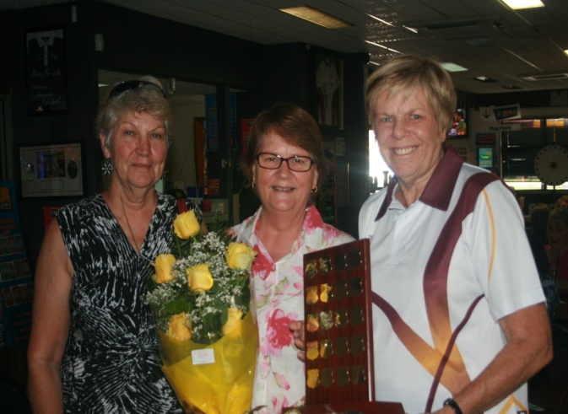

Maxine Lockman (L) and Hilary Grant (R) present Lyn Prichard with the Zonta Yellow Rose and Shield.

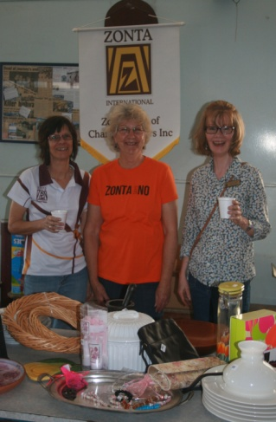

**Trash and Treasure in 2014!**

***About Zonta***

Zonta International envisions a world in which women’s rights are recognized as human rights and every woman is able to achieve her potential.

The Zonta Club of Charters Towers holds a dinner meeting on the second Thursday of the month at Henry’s Café and Restaurant, 5.30pm for 6pm.

**To find out more about Zonta, contact**

**Judy Barnes on 0418 188122**

**or visit the website** [**www.zonta.com**](http://www.zonta.com)

[Photo Caption]

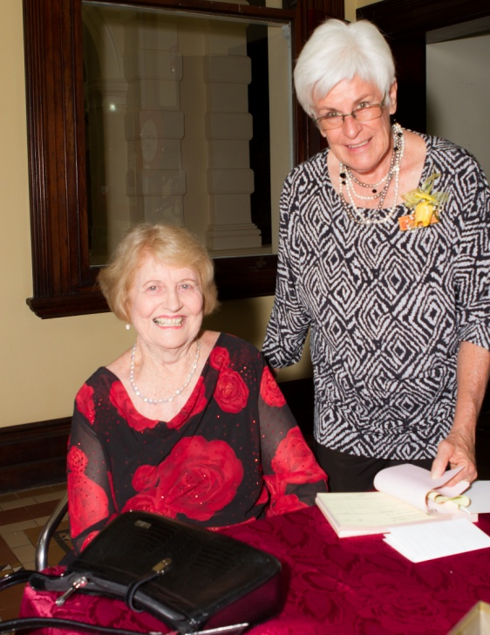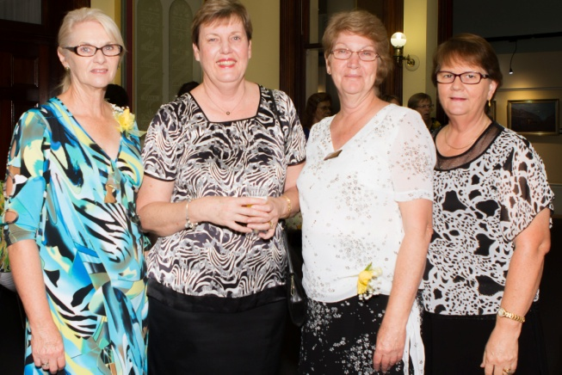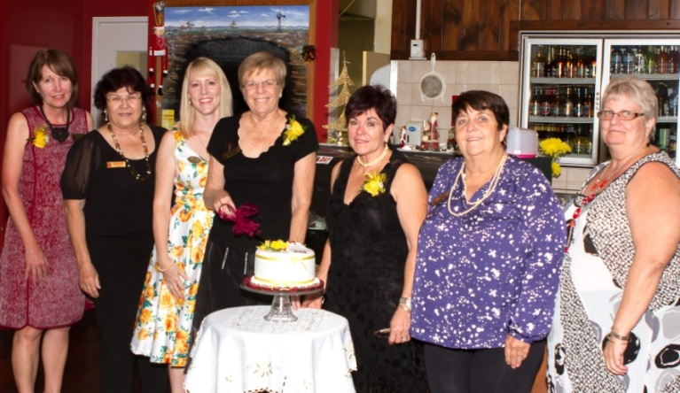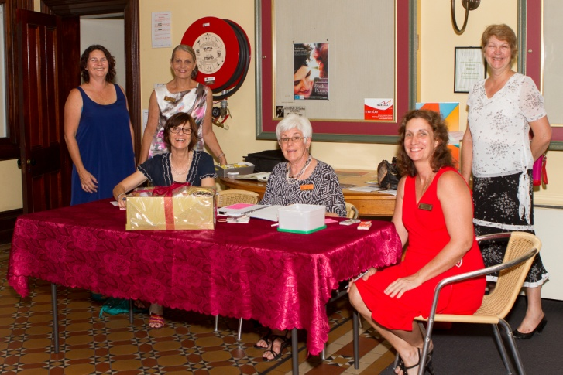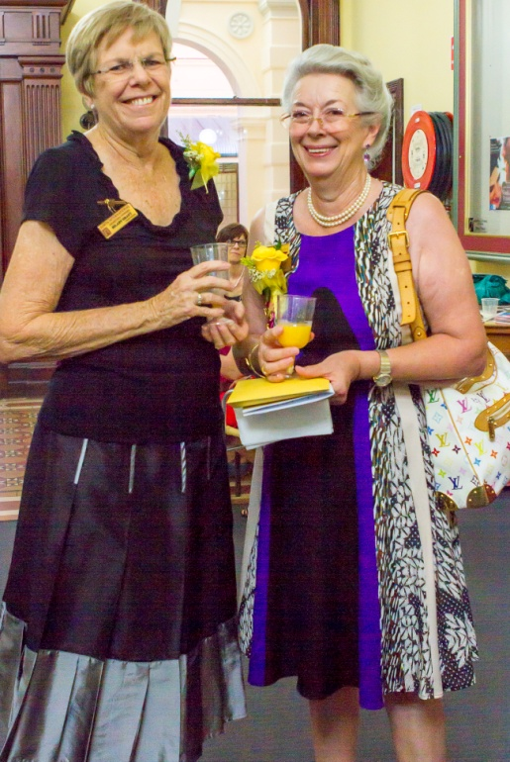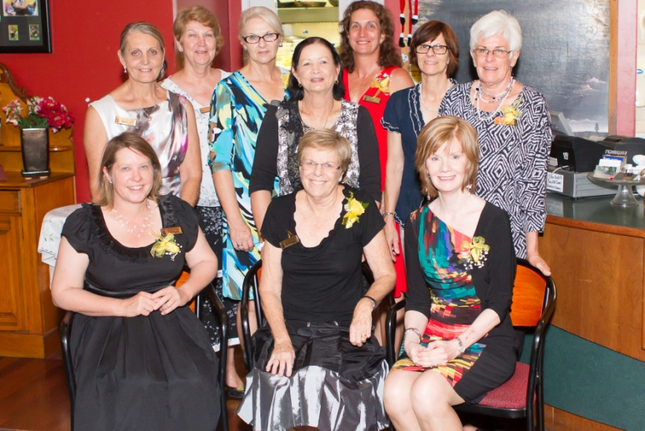

*Zonta Charters Towers 10th Birthday Celebrations*