Zonta Club of Noosa

Annual Report
2021- 2022

‘Transitions, Changes and Opportunities’

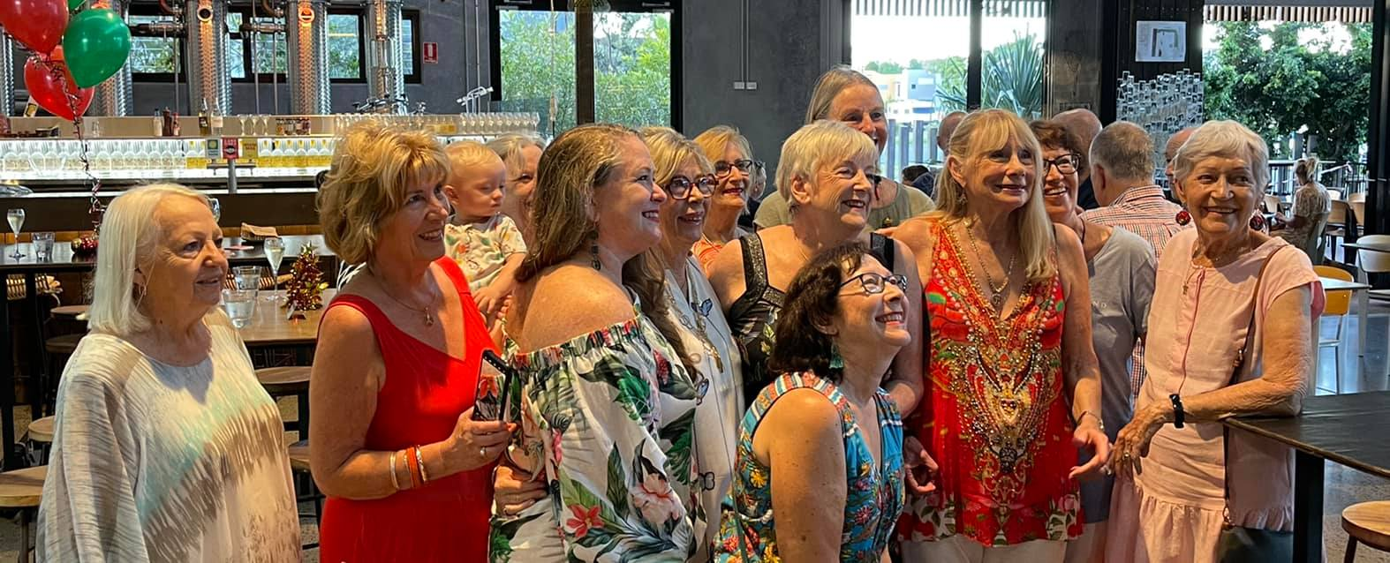

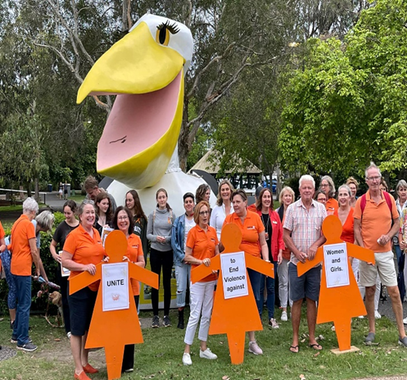

Club 1408
District 22, Area 1
PO Box 1485, Noosa Heads QLD 4567
zontanoosa@gmail.com

Club Governance
Office Bearers 2021-2022 Year

Board
President: Margie Fisher
Vice-President: Robyn O’Neill
Treasurer: Amy Ryan
Secretary: Liz Garbacz
Directors: Bronwyn Scarr
Gail Murden ( part year)
Jann Tuxford (part year)

Nominating Committee: Amy Ryan
Liz Garbacz
Helen Collins

Chairpersons: Robyn O’Neill (Advocacy and PR)
Bronwyn Scarr (Fellowship and Membership, &
Service part-year)
Gail Murden (Service, part year)

PRESIDENT’S REPORT
2021 – 2022

During the past year the ramifications of Covid continued to affect our Club and its initiatives.
I am very conscious that we have many club members who have not known our Zonta club when it was not under the constraints of Covid. It has been disappointing that we have not been able to hold the meetings in the way we planned with greater fellowship and mixing around at meetings. Also, with holding more social events. We know these things are important and it was the principal message that came through the Club survey last year was that members would like more time to get to know others both at meetings and socially.

However, a pleasing aspect of our activities has been the way club members have worked together for our fundraising efforts. For example, Sausage Sizzle, High Tea and Pop-up shop. This is Zonta at its best with members freely giving their time to achieve our goals.

Meetings
Meetings were a mixture of on-line and face to face. While the Zoom meetings serve a purpose, they do not replace the face-to-face meetings where we can enjoy the camaraderie of the fellowship beforehand.

Of major concern for the club was the loss of our permanent meeting venue with the Springs no longer opening on a Thursday night. This has proved problematic to replace as many venues are still affected with staffing issues due to Covid. We have had some success with Peppers restaurant in the evening and trialed a breakfast meeting at the Springs this month. However, we are still to determine a permanent home for our monthly meetings.

Fundraising
Our fundraising had mixed results with a total raised of just under $7000 net. The pop-up shop had a low attendance due to a very hot day. However, a joint club effort put together a very successful high tea and fashion parade and good results from the raffles. We received accolades for the function and it is hoped to repeat the success in the coming year.

The loss of two fundraising events, one to Covid (Trivia) the other to inclement weather (sausage sizzle) was concerning. This resulted in a deficit in our budget for fundraising and donations with a net loss of $1800. However, with events in the planning we should recover our financial position to meet our commitments in the coming months.

Donations and Awards
Despite the difficulties, we were able to donate $3000 to Sunny St Outreach Clinic to assist them to continue with their wonderful work. In addition, we donated $1000 of the profits of the Pop-up Stall to DV Safe Phone.

Our commitment to supporting young women in education continued with two bursaries of $1000 given to Krystal Sim for the Indigenous Bursary, and Inala Lutschini for the Women in Science award. In addition we awarded the inaugural YWPA $500 prize to Nicola Lafferty from Good Shepherd.

A new initiative was our school STEM awards. Five schools were asked to put forward a student from their school who had enrolled in a STEM university course. The club awarded these great young women with $200 each towards their studies. Thanks to Liz for her great work on this award.

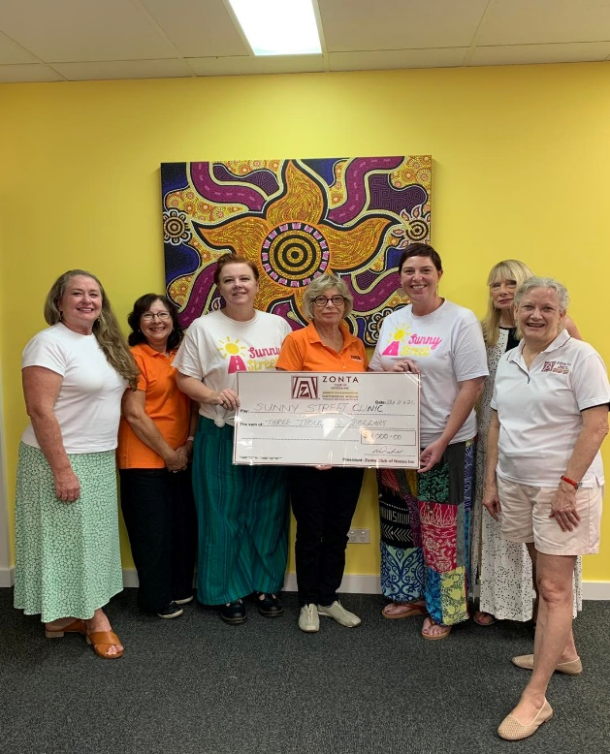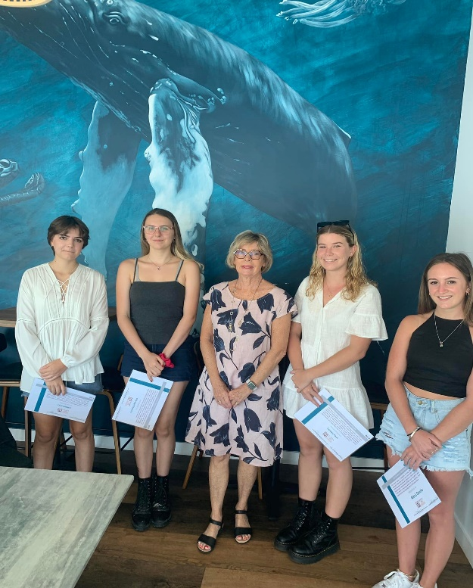

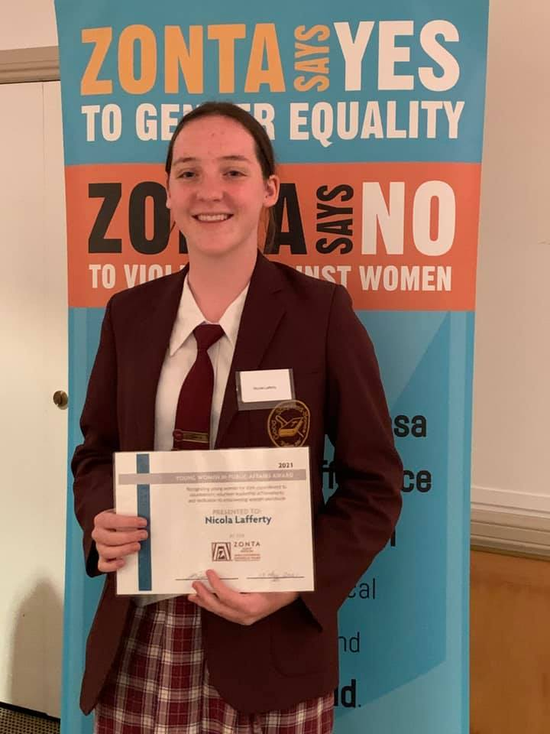

Committees
The F & M and Advocacy Committees have worked hard and had good results. The Service Committee has struggled over the last year with the loss of some key longstanding members and no chairperson but will no doubt turn a corner in the coming year. I summarise the Committee efforts below:

- Advocacy and PR achieved high profile for all our events with media releases and radio interviews. Importantly regular updates on Facebook have seen much wider community awareness. The Twilight Walk with the shoe display attracted a turnout for the 16 Days of Activism. In addition, the revamping of the display board with more current photos has created interest. Of particular success was the publicity achieved for the recent IWD with a double page spread. Great PR for Zonta.

- Despite losing four key longstanding members who retired at the end of the last Zonta year, F & M has had a good year with enquiries from prospective members and we end our year with a gain of five new members with two more inducted in April. While we lost a further 3 members throughout the year and Carolyn Winkler has just announced her retirement, we end however with a net gain. The meeting arrangements with Zoom meetings were not

conducive to having speakers but F & M did manage to arrange some interesting speakers throughout the year including Di Olson about her breast cancer journey, Ashton Wood who has started a company refurbishing used phones for DV victims, and Robyn Cadell who spoke about her tours of duty with the Australian Army.

- Service managed two sausage sizzles but the planned Trivia was postponed until June and a further sizzle was cancelled due to the weather. The recent IWD had reduced numbers due to Covid but although not a fundraiser, great raffle results netted $1300 for the Club. Service Committee members continued with the care packs over the year with an increased demand. A group also led a Birthing Kit packing session at Mathew Flinders in May and a combined group put together the breast cushions.

Finances
As at 31 March the Project bank account had funds of $4,610.32. Of concern is that our project account expenses exceeded income resulting in an overall loss of $3,919.02 for the year. However, this would have largely been mitigated if the cancelled fundraisers had been able to proceed. I am therefore comfortable that we have been fiscally responsible in keeping reasonable control of our spending. The transferring of expenses from Admin to Project of around $1600 also contributed to this loss. As mentioned, we aim to recover the deficit with planned events in the future and the 2023 budget provides for a small profit in the coming year.

As a consequence of transferring a number of expenses to the Project Account and the input of IWD raffle monies, our Administration account closed at 31 March 2022 with a healthy balance of $3,649.77. The Board will reconsider the balance of expense items between the two accounts for the coming financial year.

Summary
In summary, a problematic year with the on-going effects of Covid. However, the Club remains in good heart and new members are adding to the quality of our group. I anticipate the 2022-2023 will bring some easing of the difficulties and renewed camaraderie with regular face-to- face meetings.

Finally, I am grateful for the support, patience and cooperation of all members throughout the past year. I particularly want to thank the Board members – Robyn, Liz, Bron, Amy and Jann for the work they have done and their support of me over the year as I have grappled with the difficulties of being President through the Covid period. There have been times when our prospects seemed rather dark when we had fundraisers cancelled and problems with our meeting venue. However, there is always light at the end of the tunnel and I am confident that our new President and Board will be able to move forward with greater success in the coming year.

Margie Fisher
President, Zonta Club of Noosa Inc
15nd April 2022

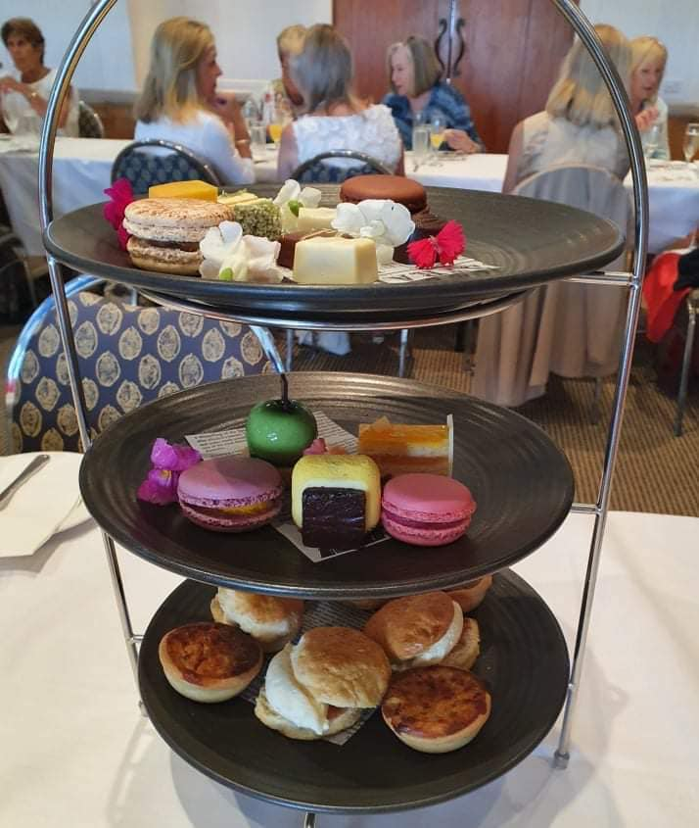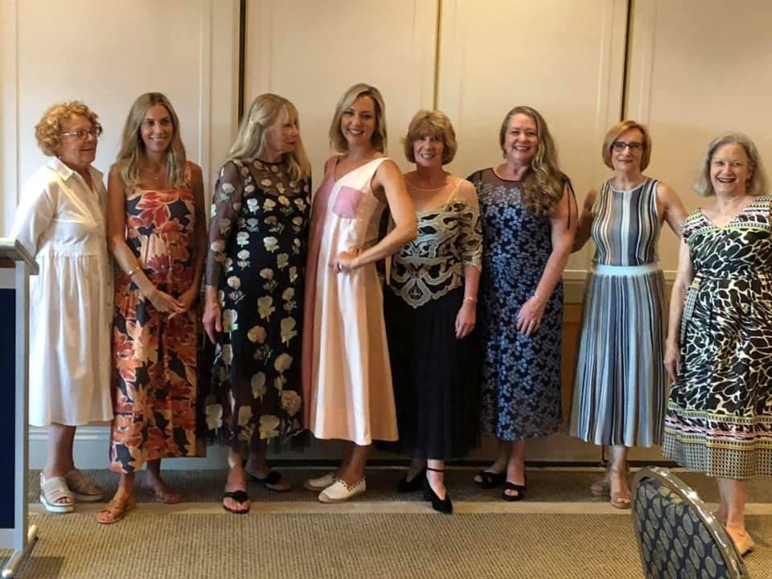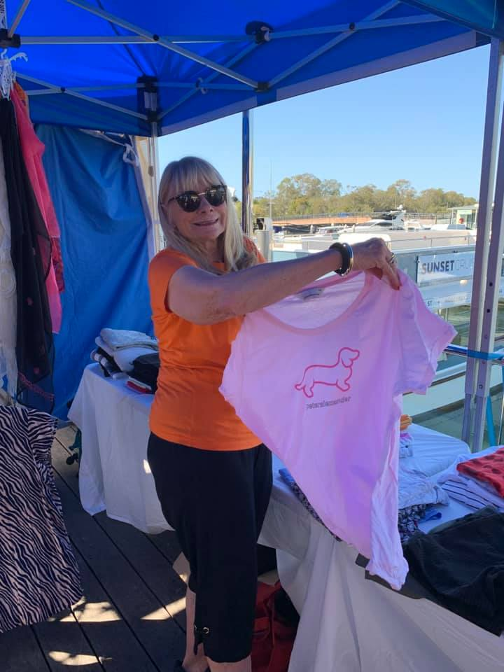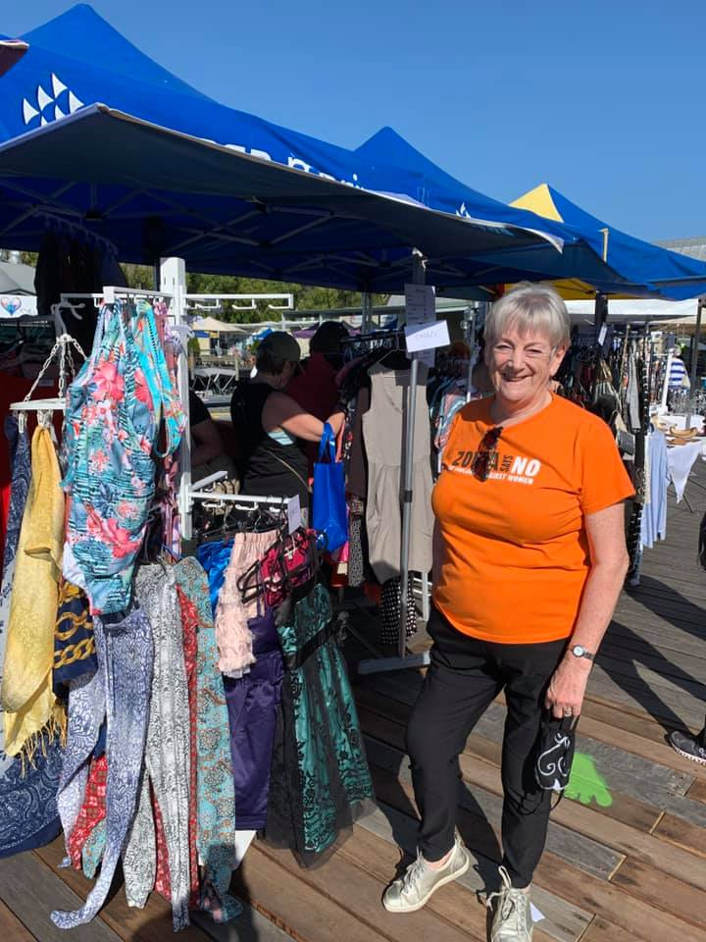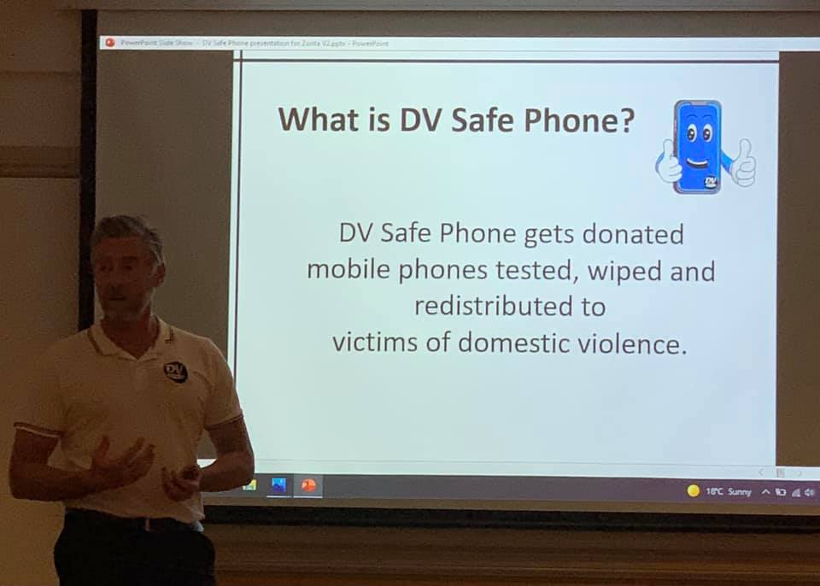

2022 ADVOCACY COMMITTEE ANNUAL REPORT
Committee: Robyn O’Neill (chair), Pat Cussens, Helen Collins, Fiona Jacobs, Jann Tuxford, Rae Smart, Moira Williamson

Role
The Advocacy Committee plays a key role in meeting Zonta’s mission ‘to empower women through Service and Advocacy at a global and local level’ by promoting the Club’s activities. While Advocacy ‘sets the message’, PR is ‘spreading the word’ via print and digital media. Our vision is to create a coordinated marketing strategy - one that accommodates our limited budget, while ensuring a fresh, modern approach to attract new donors and members.

Committee Updates
Despite the ongoing pandemic, we were able to continue our advocacy activities throughout the year, including the 16 Days of Advocacy Campaign. During 2021, the committee welcomed three new members, Jann Tuxford, Rae Smart, Moira Williamson.

16 Days of Activism
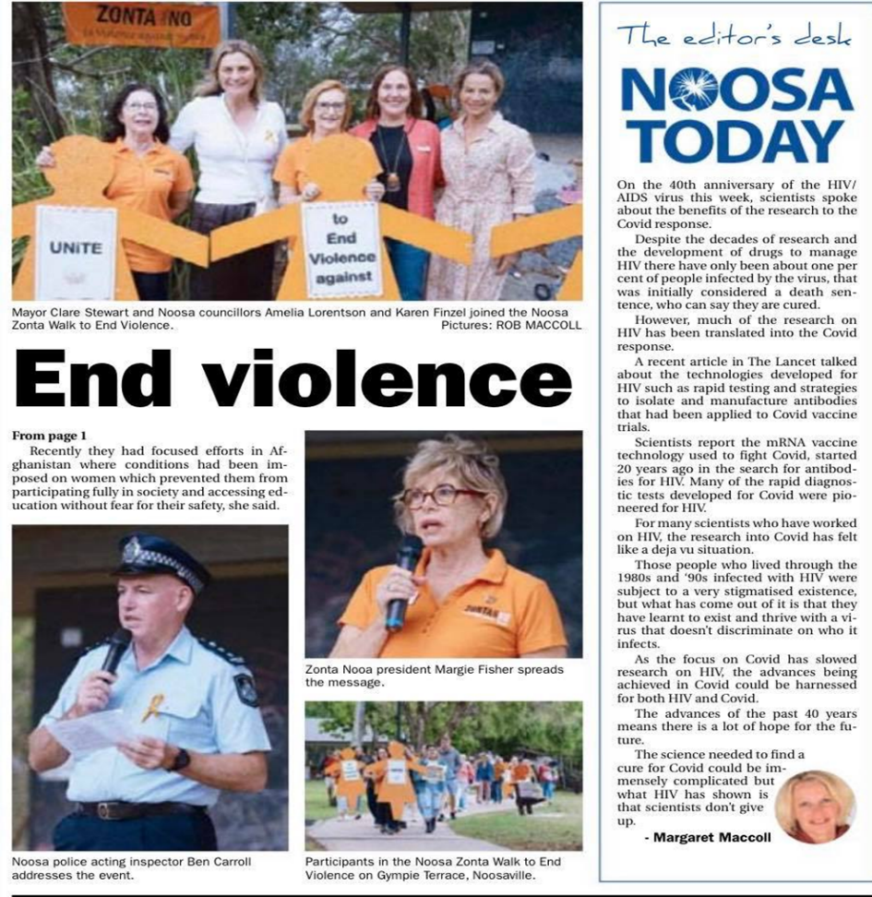

The 2021 16 Days of Activism Campaign proved highly successful.
- The riverside Walk on 28 Nov was well attended by an enthusiastic crowd, including Mayor Clare Stewart, Noosa Councillor Amelia Lorentson, and Noosa Police officer-in-charge Ben Carroll. The new order of service proved very popular, with the inclusion of an address by Ben Carroll, a candlelight vigil and the placing of candles on the river stage beside empty shoes representing the annual total of Australian victims of DV.
- As well as the usual display in the Noosa library, Bendigo Bank also hosted the display over the two-week period.
- Noosa Council once again provided great support by placing DV Support contact detail notices in their toilet facilities. The Council also displayed the DV banner in the Lion’s Park on Gympie Terrace.

PR Campaign for the IWD Breakfast
Social media advertising ensured a full house at this year’s IWD Breakfast at the Noosa Springs Golf Club and Spa Resort. One of our most successful events to date, the event was well reported, with attendance by the local State MP, Sandy Bolton and Noosa Mayor Clare Stewart.
As a direct result of the IWD, Natasha Purcell, Career Counsellor at the Good Shepherd Lutheran College sent us an email expressing interest in starting a Zonta youth group across the schools. Margie welcomed her idea, responding that we have been considering starting a Z Club in Noosa, but not until later in the year, after the appointment of the new President and Board in June.

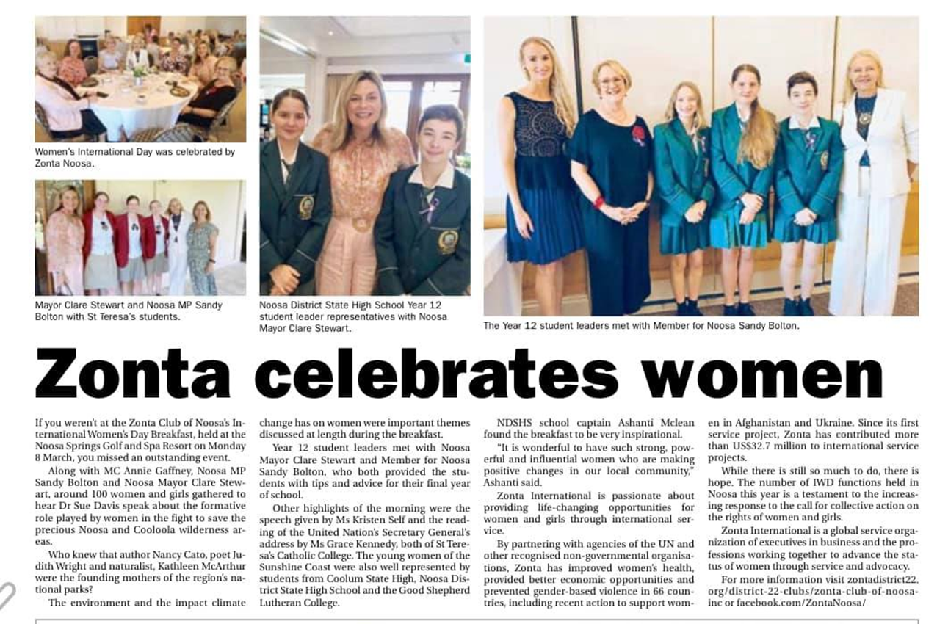

Northern Sunshine Coast Community Network (NSCCN) Meeting
Our attendance at the bi-monthly NSCCN meeting continues to provide a valuable networking opportunity, as well as a platform for spreading the word of our activities into the community.

While the new Chair of the Advocacy and PR Committee has yet to be appointed, I know that our members will continue to build on our past successes to ensure word of our Club’s value in supporting women and children in need is spread far and wide. The future is bright!

Robyn O’Neill
Advocacy Chair

03 Apr 2022

FELLOWSHIP AND MEMBERSHIP COMMITTEE REPORT 2021-2022

COMMITTEE MEMBERS: Bronwyn Scarr (Chairperson), Marg Banfield, Liz Garbacz, Linn Clarkson, Michelle Prenzler

The committee is responsible for recruitment and retention of members; organisation of the monthly dinner meetings, including guest speakers; maintenance of the Zonta database for Members and organisation of fellowship events throughout the year.

MEMBERSHIP:
Zonta Noosa started the year with 17 members having had four longstanding members leave at the end of the Zonta year - Shana Tucker, Alison Upton and Karen Gillespie retired while Jan Comins moved to Maryborough. During the year we said goodbye to the following members:
Jenny Smith
Robyn Mitchell
Gail Murden

Most of these members continue to support our fundraising functions.

We welcomed the following new members:
Jann Tuxford
Linn Clarkson
Michelle Prenzler
Rae Smart
Moira Williamson

Two new members Jillian Farrer and Lynette Ross were inducted at the April meeting whilst Carolyn Winkler has just announced her retirement. We therefore end the year at 19 members.

MEETINGS
The Club’s monthly meeting is held on the second Thursday of each month. We are currently trialing a breakfast meeting at Noosa Springs and an alternate nightly meeting at the View restaurant at Peppers.

We thought that 2021 and 2022 would be COVID free but once again our functions and fellowship events were restricted by Covid. During the year however we were still able to have some interesting speakers.

2021
April Our speaker for April was Di Olson who was the recipient of Zonta Noosa’s breast cushions. Di enlightened us on her journey through breast cancer and was thankful for the donation of the breast cushions. After the speaker we welcomed and inducted a new member, Jann Tuxford.

May At this meeting the YWPA (Young women in public affairs) award was presented to Nicola Lafferty by Councillor Amelia Lorentson. Guests for the presentation were Nicola’s family, Councillor Amelia Lorentson and Natasha Purcell (Nicola’s school counsellor)

June Planning Meeting
July This meeting was the presentation to our Bursary winners. They were:
Krystal Sim (Indigenous Bursary)
Inala Lutschini (Women in Science Bursary

Also at the July meeting we welcomed and inducted three new members to Zonta Noosa - Linn Clarkson, Michelle Prenzler and Rae Smart.

August This meeting our speaker was Ashton Wood. Ashton started a company called DV Safe Phone. He collects old mobile phones, fixes them and gives them to organisations to hand on to victims of Domestic Violence to hide and use in case of emergency. Ashton was a very interesting speaker.

September Members were asked to bring any books they had read to the meeting. We had a longer Fellowship time to allow for the sale of books.

October Liz organised a ‘get to know members’ event which was a fun night.

November We had a speaker Robyn Caddell (Robyn served 12 years in the Australian Army including 2 tours of East Timor and 2 tours of the Middle East. She spoke to us about being a female in a male dominated armed force). Robyn was a very interesting speaker who members enjoyed listening to.

After the speaker we welcomed and inducted our new member, Moira Williamson.

December No formal meeting was held as we had our end of year Christmas party. This was held at ‘Land and Sea’ brewery. Partners were invited and it was a fun night for all who attended. Members were asked to come dressed up. The ‘best dressed’ Christmas attire was awarded to MP Sandy Bolton who was our guest for the night.

January Noosa Springs advised the restaurant would be closed at night due to staff shortages with Covid. It was decided to hold a ZOOM meeting.

February Noosa Springs advised their restaurant was still closed at night time After considerable research into various options we decided to trial our February meeting at ‘View’ restaurant Peppers. This was a successful night. Members enjoyed the fellowship and the food. Two potential members attended and are now going to be inducted in April.

March Meeting was held by ZOOM.

CONCLUSION
Considering the restrictions due to Covid19 during parts of 2021 and the start of this year we are very happy that we have been successful in obtaining seven new members due to the hard work of the F&M Committee and our President. Unfortunately, due to lockdowns and various Covid restrictions we were only able to hold one fellowship event being the bowling afternoon which was great fun. The F & M Committee hopes to be able to hold more social events this coming year.

Bronwyn Scarr
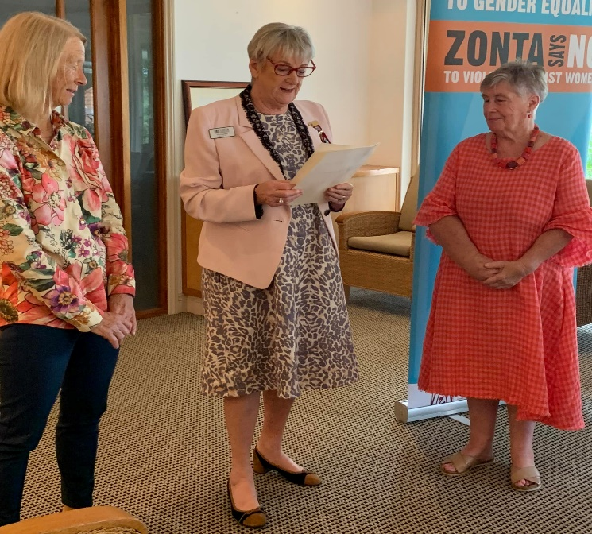
CHAIRPERSON

ZONTA NOOSA SERVICE COMMITTEE REPORT
2021-2022

Committee Members:
Gail Murden (Chair, part- year), Bronwyn Scarr (part-year) Margaret Deane, Caroline Winkler, Tracey Stubbs, Amy Ryan.

Role
The Service Committee aims to empower women and girls through international and local service projects. It does this through fundraising and awareness raising. Local projects include IWD event, care packs, breast cushions, birthing kits, support for domestic violence prevention and school and university awards.

As noted above it was a difficult year for Service with the loss of some key members and also of one of the key fund raisers. However with the assistance of other club members the group succeeded with most of their activities.

IWD
The planning for the IWD breakfast got off to a bad start with the need to change the venue. The initial difficulties with proved to be a blessing as the buffet breakfast provided by Noosa Springs had great appeal. The speaker Dr Susan Davis spoke about her work with the environment and her Wild Flower Women initiative created much interest. We were privileged to have both the Mayor and our local MP Sandy Bolton.

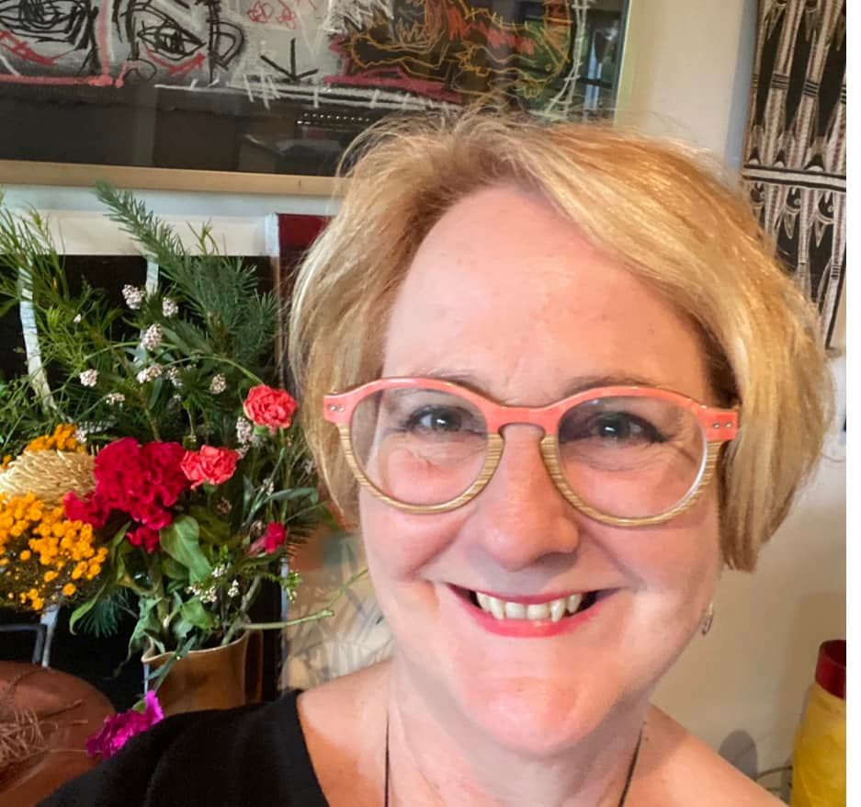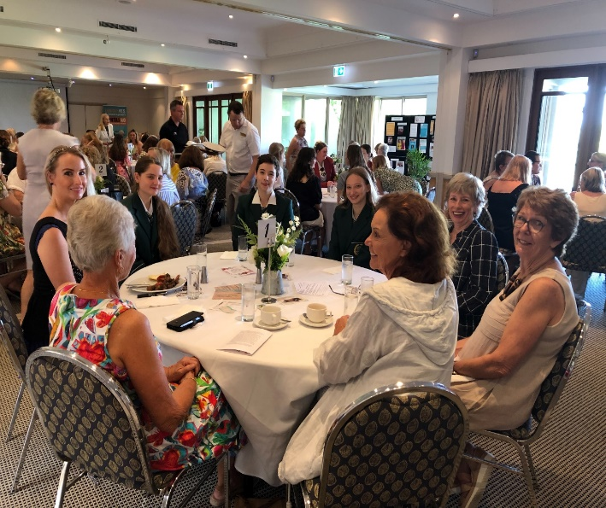

Breast Cushions
Breast cushions are an important part of our Service projects. Margaret Deane sewed the bags and various club members helped with the stuffing at Margaret Banfield’s. We know from feedback, much these are valued by the breast cancer patients this project will remain a staple project of the Club.

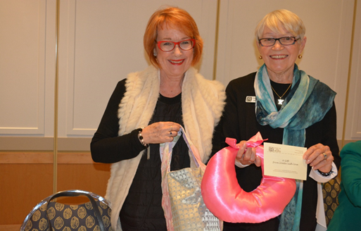

Care Packs
Although no longer a member, Alison Upton continued to collate the Care packs for the Club members to donate to Salvation Army and St Vincents. In addition Robyn distributed some to the police at the Community Liaison meetings.

Bursaries (USC):
The club sponsors three bursaries at the University of the Sunshine Coast:
- Indigenous Women in Education
- Women in Science
- JMK Women in Business

While Education is a Service goal, the Bursaries sub-committee of Tracey Stubbs and Helen Collins, undertook the hard work of screening the applicants. The interviews were completed and the winners presented with their awards at our July meeting. The high calibre of recipients and applicants again impressed. Due to lack of applicants for the JMK bursary, only two awards were given this year to Krystal Sim (Indigenous Bursary) and Inala Lutschini (Women in Science Bursary)

Birthing Kits
Matthew Flinders requested our assistance with birthing kits. Margaret Banfield, Robyn Mitchell and Margie assisted the students on the day.

Sausage Sizzle
Remarkably we managed 3 sizzles throughout the year netting $2265 for the year. As noted this is a real club effort and despite its lack of appeal to work a shift on a hot day, is an important fund raiser for the club.

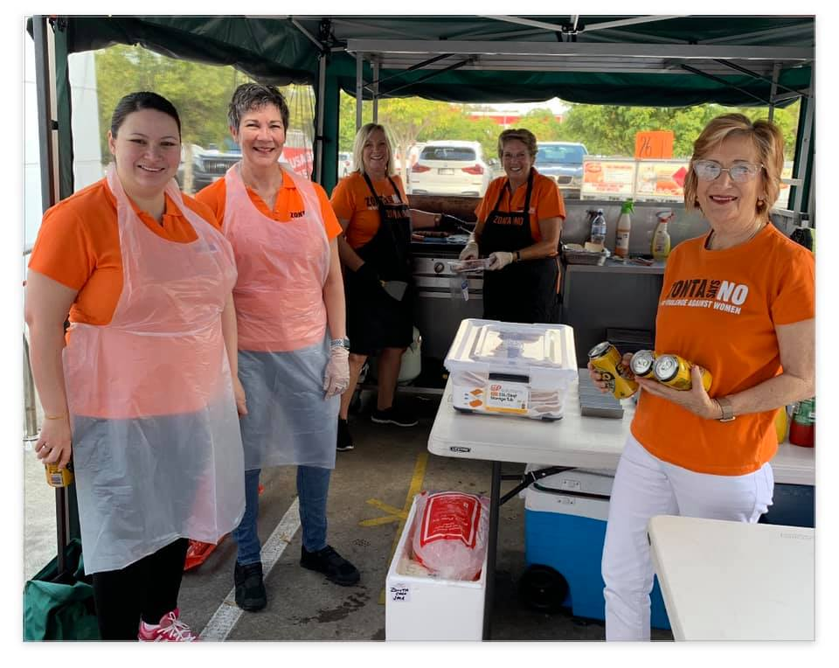

Margie Fisher for the Service Committee

