ZONTA Club of Roma
Zonta International
is a worldwide service organization of executives in business and the professions working together to advance the status of women.
Club Number 1432
Chartered 26 August 1993
P. O. Box 1003, Roma, Q 4455

Newsletter – April 2006

PRESIDENTS REPORT

Dear Members,
Well Easter has come and gone and we certainly were busy. I would like to thank everyone who helped with the float, provided our Saturday breakfast, walked in the parade and helped Rotary at the Rodeo. I would have preferred not to be ill but I managed to get to most events. I understand that Rotary were very grateful for our help and I, for one, like the idea of service clubs working together in the community.
Next Tuesday our AGM/meeting will be held here at my house at the usual time of 6:00 for 6:30pm. We’ll have our meetings then our dinner with everyone bringing a “pot”.
This is always a difficult couple of months with the changing of the board and committees but I have high hopes that all will go smoothly. Already the new committee chairs have taken over and attended their first board meeting. It seems handovers all went well and I would like to thank the former chairs for their hard work in the past year. I would also like to wish the new chairs well and know that any of us will be available to help where help is needed.
We welcome Judy Harland as Treasurer as Katie has now resigned and moved out of town. Hopefully we will see her around with young Stuart. Katie, thanks for all your hard work in the past year.
Toastmasters Welcome evening is our next event and despite it seeming to have evolved into something more than we imagined, I’m sure it will be fun. It is a fundraising event from that committee and our first venture in this direction, so it will be interesting. Ann Leahy finalise things on Wednesday night.
Remember this from last newsletter from Judy Bryant re the May meeting - All members are asked to bring a friend (or friends) to the meeting, maybe someone who has not yet attended a meeting. It is really important that all members participate and that the night has plenty of fun and fellowship. Some of our suggestions for entertainment on the night were – thumbnail sketches, run our 10 Year CD (after all – we are among friends!) and the airing and sharing of photo albums and memories of our Club’s antics. So go all out for this one girls and start rounding up a friend or two. Don’t forget to let our attendance officer know how many guests you will be bringing.
Well hope you are now all recovered from the big “Easter in the Country” and for those who were not here, recovered from your respective holidays! I look forward to seeing all next Wednesday - dress warmly as it will be on the deck and suddenly the weather has cooled down. Remember, if you are not coming or bringing anyone extra, please let the attendance officer know (Heather Mawn) not me as it just means that I then have to let her know.
Denise

Committee Chairs please invite these members to your May committee meetings to continue the Mentoring Program:
Finance – Robyn
Status of Women – Pam and Vicki
PR – Mary
Membership – Alison

Membership and Fellowship

We have had our first meeting for the “new” Zonta year. “We” consist of Jill F, Betty, Trish, Judy H, Eleanor and myself (for my sins) as chair.
Starting at the very basics of the committee’s raison d’etre, we discussed prospective membership and the correct sequence of events from prospective member to installation.
The summary of steps, done by the previous committee, were ratified and at the 18th April Board meeting these steps were endorsed for inclusion in the forthcoming “handbag” directory.
It is SO important to follow these steps to save embarassment at any stage either to the club or the “might like to be” member.
As members, we must all have the opportunity to decide who will (or won’t) be offered membership to our club. These are the steps as endorsed pending the collation and printing of the handbag directory.
- Nominating Zontian completes Prospective Members Form. (Good thing to inform President and M’ship chair as a courtesy).
- Completed form presented to the Board.
- Prospective member details presented to Zonta members.
- Objection in writing to be received by the Board within 10 days.
- Letter of invitation to join Club then sent to Prospective Member. At this time financial and time commitment should be made clear.
- Prospective Member invited to attend an Orientation meeting or a dinner meeting before making a commitment to join.
- Installation - mentoring.
Our May club meeting is Friendship Night and you are asked to bring someone, not necessarily a prospective member. This is an opportunity to “lay open the shutters to Secret Women’s Business” as some Honzons delight in calling the Zonta organization.
Jill Baker
Membership
Our doubts are traitors
APRIL ROSTER

duty | zontian
Blessing | Alison Jones
Objects | Jenny Utley
Raffle | Jill Baker & Ann Leahy
MOW (Wed 26th) | Jenny Loughnan
Please organise a swap if roster is unsuitable.
and make us lose the good
we oft might win
by fearing to attempt.
Shakespeare

Finance & Fundraising

We held meeting a Committee on 11th April. We will be holding committee meetings on the Wednesday a week before the Board meeting in future to try to accommodate all members of the committee. Next meeting will be Wednesday 10th May. I also wish to advise that Mary Teakle has very kindly offered to be Assistant Treasurer if a situation arises where Judy Harland needs some additional hands to help out. Jenny Loughnan and I have decided not to have a formal change over mainly because I have already been through the folder.
Planning is well underway with the Toastmasters Function. Denise and I had a meeting with the Toastmasters Convenor on Wednesday afternoon to ensure that everything is on track. I have done a budget for this function and so far it will be profitable venture for our Club.
We will be preparing food (cold roast beef, ham, bread, fruit etc) for platters on the Friday 28th from 1-00pm onwards. The platters will be placed on tables and the Toastmasters will then collect their food from the table (bit like a stand up fork dinner). We will replenish the platters as the food is taken.
What we need you as members to bring
- Platters suitable for meat and/or fruit/cheese (please write you name on them or put a sticker on them so we don't mix them up)
- Bread Knife and meat slicing Knife and knife to cut fruit - (Please make sure you identify your knives with a ribbon so we don't get them all mixed up.)
- Good Tongs (again please identify them with ribbon)
If you could please wear a white top and black or navy pants or skirt and your aprons. If you don't have an apron I will have one for you. I will bring the club teatowels, tablecloths hand towels and anything in our current stock that might be useful.
What will you be doing
- Picking up the goods that we have ordered from the Baker, Western Wholesalers, Woollies etc and the stuff from my office.
- Slicing meat, bread, fruit and buttering bread
- Making up fruit and cheese and food platters
The toastmasters will arrive at 6-30pm on the dot and finish at 8-30pm.
Denise Martin, Mary Teakle, Lesley Dillon, Jill Baker and Marg Harms are all helping from 1pm onwards on Friday 28th April other members are most welcome to come and help then too. If you can't come at 1pm please make sure you arrive at before 6-00pm at the Arts and Crafts room at the Cultural Centre to help and if you can’t come at all please let me or Denise know.
Ann Leahy
Fin & Fun Committee

APRIL MEETING & A.G.M.

Will be held at the 19 McEwan St Roma, Wednesday 26th

Please contact Heather Mawn
Phone 4622 4800 (w) or 4622 2207 (h)
On the Monday prior to the meeting
if you are unable to attend

In the absence of an apology,

an invoice for $14.50 will be sent to Non-Attending members to cover the cost of their meal .

DATES TO REMEMBER

- Tuesday 26th April - 19 McEwan St
A.G.M. 6:00 for 6:30
- Friday 28th April
Toastmasters Convention Catering
- Friday 5th May
Roma Show Day
- Tuesday 16th May
Board Meeting 5:30 Maranoa Club
- Tuesday 23rd May
Dinner Meeting 6:00 Maranoa Club
Friendship night - bring a friend.
- Saturday 27th May
Changeover Dinner at The Overlander
- 23 - 29th June
Zonta International World Convention in Melbourne

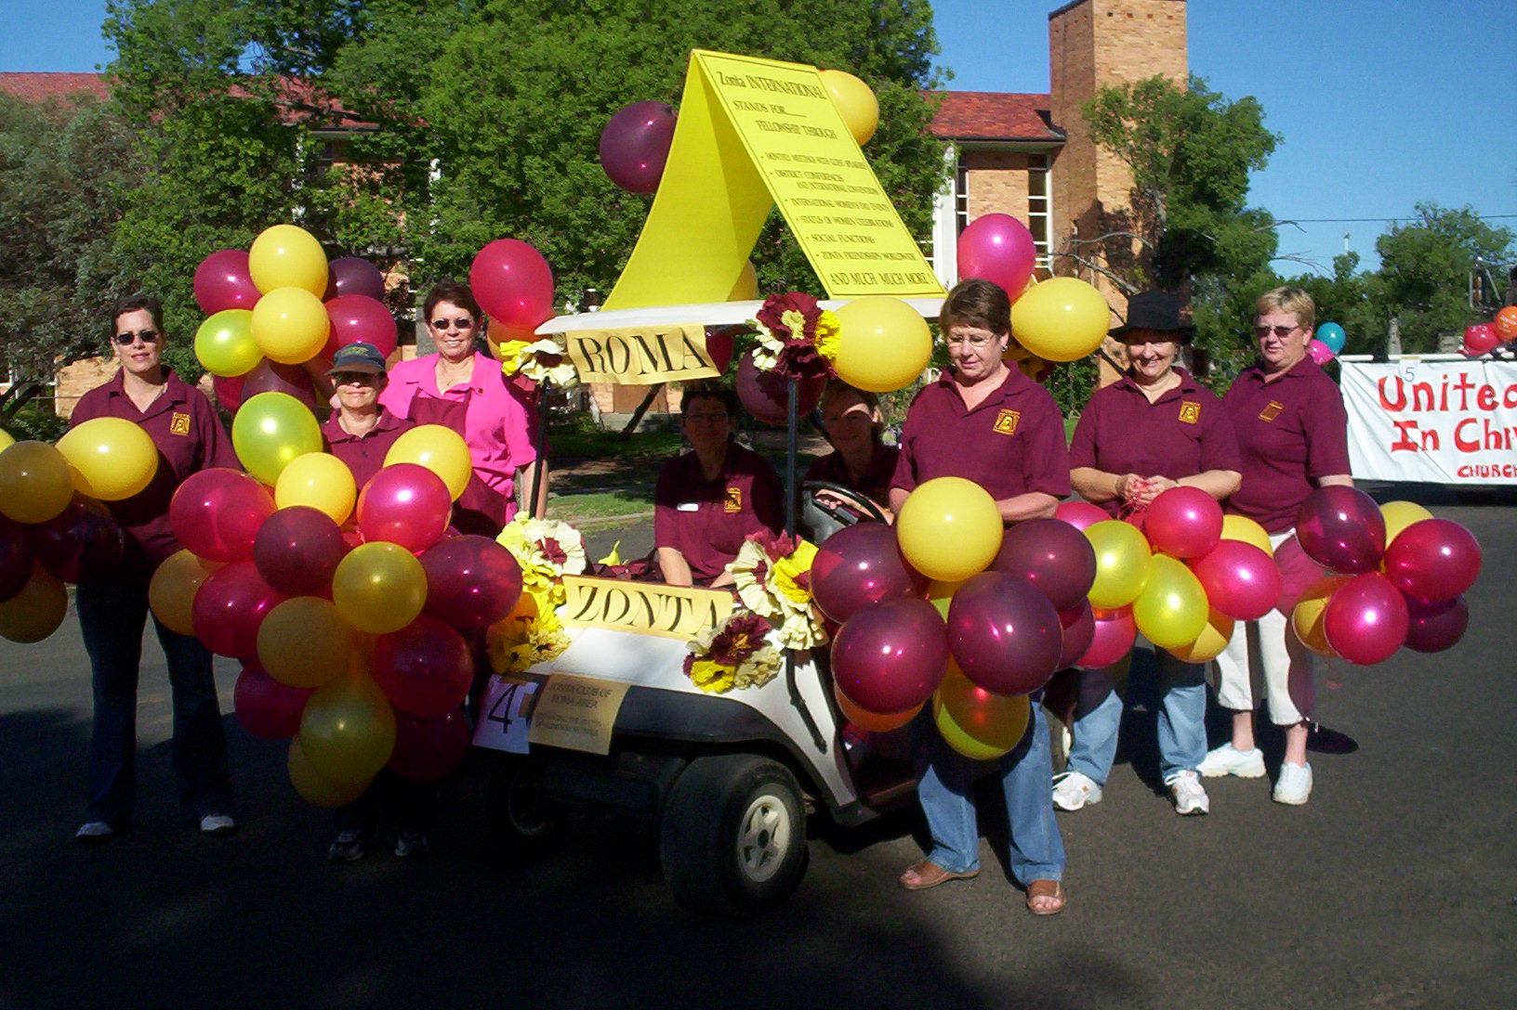
Changeover
For our newer members…
Changeover is the formal dinner we have to install both the new board and the new members.
Your partners are invited and we send invitations to other service clubs, recipients of donations, etc. This year it will be at The Overlander and everyone will receive an “official” invitation in the next couple of weeks.
This year our official Zonta guests are Ros Kinder, District Governor and Diana Douglas, Area Director. It’s usually a very enjoyable night and a chance to “dress-up”.
Alison, Leslee, Lesley, Denise, Robyn (driver), Eleanor, Suzanne & Jo

P.R.& Publicity

Heather Mawn and I completed the “handover” over coffee at Bogarts and although our new committee is yet to meet officially, the Easter Parade Float was the first assignment.
I want to thank Judy Harland for the generous offer of her new golf buggy but for logistical reasons we went with the same one as last year. Jo took this photo and I thought Des might appreciate a framed photo as a thank-you gift. Special mention to Eleanor for the brilliant idea of using the Specialist Centre and the suggestion of backing the buggy in for a secure overnight stay! Thanks also to everyone who turned up with willing hands and “hot air” for the balloons on Friday and food, coffee and laughter on Saturday to prepare us all for the parade. We all enjoyed handing out the balloons to those earnest little kids who sat patiently waiting in the gutter and it was great to see their smiling faces at such a simple pleasure.
Again it was lovely to spend time in laughter and fellowship while serving for Rotary at the rodeo.
I will get around to calling all of my committee but at this stage it looks like we may have some breakfast meetings to accommodate our work and other commitments so that sounds like fun.
We will get to work ASAP on the handbag directories and all details will be checked on Wednesday to make sure we have it as up-to-date as possible. You will have all received a Membership Directory last month, could you check it and give me any changes to make either by email or in person on Wednesday night.
Cheers
Suzanne
PR & Publicity
CONGRATULATIONS..

to our newest member, Vicki Holberton on becoming a grandmother. May you have many happy timewasting hours!!!!

You can tell when I have a space to fill, I have to find a joke…know any for the future?
THE PRESERVATION OF MAN
The horse and mule live 30 years
and nothing know of wines and beers.
The goat and sheep at 20 die
with never a taste of scotch or rye.
The cow drinks water by the ton
and at 18 is mostly done.
The dog at 16 cashes in
without the aid of rum or gin.
The cat in milk and water soaks
and then in 12 short years it croaks.
The modest, sober, bone-dry hen
lays eggs for nogs, then dies at 10.
All animals are strictly dry
they sinless live and swiftly die.
But sinful, ginful, rum soaked men
survive for three score years and ten.
And some of us, the mighty few,
stay pickled till we’re 92!
Richard Clark

