

President: Sue Droughton – 0415 177 126
Treasurer: Glenda Moor – 0468 712 993
Secretary: Patricia Clunes - 0410 617 825
Newsletter Editor: Patricia Clunes - 0410 617 825

NEWSLETTER FOR JULY 2023


BIRTHDAYS SEPTEMBER
We aren’t celebration any birthdays this month

FROM THE PRESIDENT’S PEN
Thank you to all members and HonZons who attended our 30th Anniversary celebrations on the 5 August.
The Beach House was a great venue to host the luncheon. I am sure that all of our guests appreciated our beautiful cake, souvenir biscuits, the table decorations, the delicious food and a lovely view.
Thank you to all the members and HonZons who pitched in and cleaned up. It was very much appreciated and as in the saying “many hands make light work”.
Special thanks go to Lynda for the amazing amount of time and work to get our website up and running and even more special was that the website went live on the same day as our anniversary celebrations.
On the 10 August I did my regular radio interview with Rosemary Worthington on 101.5FM, where I was able to give her an update of our website and upcoming Fashion Parade.
The BEST other news that we had this month was that we were successful with our application for a larger storage shed. Given that we are to vacate our current storage by the end of October, the timing is perfect.
A big thank you to Glenda and Deb for all the work that you did to ensure that our application was successful.
The lease is for five years, and the Council will contact us shortly to progress the tenure agreement, so at this stage we don't have a date that we become the new tenants. However we are going to need a working bee on the day that we move. Could members please ask their HonZons if they could also help us, as we are going to need every bit of help.
Did you all see the photo of our “star” Kathy in our local paper? Congratulations Kathy on your Top 5 spot for Remax's network transactions and commission-based rankings. WELL DONE.
We have seven members who are off to the District Conference in September, and I am so proud that Zonta Caboolture will be very well represented at Conference.
I look forward to reporting back to our Club at the September Dinner Meeting.
Finally, we have 12 apologies this month including myself and only 7 members and 2 guests, Trish and Meleitta attending. Be kind to Patricia as she has thankfully agreed to Chair the meeting.

Sue Droughton
President.


SERVICE COMMITTEE REPORT
Due to a very busy month, the Service Committee did not meet in August.
All committee members agreed that due to the busy workload of Birthing Kits and Breast Cushion days, we were well ahead in our work.
It was an absolute pleasure to donate $1500.00 Kmart and Woolworths vouchers to Holly the CEO of C.A.D.A. at our last Dinner Meeting. C.A.D.A has such a need for this type of assistance.
On the 23 August, I received an email from Belinda the Operations Manager of C.A.D.A. requesting more financial assistance. They wish to buy in bulk, toiletry products for 300 clients. The request is for $550.00.
Many years ago when Estrella was CEO, the Service Committee would make up the packs and deliver them to CADA. However, the biggest problem was they simply had no room to store them, and we were asked not to do anymore.
Karen and Lyn delivered more Breast Cushions to Caboolture Hospital this month.
Glenda has paid the invoice to Caboolture Special School for the Swimming Inclusion Program and also paid for 2 girls to attend the 2023 Agoonoree Camp at Samford.
On the 17 September, Carole and Patricia are going to attend a special afternoon tea and tour.
The craft ladies from Beachmere Bay have been busy making more blankets for us, so that we can donate them to needy organisations. I delivered them to Carole so that they can go to “safe rooms” at our local Police Stations.
I am hoping to hold the next Service Committee at my home on Tuesday the 19th of September.
I am not able to have a meeting on the 12th as I have medical appointments, and I only arrive home from the District Conference on Monday 11 September.

Sue Droughton
Chairman


MEMBERSHIP COMMITTEE REPORT

Prospective Members
Prospective Members Shelley, Trish Dunne and Meleitta Lowrey have been invited to our August dinner meeting. Trish and Meleitta will be attending.
Gloria Gordon from Bribie Island is interested in attending one of our dinner meetings but at the moment she is unable to drive. She will contact us again when she is mobile.

30th Anniversary Lunch.
Our Anniversary lunch was a great success, and we were honoured to have our District Governor Lyn Agnew, Lieutenant Governor Petra Ladwig and our District 22 Area Director Gwen Jull join us in our celebration.
Sixteen members and some partners attended, and apologies were sent by 5 members.
Many of our past members and Zonta friends joined us on the day to mark this wonderful milestone.
A great time was had by all.

Memorial Service at District Conference
All paperwork relating to Diana Wallman has been received by the Memorial Service team. Those attending conference will be able to attend the service on Sunday morning if they wish.
To date we have 7 members attending the conference in Mackay.

Yellow Roses
Our usual source of Yellow Roses is no longer selling them due to ill health. Annette Lovering has found out that Lisa from Willow Tree Café can get them for us at the cost of $6.00 each.

Membership Committee Chair
Pam Berkett

EVENTS COMMITTEE
13 August 2023
Deb’s home.
I have been informed by Bunnings that we aren’t on the roster for September or October and if we wish to have a BBQ in November, December or January we need to reapply on official letterhead with our Public Liability attached.
We have been at Bunnings on a regular roster since the store opened and now we aren’t!!!
I will reapply and see what happens. Do we also look at other Bunnings stores ie Pumicestone or North Lakes?
At our August meeting our main focus was the Fashion Parade this coming Friday.
We are hiring an URN from R & R Hire and borrowing one from Riana Botha (Rotary). We have always borrowed one from Sara (a previous member) who has now relocated to the Rockhampton area.
Our models for the fashion parade will be 3 from Annette’s Red Hatters group, one from my pool and one from Plantation Retirement Resort.
I will purchase some flowers to present to Sharon (Between us Girls) and Glenda has the gifts for the models in hand.
We then discussed our Guest Speaker for IWD 2024 and Glenda has sourced a speaker from USC Petrie.
Discussion was them around what to put into the gift bags. We purchased gift bags for last year but then ended up going in another direction so these bags need to be used.
Annette has done all the raffle tickets for us.
If anyone is available to show our guests to their seats on Friday that would be great.

Patricia Clunes
Events Chairman
AUGUST ADVOCACY REPORT
- The Advocacy Committee members met via Zoom meeting on Monday 31 July 2023.
- Preparation was discussed for presentation of Child/forced marriage motion for Conference. Lynda Galway provided a detailed graphic organiser for Advocacy members to complete regarding evidence to support motion. Potential questions Carole Tomvald may need to address from delegates were considered, with Advocacy members adding additional suggestions. Carole and Cecil Neilson subsequently completed significant work on a draft speech and advised how the presentation would be assembled.
- Carole sought and obtained approval to rewrite the Motion Rationale into a two page, more comprehensive version, considering other clubs’ more detailed submissions.
- Lawrence Ezedinma sought response to the request from Marie of the Zonta Club, Redcliffe asking for assistance to set up their own Gym initiative regarding Domestic Violence and Coercive Control. Members were agreeable to assisting, subject to retaining ownership of our materials developed and recognition of our club’s creation of the initiative. It was agreed to discuss this with the members of Zonta Caboolture at the next Dinner meeting in August.
- It was agreed that updates on 16 Days of Activism and the progress of the club’s Web Page would be left for the next Advocacy meeting, to focus on finalising the Motion before Conference.
- Subsequent to the Advocacy meeting, thanks to Carole and Cecil for collecting additional Orange figures, and collected by Carole. Cecil suggested requesting the club approve a $200 donation to the men’s shed for their work done on behalf of Zonta Caboolture.
Susan Lepper, Lynda Galway
Co-Chairman

CONSTITUTION & BYLAWS REPORT, JULY 2023
Mitra, Carole, Pam B, and Cecil met early in August to complete approved changes from the 2022 Zonta International Conventions for Club constitutions. Mitra typed in these required changes, and our revised Club Constitution is still being edited and will be completed early September at our Committee meeting when Cecil returns from NT.

In addition, the Committee studied the Office of Fair Trading paper on Internal Grievances Procedure, and Mitra later provided another summary procedures for grievances. At the early September meeting the Committee will suggest steps to follow based on parts of the Office of Fair Trading paper, ideas from other resources for members to consider during September.

While we need to insert the approved Zonta changes from the 2022 Convention directly into our Constitution, it is suggested that for the internal grievance procedures, there can be a reference to these them in the Constitution, for example:
The Zonta Club of Caboolture will be obliged to follow appropriate procedures as outlined in the Club’s Policy and Procedures Guidelines for Internal Grievances, based on parts of the Office of Fair Trading procedures, and other resources, as appropriate for our Club.

The actual Policy and Procedures Guidelines for Internal Grievances will be separate from the Constitution. The advantage is that if ever we wanted to change aspects of the procedures to suit our Club’s operations, we do not need to change the Constitution, just our Guidelines.
Timeline:
- August Dinner Meeting: Progress report
- Early September:
- Committee Meeting to finalise Draft Revised Constitution and Draft Procedures for Internal Grievances
- Send to all members the above draft copies. There will be opportunity for members to send comments to Committee
- At least a fortnight before September dinner meeting:
- Send to members a resolution from the Committee to approve changes and guidelines
September Dinner Meeting: Discuss and ratify changes.
Cecil Nielson - Chairman

MEMBERS OUT AND ABOUT

Long time member Cecil Nielson is currently in Darwin for some celebrations as Cecil previously lived in Darwin.
First the Uniting Church celebration of 160 years in Darwin (formerly the Methodist Church, then United Church, and now Uniting Church).

Then on Wednesday 30 August, out to Milingimbi School where she taught for years, before moving in to Darwin in a promotional position in curriculum development for Aboriginal schools in the Education Department. Milingimbi is celebrating 50 years of bilingual education (Gupupuyngu & English. She stays there overnight, fly back to Darwin Thursday and returns home to us on 2 September.

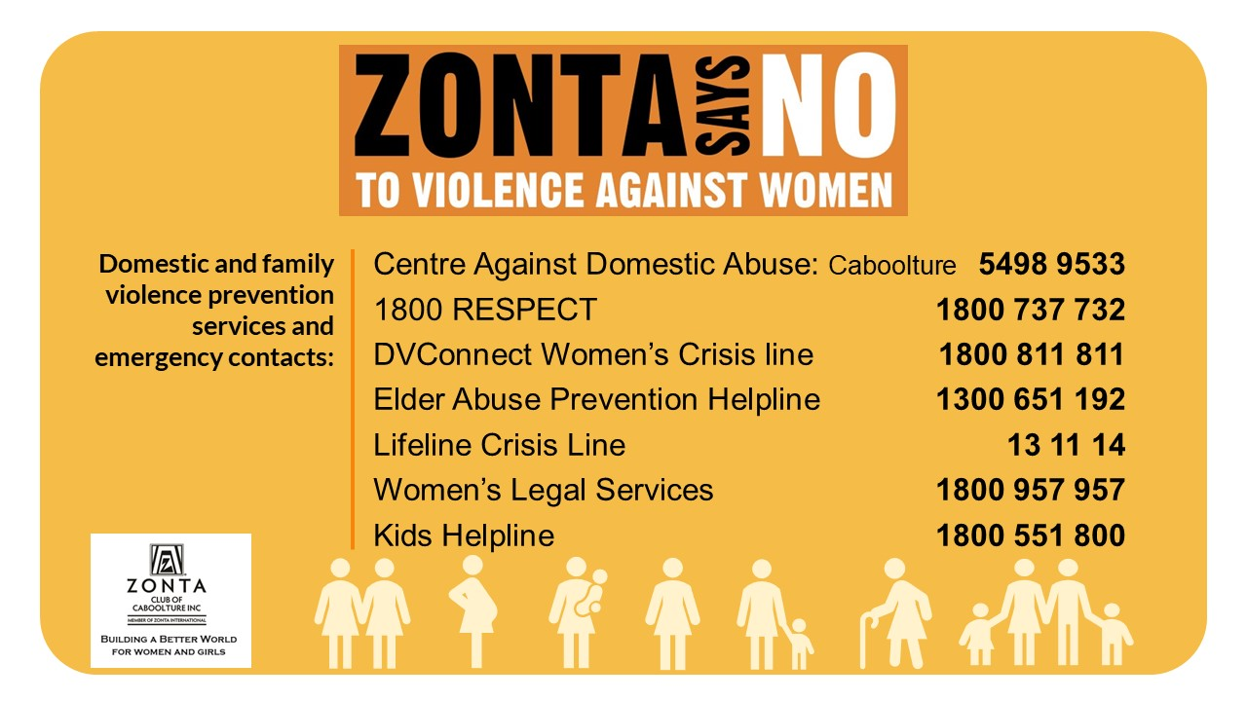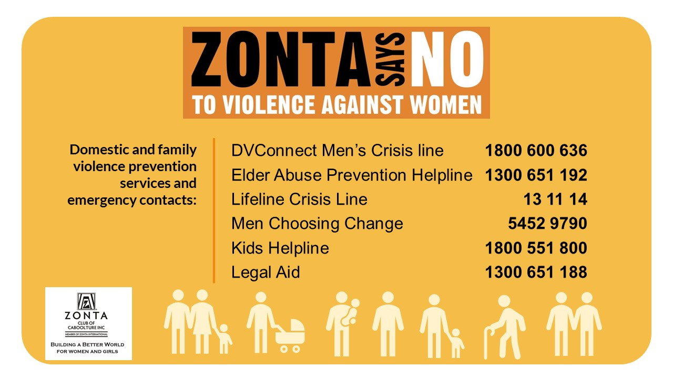

Date Claimers for 2023:
Mark them in your diary

- 8 – 10 Sept - District 22 Conference (to be held in Mackay) so far Sue, Patricia, Pam B, Karen McN, Cecil, Edith and Carole are attending.

Safe travels (especially those driving to conference) and arrive home rejuvenated

