ZONTA CENTENNIAL SCARVES

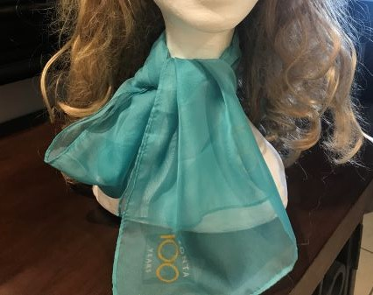
ZONTA CLUB OF  (Please omit if not being invoiced to Zonta Club.) | DATE
CONTACT NAME | TELEPHONE
EMAIL
DELIVERY ADDRESS

Quantity | Description | Amount Due
 | Zonta Centennial Scarves @ $25 each | $
 | Postage | $ 2.00
 | TOTAL | $
For direct credit payments: Account Name: Zonta Club of Mackay Inc Bank Bendigo Bank BSB: 633108 Acc Number: 150357358
Reference: SCARF Your Club Name / Individual Name

