October 2019
I n c o r p o r a t i o n Nu m b e r: I A 1 8 3 3 2
C l u b No. 1 4 9 9
C ha r t e r e d 1 3. 0 2. 1 9 9 5
Area 2 Di s t r i c t 22
President’s Message:
Fellow Zontians,
Following our successful Centenary Garden event, I feel we can confidently envisage a great night on November 8. This is the actual date of ZI being 100 years. It will be interesting to recall some of the highlights of the organisation as well as the progress women have made in this last century. No doubt we can all give thanks for the time and place each of us has occupied in this ZI timeframe.
This month we welcome the District Governor, Sandy Venn-Brown, to our dinner meeting. Her visit provides an opportunity for everyone to meet Sandy and to hear her Zonta wisdom. She will be joining us for dinner so Maryborough fellowship is assured.
Looking forward to the Stitch & Stuff morning . A great time for club fellowship as we assemble the breast cushions. We lament the fact that these cushions need to be made but we also see the need in our community and realise the value of each cushion for its recipient. So, see you there as we continue to serve our Maryborough community.
Yours in Zonta,
Denise
MEETINGS

Dinner Date: 23rd October 2019, Time: 5.30pm Fellowship, 6pm Dinner, and 6.45pm Meeting:- Venue: Blue Shades

Committees:
REMINDER:
If you are unable to attend the Dinner Meeting please advise Karen via email or phone
Membership, Public Relations, Program and Communications
1st Thursday of the month, RSL 5.30pm

Advocacy, United Nations
1st Tuesday of the month Pallas St Convenience Store 5pm

Service, Finance and Fund Raising
1st Wednesday of the month, RSL 6.00PM

Board Date
2nd Wednesday of the Month, 5.00pm
DINNER RAFFLE DONATION
October – Joan, November – Michelle, December – No meeting
BUDDIES  Michelle & Anne K & Sharon K. (new), Elizabeth & Alison B, Joan & Vicki Muller, Sandy & Nicole, Nshara & Dianne, Dawn & Denise Alison G & Meth, Karen & Doreen, Ann C & Sharon K.  COMMITTEES Membership/Public Relations/Program and Communications Michelle (Chair) & (Facebook and Web Manager), Nicole (Newsletter), Dianne, Karen, Meth, Sandy  Advocacy/United Nations Ann C. (Chair) & (Corres Sec.), Anne K, Nshara (Vice Pres.), Doreen, Vicki, Sharon Kirk (new)  Service/Finance and Fundraising Alison G (Chair) & (Director), Alison B, Dawn, Elizabeth (Director), Sharon Kirkman, Joan Brazier (Director & Ass. Web Manager)  President – Denise |  | DATES TO REMEMBER  8th November – 100 Year Anniversary Dinner – Carriers Arms  23rd November – Kick off 16 days of activism. Sleep in Car at Showgrounds  1st December - Christmas Lunch TBC.
Happy Birthday | Happy Birthday  We have no October Birthdays in our group of wonderful Zontians at this stage

As you are all aware we had our Rose Garden Ceremony. This was a lovelly day and turned out well for all who were able to attend. Some Pictures below – Thank you Sandy
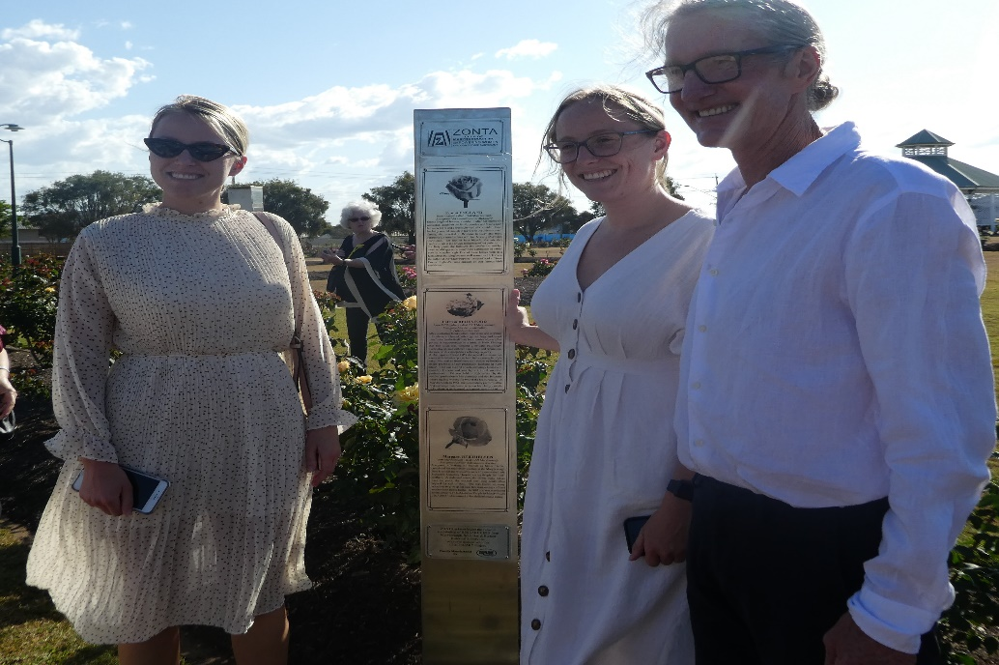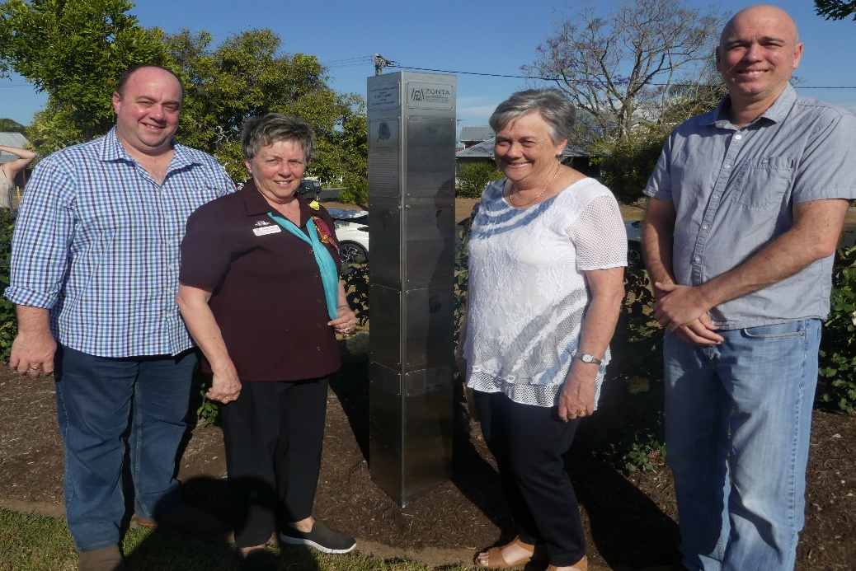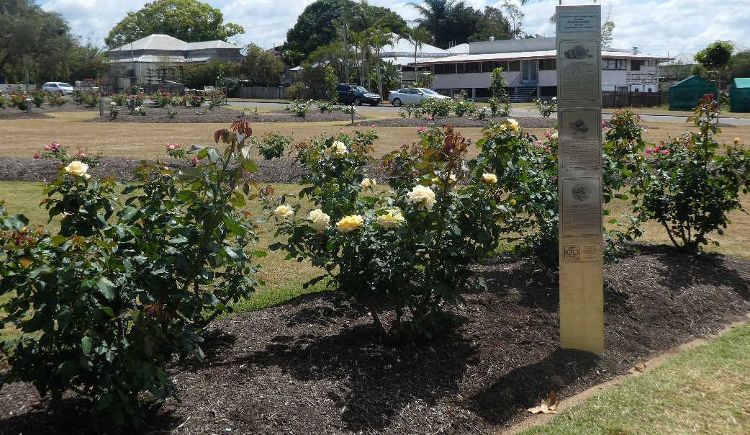
Also we have had the Stitch n Stuff day at Elizabeth’s. Thank you, Elizabeth, for hosting everyone on Saturday. Once again some pictures below with thanks from Sandy

President: Denise Wilschut denwils@bigpond.com
Email: zontamaryboroughqld@gmail.com
Maryborough Web Page: www.maryborough.zontadistrict22.org
District 22 Website: www.zontadistrict22.org
Zonta International Website: www.zonta.org

