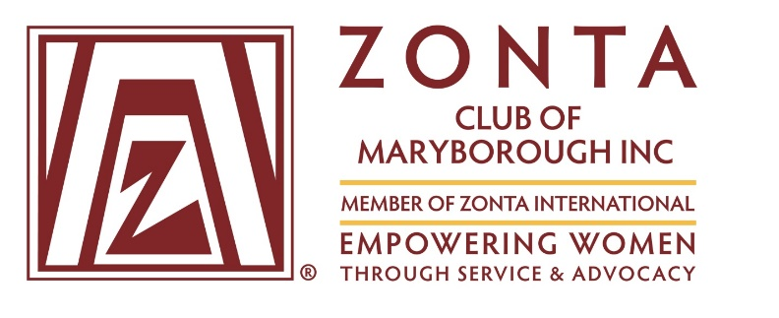

**Zonta Area 2 Director, Rosalie Welburn and the Zonta Club of Maryborough Inc.**

**invite you to join with members of all Area 2 Clubs on the weekend of 1-2 April 2017.**

**It will be an opportunity to network,**

**gain in personal skills and knowledge , and share ideas. Fellowship will be an important part of the program.**

**Theme :**

**“Empowering Women through Service and Advocacy”**

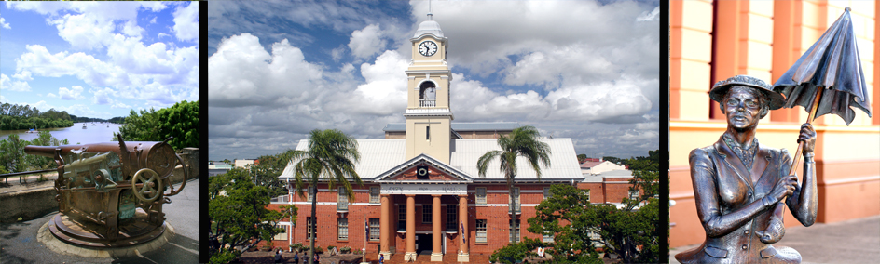

**Let us make this a weekend to remember Full details January 2017**