# Reef Talk .



# Zonta Club of the Whitsundays October 2020



Derby Day Saturday 31 October

Don’t forget your black and white and come ready for a great Zonta Day

**Report from our President – Mez**

And now it's almost the end of the year! How exciting, only one more meeting for the year - and we've achieved so much!

I know it has been a difficult adjustment period for some of our members, as there has had to be a huge restructure since we changed our governance and become a Charity, instead of an Incorporated Society... but the resilience of our club, adapting to change and taking it in our stride is fantastic.

It is always difficult when we change the way we've been doing things for the last 21 years - but in order to evolve with the times, we're riding this rollercoaster and getting to the end of it!

But I suppose if things didn't evolve, we'd all still be good little housewives, unable to work or vote and bored out of our minds 🙂🙂

**Members report**

It is hard to believe that the November GM will be our last for the year, December we have our Christmas Party. It has been a very unusual year in many ways but we as a club have overcome all obstacles and are flourishing.

It was sad to accept Wendy Downes resignation; we will certainly remember her every year when we do the Birthing Kits. We wish her all the very best in the future and thank her for all she has done for the club.

I look forward to a prosperous new year.

The Christmas party is still being finalised. Watch this space

Judy Brown Membership Director

**Service Committee –**

**Welcome to Carole who has stepped up to be Service Director.**

**Thank you, Carol**

Planning is well underway for **Derby Day** on 31 October. La Tabella. Thank you everyone for the fabulous response for gifts for raffles and we have sourced some amazing vouchers and prizes. The big one will be auctioned during the afternoon. Everyone has been very generous and there will be lots and lots of winners……..



Dress is strictly Black & White (don’t forget the hat!)   There are only 7 seats to go at time of this newsletter and we expect to see an article in both local newspapers this week.

 Thank you, Alex who has volunteered to do sweeps and auction.

Ticket price is $55, including lunch and a glass of bubbly on arrival, and the event opens at 12 noon.

* **International Women’s Day 6 March 2021**.  We have booked the Coral Sea Marina Hotel and have found some amazing speakers for the day. The IWD Committee are working hard to ensure this will be a sensational day. Watch this space as we put the programme together
* **Sausage Tasting** – don’t forget the big sausage tasting off next meeting. Start training your taste buds to recognise the difference in the five sausages on offer.
* The gift-wrapping project has been cancelled and the assembly of birthing kits has been postponed to early next year

. **Advocacy**

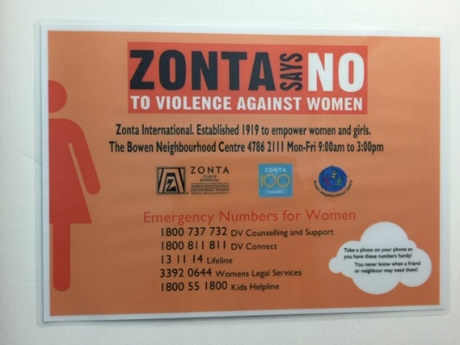

**Looking for a committee.**

Di put her hand up to be director but needs a great team behind her to carry out the most important directorate in Zonta.

She needs a strong group of Zontians to get together with Di to plan some great activities for advocacy within the Zonta code and principles

We are a club not a one-man(women) band and together little ideas can have big results and lots of doers make for little individual tasks.

Please come forward and give your name to Di.

Just one idea……..The Zonta Club of Bowen has put these signs up around Bowen. This was on the toilet door at the picture theatre. I thought this was a great idea and maybe the **new** committee might like to consider further.

**Dianne Trueman on 0408353450**

## **Pause for Thought**

**Dawn Green -meeting 15 October 2020**

Yesterday walking along the Cannonvale Beach and boardwalk, we remarked ‘what a beautiful day’ aren’t we lucky. We soaked in the wonderful weather and fabulous view.

Look around this room, look outside, we are all very lucky. Beauty and amazing friends surround us. The months of ‘Covid’ have taken their toll and have been challenging for us all.

Most of us have had trips cancelled, sometimes more than once and friends and family and friends have been unable to visit. Hopefully that will change soon. But, oh, we are so lucky to be here.

We don’t have the ‘lockdown’ our fellow Australians in Victoria have to endure. Think how their Zonta clubs must be unable to meet and share friendship we thrive on and take for granted. We girls need each other, we need to support each other, we laugh together, walk together, play and read together and work together benefitting many. We have each other. This was most evident when we recently lost our Laura. She was a much loved Zonta member who bought us fun times with aqua aerobics, Christmas parties and much more. At her passing it was amazing to see how we pulled together, comforted each other and continue to look out for each other, as hard moments enter our lives.

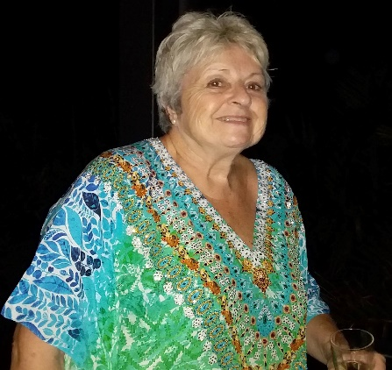

Pause to feel the little joys in life. Pause and smile. Reflect and be grateful. Sometimes we just need to put down our phones, close our eyes and take a few deep breaths. Be kind to each other we are all lucky to be here and have a wonderful lifestyle. ‘Enjoy this moment”.

**Pause for Thought” Schedule of speakers**



“Pause for thought” is a replacement for the invocation. The nominated member gives a five-minute talk on any project of Zonta International or issue that has relevance to Zonta.

General Meeting Speaker Backup Speaker

November 19th Patsy Morgan Roz Jennings

**Goodbye Wendy**

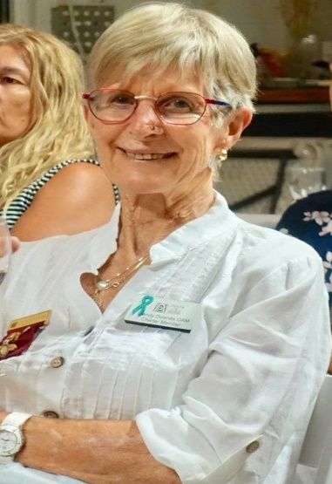

As Judy said: at the last meeting - “It was sad to accept Wendy Downes resignation”

Wendy, was a charter member of our ZONTA Club of the Whitsundays, formed in 1999 and served as President in the years 2000 and again from 2004 to 2006.  A born volunteer, she worked tirelessly for ZONTA over the 22 year period, she was involved, was an experienced member of the ZONTA Board holding numerous Board positions and always put her hand up to serve on committees and serve the community.  She travelled to many Zone meetings and ZONTA Conferences.

ZONTA members were all very proud when she was awarded in 2015, an Order of Australia Medal for Services to the Community and Running

Within the local ZONTA community Wendy’s passion lay in 2 main areas, Birthing Kits and YWPA  (Young Women in Public Affairs) Wendy coordinated The Birthing Kit program, initially begun by a Adelaide Zontian, Dr Joy O’Hazy in 1995 and from 1999, the year the club was formed, Wendy coordinated Birthing Kit packing days and took it to the Proserpine High School, Saint Catherine’s and Hamilton Island. On packing days, she used her time well to talk about ZONTA and the YWPA bursary and was always on the lookout for prospective applicants.

Whether selling “Rotary Raffle Tickets”, coordinating Bunnings BBQ’s or amassing fantastic donations to be raffled or auctioned at ZONTA fund raisers, she always gave 100%. She was a friend to many and always lent an ear or was there to support members in need.

Thank you, Wendy you will be missed.

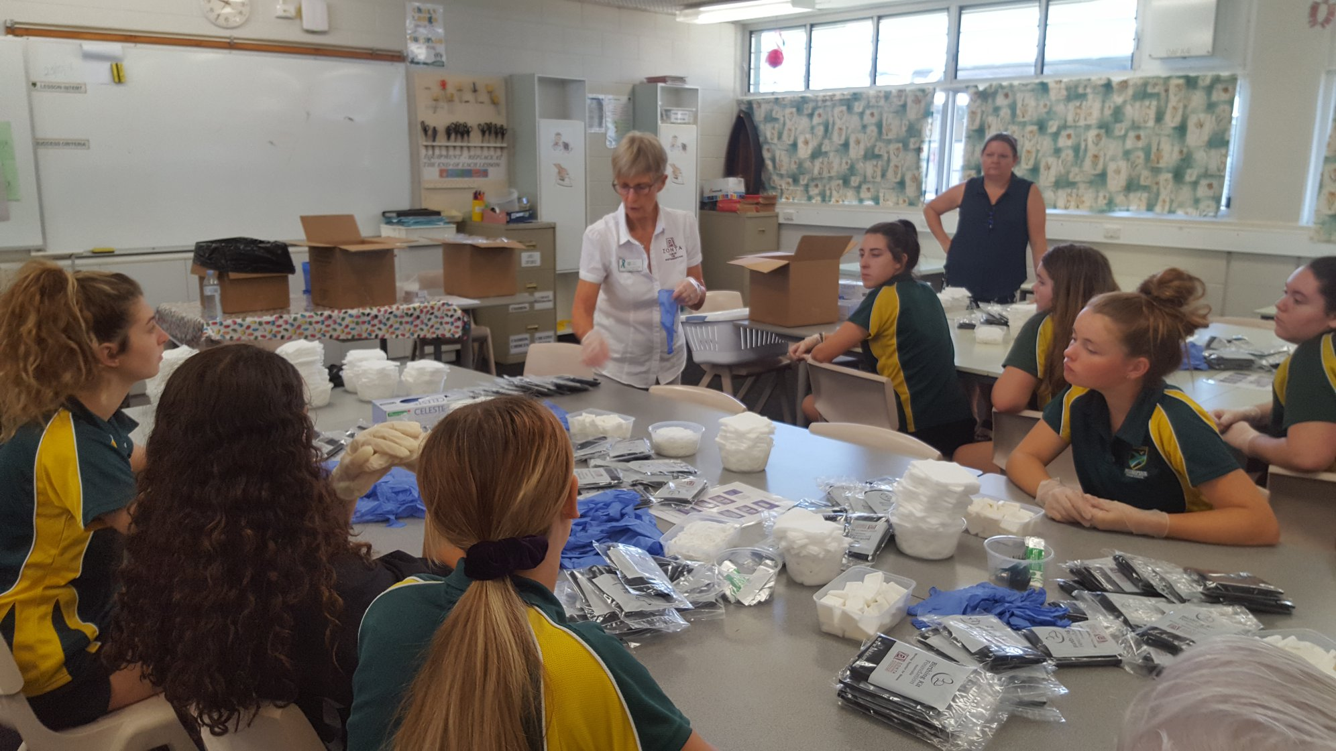

***Our Appreciative Patsy***

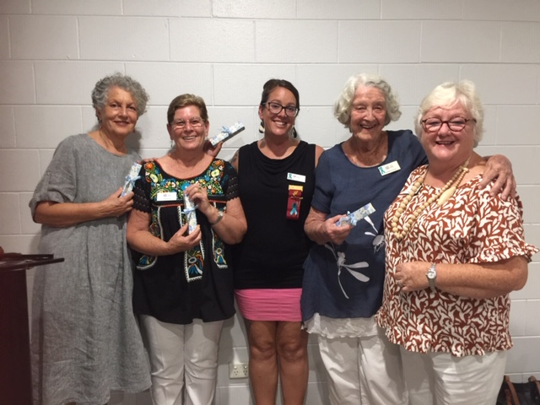

Patsy our President of last year wanted to thank her Board with a heartfelt thank you for all their efforts, assistance and back up during her year of presidency, she was very grateful and presented each member with a lovely wrapped gift.

***Come home soon Annie***

I left Australia after 3 applications to get to work.

Flying into Bordeaux France 2 july2020 where the brand-new boat was left as I ran home 23rd March. As covid hit the world.  I 're commenced the commissioning and set sail for la Rochelle a 2-day sail.

Wow what a   beautiful old town.    like Airlie small a community.   boats everywhere. I live in the lock inside the small town between 3 castles. So pretty at night. Cobbled streets. Bakeries great walks French men lots to see.

I'm busy living on the boat.my work finished early as covid stopped the USA owners getting to the boat.

So, I'm learning and modifying and ...... waiting to get home

My flight was cancelled   I'm.one of thousands with no way home till 19th Dec????  Quarantine Xmas and new year

I have the super luxury boat to live on and can afford my life here so I'm ok. So lucky not to pay accommodation.

So, I had an offer to fly France to Lisbon Portugal and sail a new 42 lagoon catamaran to gran canaries Spain.  It’s getting cooler. There is warmer   yes, I will.

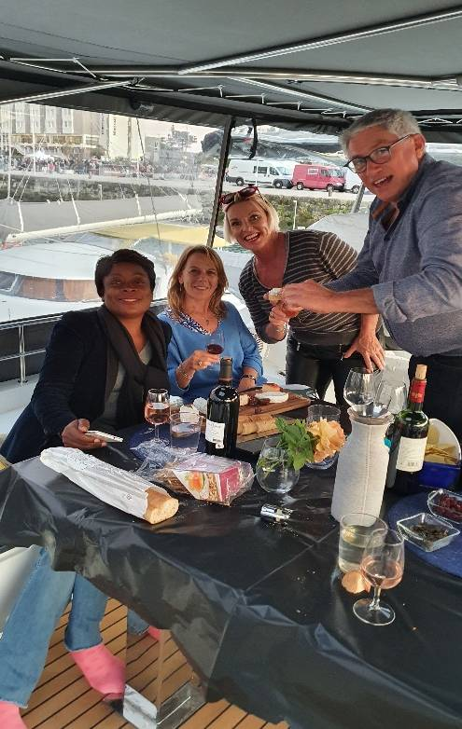

Solves my overstayed visa in France and keeps me adventurous.

So, plan b

The Aust government says we will fly 5000 people home there’s some 50,000 maybe more....so I don't think I missed flight. I call every day and no luck.  I have an offer to go to Guadeloupe with a couple and sail their charter boat in Jan and have holidays with them. the French are so nice. Often, we use Google translate and still laugh and have fun with no common language. I Love the French Hi Catherine and Tonyxxx

So dear friends I’m a little lost here at times. I spend a lot of time solo on the boat. I’m missing home and u ladies and my cat and my home. I am making the best of it.

No romance as of yet. just this covid really does suck...  but I do keep my eye out. Boy there are some attract people here... I laugh a lot. made great friends. Trying to keep my weight in the normal range. That's hard.

My work 're start s April 2021. Can I get back if I come home????

That's the question????

On Sat, 17 Oct 2020, 05:57

***Thank you, Christina, for this wonderful contribution***

***Animal Rescue – women and children***

What does animal rescue have to do with women and children? A LOT! In my 20 months of dealing with animal rescue – dogs, cats, chooks, horses and farm animals – I realise that it is just as much about people than it is about animals. I could write a book, just about the people, but I’ll tell you a few stories, where animals, women and children are the main players:

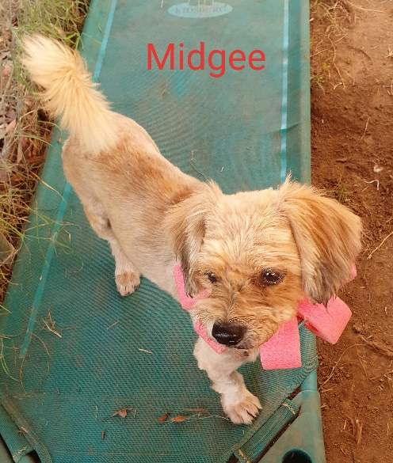

* Betty and Rusty: Midge is a dumped Maltese x, full of fleas, with matted coat. Fortunately, there are lots of good people around, saving those unwanted creatures and then phoning me up. We have Midgee cleaned up, shave his matted coat and put some meat on him. Betty is still grieving for her lost little dog. “I am not ready for another one, Christina!” But she still comes and has a look… Now Rusty and Betty are an item. They love each other and both are happy.

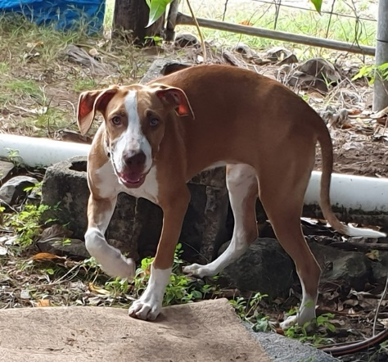

* A desperate phone call: Cathy, a victim of domestic violence, must take refuge in a safe house with her children, but she is not allowed to take the dog. The children do not only lose their home, traumatized by what they saw, but also must give up their mate. The only thing I can promise that I’ll find her a good home and I do. One feels helpless, as the animal could have helped the kids to overcome whatever they experienced.
* A girl doing the right thing: I get a message through Facebook, trying to rehome 5 cats, all unvaccinated, not desexed. I react, as I normally do, asking the obvious questions why weren’t the cats desexed, insinuating that I find that highly irresponsible… The answer was totally unexpected: “I am only 12 years old, trying to do the right thing. I know it is not good, but I try to change it”. Now, it’s my turn to apologize! A 12-year-old kid, trying to do the right thing. Mum, at least, drives the girl and the 5 cats to the farm. They all get vaccinated and desexed and all find homes! Will the action of the girl change anything? In that household, yes, as I paid for the desexing of the last remaining cat.

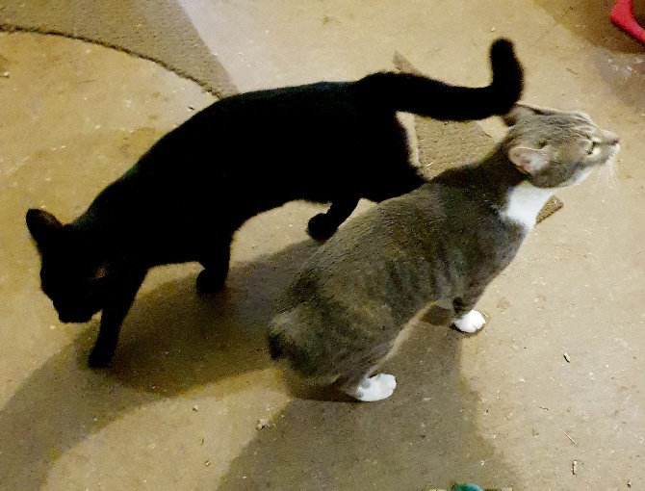

* My own story: “Christina, I need your help! I have saved this dog from being shot, after he was badly abused. He is only 4 months old and I can’t keep him, as I am working at the mines. Can we meet at the vets?” Amanda sounds desperate and I agree to meet her and the dog. When I arrive at the vet, I see a dog on the examination table, shaking like a leaf. I have never seen a dog that scared! Bear, now Boy (I wasn’t going to keep the name his abuser gave him) breaks my heart! I swear then and there that Boy is not going anywhere but will stay with me and will never be abused again! 8 months down the track and Boy has improved. He is still lacking self-confidence and does not like strange men, but he loves the other dogs and adores me, just as I adore him.

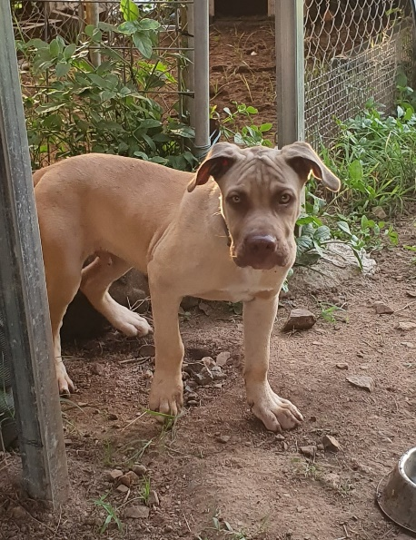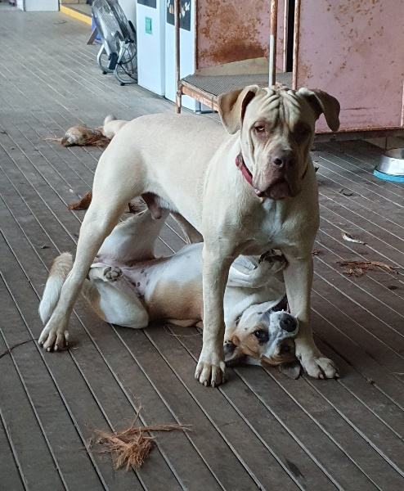

Will it ever change? Domestic violence is closely linked to animal cruelty. Men abusive to animals are likely to become abusive to women and children, because they can. Animals get dumped because some people still look on animals as property. Animals, just like a pair of old shoes, can be discarded.

The answer to my question: no, it will not change. That’s why I’ll continue what I am doing. Please, if you adopt an animal, make him or her part of your family! If you can’t don’t get a pet!!

***Christina***

***OUR Keisha***

BACKGROUND – PJ and Noelene first met Keisha in 2014 through Mandy Coles at the Crisis and Counselling Service at Cannonvale – a very shy girl who needed help. Since then we have seen her involved with Candle Lighting ceremonies, working with local groups on suicide prevention, Naidoc events each year, working with the indigenous youth and many other events.

2014 – She was invited to attend the Queensland Indigenous Youth Leadership program in Brisbane.

She also became a DRUMBEAT facilitator with friend Kalila Parter.

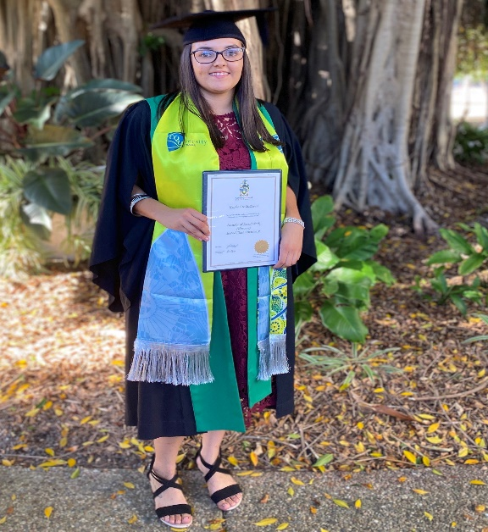

In 2016 She was awarded the Young Citizen of the Year by our local council.

Together with friend Kalila Parter, she was invited to attend the STRAIGHT TALK national summit in Canberra, which connects Aboriginal and Torres Strait Islander women with the political system and builds the capacity of women as change makers to share, learn and be effective in making a difference. A great experience for both girls who do a lot for their local community.

2019 - Keisha was selected to be part of CQU Global Outbound Cambodia Program and received a scholarship of $3000 towards costs. This involved studying community health programs.

Through all this Zonta has been there when needed, helping Keisha to achieve her goals, asking for very little but helping many on the way.

As you will see from her update below, she is working hard and has a happy home life. All this from a young girl who left an unhappy home at 16 and has looked after her family on the way. We wish her all the best for the future and look forward to hearing more success stories from her.

PJ and Noelene (adopted grandparents).

**UPDATE FROM KEISHA**

Email 14th Sept. to PJ and Noelene (Grandmas)

Hi Ladies - I've been a terrible granddaughter, so sorry I have not been in contact for a while. I hope you are both well.

I've had some big life changes, Bradley and I moved into a beautiful house together about 4 months ago. Since we have moved in, I've developed a bit of a green thumb and have been working on the garden – I've never been a gardener, so this is a new thing for me ha-ha. It was a big change for both Bradley and I to move in together however we had been together for a year and 9 months, so it was the next step.

We've also recently just got a puppy; her name is Molly and she's the cutest little thing! She's a border collie cross short haired German pointer. She has one blue and one brown eye, common for border collie breeds apparently. Her mum has one blue eye and the dad has one blue eye too. I've never seen it before, but it just adds to her cuteness.

Covid had slowed down my job prospects however in February I was acting family support worker for the Neighbourhood Centre for 3 months while the original worker was on leave. My nephew was also born in February and due to covid restrictions I was unable to go to Townsville to meet him until he was 4 months old, this was difficult as my sister and I are quite close. Covid really put things in perspective and makes you appreciate life and people more.

I've also been working at the Neighbourhood Centre for the last 8 weeks running the Drumbeat program, only two weeks to go and I've completed a 10-week program for two age groups. On Tuesday afternoons I run the program with 13-17-year old at Proserpine Community Centre, currently have 3 participants in my group. On Wednesdays I run it at Whitsunday Neighbourhood Centre with 9-12-year old and have 5 in that group. This has been very successful and it's the first one in the community that has been free as far as I am aware. We hope to run it again next school term.

I've also got a new job!! I'm now working at Electability for the Suicide Prevention Community Action Plan (SPCAP) team as the Whitsunday project worker. I'll be doing presentations and hosting pop up shops aimed at reducing the stigma of mental illness and providing support services across the region. I've been in this role for 3 weeks; it is part time and approx. 15 hours a week so it fits in well with the job at the Neighbourhood Centre.

I have resigned at the takeaway shop, I figured 3 jobs was far too much for me to handle and had to look at what was going to benefit my career aspirations. The takeaway shop job started off as a after school job in 2010, I didn't think I'd stay there for 10years. My bosses were incredible and gave me time off when I needed it for university and placement and have been like parents to me, so it was very tough to leave.

My graduation was planned for April 2020 however thanks to covid it was postponed and have recently received news that it is going ahead on 20th October 2020. I'm only allowed two guests and they have to live in the Mackay region so my sister from Townsville is unable to come. I was not going to attend as I wanted my family there but decided I will still go and celebrate my achievements of graduating and accept the praise of what was a significant life achievement.

2020 has been quite a different year with covid but for me feel I've had a lot of growth and movements happening in my life that have been quite positive.

Kind regards - Keisha.

**FINAL NOTE**- Bradley attended the graduation ceremony and Keisha's sister from Townsville was part of the crowd watching on TV outside the hall, and then they all went out for a celebration dinner. Unselfishly as usual, Keisha gave her spare ticket to a uni friend so her two children could attend the ceremony. Photo to follow.

PJ and Noelene were unable to attend the graduation ceremony but watched proudly as our girl received her diploma with honours.

When PJ returns from her sailing, we intend to get together for our own celebration and hope she will be able to attend one of our meetings soon.

You can watch the graduation ceremony on YouTube – CQUniversity MacKay Graduations 20th October 2020.

Lots of speeches first then Keisha is on about 85 minutes.

Also saw Claire Jardine (ex-member) appears at 74 minutes – I didn’t know she was graduating so that was a surprise. Congratulations Claire

***Thoughts on equality***



### “Given that we live in an era of equality, it is only fair that for every 100 men drafted for the war...We shall draft 79 women.

* Whenever I see a woman driving a bus, I smile to myself and think how far we have come in the whole equality thing compared to just a few short years ago **- Then I wait for the next bus**.
* Equality is at an all-time high thanks to Coronavirus. - **Everyone is equally fed up**.



lll

**Women’s Economic Security Statement**

In 2018 the Federal Government released its inaugural Women’s Economic Security Statement, with a focus on three key areas of workforce participation, earning potential and economic independence.

In 2020 this Statement was expanded and updated in recognition of the impact that COVID-19 has had on job security and female workforce participation.

2020 Women’s Economic Security Statement

The 2020 Women’s Economic Security Statement significantly expands on the 2018 document, with input from women across Australia. The original three key areas have been expanded to five1, being to:

* repair and rebuild women’s workforce participation and further close the gender pay gap
* greater choice and flexibility for families to manage work and care
* support women as leaders and positive role models
* respond to the diverse needs of women
* support women to be safe at work and home.

Impact of COVID-19

According to research published in the 2020 Women’s Economic Security Statement, between February and May 2020, 420,000 women in Australia lost employment, with approximately 800,000 women wanting to work more hours.

Source: [2020 Women’s Economic Security Statement](https://www.pmc.gov.au/sites/default/files/images/wess/wess-2020-report.pdf).Federal Budget boost

According to the Federal Treasurer, Josh Frydenberg2, women have made up the majority of those who lost their jobs during the current crisis. In response, $240 million has been allocated in the 2020 Federal Budget for measures and programs to support:

* New cadetships and apprenticeships for women in science, technology, engineering and mathematics
* Job creation and entrepreneurialism, and
* Women’s safety at work and at home.

Further details can be found in the [2020 Women’s Economic Security Statement](https://www.pmc.gov.au/sites/default/files/images/wess/wess-2020-report.pdf).

**October**

**Happy Birthday**

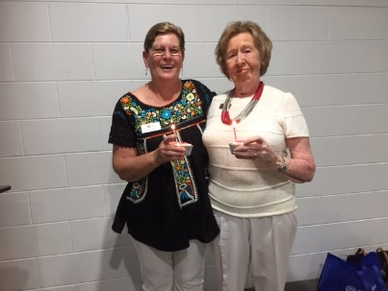

* Joan Watson 6th
* Judy Brown 17th



***Dates to remember***

* ***31 October 2020 Derby Day***
* ***6 March 2021 International women day***
* ***Book Club at Kerry Kenyon’s house last Wednesday in the month at 5.00 pm***

***Cath 0419 653 878***

* ***Knitting group April to Nov last Monday of the month at 10.00 am.***

***Carol 0417 619 098***

* ***Sewing Group ad hoc, breast cushions, turbans modesty sheets, virus masks etc***

***Carol 0417 619 098***

***Editor***

***Marlene Reiffel***

***October 2020***