
November 2005

Zonta Club of
West Moreton Inc.
Inside this Issue
1 | President’s Message
2 | Zonta Events and Reminders , Members News
3 | Committee Reports
4 | Committee Reports and Snippets
5 | Minutes
6 | Minutes
Our Club Website :

http://westmoreton.
zontadistrict24.org/

Zonta Club of West Moreton Inc.
PO Box 505
Ipswich Q 4305
Club No. 0900; District 24; Area 6


President’s News
.
.
.
Zonta Newsletter

From President Leonie
Congratulations to the members for a successful Breast Cushion day, for both the organisation of it, & participating. I was unable to attend as I was working, but I would imagine that much chatting & munching went on – that is one of the wonderful things about Zonta, that there is so much personal enjoyment at the social level while something so worthwhile is being achieved.
Many thanks also to Julie Mayer, for so ably coordinating the girls’ leadership sessions. This is going from strength to strength, with Rotary being very interested in modelling a boys’ leadership course on this pattern.
This month’s guest speaker is definitely one not to miss, so please bring as many guests as possible to hear Hugh Lunn speak.
Only two weeks after will be our Christmas dinner, again a guest night. There has been much planning going on by the committee, so I am sure it will be a memorable evening, to which all are welcome.

It hardly seems possible that it can almost be Christmas already, supposedly an opportunity to wind down a little!
I look forward to seeing you all at our next meeting.

Leonie

-----------------------

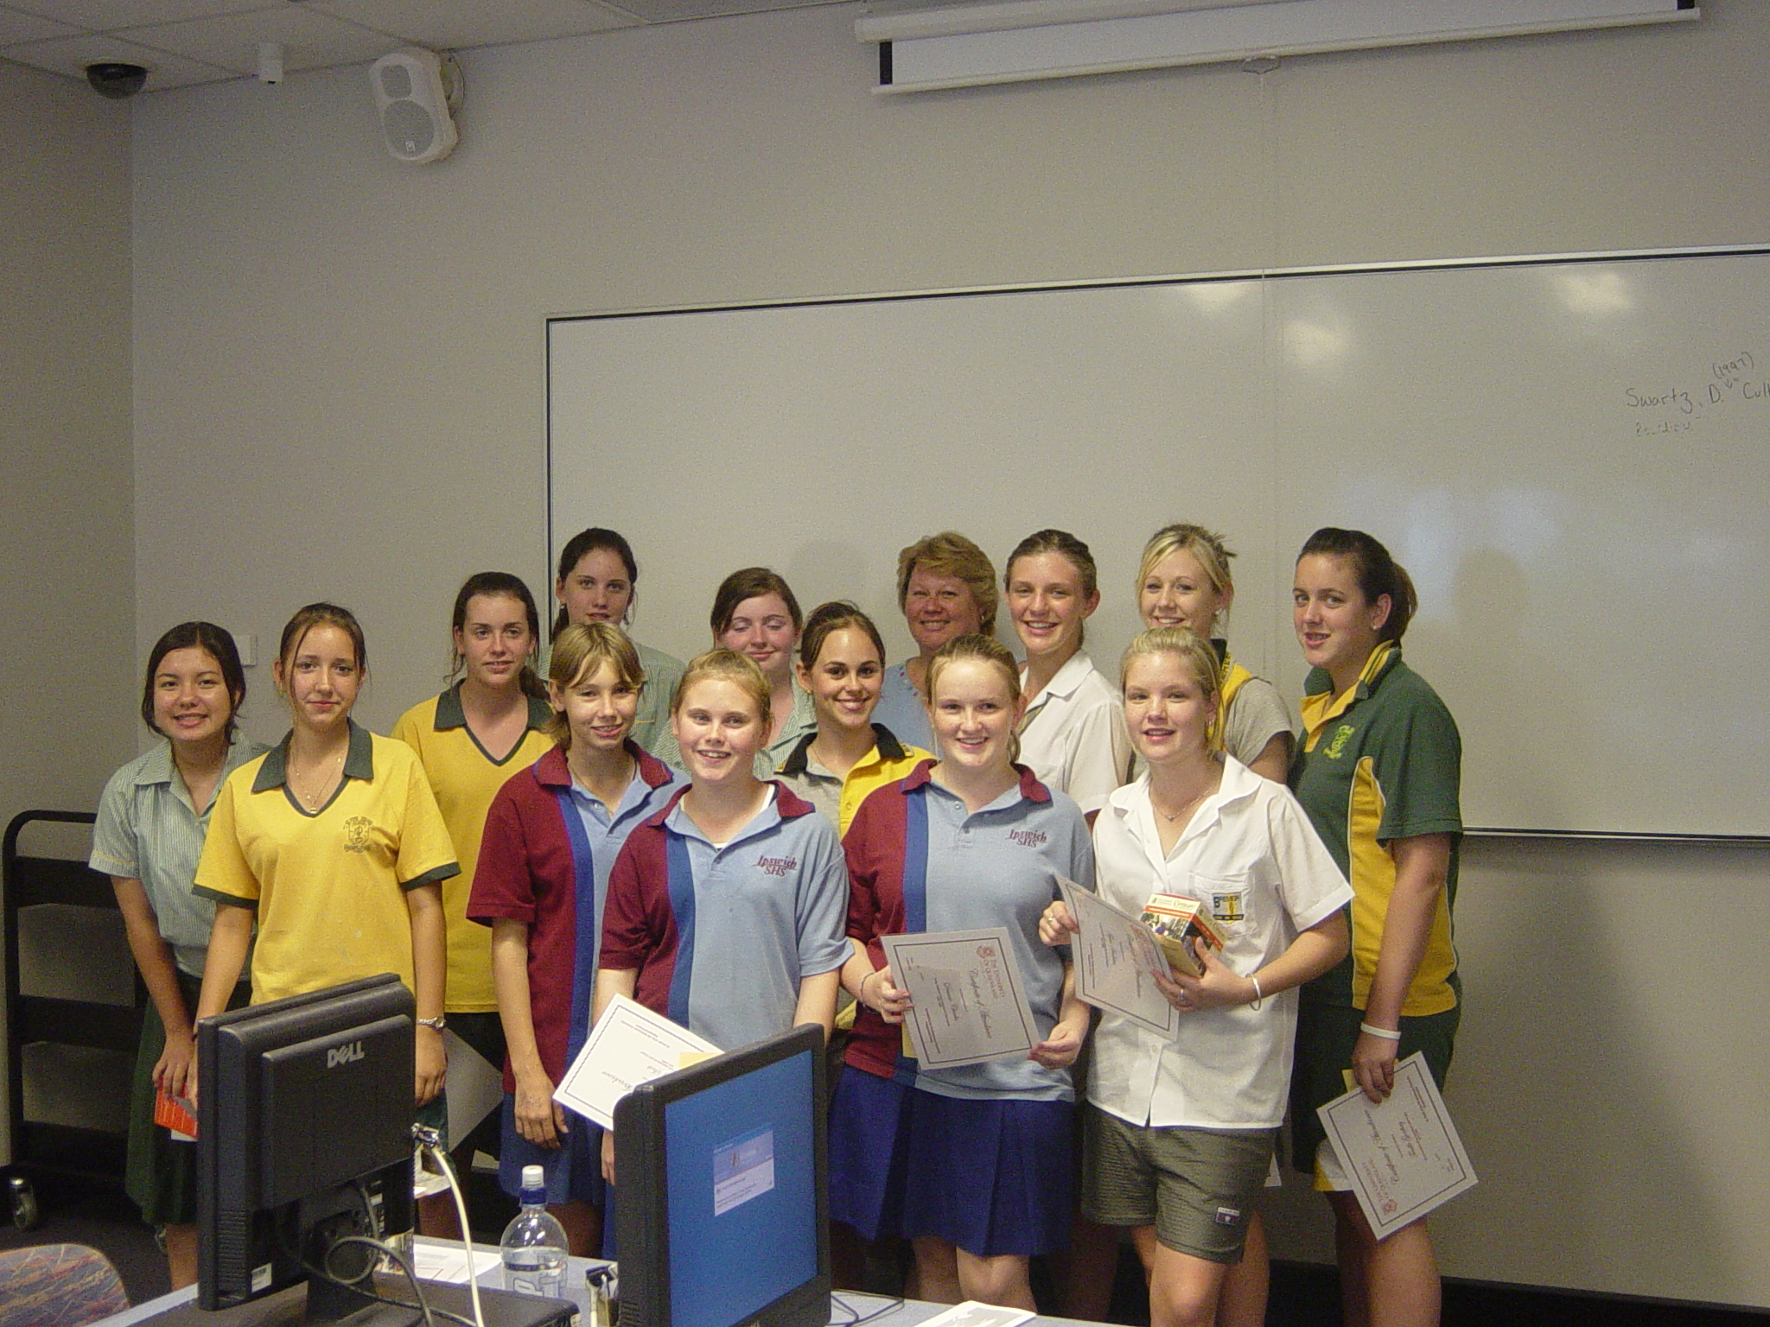

Julie Mayer and the Girls
from the November Leadership for Girls Course at UQ

NOVEMBER MEETING DETAILS

MONDAY 28th November
6.15pm for 6.30pm
at The Ipswich Club

Speaker :
Mr Hugh Lunn

Dinner Meetings Cost
for members and guests
$22 per person

IMPORTANT :

Please phone
Gillian Wilton on 3281 7611

please also indicate if you are bringing a guest or how many guests
or with apologies
or any special dietary requests
(e.g. a vegetarian meal)
before 7.15am
Friday 25th November.

REMINDER: If apologies are not received by stipulated time of the meeting week, you are required to pay for the cost of the dinner. The Treasurer will send you an invoice.
For November …

Speaker Introduction :
Speaker Thanks :
Grace & Toast : Bev J

Recipes Wanted !!
.
.
.
.
Zonta Events

Date : Monday 28th November
6.30pm at The Ipswich Club
Hugh Lunn Dinner Meeting with Guests

Date : Friday 2nd December
Newsletter items Due – to Sue Hutley. Phone through your news on 3202 3436 or email s.hutley@library.uq.edu.au

June 24-29, 2006
Zonta’s 58th International Convention - Melbourne

President Leonie still needs your recipes for the Zonta Cookbook Fundraising Project !! This will now get underway again in early 2006.
Remember that the recipe needs to be sufficiently ‘original’.
All questions or enquiries to Leonie.
You can hand write them and they will be typed out for you , or email them to
lpeasey@optusnet.com.au

Members News

Heather Brodie and Maria Stevenson represented Zonta at the 25th Anniversary Lunch of The Inner Wheel recently.

Congratulations to Pam and Des on the latest Smallwood Wedding at Pomona last Saturday.

Committee Reports

UN Committee Report:

The following information comes from the Amnesty International Australia website which we recommend to you.
The 16 Days of Activism Against Gender Violence is a worldwide event where people take action to end violence against women. It begins on the International Day to Eliminate Violence Against Women (25th Nov) and ends on the International Human Rights Day (10th Dec).
You can find out more by visiting the Centre for Women’s Global Leadership website. http://www.cwgl.rutgers.edu/
Here is an activity for each of the 16 days
- Wear a white ribbon on day 1
- Sign AI Australia’s petition for a National Plan of Action to eliminate violence against women and the ask 16 friends to do so also
- Attend one of the many organised events in that time
- Defend the rights of women worldwide. Write a letter to governments who are failing to protect women’s rights.
- Download the “What is violence against women” fact sheet and distribute it in your workplace/ community
- Challenge the myths about sexual assault and domestic violence
- Hold a morning tea to discuss these issues
- Encourage both men and women to be involved.
- Make this the theme for your next group’s meeting
- Write a letter to your local newspaper or ring a radio station highlighting the importance of taking action to stop such violence. (Send a copy top AIA for inclusion on their site).
- Take action if you witness violence happening eg call the appropriate authority
- Join the on-line forum to discuss strategies to stop the violence
- Become a member of Amnesty International Australia
- Write to your local MP highlighting the need for adequate services to help women who survived violence on their lives (send responses to AI Australia svaw@amnesty.org.au

These activities are designed to stimulate us all into action. We should be pleased if we can do at least one of them or maybe you can think of something that is more appropriate for you and your friends.

Cheryl, Margaret, Sheila, Robyn and Maria

Committee Report : Program
Update report from the Programs Committee:

From the programs committee:
NOVEMBER meeting
FOCUS ON WRITERS
The November 28th at the Ipswich Club is a special guest meeting (with an abbreviated business meeting to follow).
The guest speaker is Hugh Lunn, the Brisbane born acclaimed journalist, author (including "Over the Top with Jim", and "Fred and Olive's Blessed Lino") and broadcaster. Hugh will speak, and will bring some of his many publications for sale.
We hope an accomplished local author Toni Risson ("Licking Lizards") will also attend.

Please note duties for the evening:
Grace and Toast Bev Johnston

DECEMBER meeting --
the CHRISTMAS meeting ( December 12th) at the Ipswich Club is a special buffet menu ($35/head).

ZONTA CELEBRATES CHRISTMAS WITH CAROLS AND OLD FAVOURITES
Roger Worthington (baritone) and John Hall (pianist) will lead us in a fun and spirited musical Yuletide program. Dust off your favourite Honzons (and anyone else you care to bring!) for this spectacular guest night!

and

ZONTA PLAYS SANTA FOR THE SALVOS
All members are invited to bring gift/gifts that will be part of the Ipswich Salvation Army Christmas giving.
This year, the Salvation Army suggests we focus on giving to young people aged 13 to 15 years (and please mark whether suitable for a boy or girl or either.)
The Club may also present the Salvo Christmas Appeal with a cheque.

Ladies please note duties for the December evening:
Introduction Marie Kavanagh
Grace and Toast Maria Kelly
Vote of Thanks Tina Kelly

Pam van de Hoef
Chair

Membership Committee Report :

We are having queries from prospective members.
All new members note that we are having a New Members night in mid February.
HAVE A GREAT CHRISTMAS AND A FRUITFUL ZONTA NEW YEAR.
Gillian, Heather, Myrtle & Vicki

Status of Women Committee :
The Breast Cushion Making day on the 6th November was enjoyable. Thanks to those who came along. It was useful having a ‘little helper’ aka Olivia Hutley to help fetch the different parts of the cushions. Thanks also to Marie K who has done a lot of the extra sewing for the cushions and arranging all the fabric etc.
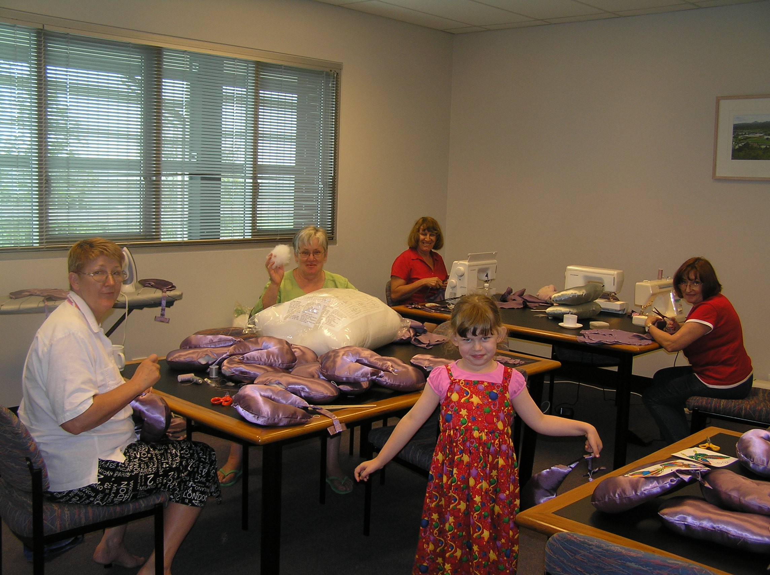
The Team keeping Busy.

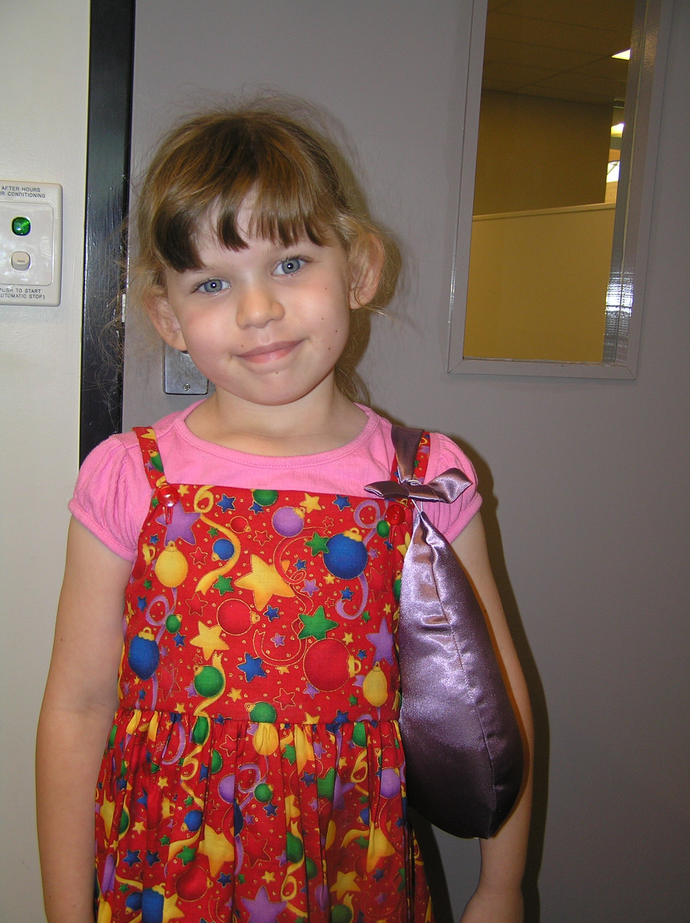
Helper Olivia tests out the finished product – as a handbag.



Zonta Badges

These will be distributed in early 2006. Prices to be advised.

For Your Diaries –
Meetings Dates 2005:

28th November – Hugh Lunn & meeting
12th December - Christmas Dinner

Xmas Stockings – Final call for this year for Zonta Aprons
The West Moreton Club’s Aprons are available for members to purchase. $20 is the members price. Please bring along your cash or cheque to the November Dinner meeting for Christmas presents or contact Helen Walker. The non-club members price is $25.
---------------------------------
Zonta Prague Holiday Week 2006 - 23-30 September 2006
for Zontians and Friends

Highlighting UNESCO listed heritage the week of sightseeing tours including Prague Castle, the towns of Liomyau and Kutna Hora, concerts, a river cruise, cathedrals and baroque ….
It sounds like a wonderful week !

Approximate price is 10000CZ (350 EUR) and 4 star hotel is 175 EUR.
For more details or to register your interest contact :

Dana Mikulejska
V krovinach 8
147 00 Praha 4
Czech Republic
Email : dmikulejska@upv.cz

