
Club No. 680, Area 1, District 22 – Charter Date 01.10.1971 – ABN 47 885 713610
GPO Box 1768, Brisbane Q 4001
Newsletter – JANUARY 2014
President – Pamela Deakin; Vice-President – Caroline Heim
Secretary – Adrienne Irvine; Treasurer – Christine Maclean;
Directors – Christina Carleton, Susan Davies, Merryl Ducat, Genevieve Gray, Kelly McIntyre
Newsletter Editor – Vacant.

DATE CLAIMERS, REMINDERS, & EVENT INFORMATION
WED. FEB 5 | CLUB DINNER MEETING 6.30 pm for 7.00 pm at the United Service Club. The guest speaker is Dr Emma Duncan, Associate Professor at the University of Queensland Diamantina Institute.
THUR. MAR 6 2014 | INTERNATIONAL WOMEN’S DAY BREAKFAST – at the Brisbane Convention Centre.
SAT. MAR 22 2014 | AREA 1 & 3 MEETING – to be held in Kallangur, hosted by Caboolture Club. The theme is Lifting the Cloak of Invisibility. Early bird registration is available until 22 February.
TUES. MAR 18 to SAT. MAR 22 | ZONTA BRISBANE ART SHOW at the Royal Queensland Art Society Gallery on Petrie Terrace. There will be an opening event on the Tuesday evening. Read more in the newsletter.
JUNE 27 –JULY 1 | ZONTA INTERNATIONAL CONVENTION in Florida. The biennial convention is an opportunity to network with Zontians from across the globe.
The United Service Club has a strict deadline for finalising meals. As it is assumed you will be attending all meetings of the Club unless an apology is received, it is critical that you let Chris Maclean know by noon on Monday, February 3 if you will not be attending the meeting. Chris must also be advised by that deadline of any guests. Telephone: 0407 574 404; Email: christinemac@gmail.com. Any member from whom an apology is not received in time is automatically invoiced for the meal ordered for her ($43).


Windana has a number of babies in residence at the moment and this month would love:
- Cot sheets
- Single bed quilts
- Shampoos and conditioners
Windana always appreciates our generous donations.
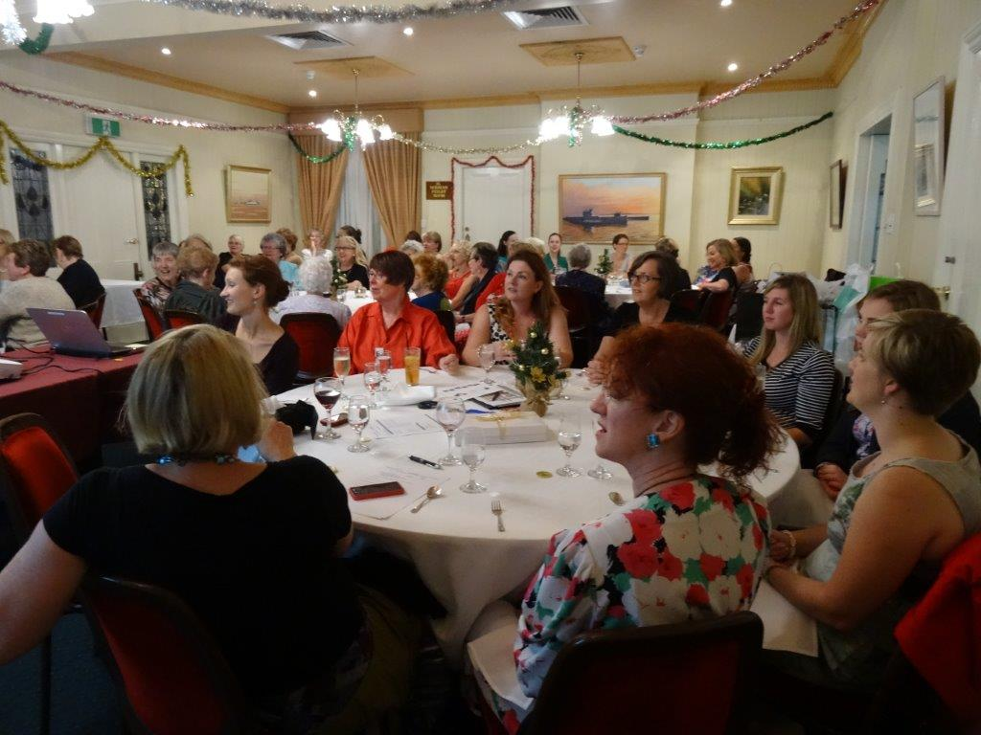
PRESIDENT'S MESSAGE
Dear Club Members
I hope all members enjoyed the Christmas and New Year period and are feeling refreshed, ready for another busy year.
The photo to the right is a reminder of our pleasant Christmas dinner. In the photo gallery there is a lovely snap of our Vice President Caroline Heim who did such a great job of hosting the festivities.
Now is the time to review our service and advocacy programs and to decide the direction and projects for the coming Zonta Year. I urge members to respond to Adrienne Irvine’s call for nominations for service projects in 2014-2015.
There will be meetings called in February to discuss service and advocacy, Please attend these meetings and have your say about the Club’s programs and priorities.
The District Governor, our Club member Judith Anderson, reports that the District undertook an impressive range of activities to support the Zonta Says No Campaign. The activities to raise funds and awareness of the need to eliminate violence against women and girls included market stalls and Zumba for Zonta (now there’s an idea!). A variety of advocacy activities was undertaken including liaison with local police and radio interviews.
I encourage as many members as possible to attend the Areas 1&3 Meeting on Saturday 22 March. The program is now available and there is more information in the newsletter. Also pencil into your calendars the opening on Tuesday 18 March of the keenly anticipated art exhibition organised by Club member Liz Heber and her artist friends to benefit the Club. Read the newsletter for more.
I am looking forward to seeing you again at the February dinner meeting,
Yours in Zonta
Pamela Deakin
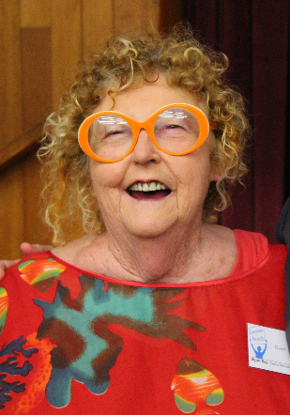
ART SHOW PROMISES QUALITY AND FUN
Club member Liz Heber (pictured left), together with ten or so of her very talented friends, will exhibit their works to benefit our Club in March.
The exhibition will be held at the Royal Queensland Arts Society building on Petrie Terrace.
We will have an opening night on Tuesday, 18 March, and the exhibition will continue to the following Saturday afternoon, 22 March.
Liz says that the artists work in various media from an emerging naïve painter to exquisite silversmiths, a wood-working genius, crazy painters, beautiful glass works, jewelry and things to wear. It will be high quality and fun.
There will be at least one artist on hand during the exhibition’s opening hours and visitors will be welcome to have a cup of tea and chat.

AMELIA EARHART FELLOWSHIP PROGRAM PASSES 75th MILESTONE
Every January, Zonta International celebrates Amelia Earhart month. Since Zonta established the Amelia Earhart Fellowship in 1938, more than 1400 women in over 68 countries have been assisted to pursue post-graduate studies in aerospace-related science and engineering.

HONOURS
Two of the Club’s Woman of Achievement Award winners are recognised in the Australia Day 2014 Honours List.
Dr Lee-Anne Perry was made a Member of the Order of Australia (AM) for her service to secondary education. Lee-Anne is Principal of All Hallows and was our 2009 Woman of Achievement.
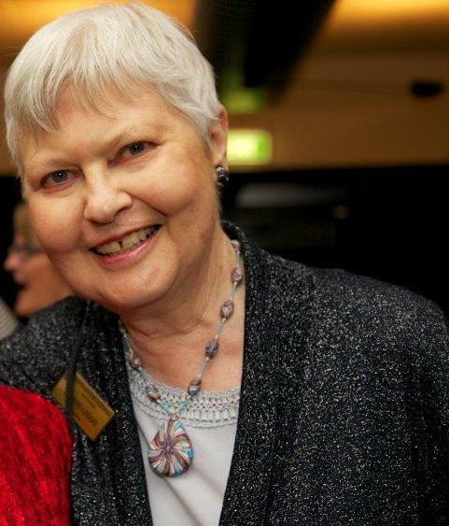
Our 2001 Woman of Achievement, Dr Dimity Ann Dornan AM, has received further recognition under the Order of Australia by being made an Officer of the Order (AO). Dimity founded Hear & Say and has gone on to establish healthcare and clinical training programs internationally to prevent and treat hearing loss in babies and young children.
Dimity was also included in the YWCA Queensland’s 125 Leading Women announced in November 2013 to celebrate the organisation’s 125th anniversary.
The 125 women honoured by the YWCA also included Club member Sally Anne Atkinson AO and a number of other women associated with the Club: Keri Craig, fashion designer, was our third Woman of Achievement Award recipient in 1985; Hetty Johnston, founder of Bravehearts, won the Woman of Achievement Award in 2005; Kay Ganley, Chief Executive of Charlton Brown, a training organization in the community services field, was the 2013 winner of the Woman of Achievement Award; and Dianne Leggo (pictured right) who will be known to many members for her instrumental role in establishing a number of Zonta Clubs throughout regional Queensland as well as internationally.
AREA MEETING
The Areas 1 & 3 Meeting will be held on Saturday 22 March 2014 at the Norths Leagues & Services Club, 1347 Anzac Avenue, Kallangur. The meeting this year is hosted by the Zonta Club of Caboolture. Early bird registration for $60 is now open and will be available until 22 February. An email with a link to the registration service (Stickytickets) has been emailed to members, and is also available from the President.
The theme of the meeting is Lifting the Cloak of Invisibility – reaching our biennial goals of visibility and credibility. The interesting program includes a presentation by Club member, Prof. Kay Saunders, on club histories, as well as a ‘progress report’ to clubs by District Governor, Judith Anderson. Other relevant topics include including fundraising with an opportunity to donate clothes, shoes, bags, etc. to Dress for Success.

PHOTO GALLERY
1
- The Club has a new baby! Mary Alexandra Stoker, daughter of Amanda and Adam, was born on 31 October, weighing a healthy 8 lb 6 oz. Isn’t Mary beautiful?
- Do you recall Kenny Koala who resides in Leigh Eagle’s bushland backyard? Kenny has a girlfrend!
- Club Vice President, Caroline Heim, shows why she was a hit busking on the streets of New York.
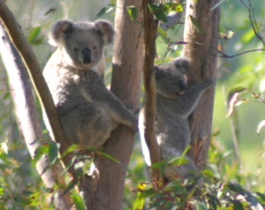
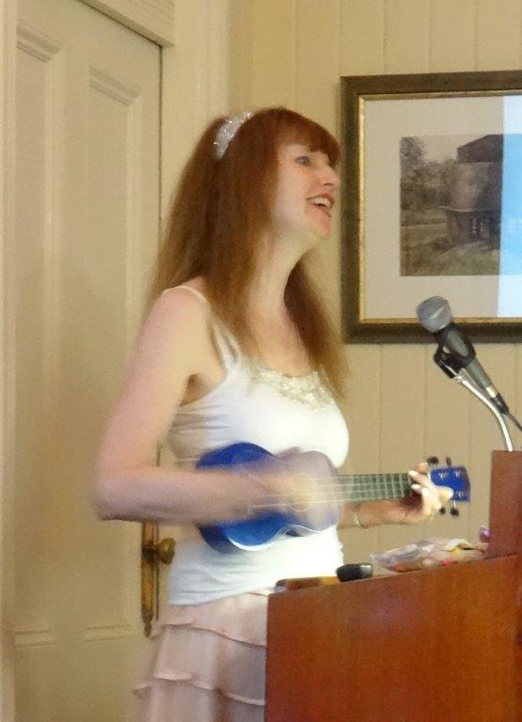
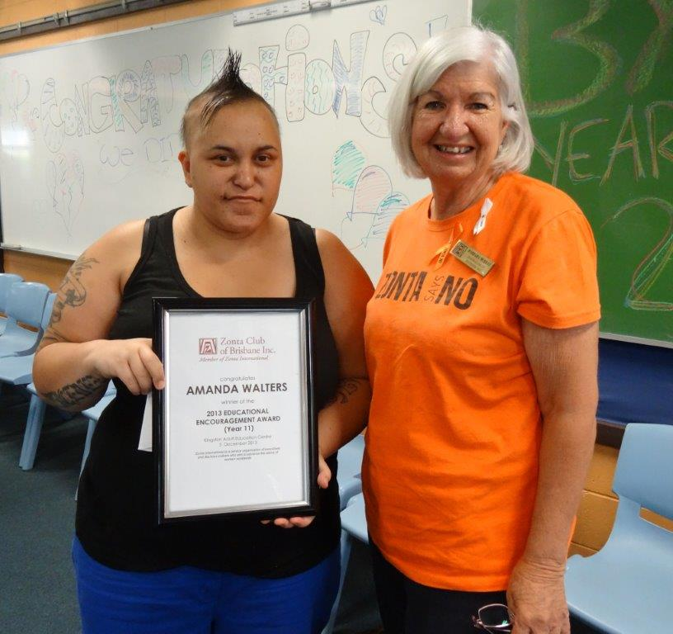
- Barbara Murray presents the Club’s Educational Encouragement Award to Amanda Walters at the Kingston Adult Education Centre.
2
3
4

