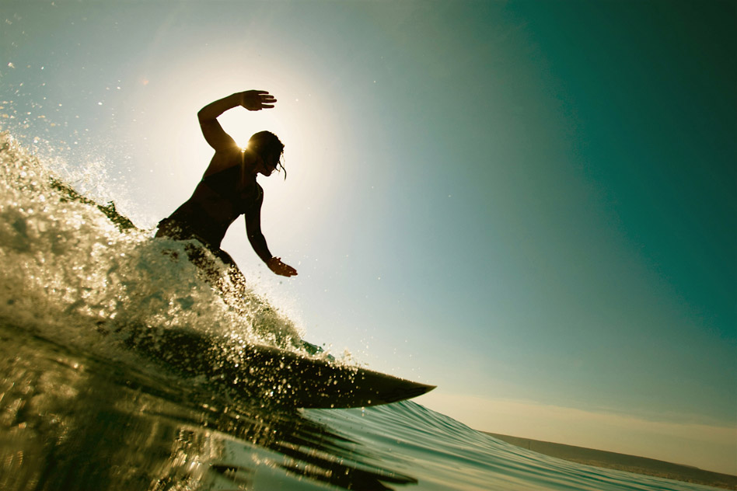
Zonta
Southern Gold Coast
Tweed

SS
Soursss
SEPTEMBER
Newsletter
Hi All. Another month has rolled around and lots to report from Zonta conference and all of our activities.

CONFERENCE/PRESIDENTS REPORT

Kaye, myself and Louise were fortunate enough to attend District 22 conference in Brisbane. We arrived on the Friday afternoon with our first official ceremony being the opening of conference which was just a short walk away at the Parliament House annexe. Among other things there was a flag ceremony with a parade of all the official flags, national anthems of Australia and Germany, entrance of the official party and a great welcome to country by Uncle Joe Kirk. This was followed by cocktails and nibbles. Certainly got us all in the mood for chatting and meeting new friends.
As the delegate for our club I needed to have a good understanding of the motions that were up for debate and vote on them according to the clubs wishes. So some study was needed.
Saturday was a very full day including the welcome by our District Governor Ans Van Erp, ZI Foundation Ambassador Report by Anne Kuhneman, lots of voting and some very inspiring guest speakers. A stand out was Dr Luc from the Congo and his wife Delice who were in a panel discussion with Jenny Weaver from the Birthing Kit Foundation. Dr Luc showed a short video of distribution of birthing kits and how excited the villagers were to get these simple life saving packs.
Saturday night dinner was wonderful with good music and lots of dancing. Any clips you saw of me, were me doing ‘ The Time Warp’. Did not think I had it in me anymore. I was wrong. Ha Ha.
The highlight for me on Sunday was hearing from the ZI and D22 YWPA Winner 2016 Phoebe Frederick, D22 YWPA Winner 2017 Linden Peacock and via skype from London D22 JMK Winner 2016 Georgia Grayson. What inspiring, outstanding young women. So good to know they will be future role models for women everywhere.
Most educational for me was learning more about the endowment fund and how that operates. We can all make a contribution at any time and it means Zonta will always have funds to support our various projects. The core gift is held forever, so only the interest on the money is used.
We all enjoyed the conference and learnt a lot. Met some truly remarkable people.
Big thanks to the wonderful committee who did all the hard work and especially our lovely DG Ans.

‘We are an army, who through fellowship, understanding, co-operation and goodwill are an irresistable force to ensure womens’ rights are human rights”

Photo of me, Elaine Harrington Director of Area 3, Kaye and Louise. Just before conference dinner

ENTERTAINING UTE
Such a joy to have some more time with Ute Scholtz our Zonta International representative at conference all the way from Germany as she made her way south to Newcastle via the Gold Coast.
For those who could I know you all made her feel welcome and showed her why we all love this part of the world. She is a fun lady and we could not have had a better ZI rep.

BLUE ILLUSION FASHION PARADE
Big thanks to the lovely Cathy and her staff for hosting our fashion parade again. We all bought up big and are anxiously waiting to see how much we made. This parade saw the introduction of 2 new models in Kaye and Pauline and they did a great job. Also many plaudits for our stalwarts Susie and Lesley-Anne, as usual the clothes always look so much better when being modelled.

MARYMOUNT COLLEGE INTERACT CLUB
I attended the interact club meeting this week and was delighted to see it is a student club. I met Eshwin the treasurer and the very enthusiastic Taylor Lance who is enrolled at Southern Cross University to do Nursing next year. Taylor attended a birthing kit packing day with a neighbour a few years ago and became very keen to help the cause with some fund raising. What a great story! Now she has agreed to go onto our “Friends of Zonta’ contact page so hopefully we will be seeing a lot more of her. The donation of $600 will occur by bank transfer. Great effort, thank you to all who participated in the fund raising at the college. Also thanks to the teacher co-ordinator Irene Scott.

WORKING BEE AT THE SANCTUARY
Thank you to all who attended on Saturday 23rd September for our first week-end visit. Some other volunteers from other groups were there too I believe so it would have been very helpful I am sure. Don’t forget to look out for suitable Christmas presents for the ladies and children if you see any as we all get into the swing of Christmas again.

FRAMING FOR ART
Very exciting news about our fantastic donated art. When out and about I decided to get some quotes and on the recommendation of Linda Davis who was responsible for us having the art donated I went to “Cheap as Chips Framing” in Burleigh Heads. Long story short I met with Gerald who is keen to support us and he is doing our frames for a fraction of what they would cost. Can’t wait to see how they look in a couple of weeks time. Next job is to decide how we will sell them to get maximum profit. Thinking caps on members.

KNICKERS
Don’t forget to get collecting. New kickers of all sizes needed for our next sexual assault care packs assembly day. The lovely Cathy at Blue Illusion, Robina has agreed to be a collection point for us, so if anyone wants to contribute they can drop them there [somehow doesn’t sound quite right] Of course members can also be collection points and bring them to next meeting or to the day.

SAVE THE DATE
Sexual Assault Care Packs assembly day combined with next meeting. Louises’ house Sunday 19th November 1230 NSW 15 Dundee Drive Banora Point

Bunnings Barbeque 25th November. Volunteers Needed

Christmas Party TBA

