

***Don’t Forget….***

**Donut Stall**

Date: **Sunday** **June 28**

Venue: **Charity Markets**

**Centenary Park**

**July Meeting & Movie Night**

Change of date to: **July 16**

Change of venue to **12 Churchill St**

**President Hilary’s home**

Time: **5.30 for 6pm**

**2015 Executive - Contacts**

**President: Hilary Grant**

**P: 4787 8266 / 0419 787 955**

**E:** [Garygrant2@bigpond.com](mailto:Garygrant2@bigpond.com)

**Vice President: Tania van Wijk**

**P: 4787 1360 / 0407 020 121**

**E:** [tania_jane@bigpond.com](mailto:tania_jane@bigpond.com)

**Correspondence Secretary: Lesley Collins**

**P: 4787 1215 / 0418 758586**

E: [lesley.collins11@gmail.com](mailto:lesley.collins11@gmail.com)

**Minutes Secretary: Helen Dixon**

**P: 4787 1093 / 0499 205 978**

E: [hdixon@ctrc.qld.gov.au](mailto:hdixon@ctrc.qld.gov.au)

**Treasurer: Robin Bassingthwaighte**

**P: 4787 7730**

**E:** [robbass48@gmail.com](mailto:robbass48@gmail.com)

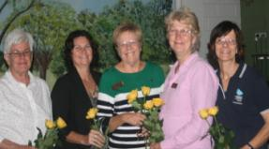

**Zonta Charters Towers Executive** (L to R):

Robin Bassingthwaighte, Treasurer,

Tania Van Wijk, Vice-President,

Hilary Grant, President,

Maxine Lockman, Correspondence Secretary

Bea Harris, Minutes Secretary.

Kaylee Cumming receives a cheque from President Hilary Grant to attend the

National Youth Conference in Canberra

**Newsletter : June 2015**

***From the President***

The last three meetings have given members a lot to think about, after hearing from our guest speakers.

At the June meeting, the Charters Towers Neighbourhood Centre Community Development Officer Elvene Whitbread spoke to us about domestic violence.

The recently completed report by Quentin Bryce noted that 66,000 incidents of DV were reported to Queensland police in 2013-14. When you consider that only one in four incidents is reported, the number is staggering.

Elvene asked that members become aware of what constitutes domestic violence, not just physical violence, and be supportive of victims who usually feel the DV was their fault.

Tania Downs spoke at our May meeting of her journey with breast cancer. Tania now makes every day count and enjoys life with her family to the fullest. I’m sure Tania’s talk made us sew with a little more purpose at our breast cushion sewing day later in the month.

Fourth year Social Work student at James Cook University, Kaylee Cumming, spoke at the April meeting. Kaylee had been selected to represent her community and young Australians at the National Youth Conference in Canberra and was seeking financial support.

Members were impressed by her passion for her course and her commitment to working with young people and were happy to support her.

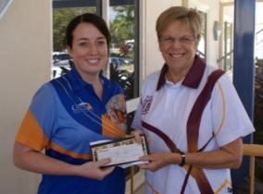

**2015 Changeover Dinner 11 June 2015**

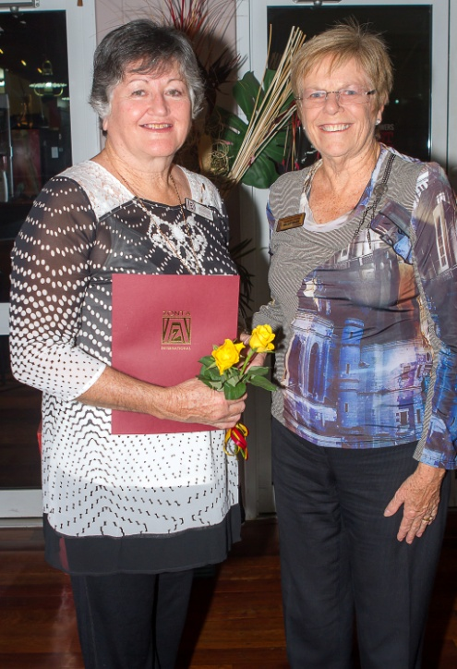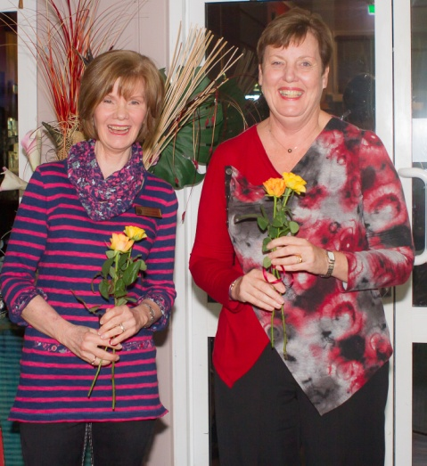

President Hilary Grant welcomes new member Robyn Pratt

Incoming Secretaries, Lesley Collins and

Helen Dixon

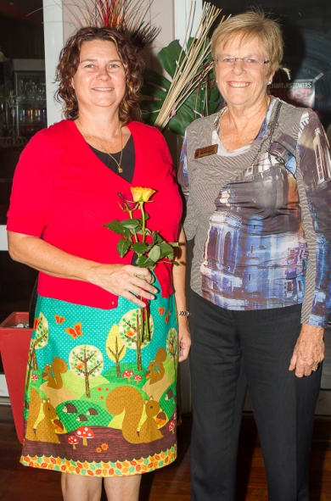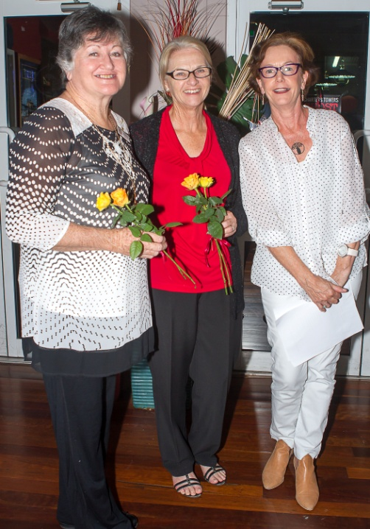

Directors

Robyn Pratt and Judy Barnes

are congratulated by Corral Clarke

Vice-President Tania Van Wijk and President Hilary Grant

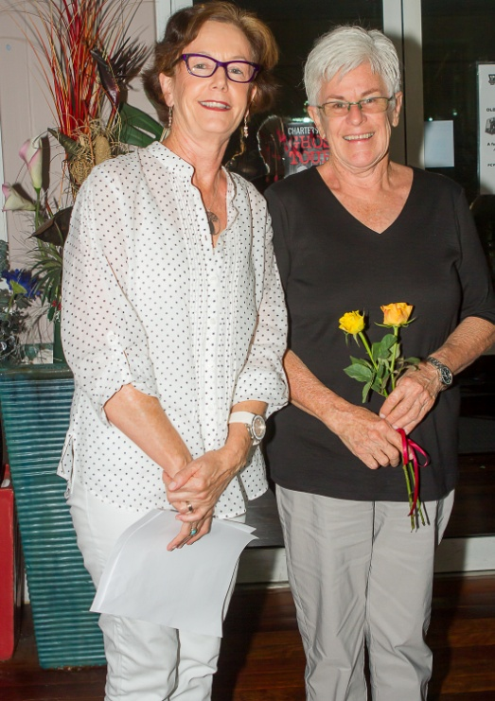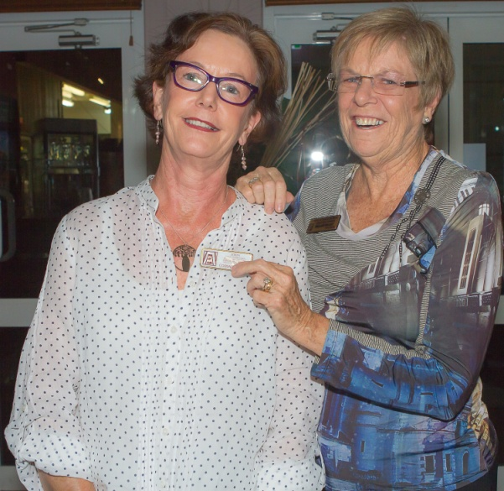

President Hilary Grant presents transferring member Corral Clarke with

her Charters Towers badge

Corral Clarke and

Treasurer Robin Bassingthwaighte



**The Zonta International Foundation**

**5 Things You Should Know:**

1. The Zonta International Foundation has raised almost $US31M since 1994;
2. More than 2 million women’s lives have been impacted through Zonta projects in 57 countries in cooperation with UN agenda and other NGO’s.
3. US$10M has been invested in women’s education through 1,438 Amelia Earhart Fellowships, 357 Jan M Klausman Women in Business Scholarships and 721 Young Women in Public Affairs Award;
4. More than 66,500 donations have been made to the Foundation since 1994;
5. The 2014-2016 Biennium Fundraising Goal is US$5.3m to fund the Zonta International Service and educational programs.

***About Zonta***

Zonta International envisions a world in which women’s rights are recognized as human rights and every woman is able to achieve her potential.

The Zonta Club of Charters Towers holds a dinner meeting on the second Thursday of the month at Henry’s Café and Restaurant, 5.30pm for 6pm.

**To find out more about Zonta,**

**Contact Judy Barnes on 0418 188122**

**or visit the website** [**www.zonta.com**](http://www.zonta.com)

**Well Women Workshop**

The Well Women Workshop, held on March 14, was very well received with 20 local business owners and five Zontians attending.

Vice President Tania van Wijk suggested the workshop as local business owners are feeling the effect of the ongoing drought with constricted sales and income.

“Financial burden is well known to have significant effects on the individual’s ability to cope with everyday stressors and demands,” Tania said.

“People may find they are prone to feeling anxious, overwhelmed and hopeless, with an inability to look forward to brighter and more hopeful times.”

The workshop was all about helping business owners develop creative coping strategies to guide them in improving emotional energy and creativity levels to bring greater satisfaction and meaning into their lives.

Presenters were Frontier Services Support Services Co-ordinator Jeanie Brook and author and community health worker Tamara Hogan.

The workshop was followed by supper which allowed the participants to network and compare experiences.

Our thanks to Tania for pulling the workshop together, to Sue Farmer for the venue and supper, and to the members who helped make and assemble the goody bags which were handed out to each participant.

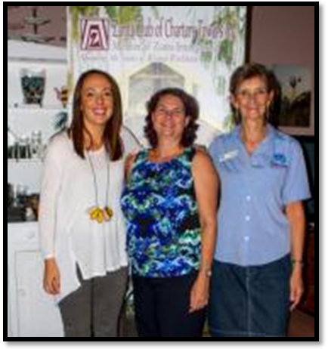

Well Women Workshop Presenters Tamara Hogan (left) and Jeanie Brook (right)

with Vice President Tania Van Wijk (centre)

**Zonta at work and play…..**

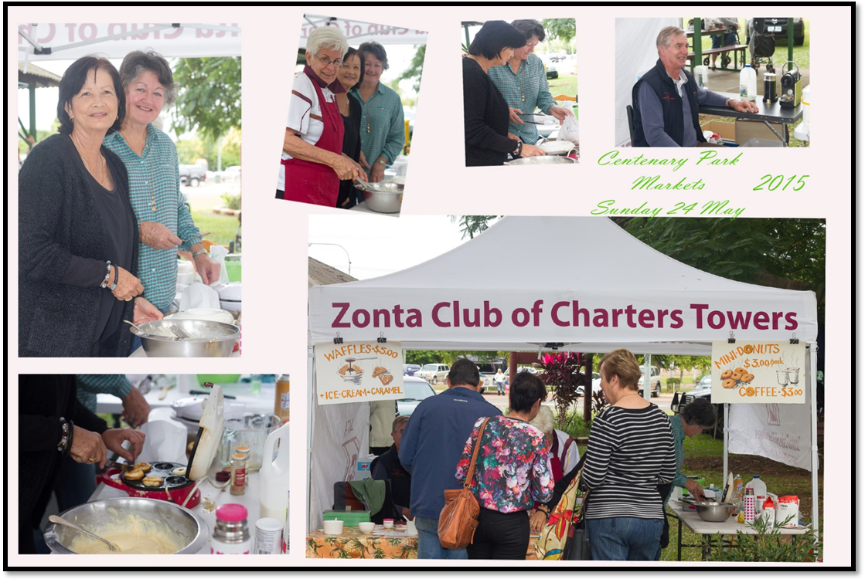

Making Breast Pillows - Sunday 24 May and Sunday 31 May

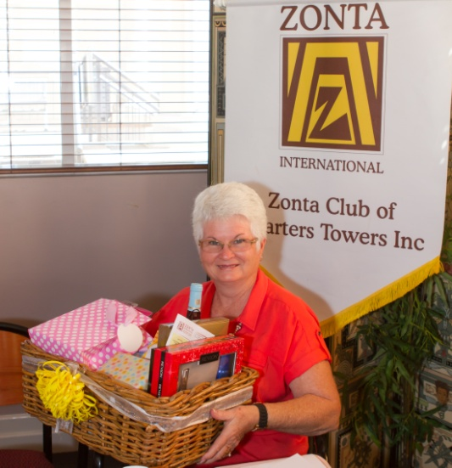

Mother’s Day Morning Tea 10 May:

Kate and Carmen Thomson (left) and

Jan Maher (right)

