NEWSLETTER
MAY 2018

PRESIDENTS REPORT
Well once again a very busy couple of months with lots of fund-raising, our AGM, Area 3 meeting and welcoming new members. Jess Pearson and Trish Williams we are very excited to have you both in our club and hope that our association will be a satisfying, positive experience. We look forward to sharing some fun and employing your considerable talents to benefit the lives of women and girls both locally and across the world through Zonta projects.
We are all a bit worn out after two Bunnings Barbeques and a Blue Illusion Fashion parade. But our funds are growing which means we can support more projects, giving us all renewed enthusiasm.
Not to mention our Go Fund Me page to raise funds for birthing kits this year. We are now made over $1800 , which means we are over half way to our goal. Fantastic effort everyone! Don’t forget to encourage friends and family to pass it on through their networks as well. In case you need it here is the link again.
https://www.gofundme.com/zontas-birthing-kit-fundraiser
Thank you as always for your donation!

AREA THREE MEETING AT BEAUDESERT

Well this was a very a enjoyable, informative day meeting up with some previous friends and making some new ones. I sat with a group from Caloundra Club and they were a lot of fun, making me feel very welcome, not to mention a wealth of knowledge about all things Zonta. As usual Beaudesert Club did a wonderful job of planning and executing a very successful meeting. The time keeper was very strict but that worked well. It was great to meet up with Ans again, thank her and wish her well in the future on behalf of our club. I mentioned another dinner get together [like we had last year} after Convention and she is all for it. Took some photos of orange women and would like to get a couple for our club.

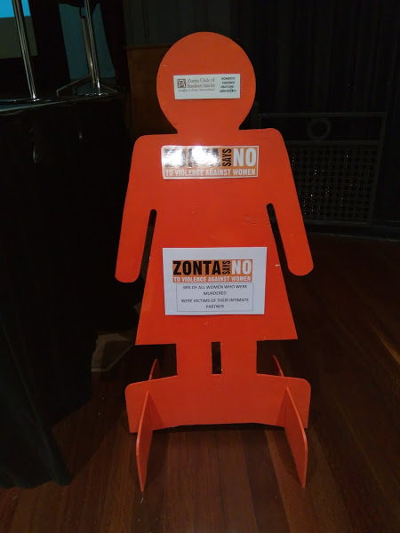

BUNNINGS at TWEED
Once again another very successful day, exceeded all expectations again. Big thanks to all who were able to help. Real commitment and conviction right there.
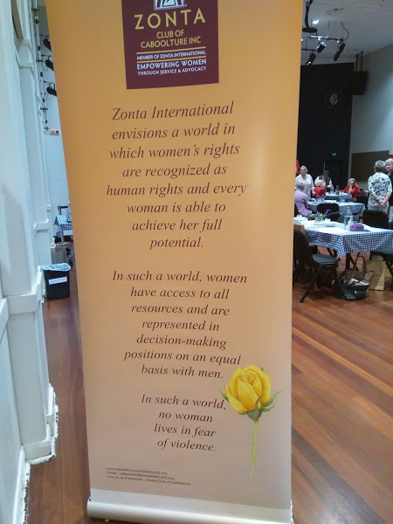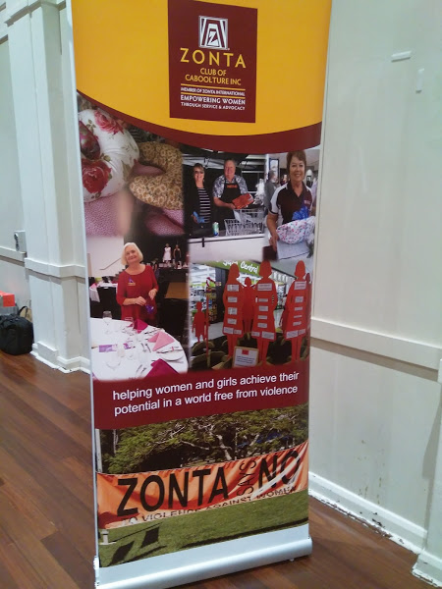

WAS RATHER TAKEN WITH THIS DOUBLE-SIDED BANNER AT AREA MEETING. It was explained to me that some members wanted words and some wanted photos on the banner so this was a compromise.

BLUE ILLUSION FASHION PARADE
Once again great fun. I had to be practically thrown out at the end. Was the first to arrive and the last to go. Big thanks to the staff as usual. They did a great job and the new manager Cassandra was lovely and very helpful. Our members Lesley-Anne, Susie and Pauline once again did an inspiring job of modelling and made all the clothes they wore look even better.
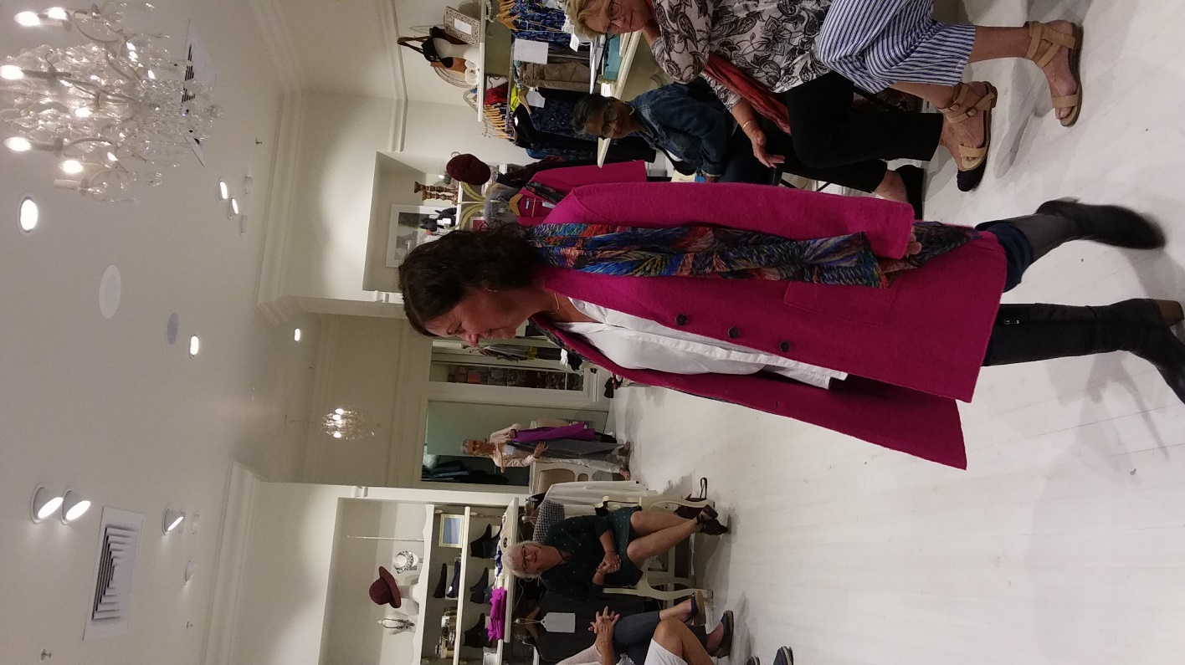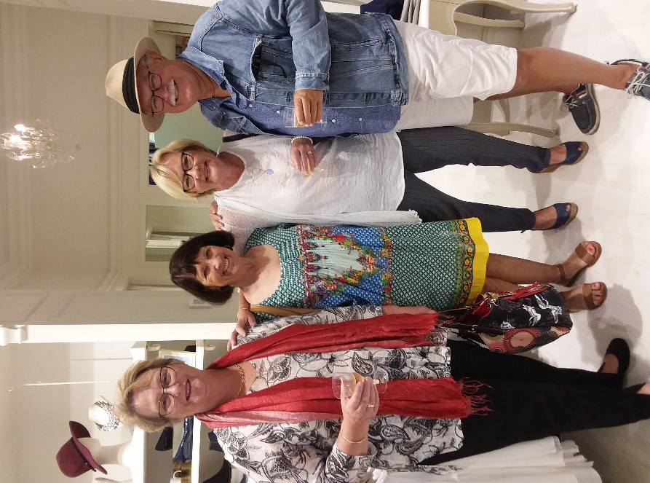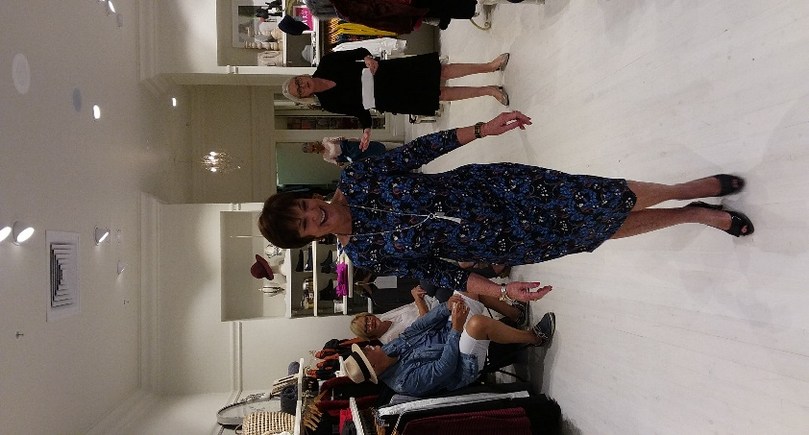

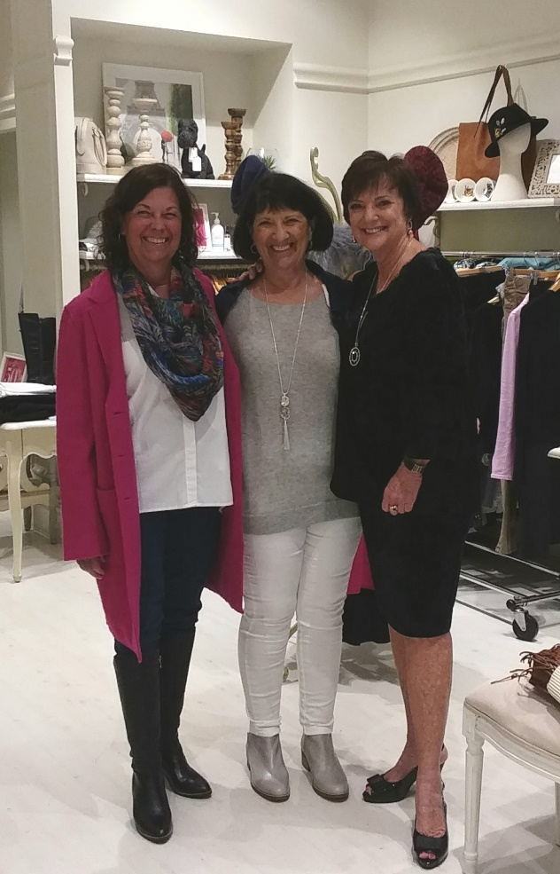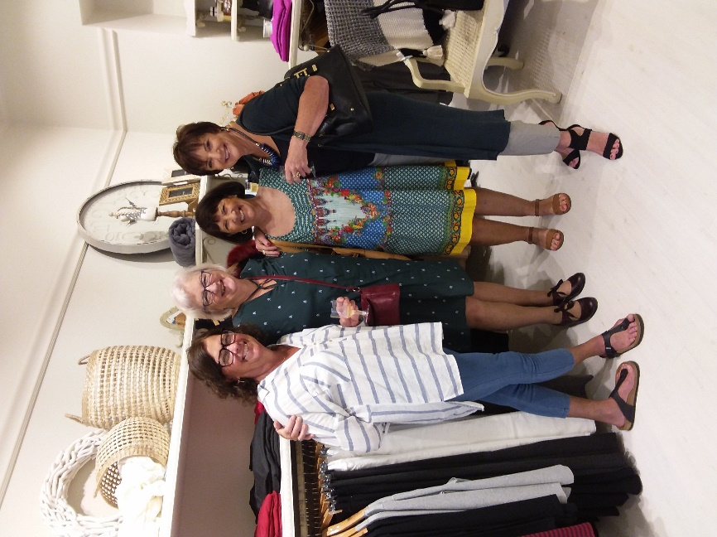
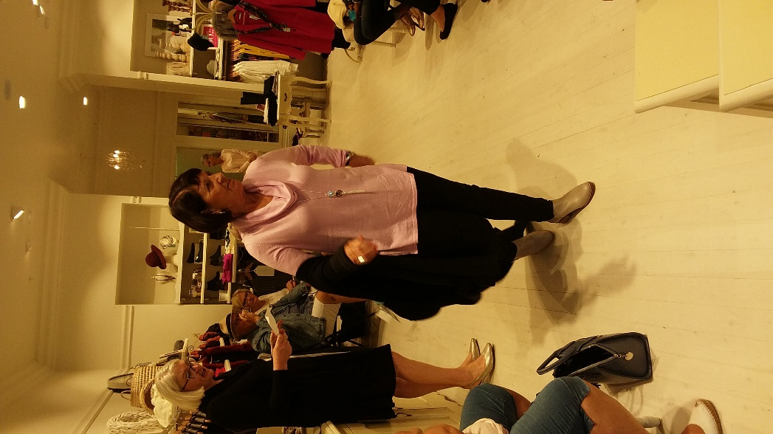

SANCTUARY VISIT

Went out to see Simone and discuss where she sees our role in the coming year. She totally emphasised how really grateful she is for all that we have done out there. Even though she has lots of support now she says that without the help early on, big and small she would definitely not have got so far. The Sanctuary is definitely looking like a real home now, with the main house cleared out and looking spacious and inviting. All old carpet gone, replaced by tiles in bedrooms and outside veranda looking very comfy and practical.
We have reached agreement that she will notify me of any special needs of help and if possible we will respond. Eg cooking for recent working bee. This is instead of our regular monthly visits. Of course any of us is welcome if we wish to visit anytime. They have now fenced off an area 25 x 25 metres in the lower paddock for a vegie garden and any helpers to get that going will be appreciated.
Her main aim now is the outside kitchen, so we discussed electrical goods for the area eg cookers, microwaves, dishwasher. Best to get these new. Will discuss at next meeting. Below is back area, members worked hard to get this tidied.
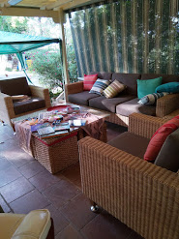
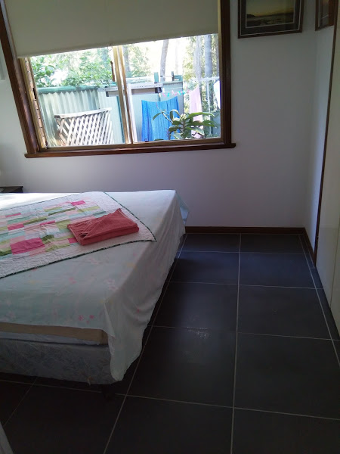
One of the rooms where old carpet pulled up and now bedroom

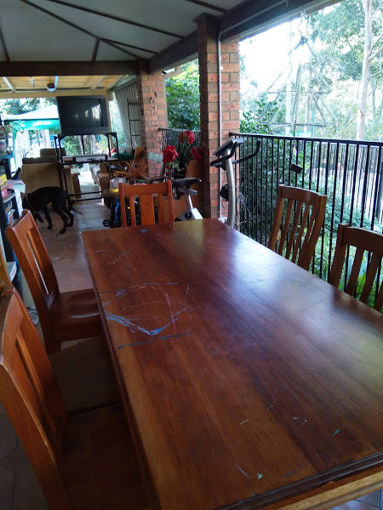

Outside area used for painting classes
ANNUAL GENERAL MEETING – INCOMING BOARD & DIRECTORS
President - Rhonda Allen
Treasurer - Lesley-Anne Marsh
Minutes Secretary - Susie Dunn
Directors -
Merle Stephan - Breast Cushions
Louise Frost - Care Packs
Jess Pearson - Fund raising and social media

SAVE THE DATE
Monday 21st May – Dinner meeting 6 for 6.30pm at South Tweed Sports Club
GUEST Annie Ford Rose to talk about Love Bites
Monday 11th June - Board Meeting – 6pm Currumbin RSL
Monday 18th June – Dinner meeting 6 for 6.30 at South Tweed Sports Club

