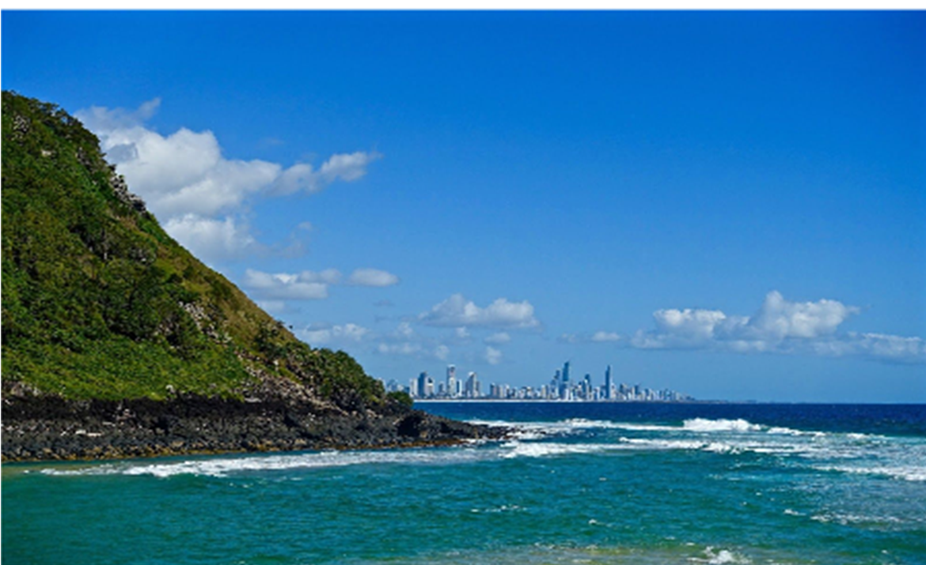

PRESIDENTS REPORT
MARCH
2018
Zonta
Southern Gold Coast
Tweed

SS
Soursss
Newsletter
As I sit here on this beautiful autumn morning, sun streaming in across the patio and into my door, gentle breeze, birds singing, it is impossible to understand what too many women are enduring across the world, right at this moment. By an accident of birth, or fate or luck it is not me but it could so easily be. It is so easy to throw up our hands and say what can we do? Then I think of Zonta and what we are doing here and across the world. Through Zonta International projects we can help women and girls achieve their best through education and all kinds of practical support. Change is slow and won’t happen overnight [unfortunately]. But we are making a difference now and for the coming generations yet to be born. Alone it is easy to feel despondent but together we can and do achieve a lot. A very busy time coming up for our club with lots of full on fund raising which will allow us a lot more options when we think about our service projects for the new Zonta year. Speaking of which not long to conference now and I can’t wait to see what the new biennium goals are. Also excited to report that our club is enthusiastic about the offer of a bursary to a girl who is in need of some extra support to complete her secondary education. Letters will be going out to our local schools this week. I wonder what those girls in school in Madagasgar are doing right now.

SOROPTOMIST TRIVIA NIGHT
How good was it to all gather on a wild stormy evening at Burleigh Surf Club for a trivia night with the Soroptomist Club? Many of us there were not aware of what they did and meeting them and learning more was great. We have now linked up with a lovely bunch of people who have promised to come to our theatre night as we will come back to support their efforts in the future. It was also good for all of us to meet and just enjoy each others company as a club. [the gavel may have come in handy at times.] Unfortunately I cannot report that we won anything as some of the questions were a bit obscure, we will blame that anyway. The important thing was the funds were being raised to sponsor 3 women to have the fistula repair surgery and rehabilitation at the Catherine Hamlin Hospital in Ethiopia, which is a cause very dear to our hearts.

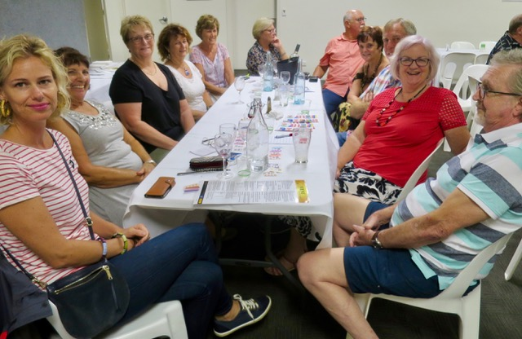

Kaye and Andrew were obviously paying attention up the back

WORKING BEE AT THE SANCTUARY
EXTRA SPECIAL THANKS to those who were able to get along. It was a particularly hot, sunny, humid day when just breathing makes you sweat. Simone had suggested a few jobs we might like to tackle eg painting the finished unit, hanging some prints on walls, shovelling hay or pulling up old carpet. Our intrepid members chose to lift carpet and what a brave choice. I know what we do is so appreciated but this seemed to be above and beyond. It is great that we can tackle some of the big jobs, but please take care. Keep in mind we can just visit for a cuppa and a chat if that is all we can manage on the day.

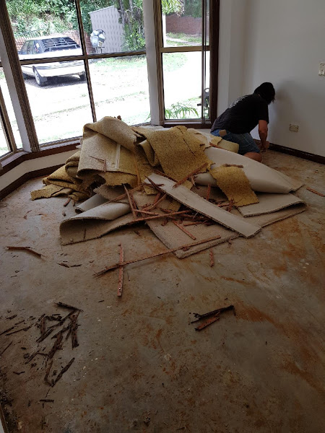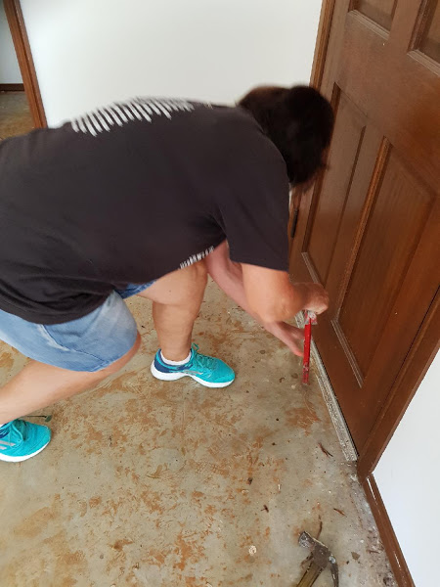

Pauline working hard.

LOVE BITES PROGRAM
This program was mentioned at our last meeting with a view to possibly sponsoring it in a school or several schools if there is not this or a similar
program currently being run there. It seems like a concrete way to promote prevention of violence against women. Early intervention is a key factor with some of our young people having poor or absent role models at home.
Some background about the program -
Love bites program was developed in 2003 on the mid north coast of NSW. It was supported by the National Association for Prevention of Child Abuse and Neglect [NAPCAN} in partnership with community organisations and schools. Love bites is a respectful relationships program for young people between 14-17 years old and is usually run as a one day workshop. The curriculum
addresses both domestic and family violence and sexual assault. This includes defining different types of relationship violence, myth deconstruction, ethical bystander strategies, skills building activities and the promotion and modelling of respectful behaviours.
I have made initial enquiries to determine what our next step may be. Hold that thought until next meeting.

Days for Girls
We are going to have a very special speaker next meeting in Kathy Rodgers. She is the boss of Days for Girls Gold Coast and will be able to inform us about the great work that is being done in that space. Days for Girls has reached over one million women and girls in 116 plus countries with kits and menstrual health education. This translates to over 115 million days of dignity, health and opportunity for women.
The founder Celeste Mergens was working with a family foundation in Kenya in 2008 when she asked ‘What do the girls do when they have their period?’ She was told they wait in their rooms. She learned that girls were sitting on cardboard for several days each month, often going without food. This prompted her first intervention - disposable pads. But disposal of them was not sustainable. Plan B involved a washable long lasting pad and the kits were born. We can all be involved in this, the beauty of it that there are many ways to help out and Kathy will give us lots more information at the next meeting.

BUNNINGS BARBEQUE

B

BUNNINGS BBQ
14TH APRIL – BURLEIGH WATERS
28TH APRIL – TWEED HEADS

COMBINED AREA 1 AND 3 MEETING
THE CENTRE BEAUDESERT
APRIL 21ST 8.30 – 5 PM

BLUE ILLUSION FASHION PARADE
5TH MAY 11.30
ROBINA TOWN CENTRE

INTERNATIONAL CONFERENCE
Registration is now live

NEXT MEETING
MARCH 19TH
SOUTH TWEED BOWLS CLUB
6 FOR 6.30 QLD

SAVE THE DATE

