NEWSLETTER – MARCH 2013
In this Issue:

- 2013 IWD Guest Speaker
- St Gabe’s Z Club
- Update on 2012 Higher Education Scholarship Winner
- 2013 Higher Education Scholarship Winner
- IWD Yellow Rose Honour Role
- 2012 in pictures

2013 Guest Speaker

Kylie Stretton, her husband Shane and children Ella-Beth and Clancy live on a small block just south of Charters Towers. They run a small beef herd as well as their own livestock agency.

Kylie is a passionate advocate for Australian agriculture and rural communities. She channels this passion into initiatives such as a Facebook site, Ask An Aussie Farmer, “an idea grown by real Aussie farmers so that you can have your food and fibre questions answered by those who produce it for you.”

In 2012 Kylie became an Art4Agriculture Young Farming Champion representing Beef. In this role, Kylie visits schools in urban areas such as Brisbane and Sydney to talk to students about beef production, life on a cattle station in Northern Australia and careers in agriculture.

Kylie was a 2012 finalist in the Queensland Rural, Regional and Remote Women’s Network’s (QRRRWN) Strong Women Leadership awards for her dedication in telling the story of rural Australia. She has recently been appointed the QRRRWN Social Media Coordinator, assisting the organisation in its goal of growing the potential of individual women in regional communities through a collaborative, innovative network.

Zonta International is a worldwide service organisation of women in business and the professions working together to advance the status of women through service and advocacy. Today 30000 women in 1200 clubs in 67 countries are involved in Zonta projects. Find out more www.zonta.org

The Zonta Club of Charters Towers is pleased to welcome the St Gabe’s Z Club.

The St Gabe’s Z Club received their Charter from Zonta District 22 Governor, Judith Anderson on Wednesday February 13 at a special charter dinner.

Sponsored by the Charters Towers Zonta Club, this group of young women from All Souls St Gabriels School has already embarked on their project of service, raising funds for the purchase of materials to assemble birthing kits for women in third world countries.

St Gabe’s Z Club President, Cheyenne Gamble is looking forward to the year ahead as she and her team embarks on their journey of service, advocacy and advancing the status of women, with a particular interest in the way young rural women can achieve their goals and aspirations.

The Z clubs are designed to provide opportunities for members to develop communication and leadership skills, explore career alternatives, and to participate in community, school and international service projects.

There are currently 234 Z and Golden Z Clubs in 19 countries around the world working to improve their society and the world.

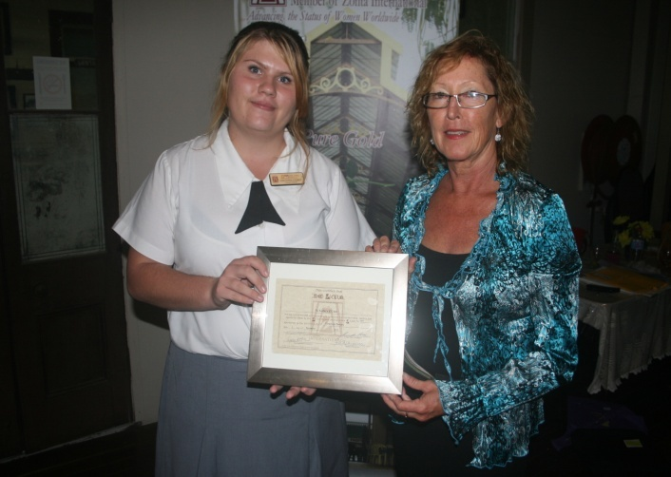
District Governor Judith Anderson and Charters Towers President Jenny Black welcome the St Gabe’s Z Club members (Photo courtesy of “The Northern Miner”)
St Gabe’s Z Club President Cheyenne Gamble and ASSG teacher Helen Leicht proudly display the club charter

2012 scholarship recipient Megan Stafford continues to excel in her Bachelor of Multimedia Journalism achieving the status of “Best Second Year Journalism Student (an award she also received in her first year). As well as her university studies, Megan works 16 hours a week on “The North Queensland Register” covering many events from her home area of Richmond. To that end Megan decided to spend her scholarship cheque on an SLR camera, a necessary piece of equipment for her study and work.

2103 Higher Education Scholarship Winner
Lauren Briody

After residing in Charters Towers her whole life and attending Columba Catholic College, where she was College Prefect, Sportswoman of the Year and College All-Rounder, Lauren is now undertaking university studies in Brisbane. Lauren has just commenced her second year of a Bachelor of Architectural Studies at the Queensland University of Technology. She is also undertaking the study of a second major of Construction Management. Lauren has always wanted to study Architecture from a very young age and is enjoying the course immensely. Within the next few years Lauren hopes to travel and study abroad as much as possible, before gaining her Australian Architectural Registration and practicing as an Architect both in Australia and internationally.
Lauren would like to thank the Zonta Club of Charters Towers for the generous scholarship which will undoubtedly assist in managing the additional, yet unavoidable, travel, commuting and accommodation costs that young women in rural areas attending university face. Often these additional expenses, coupled with the already excessive costs of university, prohibit young women in rural communities from gaining a higher education, so the work of Zonta is definitely invaluable.

The Zonta Yellow Rose Honour Role

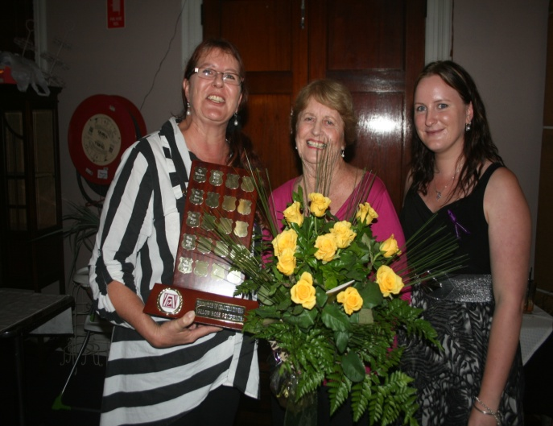
Each year on International Women’s Day, the Zonta Club of Charters Towers presents a bunch of yellow roses to a member of the community to acknowledge their service over many years.
2007 Lyn Snowdowne- Charters Towers Queensland Cancer Fund and Lions Club
2008 Ann Dunn- Lions Club
2009 Dot Birgan- First and Only female mayor of Charters Towers
2010 Shirley Symes- Restoration of the Stock Exchange, reopening of the Don Roderick Gallery
2011 Meg Ogilvie- St Vincent de Paul and Towers Players
2012 Dulcie Black- Leukaemia Foundation, supporter of the Arts (RADF, Arts Council, Towers Players)
2013- ?

2012 Yellow Rose recipient – Dulcie Black is congratulated by her daughter and granddaughter, Su and Sarah McLellan

