
June 2005

Zonta Club of
West Moreton Inc.
Inside this Issue
1 | President’s Message
2 | Zonta Events, Meeting Details and  Members News
3 | Events and Birthdays
4 | Zontians You Should Know & IGGS Z-Club
5 | UN Newsletter
6 | UN Newsletter
7 | New Committees
Our Club Website :

http://westmoreton.
zontadistrict24.org/

Zonta Club of West Moreton Inc.
PO Box 505
Ipswich Q 4305
Club No. 0900; District 24; Area 6

President’s News
.
.
.
Zonta Newsletter
From New President Leoney Peasey
What an amazing start to our new Zonta year – I must thank everyone who contributed to making the Change-Over dinner such a success. Seeing our members, families and friends, as well as our invited guests so engrossed in conversations and enjoying the ambience on the verandah of the Ipswich Club, convinces me that the forth-coming functions will be eagerly anticipated and supported.
Sue Hutley and I attended a meeting at UQ Ipswich on Wednesday 15th June to discuss the Leadership for Girls programme with Michael Cuthill. Michael is now in the process of developing strategies and evaluation criteria, which will in turn give us greater feedback.
Although Elizabeth Hudson may not be available as facilitator, it appears that there will be a suitably qualified person to ensure the continuation of the programme.
I hope that the ties between UQ Ipswich and Zonta will soon be further strengthened by the formation of a Golden Z Club.
July promises to be a busy month, commencing with the dinner at the Parliamentary Annexe for Mary Ellen Bittner on the 13th July. If you wish to attend this dinner, please contact Helen Walker.
A Presidents meeting is to be held at Diana Douglas’ home on the 16th July and board members are also invited to attend.
The 17th July is of course the Heritage Homes Tour, which promises to live up to its usual excellent standard, this year having five homes to visit. This wonderful fund-raising effort would not be possible without the kindness of the owners in opening their private homes to us.
The following week is Toowoomba Zonta’s ‘Quilts for a Cause’. Perhaps a car pool can be arranged for those who wish to attend?
Chairs are yet to be appointed for the new committees, which are listed further on in the newsletter.
I would ask that at your first meetings your chair-person be appointed, and your meeting dates set for the first half of the year, and forwarded to me, as I would like to attend a meeting of each committee.
I am looking forward to a great year for our club, building on the hard work of our members to continue to raise funds for Zonta International and our community, welcoming new members, and enjoying the friendships which develop.
Leonie

.
.
.
.
Zonta Events

Date : Monday 27th June
6.15pm at The Ipswich Club
Zonta Dinner Meeting

Date : Friday 15^{h} July
Newsletter items Due – to Sue Hutley. Phone through your news on 3202 3436

Date : Sunday 17th July
Heritage Homes Tour

Date : Sunday 24th July Toowoomba Club’s Quilt for a Cause

Date : Monday 25th July
6.15pm at The Ipswich Club
Zonta Dinner Meeting

Date : Sunday 25th September 2005
Toowoomba Garden City Club’s Jazzfest in the Garden

Date : Friday 7th – Sunday 9th October
Gold Coast
District 24 Conference
Zonta – Making a Difference
June 24-29, 2006
Zonta’s 58th International Convention - Melbourne

JUNE MEETING DETAILS

MONDAY 27th June
6.15pm for 6.30pm
at The Ipswich Club

FIRST MEETING OF THE NEW COMMITTEES

Usual Dinner Cost - $22 per person

IMPORTANT :

Please phone Vicki Doig on 3812 8009

please also indicate if you are bringing a guest
or with apologies
or any special dietary requests
(e.g. a vegetarian meal)
before 9am Friday 24th June.

REMINDER: If apologies are not received by stipulated time of the meeting week, you are required to pay for the cost of the dinner. The Treasurer will send you an invoice.

Door Duties : Vicki and Gillian

Members News
Heather Brodie is off the Europe for 6 weeks – through Norway, Oslo, Great Britain and taking in all the ‘romance’ of Europe including Prague – where she will be catching up with some Zontians and delivering Ipswich gifts. Past Member Rae Peacock and husband Doug also going on holidays at the same time to Alaska and the Rocky Mountains.
Dianne and Jennifer took a quick trip to Bali recently. They recommend buying pearls there and would like to suggest a Zonta 5-day retreat there sometime next year ☺ ☺
Pam Lane has been very busy at work lately and we wish her well.
Jennifer and Peter are off winter-tripping to Canberra, lunching at Parliament House, catching Question Time and also seeing family.


Reminder :
AN INVOICE WILL BE AUTOMATICALLY SENT TO MEMBERS FOR THE COST OF THE DINNER IF THEIR NAME IS NOT ON THE APOLOGY LIST.

Heritage Homes Tour

Don’t forget to contact Pam Lane to secure your seats for Sunday 17th July. More Flyers available at the June Meeting.
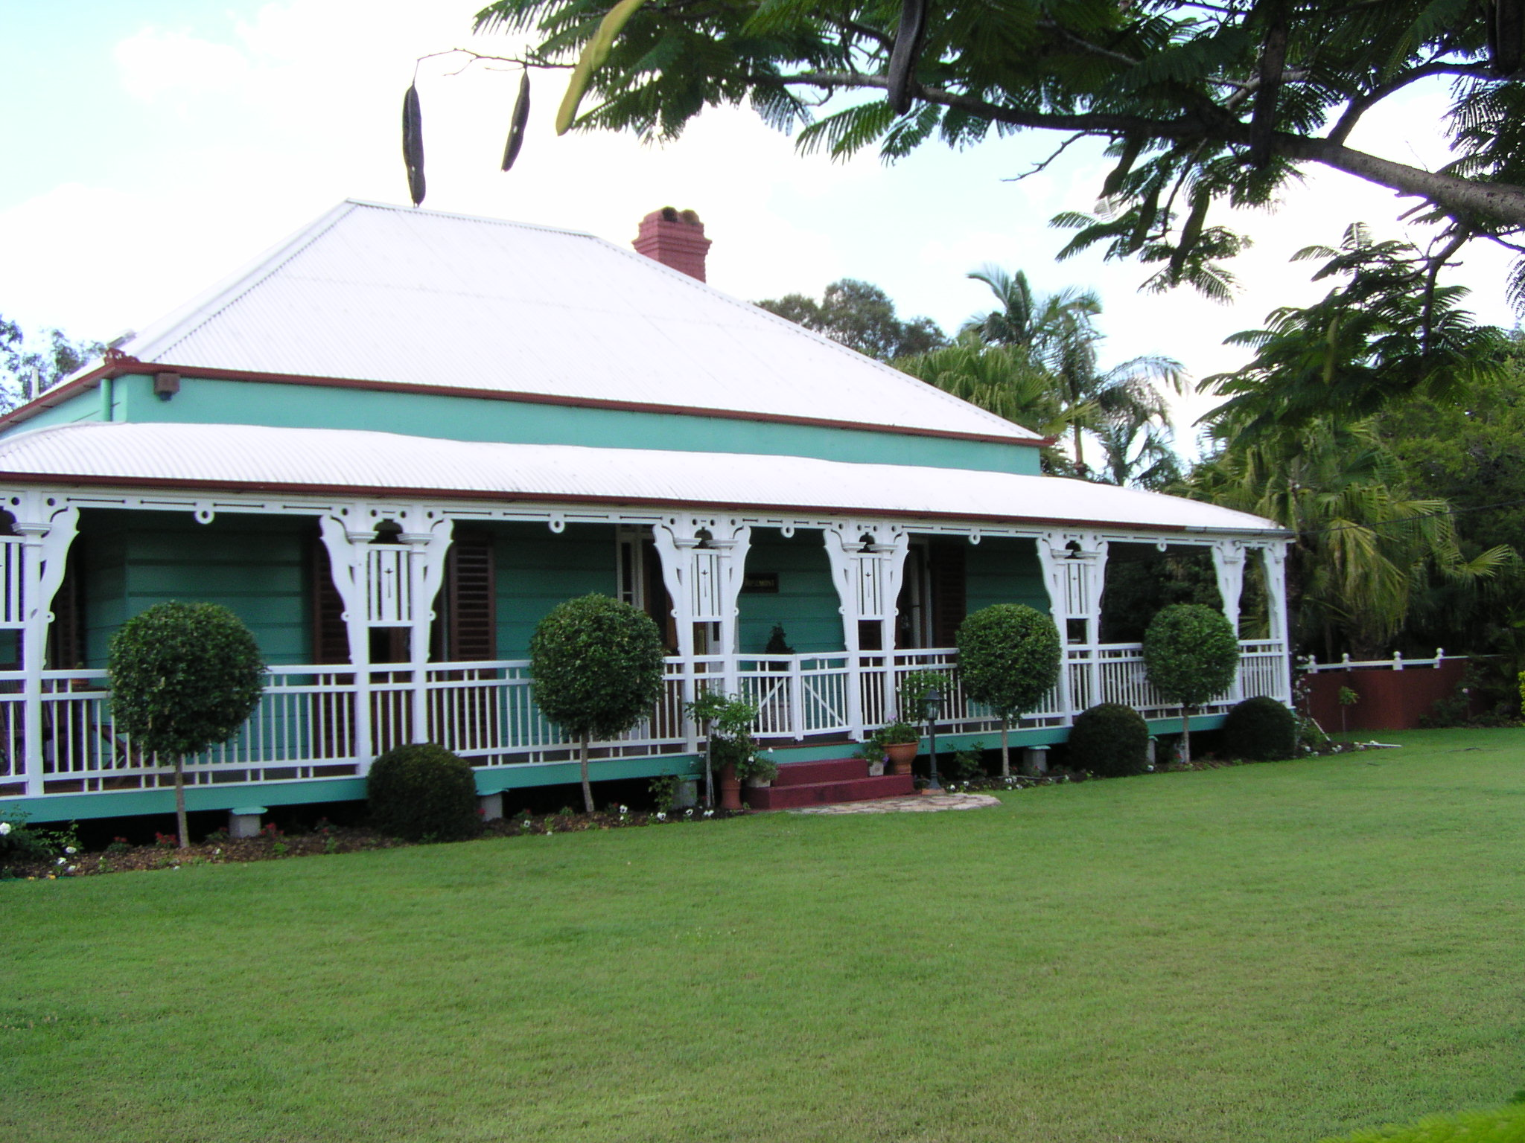

Reading Challenge
RIVERBEND READERS’ CHALLENGE
FOR FURTHER INFORMATION:
Speak to Eirys or log onto www.riverbendreaders.com.au

Mary Ellen’s Visit
When : July 13, 2005

Dinner with Zonta International President, Mary Ellen Bittner at the Parliamentary Annexe, Alice St., Brisbane, hosted by The Honourable Desley Boyle, Minister for the Environment, Local Government, Planning and Women. Cost $40.00. 6.00pm for 6.30pm.
Inquiries can be made by contacting Ros Kinder on 3378 3675 or 0419 026 756 or by email : roskin@gil.com.au

Did you know?

International President 2004 –2006, Mary Ellen Bittner, has been a member of the Zonta Club of Washington DC since 1982. She has a Master of Arts degree in economics and has been recognised as a “Woman of Courage & Vision” by the Drug enforcement Agency. She is a Chief Administrative Law Judge, US Department of Justice, Drug Enforcement Administration and her responsibilities include the hearing and deciding of complex cases arising under the US Controlled Substances Act & Administrative Procedure Act, heading the office, preparation of budgets & overseeing of operations and supervision of staff. Her personal interests include programs that help women achieve economic self sufficiency and mentoring and her hobbies are cooking and needlework.

Please take the opportunity to meet and speak with Mary Ellen on July 13 in Brisbane.
West Moreton RSVP’s to Helen Walker A.S.A.P !!

Zonta Club Birthdays
Many Happy Returns in June to :
Vicki Glenn
Amy Bev
and Many Happy Returns in July to :
Joie

[ Did we miss your name? Please contact Eirys to confirm your birth date for our records – or catch up with her at the June meeting ]

From Toowoomba…

ZONTA’S

QUILTS for a CAUSE

AN EXPO OF QUILTS

BROUGHT TO YOU BY
THE ZONTA CLUB OF TOOWOOMBA AREA INC.

SUNDAY JULY 24TH

10.00AM - 4.00PM

THE GLENNIE ROOM
GLENNIE SCHOOL
HERRIES STREET TOOWOOMBA

ADMISSION $10
ALL PROCEEDS
INCL. GLASS OF AMPAGNE TO BREAST CANCER
OR TEA OR COFFEE ASSOC.OF QLD

ENQUIRIES
TwBa Club Members
VICKI 0412360197
HELEN – 0403005943
AMANDA - 46323812



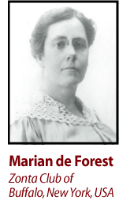

Honored at Zonta’s Gala 15th Anniversary Celebration as the founding mother and “original moving spirit” of the Confederation of Zonta Clubs, Marian de Forest created the first women’s service classification system prompting the creation of Zonta.

Elected president of the Confederation in 1924, she was among the first members to stress the importance of Zonta’s international growth. At her death in 1935, after 15 years of membership, Marian had helped the Confederation grow from nine to 124 clubs in North America and Europe.

PROFILE :
IPSWICH GIRLS’ GRAMMAR SCHOOL - Z CLUB
Formed: January 1996 with 30 members a ranging in age from 12 to 17 years

Location: Ipswich, Queensland, Australia

Sponsored by: Zonta Club of West Moreton Area Inc.

Service Activities:
- Participation in Clean Up Australia
- Collection of books, stationery items and clothing for orphanage in Thailand and a school in Vanuatu
- Helping to promote Zonta in the local community
- Addressing the school assembly to raise awareness about global issues relevant to women
- Co-ordinated school wide support for Save the Children Fund, Cancer Fund and UNICEF projects

Fund Raising Activities:
- Hot chocolate stall before school
- Muffin stall at the school Medieval market day
- Fashion Parade with Ipswich Grammar School
- Making and selling ribbon badges for International Women’s Day (purple, green and white)
- Making and selling raffia dolls at the school International market day

Organisations supported:
- Unifem Australia
- Hamlin Fistula Relief and Aid Fund
- Medecins sans Frontieres
- Ipswich Women’s Centre against Domestic Violence
- Vanuatu village primary school
- Dale Spender’s Second Chance Program
- Abused Child’s Trust

Latest News : The Z Club has combined with the IGGS Amnesty International committee to run a hot chocolate stall before school three mornings a week. It has been a successful venture and they plan to continue with it next term. It should be even more popular as the weather becomes colder. At the IGGS Open Day on 23 July the Z Clubbers will run a stall, possibly a combined fundraising-awareness raising stall, but more on that at a later date.

2004-2006 Zonta
Biennial Goals
- Focus on our Mission
- Combine Service and Advocacy
- Recruit, Retain, Rejuvenate

June 2005
Volume 2
ZONTA

INTERNATIONAL

DISTRICT 24
Inside this Issue
1 | United Nations Days coming up  How some Clubs have promoted UN Days  Australia’s report to CSW
2 | Female Genital Mutilation  Conference 2005 UN Committee Recognition Awards
District 24 Website:
http://www.zontadistrict24.org
Zonta International Website:
http://www.zonta.org

Margaret Casey
District 24 United Nations Chairman
Email: excels@gil.com.au
PRESIDENTS - PLEASE COPY OR CIRCULATE TO EACH CLUB MEMBER
.
.
.
International Newsletter
For future reference as necessary.

Welcome to the United Nations News Letter No 2.
Thank-you to the Clubs who have gone to the trouble of forwarding their Newsletters and Reports to me. It is gratifying to see the work that is done at a Club level.
United Nations Days
June
4th - Day of Innocent Children and Victims of Aggression
5th - Environment Day
26 - Day against Drug Abuse and Trafficking
July
11th - World Population Day
September
8th- Literacy Day
Third Tuesday - Day of Peace

What Clubs have been doing to Celebrate and Promote the following United Nations Days.
8th March – International Women’s Day / Rose Day
Toowoomba Club organized an International Women’s Day breakfast; Lyn Boyle from ‘The Chronicle’ was their guest speaker. Toowoomba Gardens Club had 7 of their members in attendance. It is great to see Clubs supporting other Clubs functions. Congratulations to you all.
Bundaberg Club held a breakfast also. A PowerPoint presentation was shown, honouring some of the pioneering women, innovators and unsung heroines of their district. Their guest speaker was Hazel Marland OAM, a most remarkable woman.
Wynnum Redlands Club member Judith Trevan Hawke organized a very successful International Women’s Day dinner, guest speaker being Rotary Peace Scholar Sanjana Hattotuwa.
7th April – World Health Day Sydney Breakfast Club was informed through their newsletter of the high mortality rate of both women and child during and post childbirth in under developed countries.
COMMISSION ON THE STATUS OF WOMEN
In a statement released recently Australia has reaffirmed to the Commission on the Status of Women of its strong commitment to the Beijing Declaration and Platform for action.

The reports that the regional groupings submitted to CSW 49 make it clear that despite the many differences between individual countries and regions, there are threads of common interest that we can address. International cooperation to achieve tangible results for women in these areas of common interest is crucial.

Some of these common threads under the 12 areas for action are: the feminisation of poverty; under-representation of women and girls in non-traditional fields of study; HIV/AIDS; cultural and social issues that hamper States' efforts to combat violence against women; the trafficking of women and children; implementation of UN Security Council Resolution 1325; valuing women's unpaid work; the gender wage gap; linking the Beijing process with other international processes for the advancement of women; accessing reliable and relevant sex-disaggregated data; and continuing stereotyped portrayal of women in the media.
(Extracts from Australia’s Country Statement to CSW)
FEMALE GENITAL MUTILATION
Are you aware that approx 6,000 females each day are victims of Female Genital Mutilation? The Fourth UN World Conference on Women, held in Beijing in 1995, represented a historic attempt to overcome the traditional neglect and indifference surrounding women’s human rights. The Beijing Declaration and Platform for Action underscored the obligations of governments to combat violence against women - including FGM - as a priority. In April 1997, three UN agencies - the World Health Organization, United Nations Children's Fund and United Nations Population Fund, unveiled a Joint Plan to bring about a major decline in FGM within ten years and to completely eradicate the practice within three generations.
At an international level, the Plan of Action recommends the inclusion and integration of FGM in the work of various UN specialized agencies and other UN bodies, including the Commission on the Status of Women and relevant treaty bodies such as the Committee on the Rights of the Child. It also urges NGOs to integrate and reinforce their activities.
Zonta Action
An article in the April 2005 Edition of The Zontian p4-5 provides further information on this subject and of course one of International Service Projects over four years 1998-2002 was to make citizens in Burkina Faso aware of the harmful and serious affects of FGM so that this practice will ultimately be abandoned in this country. The project was managed through UNICEF which has developed a comprehensive strategy to eliminate FGM in East and Southern Africa employing the same community based mobilization strategy that was proved successful in Burkina Faso. Countries to be included are Ethiopia, Eritrea, Kenya, Somalis, Tanzania, Uganda and Zambia.
In a statement issued by UNICEF in March 2003 UNICEF stated “With Zonta’s support, Burkina Faso’s fight against FGC has become a model for other countries within the region to successfully work to eliminate FGC. On behalf of the US Fund for UNICEF and the women and children of the world we thank Zonta International for its generous contribution”.
CONFERENCE 2005 UNITED NATIONS COMMITTEE AWARDS/RECOGNITION
Submission - Each club is invited to submit one A4 page outlining UN Committee activities, eg Club Awareness program maybe via Newsletter of Guest Speakers, Community based
Activity etc. Details to be included with submission are as follows – Club Name, Area, Contact details of Club, Activity/Program details, and Actual time involved in providing Activity/Program.
Deadline – Each submission must be received by 16th September, 2005 to enable judging. Late submissions cannot be accepted. Please email to Margaret Casey excels@gil.com.au or post to PO Box 700, Bulimba Q 4171.
Websites for Further Information
www.zonta.org
www.zontadistrict24.org
www.un.org
www.un.org.womenwatch/daw
www.unifem.org
www.inicef.org
Club Newsletters/UN Committee Reports
Don’t forget to include me on your distribution list for these documents so I can share your successes with other Clubs.

ZONTA CLUB OF WEST MORETON
2005-2006 COMMITTEES

Status of Women: Finance/Fundraising:
Glen Walters Gaye Anderson
Sue Wigley Pam Lane
Kath Everett Bev Johnston
Marie Kavanagh Di Maccheroni
Joie Dwyer Maria Kelly
Narelle Gotting

United Nations: Programme:
Margaret Evans Jennifer McMahon
Sheila Ireland Amy Mullins
Cheryl Klaassen Pam Van de Hoef
Maria Stevenson Carolyn Maddox
Robyn Hargreaves Donette White

Public Relations/ Newsletter: Sponsorship & Grants: (Tentative)
Eirys Jones Sue Hutley
Joc Steele Leonie Peasey
Pam Smallwood (Archivist) Jennifer McMahon
Sue Hutley (assisting) (assisting)
Membership: Nominating Committee:
Myrtle Green Amy Mullens
Vicki Doig Robyn Hargreaves
Gillian Wilton
Heather Brodie

