

CHARTERED 10.5.1994 INTERNATIONAL DISTRICT 24
Club No 1475

June Newsletter 2008

Meeting Time:-

6pm for 6.30start

The Club meets on the second Tuesday of each month (except January)

Kalamia Hotel Ayr

Postal Address

PO Box 2204

AYR Q 4807

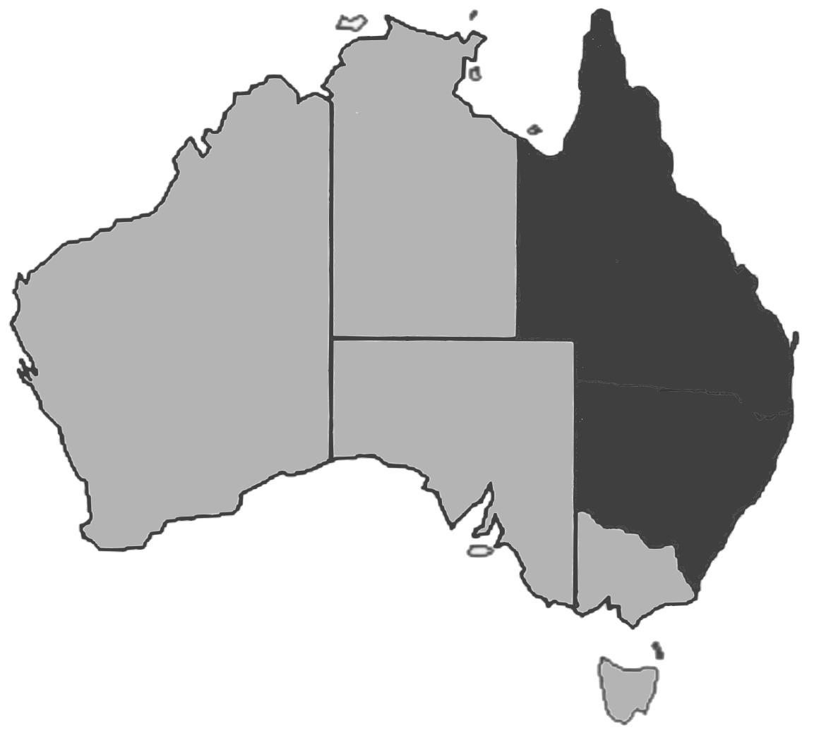

PRESIDENTS REPORT

Welcome everyone to our meeting tonight. It’s the start of a new Zonta year and one that I personally am very much looking forward to. We had our first Board meeting a fortnight ago which proved to be a very informative meeting. All members have been divided into committees – you will find a list in the newsletter tonight. In due course, your committee chair will contact you and bring you up to date on various issues and of course, ask for your input. Please try to participate in this as we are all part of the club and I would hate to have only a few of us make all the decisions regarding our goals and direction.

The next big event we need to deal with is the Car Boot Sale on June 29th. Please get behind this and support organizer Raelene. More on this tonight.

Thanks to those who participated not only in the Relay for Life but also dropped into Giovanna’s home for a drink in the last few weeks. Funds raised will be forwarded onto the Cancer council.

Enjoy the meeting tonight – take a few deep, calming breaths and share your health tip with us. We all stand to learn something I’m sure, and this is one thing I hope we can continue to do throughout this Zonta year – learn something about anything! Knowledge is so valuable.

MARGARET

President:
Margaret Williams

Vice President:
Rita Cranitch

Minutes Secretary:
Judy Scanlon

Correspondence Secretary:
Karen Clarke

Treasurer:
Sandra Roncato

UST TO REMIND US

ATTENDANCE

Giovanna Gabiola is our new attendance officer. Please advise Giovanna by 10am on Monday if you cannot attend the meeting or are unable to stay for the meal.
Giovanna can be contacted on:

4783 3660 (home phone)
4783 2377 (fax) 4783 2777 (work)
0418 186858 (mobile) or via email
jgabiola@bigpond.net.au

Fees: Meeting & dinner $20
Meeting only $5
Fee if apology received $5
Fee if no apology made $20

ZONTA BURDEKIN MEETS EVERY SECOND TUESDAY OF EACH MONTH AT THE KALAMIA HOTEL – 6PM FOR A 6.30PM START.

RAFFLE

Tonight: Dalma Cambruzzi

Next month (July): Kathleen Carew

Birthday Celebrations for June!!!!
Have a Happy Birthday
Ruth Diehm, Giovanna Gabiola, Mary Lynch and Majella Meehan.
Hope you enjoy the special day.



Menopause the Musical

Zonta ladies have organised a group of 18 to see Menopause the Musical and are planning to have dinner at the Chinese Restaurant before hand at 6.00pm. A smorgasbord will be available for convenience otherwise normal menu will apply.

Anyone who has purchased their tickets separately to the group booking is certainly welcome to meet up with the group for dinner.

Please let Karen know as she is advising the restaurant of numbers. We are giving the restaurant numbers due to dining early to be out on time for the show.

From the Manual

Attendance Requirements:
Any member who is absent from all Club meetings for two consecutive months without excuse deemed adequate in the opinion of the board may be notified that membership may be forfeited. Should the absences continue following this notice, the board may notify the member that membership is forfeited. Attendance requirements can be met by attending a meeting of another Zonta Club.

A PROMOTION FOR BETH HONEYCOMBE

After 3 years as a director, Beth has been elected Board Chairman of Tropical Medical Training.
TMT is responsible for an area from Sarina, west to Longreach to the border and north to the Torres St.
Its task is post graduate General Practice training and education in the region.
Its home base is TMT House, adjacent to Red Cross House near the Townsville General Hospital

RELAY FOR LIFE

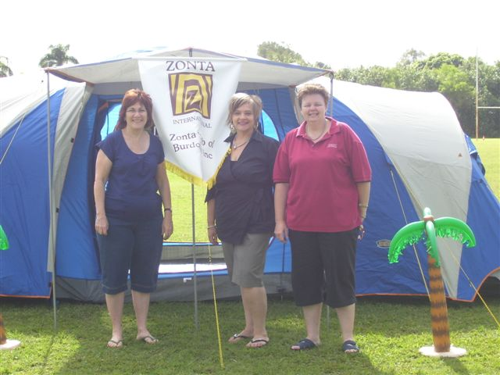
What a new experience. Thanks to the ladies and their husbands for attending. Raelene and family, Beth and Gary, Judy and Ross, Rita and Brian, Janice and Bill, Kathleen, Karen, Dalma, Pierina, and Jo.

Thanks to Kathleen for providing such comfortable
Accommodation. The tent was assembled and the club
Banner flying.

The relay was opened by a walk around the track by the
Survivors and Carers. This was very emotional. From then
On it was up to the teams to have a representative on the
Walking track. There was plenty of entertainment going on
All evening until midnight. At 6pm there was a lighting of the candles ceremony. A message was written on a bag and the candle was put inside and these candles lined the walking track.
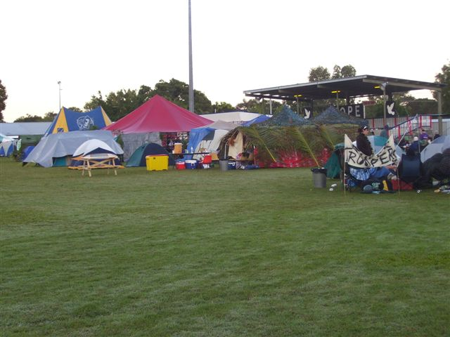
Rugby Park looked like ‘tent city’. There was plenty of
chatting going on and certainly many friendships renewed.
A wonderful get together for all the community. As the
evening got later many of the crowd went home to warm
beds. Rita felt so bad that she went home early and
and came back with Brian in toe at 1.30 and stayed
another hour. Dalma got out of her cosy bed at 4am to
join the troops who walked through the night. We had
worked out a theory that had each member doing 4
rounds of the track then turning in. Brian and Rita walked
with Brian returning to the tent and laying flat out on his back on the ground and sleeping until the next round. Raelene even tried the hard ground. She arrived after working at a wedding and had with her troops from the Kalamia to keep the relay moving. Rosemary and Ray came after the Giru Debutante Ball. New faces were a delight to see.

By daylight some of us were a little worse for wear. Breakfast of bacon, sausage, baked beans, egg, fried onions and capsicum was served with the compliments of the Rotary Club. Free tea and coffee was available through out the relay compliments of ‘Sax’.

Lachlan was very busy during the evening making sure that the tent was always used to the full capacity. There was mosquito netting so when someone left the tent it was Lachlan’s job to make sure that the screen doors were opened and closed. He was also making certain that the correct vents were opened or closed. This was the latest he had ever stayed up.
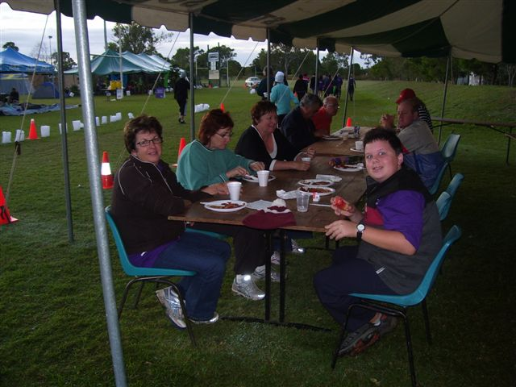
THANKS AGAIN TO ALL WHO WERE

INVOLVED IN ANY WAY NO MATTER HOW

BIG OR SMALL. CANCER IS THE WINNER

Birthing Kits

Dear Zonta friends,
We have just received confirmation we will receive another $200,000 from AusAID for another year. The Zonta Birthing Kit Project will distribute 150,000 kits again and fund midwifery training programs in Vietnam, Tibet, Kenya and Ethiopia, and possibly PNG - all depends on additional funding.
We have applied to other organisations for additional funds as we have had requests for 3,000,000 kits from UNFPA and UNICEF just for Ethiopia.
They have the organisational structure to distribute our kits to women where 100% of births are at home. Many die at home.
The monitoring team found in one province in Ethiopia the Traditional Birth Attendants who had received midwifery training along with our kits had discontinued Female Genital Circumcision. A benefit that was not predicted.
AIDs is rife in the communities, especially Africa and midwives who are frightened of getting AIDs choose not to assist AIDS infected women. The percentage of midwives getting AIDs is quite high. With our kits the midwives will assist these AIDs infected women. Not all babies whose mothers have AIDS will have AIDs themselves. Another benefit we had not predicted.
The Foundation can see we are at the next phase in the project where it will need to grow outside of Australia to source our kits from other Zonta clubs around the world. We are working on strategies for how this can happen. We will soon need to talk to ZI and ZIF.
If there is an opportunity at International Convention in Rotterdam for support for the Birthing Kit Project to be expressed it would be beneficial.
So far there are no Board members going to Rotterdam as we have just come back from Ethiopia and Vietnam on monitoring visits. In the past we have had meetings with the Zonta International representatives in Hawaii, Gothenburg, Melbourne and find the time constraints with a convention can be very limiting. In 2004 we presented the following Zontians with information Mary-Ellen Bittner, Val Sarah, Marg Holzberg, Jane O'Brien, Liz Woodgate, Mary Magee and Ros Kinder. We have met with many other Zontians over the 9 years of this project.
Our dream was always for Zonta to be synonymous with Birthing Kits.
We would have our own project badge, like Rotary and Lions.
We have considered sending 2 board members to USA and meeting with ZI Board and ZIF representatives when the new District Governors meet.
We would expect to have the structure of what would potentially work fully researched.
If any one would like a more thorough idea of the project and is happy to talk to future candidates on our behalf at the convention, especially at the meet the candidates session - I am happy to put one together.
We will have a newsletter ready next week and a District report this week to let everyone know it is all go for the next year.
It is always reassuring to get our funding from AusAID.
Kindest regards
Julie Monis-Ivett
Zonta Birthing Kit Project District Coordinator
Birthing Kit Foundation Chair

ZONTA CLUB BURDEKIN

2008/2009 BOARD AND COMMITTEES

President: Margaret Williams

Vice President : Rita Cranitch

Minutes secretary: Judy Scanlon

Correspondence secretary: Karen Clarke

Treasurer: Sandra Roncato

UN (& past president) Giovanna Gabiola

Service: Kathleen Carew

SOW: Janice Micola

PR & Communications: Beth Honeycombe

OMC: Rita Cranitch

Attendance: Giovanna Gabiola

Friendship: Raelene Grantz

Newsletter: Janice Micola and Margaret Williams

COMMITTEES

STATUS OF WOMEN SERVICE OMC PR &
COMMUNICATIONS
Chair: Janice Micola Chair: Kathleen Carew Chair: Rita Cranitch Chair: Beth Hoeycombe
Sandi Milani Mary Lynch Giovanna Gabiola Peta Bird

Judy Scanlon Karen Clarke Beth Hancock Dalma Cambruzzi

Pierina Dallecort Robyn O’Sullivan Joan Heatley Raelene Grantz

Ruth Diehm Joan Ruddell Majella Meehan Rosemary Menkens

Jill Giddy Mary Anne Fraser Lyndy McCathie Loreta Blanco

Jan Hollingsworth

Sandra Roncato

Josephine G. Cooke (1931-2008)
Zonta International President 1996-1998
“Women’s rights are human rights. We, the members of Zonta International, understand that now that we have broken the silence, we must break the cycle.”
Past International President (1996-1998) Josephine G. “Josie” Cooke’s words are as inspiring today as when she spoke them at a 1998 conference. Josie died 4 March 2008 at the age of 76.
A native of Philadelphia, Pennsylvania (USA), Josie was born 5 May 1931 and at the age of three was diagnosed with rheumatic fever. She was unable to attend school for much of her childhood, but graduated with her class in 1948. She attended Virginia University in Richmond, VA but was diagnosed with sickle-cell anemia at the age of 19 and returned to Philadelphia. Josie was told her life expectancy was 30 years, but with her characteristic tenacity and optimism, she pursued her education and a full family and professional life, despite an illness that was often painful and debilitating.

Josie began her career teaching functionally illiterate adults. In 1967, after moving to southern California, she began a second career in the mortgage banking industry. In 1990, Josie and a partner organized C & L Mortgage Services, Inc., providing consultative training and regulatory compliance audit services to mortgage lenders.

Josie joined the Zonta Club of Los Angeles in 1976. “For me, the appeal of Zonta was its Amelia Earhart Fellowship (to provide scholarships to young women pursuing careers in aviation and aeronautics), but I knew nothing about the Zonta organization in general. And when I learned about what they were doing for women in areas of education, I thought, ‘Oh, great! This is a good thing to do.’”(1) A year after joining, she was elected President of the Club. She went on to serve as area director, lieutenant governor and district governor, and then as International director, vice president and president-elect.
During her service as Zonta International President (1996-1998), Josie opened the country of South Africa to Zonta. “I had the opportunity…to visit South Africa in 1996 and found a country with wonderful resources wealthy and yet stricken with poverty, crime, segregation, and discrimination. Unbelievable.”

She was instrumental in the formalization of the Zonta International Strategies to Prevent Violence Against Women (ZISVAW) Program to reduce the incidence of violence against women and girls by supporting prevention and advocacy strategies. “I was so very pleased at the end of my term [as Zonta International president] the board recommended that ZISVAW should be an ongoing international project … It’s a beginning. ZISVAW. I would like to see the day come when ZISVAW is no longer needed. That’s the goal.”(2)

In addition to her deep commitment to Zonta activities over 32 years of membership, Josie was actively involved in her church, her community and other industry organizations. She was an activist and Board member of the Sickle Cell Disease Foundation of California. She was also active in Volunteers in Aid of Sickle Cell Anemia and Delta Sigma Theta Sorority.
She was a lover of music and an accomplished singer, sharing her joy even in the face of many personal challenges.
“Josie was a positive bright light, a determined woman, an extraordinarily wise lady, and a great inspiration to me and to many,” said Zonta International Executive Director Janet Halstead.

In 2007, author and founder of Documentary Arts Alan Govenar, himself a member of the Zonta Club of Dallas, included his 2004 interview with Josie in his book, Untold Glory: African Americans in Pursuit of Freedom, Opportunity, and Achievement. Josie said, “I guess I’ve had the pleasure of having more positive results than negative results … there’s an old religious song that we sing, ‘I’ve had some good days, I’ve had some bad days - Hills to Climb. I’ve had some lonely days, I’ve had some sleepless nights, but when I look around and I think it over, all of my good days outweigh my bad days.’ If it doesn’t go right, I turn around and make another path … I know I have to do something with the rest of my life. And I don’t know what that is; I don’t know what that purpose is. But I look at all opportunities as a purpose, as a purpose for me, to do something good for somebody else. That’s what I do with my life.” (3)
Josie’s daughter, Tracey Harris, is a member of the Zonta Club of Los Angeles. Josie’s family has requested memorial contributions to the Zonta International Foundation be directed to the ZISVAW Fund.

