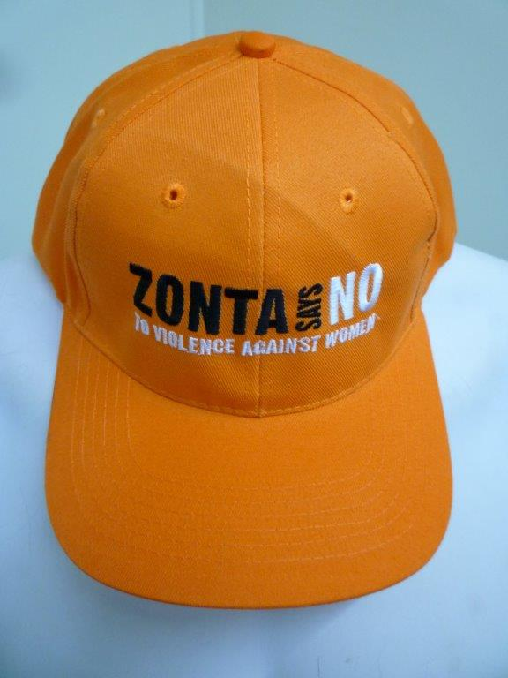

The Zonta Club of Caboolture is taking orders for “Zonta Says No
to Violence Against Women” embroidered caps. Great tools for advocacy events for both Zontians and volunteers.

Zonta Says No caps are $10 each

Enquiries: Pam 5429 3660 (H) Mob: 0407 169 682 or Glenda 0754290982
Mob 046 871 2993

PLEASE EMAIL ORDER FORM TO:
Email: caboolture@zontadistrict22.org

Name of Club ..………………………………………………...............................

Postal Address ………………………………………………...............................

Contact person………..………………………………..Ph:……………………...

Email………………………………………………………………………………..

Method of Payment……………………………………………………………….

Delivery: Circle one option

To be collected OR Please post (free post)

Post cheque to Zonta Club of Caboolture Inc, PO Box 1829, Caboolture, Qld 4510

OR
Direct deposit to ANZ BSB 014305 Account No. 259361294
Please put Club Name and Caps as the reference

