PRESIDENT’S PATTER
August 2020

Well hello! This is the first of what I hope will be regular newsletters. Always daunting committing to something like this but I do believe communication is important for us all and the need for greater communication was listed as an important factor in the questionnaire.

I do want to thank you all for the time you put into responding to the strategic planning process. It has given us a good blue print for the way we want to manage the club going forward and the things that are important to you as club members. I also want to thank you for the support you have given me as I start out as the new President. I have been very touched at some of the messages of support.

It certainly is a different time for us all. The impact of COVID 19 will be with us for some time and certainly will impact on how we will be able to conduct our business going forward. While fundraising may be limited, it gives us time to focus on Advocacy for Zonta’s goals of empowering women and girls, with a particular emphasis on homelessness for older women this biennium.

My personal goal is that we will all work together as a club rather than being too disparate in our approach through committees. This will mean than some of our activities will be by sub-committees brought together for the specific event. A kinda ‘horses for courses’ approach with the best persons allocated to the task. To that end we will need volunteers for the agreed events at our last meeting. Every function will require a team but also we need someone who is prepared to step up and be the leader of the team. So be brave and hold up your hand! We’re right behind you.

MEMBER UPDATES
I hope here that I can share some news of club members. That will depend a lot of course on you letting me know what is happening! While travel is still restricted, some of you may be off on road trips and can share items of interest with us.

Sadly I do have to advise that Karen lost her dear Dad recently. And now Maryanne advises that her 90 year old Dad in New Zealand is very sick. It doesn’t matter how old they are, they are still our parents and have been such a key part of our lives.

FELLOWSHIP
Many thanks to the Fellowship team for organizing the meet on the river. It was a lovely afternoon helped by it being a beautiful day. Very enjoyable and it was nice to see the significant others there also.

ADVOCACY
On Wednesday August 5, ‘The 2020 Annual Forum on Women and Homelessness’ will be held. Robyn O’Neill as our Advocacy Chair is attending this forum and will report back, but all are welcome to ‘Zoom in’. You can register for the event through https://ladymusgravetrust.org.au/annual-forum/

SAUSAGE SIZZLE
We’ve been fortunate to secure a sizzle on August 8. Bunnings are stipulating that we need 5 people on every shift so we have a couple of spots free. If you have not put your name forward and can help please let Gail (0402 495 699) or Margaret D (0438 187 210) know. Carolyn Hay has kindly offered to help on the last shift so if you know of another ex-Zontian or a family member who would help please let one of the girls know.

ZI NEWS

The results of the recent international voting may be found find on the Zonta International website at www.zonta.org/Web/My_Zonta/Tools/Membership_Tools/Elections_and_Voting.

‘The Zontian’ Issue 4 has been circulated to you. I recommend it to you for reading especially pages 16-17 which gives us a plan as to how to light up the town orange!

On July 30, Zonta International encouraged its members throughout the world to promote activities to recognize the World Day Against Trafficking in Persons, which was proclaimed by the United Nations General Assembly in a resolution adopted in 2013. The day was established to raise awareness of the plight of human trafficking victims, and to promote and protect their rights. A 2019 report from the International Labour Organization estimated 3.8 million adults and 1 million children were victims of forced sexual exploitation in 2016 around the world, 99% of which were women and girls. Traffickers primarily target women because they are disproportionately affected by poverty and discrimination, factors that impede their access to employment, educational opportunities and other resources.

DISTRICT NEWS
The new District 22 board was installed last Saturday. Unfortunately, due to the vagaries of Zoom I was unable to see this, but congratulations once again to Pat Cussens for her appointment as Area 1 Director. She’s on the job and has already called a meeting of Presidents to be held this month! Congratulations also to our new D22 Governor Bridget Mather and Lieutenant Governor Lyn Agnew. We look forward to welcoming them to Noosa soon.

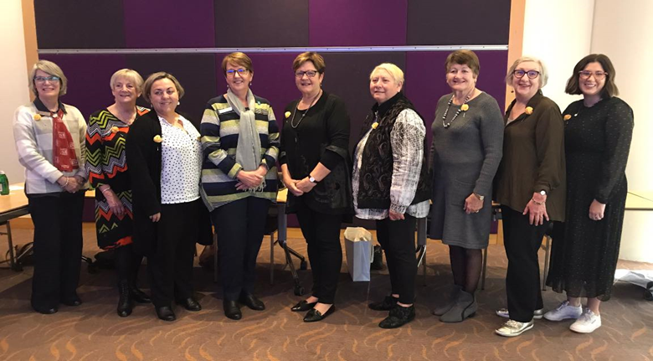
As her parting words, outgoing Governor Sandy Venn-Brown advised the following:

3 clubs chartered Z or Golden Z Clubs giving District 22 a special recognition for one of five Districts to meet the Biennial Goal for chartering 3 or more Z clubs
- Zonta Club of Pine Rivers Inc - Z Club of Mt Alvernia College
- Zonta Club of Cairns Inc. - e-Z Club of Cairns SDE
- Southern Gold Coast-Tweed Inc - Griffith University Golden Z Club
Zonta Club of Mackay Inc. received one of 5 special awards for chartering the most number of Z clubs in Zonta history!

Seven clubs gained a 30% increase in membership -
- Zonta Club of Toowoomba Garden City Inc,
- Zonta Club of e-club of Queensland,
- Zonta Club of Brisbane Breakfast Inc,
- Zonta Club of Hervey Bay Inc,
- Zonta Club of Beaudesert Area Inc,
- Zonta Club of Wynnum Redland Inc,
- Zonta Club of Caboolture Inc,
We have some lessons to learn here! In addition to these membership awards, District 22 was the only district to receive YWPA and JMK winners in both years of the Biennium.

THINGS TO THINK ABOUT
A recent article in the Weekend Australian posited a view that the reason women tend to not opt for STEM subjects at university is that women are shaped by their evolutionary past. It all comes down to biology apparently and our role is to rear children successfully! Who knew?! The article goes on to state that STEM subjects need a high mathematical ability and at which boys are only slightly more proficient. Girls on the other hand out- perform boys in verbal skills in every one of the 67 countries studies. (We all knew that in Australia). However, the article argues that when girls perform as well if not better in maths than boys, they have more career options open to them because of their superior verbal skills! Thus, they tend to not opt for STEM careers. The article states that surveys of gifted women and men show that “where men get satisfaction from being the best in the field, satisfaction among women is more tightly linked to the quality of their social relationships”. Furthermore, the article posits “should our social goals of creating more female engineers trump our scientific understanding of why most women don’t want to be engineers?”
To discuss sisters! Madeleine Beekman,Professor of Evolutionary Biology, Univ of Sydney; Bill Hippel, Professor of Evolutionary Psychology, Univ of Qld. Weekend Australian 11 July 2020. Pg 14.

If you have not heard the speech below before I recommend you have a listen to this powerful reply by Rep Alexandria Ocasio-Cortez to sexist verbal abuse by Rep Ted Yoho.
https://www.washingtonpost.com/lifestyle/style/aocs-speech-about-ted-yohos-apology-was-a-comeback-for-the-ages/2020/07/23/524e689a-cb90-11ea-91f1-28aca4d833a0_story.html

MEMBER PROFILE
I’d like to feature a club member every newsletter and lest you think I am going to pick on you first I thought I would start with me! I will though ask you to volunteer to participate as there is a lot we can learn about and from each other. So here goes!

Some of you may recall that the first three years of my life were spent on Thursday Island as a child of missionary parents. We moved there from NZ when I was three weeks old. We returned to New Zealand and my schooling was a mixture of country schools and high school back in Auckland. I did not go to university when I left school as you didn’t do that unless you wanted to teach in those days! I subsequently did my studies in business management in my 30’s.

I have been fortunate to hold management positions in accounting and law firms, both in HR and general management. I also spent some time in the disability sector which was both rewarding and confronting! I did learn a lot through that experience. I moved to Australia in 2005 to join the Sydney office of Grant Thornton, a mid-tier international accounting firm, (I had been CEO of the Auckland office before that). My most taxing role was as Head of People and Culture for Grant Thornton Australia. This meant much travel around Australia and overseas for conferences. Enjoying but tiring.

I retired to Noosa in 2015 after 5 years in a ‘sunset’ job in another accounting firm.

Retirement for me has meant the opportunity to give back to the community. I initially thought of joining Rotary again (I was in the Auckland Club for some 10 years), but after chatting to Carolyn Hay one day I was attracted to the ideals of Zonta. The last four years have been very rewarding and have seen a broadening of my knowledge of the needs of women and girls around the world.

Another community undertaking is as a director of Noosacare. The board is committed to high class aged care and I am very proud of the work the CEO and team do. Bridge and the Chorale fill the rest of my days (or did pre Covid)!

Most important to me are of course are my two sons and family - James, Rob and his wife Rachel, and my five beautiful grandchildren. Unfortunately, three of the munchkins are in Melbourne and the other two in Auckland so catching up is not easy. Thank goodness for Facetime!

DATES FOR OUR DIARIES
- Annual Forum on Women and Homelessness 5 August
- Sausage sizzle on Saturday 8 August
- Next club meeting will be on 13 August when we will present the awards to the Bursary winners.

