Area 2 Meeting Program
Sat 11th & Sun 12th April 2015
Courage, Conviction & Commitment
Hosted by:
Zonta Club of Longreach Inc.
Area Director—Jan Landsberg

REGISTRATION FORM

ZONTA CLUB:
NAME:
OPTION | YES | COST | TOTAL
Friday Night-RSL Club 6.30pm drinks & dinner |  | At your cost
1. Saturday only 9am-3.30pm |  | $36.00
2. Saturday Night -Drinks & Canapés at Australian Stockmen Hall of Fame 5pm-6.30pm  Show by Lochie Crosser  Dinner at Qantas Founders Museum  6.30pm-10.30pm Cash Bar |  | $50.00
Partner Sat night  Drinks, Canapés, Show and Dinner |  | $50.00
3. Sunday only 9am-11.30am |  | $22.00
4. Sat. & Sun. Day Registration |  | $50.00
5. Full Registration –all inclusive  Sat, Sat night show & dinner, Sun |  | $100.00
Sunday Lunch- Qantas Founders Museum |  | At Your Cost
Dietary Requirements
Total Cost
Payment may be made by cheque payable to Zonta Club of Longreach Inc. and
sent to PO Box 177, Longreach Qld 4730 together with the Registration Form or by Direct Deposit to the
Club’s General Account at Westpac Bank BSB: 034-194 Account # 990 000 with the
Registration Form being emailed zontalongreach@gmail.com
Please book by Fri 27th Feb and pay by Fri 13th March 2015 More details to follow in March
Sponsored by Qantas Founders Museum
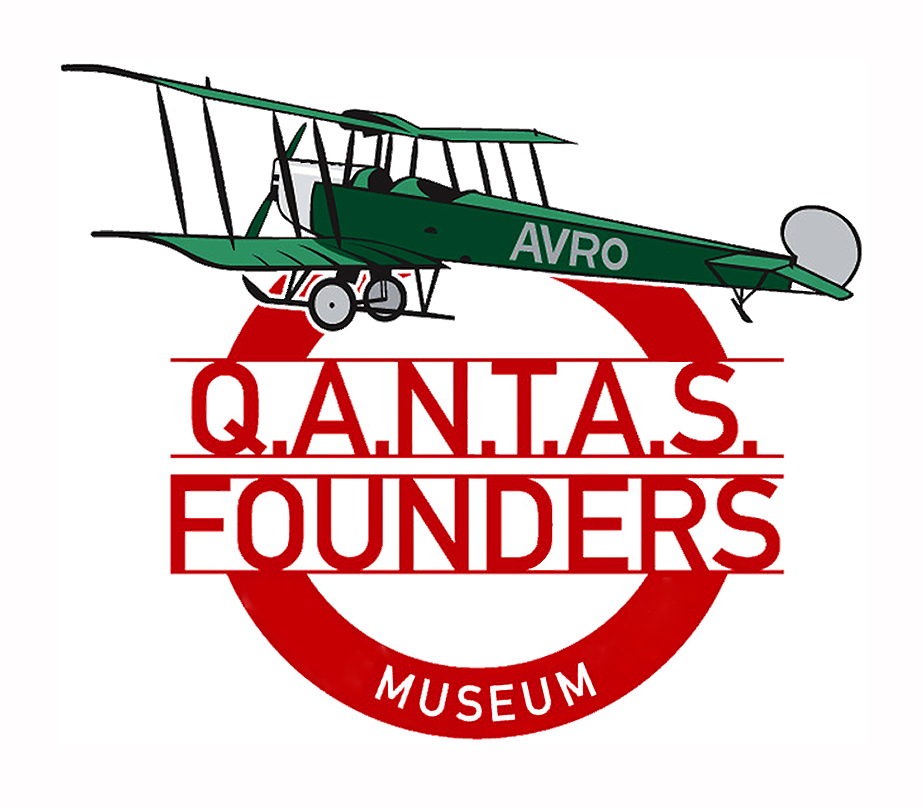

Accommodation is available at
Albert Park Motor Inn
Cnr Stork Rd & Landsborough Highway
Longreach Q 4730
Ph 07 4658 2411
Mention Jane’s name and Zonta when booking
Double $140 per night
Single $120 per night
Albert Park is across the road from Qantas Founders Museum and is walking distance

Jumbuck Motel
Sir Hudson Fysh Dve
Longreach Q 4730
Ph 07 4658 1799
$110 per room single (queen bed)
$115 per room double (queen bed)
$125 per room twin share (queen bed + single bed)
$135 per room triple share (queen bed + 2 single beds)
Please mention Zonta when booking
The Jumbuck Motel is 2 blocks from the museum

As that time of year is busy in Longreach it is advisable to book as soon as possible to ensure availability

Tourist Attractions
Australian Stockman’s Hall of Fame ph 07 4658 2166
$27 per adult group rate
Mention you are from Zonta
www.outbackheritage.com.au

Qantas Founders Museum ph 07 4658 3737
Museum only $18 per adult group rate
Museum and 747/707 jet tour $40 per adult group rate (bookings essential)
www.qfom.com.au

Other attractions in Longreach

Kinnon & Co Cobb & Co Coach Ride
ph 07 4658 1776 email info@kinnonandco.com.au
Kinnon & Co sunset cruise
www.kinnonandco.com.au

Outback Aussie Tours sunset cruise
ph 07 4658 3000 email info@oat.net.au
www.outbackaussietours.com.au

