A Brief History of the Zonta Club of Wynnum Redland Inc – Club No. 0988
District 22, Area 3
The Zonta Club of Wynnum Redland was chartered on 25th September, 1981.
- Dr Helen Rowe from the Zonta Brisbane Club was the person who did the SOM and gathered 25 women from our local community for an organisation meeting which was held at Whepstead Manor.
- A Charter Dinner was held at the Moreton Bay Trailer Boat Club, Manly.
- Prospective members were leading business women within the local community.
- Charter Membership: 25. President Faye Bartley, 1stVP - Judy Holt, 2nd VP - Beverley Tanner, Treasurer - Patricia Henning, Secretary - Mary Guy, Minutes Secretary – Phyllis Pledger.
- Our District Governor at the time was Jeanne Edgar from New Zealand. Also at that time our club was in District 16 that encompassed Australia and New Zealand.
Meetings:
2nd Monday of each month with the exception of January, usually with Guest Speakers. Board Meetings are held last Monday of each month.
Club Board & Committees:
For most of its history the Board has comprised of the President, 1st Vice-President, 2nd Vice President, Treasurer, Secretary - Minutes/Correspondence and then usually 3 Directors. Board members usually chairing the Committees which consist of Advocacy, Membership, Service, Nominating Committee.
Membership:
Member numbers have fluctuated between 20 and 30. We try and maintain links with former members through personal invitation to events.
Advocacy:
We have been involved in a number of activities to promote Zonta’s Objects. Our Club in all aspects tries to adhere to Zonta International Goals. International Women’s Day Dinner has been taking place since 2000 and is one of our major fundraising events for the year. Our Young Woman in Public Affairs recipient has also been presented at this function. Our club actively promotes the ZONTA Says NO Campaign.

Club Initiatives:
- 1982-85 – Sponsor of young girl in Bolivia through Foster Parents Plan.
- Continued donation of Christmas goods/hampers to needy families, later to Domestic Violence Assn.
- 1987 – work done towards Park for Handicapped – Perfumed Garden/Braille Trail.
- 1988-1992 – Chicken & Champagne Breakfast to Strawberry Festival organisers. Donation of Christmas tree to Cultural Centre.
- 1989 – Participated in Strawberry Festival Parade – members marched & rode dressed according to the decade they represented.
- 1990 – Sponsor of ‘Women’s Only’ night to support Health Dept. Campaign against Breast Cancer, Papilloma Virus & Cervical Cancer.
- 1993-1995 – Area 3 Project – cervical cancer Vaccine trials to Princess Alexandra Hospital.
- 1996 – Sponsor of local young blind girl to attend visually handicapped games in Canberra.
- 1999 – District 24 Project – development of Cervical Cancer Vaccine Princess Alexandra Hospital. Supplied sewing implements to East Timor to assist local village women.
- 2001 – support to Redlands Domestic Violence service by way of donating needy items. Hosted District 24 Board by way of dinner at Diane Harmsworth’s home.
- 2002 –Breast Cushion working Bee – first assembly volunteers to cut, sew and fill. Donation of cushions to Redland and Mater Hospitals.
- 2004 – Museum project – grant of $1500 from Office of Status of Women for audio visual exhibit.
- 2005 – Relay for Life – afternoon tea provided for survivors and carers. Assisted Maybanke with donation of outdoor setting to value of $1000.00. Hosted Fashion Parade to raise further funds.
- 2006 – “Women of the Redlands” Expo held in conjunction with Redland Museum – opening performed by Governor of Qld Ms Quentin Bryce. Continued with Breast Cushion making days.
- 2007 – International Women’s Day Dinner with guest speaker Professor Ian Frazer was a well-attended event. Continued with ‘Relay for Life’ afternoon tea. Another presentation of Christmas goods/hampers to Silky Oaks and Maybanke.
- 2008-2011 – Continued fundraising activities which included Garage Sale, Crazy Whist Night, Sausage Sizzles, Hats and High Tea Afternoon, Christmas in July functions, International Women’s Day Dinners.
- 2012 – 2014 – continued fundraising efforts. Cocktail Hour held to celebrate member Judith Trevan-Hawke’s position of District 22 Governor. Continued Christmas goods supplied to Maybanke and Silky Oaks. Zonta Says No to Domestic Violence high on the agenda with signage erected at Redlands United Football Club and sponsor of gazebo for Wellington Point Sparks Club. Membership of the club has continued to climb.
- Melbourne Cup Day Function was held as a major fundraising activity for our club, along with Fashion parade and Trivia Night held in conjunction with Redlands Centre for Women.

Area and District Activities
Our Club has actively contributed to Area Meetings since our Charter and has been represented at every District Conference since our Charter. We have had several members who have served on the District Boards. We are proud of our member Judith Trevan-Hawke who is District 22 Governor (2014-2016).

We have had members attend International Conventions as below:
1984 | Sydney | Beverley Tanner
1992 | Hong Kong | Phyllis Pledger, A Gildner
1998 | Paris | A Gildner, Jo Hieatt
2002 | Gothenberg, Sweden | A Williamson
2004 | New York | Janet Mylne, D Harmsworth & Jill Maclachlan
2006 | Melbourne | Judith Trevan-Hawke, Janet Mylne, Jo Hieatt, Diane Harmsworth
2010 | San Antonio USA | Judith Trevan-Hawke, Janet Mylne
2012 | Torino, Italy | Diane Harmsworth, Janet Mylne, Judith Trevan-Hawke
2014 | Orlando USA | Judith Trevan-Hawke, Diane Harmsworth

Members who have gone on District Boards:

Years of Service | Member | Position
1998-2000 | Lyn Albin | District Treasurer
2002-2004 | Diane Harmsworth | Area 5 Director
2004-2006 | Diane Harmsworth | District Secretary and Chairperson of the District Nominating Committee
 | DIVISION OF THE DISTRICT 2008 NOW DISTRICT 22
2010-2012 | Judith Trevan-Hawke | Area 3 Director
2012-2014 | Judith Trevan-Hawke | Lieutenant Governor
2011 | Diane Harmsworth | District Credentials Chairperson
2014-2016 | Judith Trevan-Hawke | District 22 Governor
2013-2016 | Janet Mylne | District 22 Service Chairperson
2015 | Diane Harmsworth | District 22 Credentials Chairperson Conference

ZONTA CLUB OF WYNNUM REDLAND INC
MEMBERSHIP LIST

Club Member Number | Name | Date of Joining | Date of Leaving
0001 | Lola Armitage | August 1981 | May 1985
0002 | Joan Tuffley | August 1981 | October 1982 (Deceased)
0003 | Beverley Bishop | August 1981 | May 1985
0004 | Mary Guy | August 1981 | May 1989
0005 | Patricia Hemming | August 1981 | August 1982 (Deceased)
0006 | Edna Clegg | August 1981 | February 1982 (deceased)
0007 | Julie Ridgeway | August 1981 | November 1982
0008 | Claire Hickey | August 1981 | March 2014
0009 | Marion Clegg | August 1981  Feb 1984 | December 1982 &May 1990
0010 | Kath McNeilly | August 1981
0011 | Wendy Hart | August 1981 | August 1988
0012 | Jean Gibson | August 1981 | June 2003  Deceased Feb 2008
0013 | Mollie Martin | August 1981 | May 1987
0014 | Judith Holt | August 1981 | July 1983
0015 | Barbara Carter | August 1981
0016 | Laurie Trotter (Delbridge) | August 1981 | August 2011
0017 | Faye Bartley | August 1981 | April 1984
0018 | Wendy Jewell | August 1981 | August 1982
0019 | Joan Barnes | August 1981 | February 1988
0020 | Pauline Denisenko | August 1981 | June 1982
0021 | Phyllis Pledger | August 1981
0022 | Susan Horton | August 1981 | May 1989
0023 | Dianne Creamer | August 1981 | May 1995
0024 | Beverley Tanner | August 1981 | June 2012
0025 | Fay Reepsdorf | August 1981 | May 1986
0026 | Pat Theo | October 1981 | May 1985
0027 | Sue Beckinsale | February 1982 | May 1983
0028 | Jan Cooper | June 1982 | February 1990
0029 | Margaret Hudson | June 1982 | May 1983
0030 | Katrina Angus | September 1982 | May 1983
0031 | Mandy Hill | October 1982 | April 1984
0032 | Christine Houghton | November 1982 | May 1983
0033 | Sandra Swaney | May 1983 | October 1983
0034 | Beverley Uhlmann | June 1983 | April 1984
0035 | Jan Parnell | June 1983 | April 1988
Member Number | Name | Date of Joining | Date of Leaving
0036 | Margaret Harrison | June 1983 | December 1988 (Deceased)
0037 | Shirley Graham | October 1983 | April 1984
0038 | Hazel Knight | October 1983 | May 1995
0039 | Lorraine Skopp | February 1984 | June 1987
0040 | Fran Bradford | February 1984 | February 1985
0041 | Vicki Rothlisberg | March 1984 | April 1985
0042 | Wilma Sullivan | March 1984 | May 1985
0043 | Helen Reason | March 1984 | July 1985
0044 | Denise Gillespie | August 1984 | February 1988
0045 | Beverley Mercer | August 1984 | May 1989
0046 | Diny Appleby | April 1985 | February 1988
0047 | Julie Murray | April 1988 | November 1986
0048 | Lyn Albin | February 1986 | May 2001
0049 | Jeannie Valentino | November 1986 | June 1988
0050 | Sandra Lancaster | August 1986 | September 1992
0051 | Margaret Darley | September 1987 | March 1989
0052 | Meg O’Driscoll | November 1987 | May 1990
0053 | Lorna Ardley | September 1987 | March 1989
0054 | Helen Pizzey | June 1987 | May 1989
0055 | Heather Fenton | June 1987 | November 1988
0056 | Caroline Thomas | April 1988 | May 1989
0057 | Barbara Taylor | May 1988 | May 1989
0058 | Margaret O’Donnell | July 1989 | May 1992
0059 | Robyn Lindsay | June 1989 | May 1996
0060 | Louise Mercer | August 1989 | December 1990
0061 | Alice Cullen | August 1989 | October 1990
0062 | Sylvia Ferris | September 1989 | May 1991
0063 | Angela Williamson | February 1990 | June 1994
0064 | Joy Bonney | September 1990 | June 2010
0065 | Genevieve Turner
0066 | Mary Nolan | October 1990 | May 1992
0067 | Anneliese Gildner | November 1990 | June 2003
0068 | Judith Slagle | May 1991 | May 1992
0069 | Mary-Lou Podagiel | June 1991
0070 | Roslyn Beveridge | August 1991  Re-joined 2010 | May 1995  2014
0071 | Lorraine Stansfield | September 1991 | April 1997
0072 | Noreen Harbecke | March 1992 | May 1995
0073 | Jenny Reason | May 1992 | April 1998
0074 | Michelle Allatt | May 1992 | May 1995
0075 | Jan Cooper | May 1992 | April 1998
0076 | Suzie Bonnell | September 1992 | May 1995
0077 | Janette Smith | November 1992 | May 1994
0078 | Trish Sullivan | November 1992 | May 1995
0079 | Janette Ratcliffe | June 1993 | May 1995
0080 | Cathy Floyd | June 1993 | May 1994
Member Number | Name | Date of Joining | Date of Leaving
0081 | Janet Mylne | July 1993
0082 | Debra Wardle | July 1993 | March 1997
0083 | Sandra Tillack | July 1993 | March 1997
0084 | Decalie Newton | February 1994 | May 2006
0085 | Deb O’Mullane | March 1995 | April 1998
0086 | Diane Harmsworth | June 1995
0087 | Gail Abbott | June 1995
0088 | Johanna Hieatt | June 1995
0089 | June Calvert | June 1995 | May 2000
0090 | Janelle Liddle | March 1996 | April 1998
0091 | Helen Townsend | June 1996 | May 1999 (Deceased)
0092 | Margaret Finnegan | June 1997
0093 | Angela Williamson | June 1997 | 2005 (Interstate)
0094 | Annette McCarthy | July 1997 | May 1998
0095 | Judith Tottle | August 1997 | May 2000
0096 | Carol Hamilton | May 1998 | May 2001
0097 | Marilyn Smith | June 1998
0098 | Barbara Wills | February 1999
0100 | Rosemary Conlon | June 1999 | May 2001
0101 | Kerry Nader | December 1999 | March 2007
0102 | Andrea West | December 1999 | 2004 (Deceased 2010)
0103 | Stephanie Kratzman | May 2000 | 2004
0104 | Kay Russell | August 2000 | April 2002
0105 | Sherry Kelly | October 2000 | February 2002
0106 | Lorraine Stansfield | November 2000 | 2004
0107 | Christine Scott | November 2000 | 2004
0108 | Lynne Friss | November 2000 | May 2006
0109 | Jill Maclachlan | August 2001 | May 2008
0110 | Margaret Uhr | September 2001 | May 2002
0111 | Judith Trevan-Hawke | April 2002
0112 | Julie Hossack | May 2002 | May 2008
0113 | Pam Greenway | May 2003 | May 2007
0114 | Philippa Fenwick | May 2003
0115 | Marilyn Steenland | May 2003 | May 2013
0116 | Jill Allen | September 2000 | May 2014
0117 | Sandra Franklin | 2005 | 2005
0118 | Jillian Smith | October 2005 | May 2008
0119 | Meg Scott | December 2006 | March 2009
0120 | Melinda Clynick | May 2008 | February 2009
0121 | Anita Plath | May 2008 | March 2009
0122 | Chris Baggarley | April 2008 | August 2008
0123 | Janet Forge | July 2009

Member Number | Name | Date of Joining | Date of Leaving
0124 | Debbie Clancy(Jackson) | September 2010
0125 | Gail Matthey | October 2010
0126 | Jayne Wambaa | August 2011 | September 2012
0127 | Rachel Mackie | August 2011 | April 2013
0128 | Michelle Glanville | April 2012 | April 2014
0129 | Zora Abbot | November 2012
0130 | Angela Hill | May 2013
0131 | Nikki Redmond | May 2013
0132 | Julie Mayer | February 2014 | July 2014
0133 | Roslyn O'Grady | April 2014
0134 | Carole Moore | October 2014
0135 | Deb Kellie | November 2014
0136 | Justine Kennedy | May 2015
0137 | Savannah Falzon | May 2015
0138 | Katrina Beutel | May 2015
0139 | Narelle Anderson | May 2015
0140 | Desley Hegney | May 2015 | October 2015
0141 | Ros Beveridge | May 2015
0142 | Patricia Lavelle | May 2015
0143 | Irene Henley | Dec 2015
0144 | Gail O'Keefe | Dec 2015
0145 | Julie Cardiff Tfr Mackay | March 2016
0146
0147
0148
0149
0150

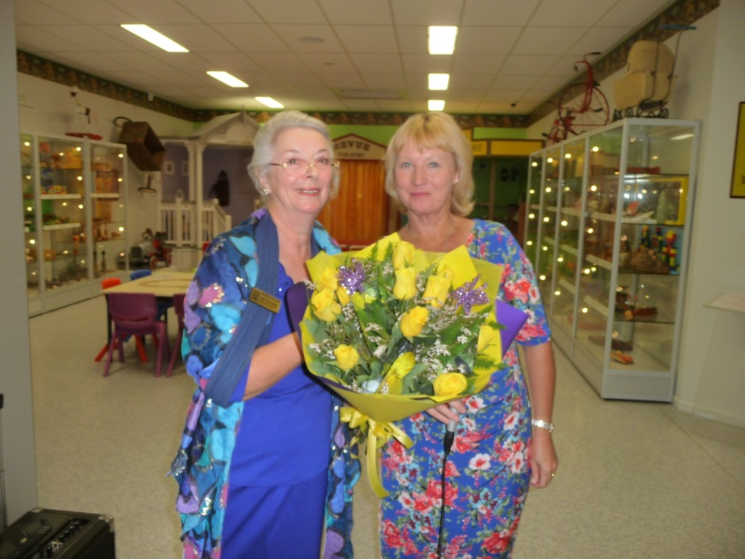
District Governor Judith Trevan-Hawke with President Debbie Jackson
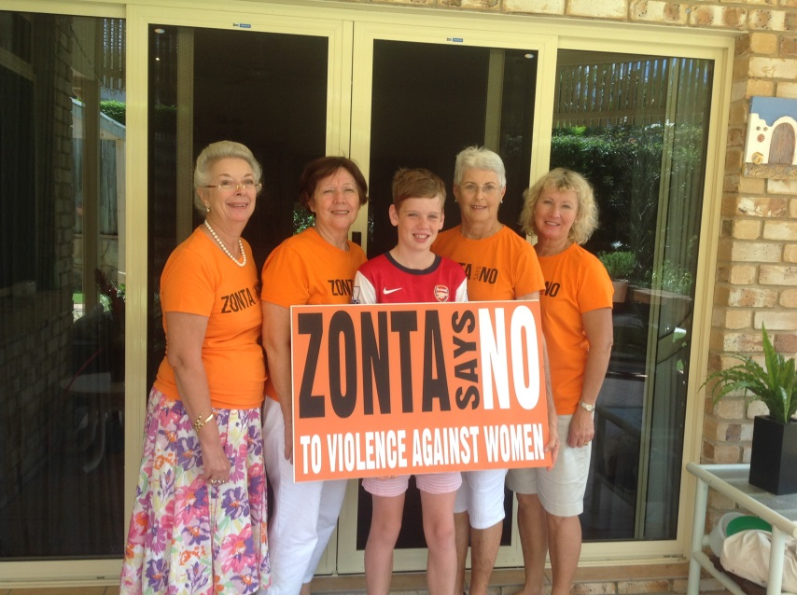
Advocacy in action
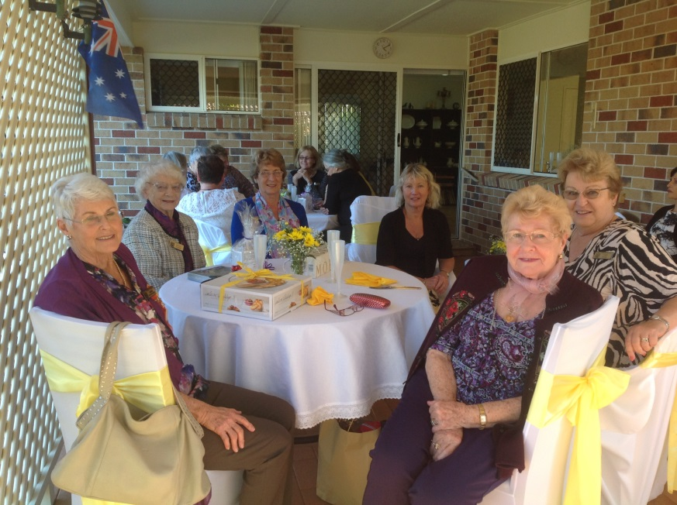
High Tea Festivities
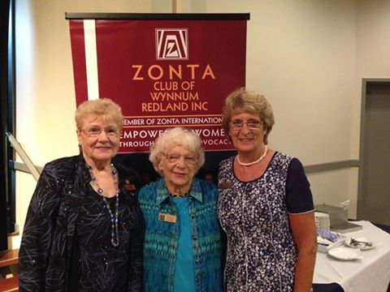
Charter Members - Phyllis Pledge, Kath McNeilly OAM, Barbara Carter

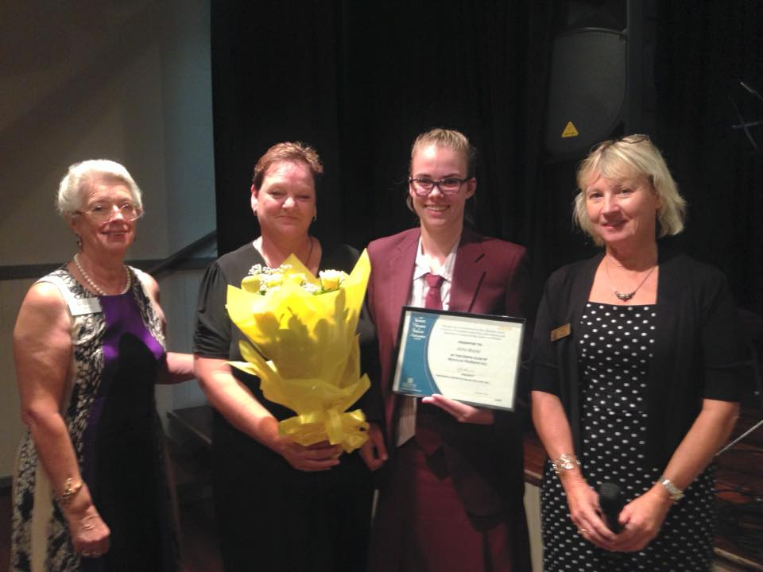
YWPA Recipient Asha Mortel 2016
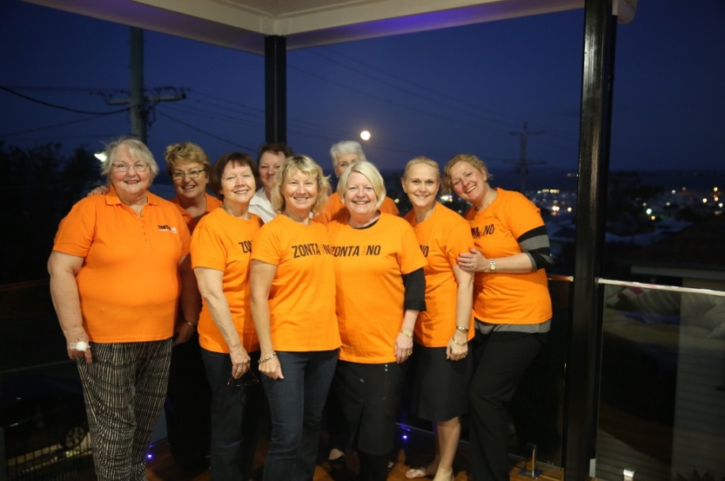
Members in Orange!
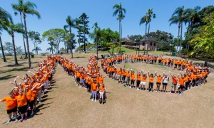
Area Project Advocacy

