President: Sue Droughton – 07 5496 8909 (H) 07 5498 6699 (B)
Treasurer: Pam Termont-Schenk – 07 5496 2035
Secretary: Glenda Moor - 07 3385 6160
Newsletter Editor: Patricia Clunes- 07 5498 6066 or 0410 617 825

FROM THE PRESIDENT’S DESK.

When I was growing up I was always under the impression that when you hit
your sixties that life slows down for you, well, I'd really like to know
when that's going to happen, because, for the past few months my feet have
hardly touched the ground.
Recently, Sandra, Pam T/S & I attended the morning tea & opening of the
Multicultural Project. We met the new project co-ordinator Tracey Singh, who
I think will do a wonderful job of the research survey. We were introduced
to the twelve women who have been employed to carry out this work. The women
are truly multicultural, they represent India, the Philippines, South America, China, Thailand & Peru to name a few. We as a club we will be very interested as to how this project will proceed, and they will keep us informed every step of the way.

Last Sunday week ago, Pam B. Glenda, Annette & I along with our partners went on the Morayfield Lions Bus Trip to Harlin for lunch and a winery stop on the way home, it was a lovely day, and I thank Glenda for inviting us.

I am also busy at home preparing for interstate visitors arriving on Saturday, they are my friends from Adelaide. Judy Steele is very well known to some of the Zonta Clubs from Adelaide, as she takes birthing kits with her to Uganda, where she along with the Australia Christian Outreach Centre has established a hospital and a walking clinic, her work is absolutely amazing, and I just wish that she would have arrived in time to come along to our Diner Meeting on Thursday night so that you could meet this wonderful woman.

Last week Pam B & Sara both flew out for overseas holidays, only problem for Sara was her daughter Catherine fell over at school the day before they were to leave and broke her arm, so Sara had to spend most of the day at the hospital, putting her very much behind for her preparations. But she managed
to find time to drop in to me the most amazing raffle prizes for our theatre afternoon for "Busting Out". She deserves a BIG Thank you.

Shirley Crane is our guest speaker this month for My Beautiful Career.

Don't forget, if you are unable to be at the Dinner Meeting please advise Glenda, & I will see you all Thursday night.

Sue

BIRTHDAYS & ANNIVERSARIES

Happy Birthday Pam T-S – 22/7
Anniversary – Helene and Michael 25/7

TREASURERS REPORT
You should have received this from Pam by now.
A reminder that if you miss a meeting, regardless of apology, you need to pay $5.00 at the next available meeting. This is an admin fee and is built into our $20 we pay when we have dinner. If you attend dinner and don’t eat then you still need to pay the $5.
If you are unable to attend a meeting please give Glenda a telephone call on 3385 6160 (a/h)

STATUS OF WOMEN – SERVICE

After looking at the District Report on club activities it is evident that in 6 of the 7 categories we are well above average in our service to the community in regard to members hours of service and money contributed in relation to our membership numbers. It is only in the category of “legal support and advocacy” that we have no direct input. So WELL DONE to us.

2000 birthing kits have been ordered and we will have an assembly day at Blue Care on Sunday 3 August.

Pam T-S is snowed under with her interest commitments plus being our treasurer so I will be organising the Banksia Bursaries for 2008.

We have received a request from RAaFTS (Relationship Assistance and Family Therapy Service) to give financial support so that 16 women can do an EMPOWER self defense and self esteem course related to violence against women. The course will be run by Tony Deckers who is a qualified instructor/ examiner of Ti Aikido. It will be 2 hours in duration and be held Early August. We are being asked to contribute $301.72 to pay for the instructor for the 16 women, people to mind their children and some pizzas to feed the kids.

At the June dinner meeting you will be asked to vote on a motion to allocate the money to help these 16 women to do a self defense course which will increase their confidence, help their moral and help them with anger management.

After careful consideration of the ZI awards in YWPA, Amelia Earhart and Jane Klausman, the Board has decided to recommend to members at the June dinner meeting that we consider offering a Jane Klausman award for 2009. Candidates should be living in the Caboolture area. The suggest prize amount is $1000. The JK award would involve girls studying at a university level, which hopefully would be easier for our members to manage than trying to deal with the high schools. We will need 3 members to organise the competition and 3 to be the judges. We can only do this if people are willing to do the work to put this thing together.

At the June dinner meeting you will be asked to consider if our club should do this award and if you are willing to help. If those answers are positive then you will be asked to agree on the amount to be given in prize money.

Our June dinner meeting night is a special night for my Michael as he is being installed as Master (President) of one of his Masonic lodges. Therefore I will NOT be at the June dinner meeting. Yes I know I’ve been very slack lately – but fingers crossed I will see you at the July dinner meeting and before that at our theater afternoon for Busting Out as I’m helping Patricia with the afternoon tea.

Date for the Orchid Show at Mt Cootha Botanical Gardens is the weekend 28/29 June. Some of the proceeds will go to the Cancer support group at Caboolture – which we supply with breast cushions.

The following is from Julie who is a members of the Birthing kit foundation. I asked her if there was some way people could help other than doing up the kits and here is her reply. I have told her how to get a website built for free by Uni Honour students.
Just letting you know we are still working on how other Zonta members can be involved in this project.
We have not yet come up with a firm list of ideas.

It has been a busy month as we needed to finalise our proposal to AusAID for next years $200,000 in funding which we have just received. This takes about 50 hours of work and is somewhat consuming as it has to be precise.

Some that spring to mind are -

We need members with grant application skills - even money for computers, funding for specialist assistance with OAGDS, funding for PR banners etc etc. It would be great to have at least one set of these in each state for major fundraising events - they travel poorly.

We need assistance in getting OAGDS for tax deductibility - a huge job but so important

Any members with PR and fundraising skills to take us to the next level as we need another $72,000 after our Zonta clubs have made their assembly day contributions. Members with contacts who may support us financially. TV contacts - Newspaper contacts etc

Website skills to make our website more interactive
Members who are travelling to a country and can visit a clinic we work with who may be able to take kits with them.

Members with midwifery or nursing training who would like to help at some clinics. - they would need to pay all their own expenses.

Members who would like to do voluntary work in some countries where we have projects who could possibly evaluate our projects. e.g. Kenya, Madagascar, Malawi, and the list goes on.

I hope these give you some ideas.

If you have some of your own ideas please feel free to send the suggestions.
We are very open to ideas.

Regards

Julie Monis-Ivett
Zonta Birthing Kit Project District Coordinator
Birthing Kit Foundation Chair.

ORGANISATION, MEMBERSHIP CLASSIFICATION.
(Cecil, Sandra, Shirley, Chris)

Membership
A further Invitation by email has been sent to Joanne Bakker (Shared Services) to attend the June Club Dinner Meeting. A card with a get-well message from Zonta was sent to Cecil.

Membership Directory
The OMC Committee is awaiting advice re confirmation of all committees before adjustments to the Directory can be made.

New members’ Information Kit
Work is still ongoing.

Cecil Nielson
Acting OMC Chair

FINANCE & FUNDRAISING

100 tickets have been sold to Busting Out. We just need to provide a lovely afternoon tea. If you can help please let Patricia know as I am resting in Thailand getting ready for my shopping excursion or two.

All is going well for the shopping trip. We have 14 seats at a minimum left …. Who would like one or two?

Sara

PUBLICITY AND PUBLIC RELATIONS

We still have 4 tickets (out of 100) for Busting Out. Do you know anyone who is still interested?

Tickets for the Shop until you drop are selling well with 31 booked and only another 14 needed to make this day successful. So rally around and find a sister, relation, friend, neighbour etc to get our numbers. It will be a fund day out for $30 with BYO lunch, drinks, nibbles etc. Raffles will be conducted.

We are still trying to get some publicity in the paper for our Birthing Kit Assembly day. Maybe it will be in the paper closer to the day.

We are hoping to have a function in October to celebrate UN day with guest speaker Sally Cameron from Noosa. Other details will come to hand as time goes by.

Below is a photo taken at the plaque dedication day. In the photo LR is Maree, Pam B, Sandra, Cathy, Helen, Patricia, Sue and Glenda and the pastor whose name escapes me at the moment!!!

Hon Zons Peter and Michael were also at the dedication ceremony.

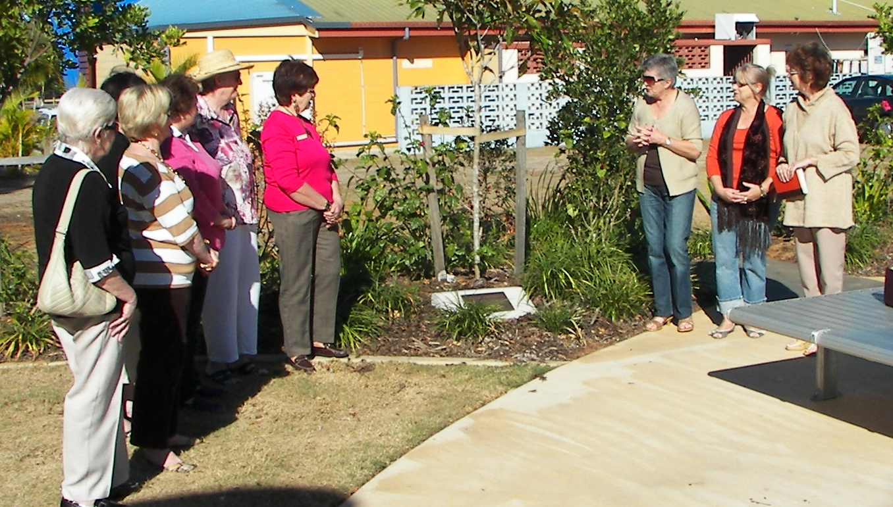

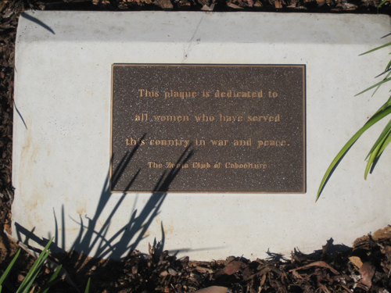

Glenda Moor
Chairman

DATE CLAIMERS

05 July – Busting Out – 12th night theatre – 2.00pm
19 July – Shop until you drop – 7.45 am at Morayfield Shopping Centre Bus Depot.
02 Aug – Phoebe Rose Charity Dinner and Auction - $50 per person, 3 course meal, auction (more info as it comes to hand)
03 Aug – Birthing Kit Assembly Day –Blue Care Mobile Day Respite Centre.

