President: Sue Droughton – 07 5496 8909 (H) 07 5498 6699 (B)
Treasurer: Pam Termont-Schenk – 07 5496 2035
Secretary: Glenda Moor - 07 3385 6160
Newsletter Editor: Patricia Clunes- 07 5498 6066 or 0410 617 825

FROM THE PRESIDENT’S DESK.
My personal thanks go to all who worked so hard and contributed so much to make our International Women's Day luncheon a huge success, to have 109 ladies + one gentleman attend is testament to your work. Having to turn ladies away on the morning who still wished to be there just goes to show how popular our function has become. The quality and the number of raffle prizes was amazing, the young high school ladies from Mueller College had a fantastic haul to take home.

On Saturday night the 8th March I attended (representing Zonta Caboolture) BPW's Candlelighting ceremony at the Caboolture Golf Club, as always, it is a special and moving ceremony and I thoroughly enjoyed the night.

Recently I sent out to you all the information (and attachments) that is needed for our postal vote for the proposed District 22, once again can I please ask to you to read all this so we can vote on the motions at our Dinner Meeting, if you did not receive the Ballot Information please let me know and I will resend it to you. The Ballot papers have to be returned to the returning officer by 28th April 2008.

Patricia Rios (Multicultural Planner) from the Community Development Unit, Moreton Bay Regional Council will be our guest speaker this month. Patricia has approached Zonta Caboolture for some funding for a project involving our community CALD women. CALD is Women from Culturally and Linguistically Diverse Backgrounds. Patricia will address our meeting and then respond to questions, she is working very hard with CADET Employment and has approached the Department of Employment and Industrial Relations for funding this Multicultural Women's Research Project.

I am also very pleased to hear that tickets to our theatre matinee "Menopause the Musical" have almost sold out. We only need to finalise the arrangements for the High Tea, so please if you can spare time on Saturday afternoon April 19th come along with your lovely home baked goodies for our guests to enjoy. Lewis from Twelfth Night Theatre considers our suppers "exquisite & lavish". For those of you who hate the parking at Bowen Hills we have a bus booked for only $13.00 return.

Finally, on a personal level I sincerely thank all of you who so generously donated to my "Shave for a Cure" I raised approx. $1000.00.

Congratulations to Pam Berkett on her latest granddaughter – Ella Olivia born on Friday to daughter Sarah and her husband Pommy.
Patricia Clunes is this month’s dinner speaker for “My Beautiful Career ".

See you all soon.
Sue
BIRTHDAYS

Cathy Jones 8/4
Happy birthday Cathy. Hope to see you back at Zonta soon.

TREASURERS REPORT
You should have received this from Pam by now.
A reminder that if you miss a meeting, regardless of apology, you need to pay $5.00 at the next available meeting. This is an admin fee and is built into our $20 we pay when we have dinner. If you attend dinner and don’t eat then you still need to pay the $5.
If you are unable to attend a meeting please give Glenda a telephone call on 3385 6160 (a/h)

STATUS OF WOMEN – SERVICE

The Bribie Island & District Neighbourhood Centre has a need for some
toiletries to fill the emergency packs they give to women who need
emergency accommodation. We have a box of these supplies so our Board
has recommended that these supplies be given to BINDC.
You have all received information about a Women's Health Forum which
is being sponsored by the Zonta Club of Gold Coast/Tweed. Please read
the information and let me know if you think that we could/should do
something similar here in Caboolture early next year. It will take
several months to set up a forum as participants (stall holders and
guest speakers) need a lot of advance notice.

No breast cushions will be needed before November so we will have a
"stuffing night" in October.

How about those ladies at the Birthing Kit Foundation! Aren't they doing great work and the terrific thing is that we are a part of it all. We will be ordering 1000 kits shortly and we will have a packing day sometime July/August.

Our Club guest speaker this month is Patricia Rios to tell us all about
the Multicultural project. Please direct all your questions to her as we
need to be well informed about her project in order to make the
decision to agree to give the project our financial support.
We received a big thank you for the fridge from the Deception Bay
Flexible Learning Centre.

Community Angels are having a luncheon on 8 May - we are invited so I will give you details later. They will display a photo of the fridge and also the sewing machines with an explanation that Zonta Caboolture donated them to DBFLC
We have 15 + people coming to our Seminar on 2 April. On 27 March, Marie and I will contact all the people who have agreed to come to the seminar to check that they are still coming. On 25 March I will send a reminder e-mail to all the organisations to who I e-mailed seminar fliers to a month ago.

Cheers
Helene (SWS Chair)

ORGANISATION, MEMBERSHIP

ORGANISATION
Constitution/Bylaws Working Group (Sandra, Cecil)
The revised Constitution has been sent to the Office of fair Trading

MEMBERSHIP
Barbara’s transfer details have been sent to Zonta International and to the District Treasurer. Induction for intending new members Annette and Chris will be postponed until August this year as Chris will be away May to July.

Content for the new member’s booklet is currently being reviewed. Many thanks go to Glenda for adapting the NZ booklet to our computers and to Sandra for persisting with the format.
SURVEY
Every member has a copy of the full survey now – Parts 1 and 2. The OMC Committee will consider the parts relating to this committee’s functions. All members need to consider implications for our club from Part 1.

Cecil Nielson
Acting OMC Chair

FINANCE & FUNDRAISING

Thank you all Zontians for making this year’s IWD luncheon a great success. I believe all who attended had a wonderful time, the food was tasty and the raffle prizes a big draw card. I’ve got a few ideas for next year so we’ll start planning around August.

We have 14 tickets left for Menopause the Musical which we believe will be sold by the end of the month so no need to advertise this one. At the March meeting we will need to know if you can assist with the High Tea on the day.

Our next function after our Theatre gig will be the Caboolture Urban Country Music Festival where we will be selling our badges. Our place has been confirmed and I have our remaining badges which need to be counted. I’ll be placing an order for more stock in April.

Sara

PUBLICITY AND PUBLIC RELATIONS
Barbara Brann’s farewell lunch at Sandra Cooke’s home
Back Row - L-R – Pam, Shirley, Helene, Cathy, Sue, Sara, Shirley, Sandra
Middle Row – L-R – Glenda, Barbara, Marie
Front – Annette.

Advertising for the "Guidelines for a Healthy Mind" Seminar (2 April) is needed in order to fill the 30 places available. Ask Glenda for a copy of the flyer to drop into your local doctor's surgery, notice boards in shopping centres etc.

Ticket sales for Menopause, have gone really well thanks especially to Janette Spillane and Pam Berkett in their train travel to and from work. We now only have about 14 tickets left. There are still seats on the bus if you would like to travel by bus for $13.00 return. Members who are not attending the production, may be able to help out by providing afternoon tea and/or helping to serve the afternoon tea to guests.

Caboolture's Urban Country Music Festival is fast approaching (2-5 May). Sara will check on the supply of badges and reorder if necessary.

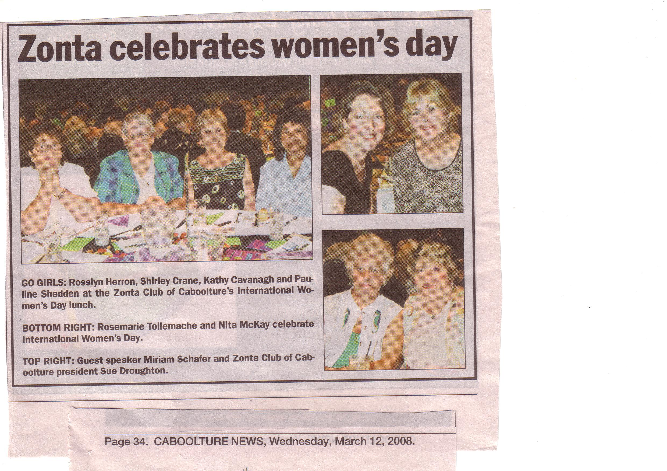
The IWD was a huge success with 106 people attending this year. Prizes galore ensured that many people left carrying handfuls of goodies with them. The guest speak was well received and sold her books at the end of the function. Thank you to all concerned, especially Sara and Patricia.

Easter Sunday's catering went off well. Sue and Richard, Patricia and Neil, Sara and Josephine, Edith and Peter, Pam B, Glenda, and Cathy donned the aprons and rolled up their sleeves for a successful evening of fellowship with members of the Caboolture Community as they celebrated a 60th , 70th and 80th birthday with 200+ friends and relations. (Remember to record your 3.5 hours)

Glenda Moor
Publicity and PR.

Area Meeting at Noosa

A few statistics from Patricia Lawson and Vicki Varthas:

- Our club will be part of District 22 Area 1 starting the new biennium
- In the last biennium, our two areas gained 90 new members.
- Vicki wants to increase membership in District 22 by 8% (just over 100)
- 25th – 27th September 2009 will be District Conference, looking at Townsville

Wonderful talks on Human Trafficking (in Labour) by Sally Cameron from Zonta Noosa and Sister Pauline Coll, Chairman Australian Catholic Religious Against Trafficking in Humans (ACRATH).
- Handouts were given to us and I think we will print them for all members or scan and email. If you could email me with your preference we can get that done.

- Watch for fair trade items when shopping. Worst offenders for child labour are the cocoa plantations “Egg farming” mostly in eastern Europe is new form of trafficking.

- The women undergo IVF treatment, eggs are extracted and then sold.
- Surrogate Mothering is big also. The eggs from above are harvested and implanted into a surrogate, the baby is born and then given to adoptive parents

DATE CLAIMERS

Sat. 26th April – meeting at Duhig Hall, Lourdes Hill College – Hawthorne, Brisbane to discuss strategies for Brisbane and Queensland re Anti-trafficking. Working towards greater collaboration

Thurs. May 15th – evening screening of “The Jammed” (with some conversation) at same venue as above

Even more statistics from Bev Folliott (ZI Foundation).

Dist 24 was - the top district for funds paid to ZI Foundations
- the top district for money spent on Women in Public Affairs
- the second highest district for providing funds for ZISVAW
fifth highest district for providing funds for J M Klausman awards

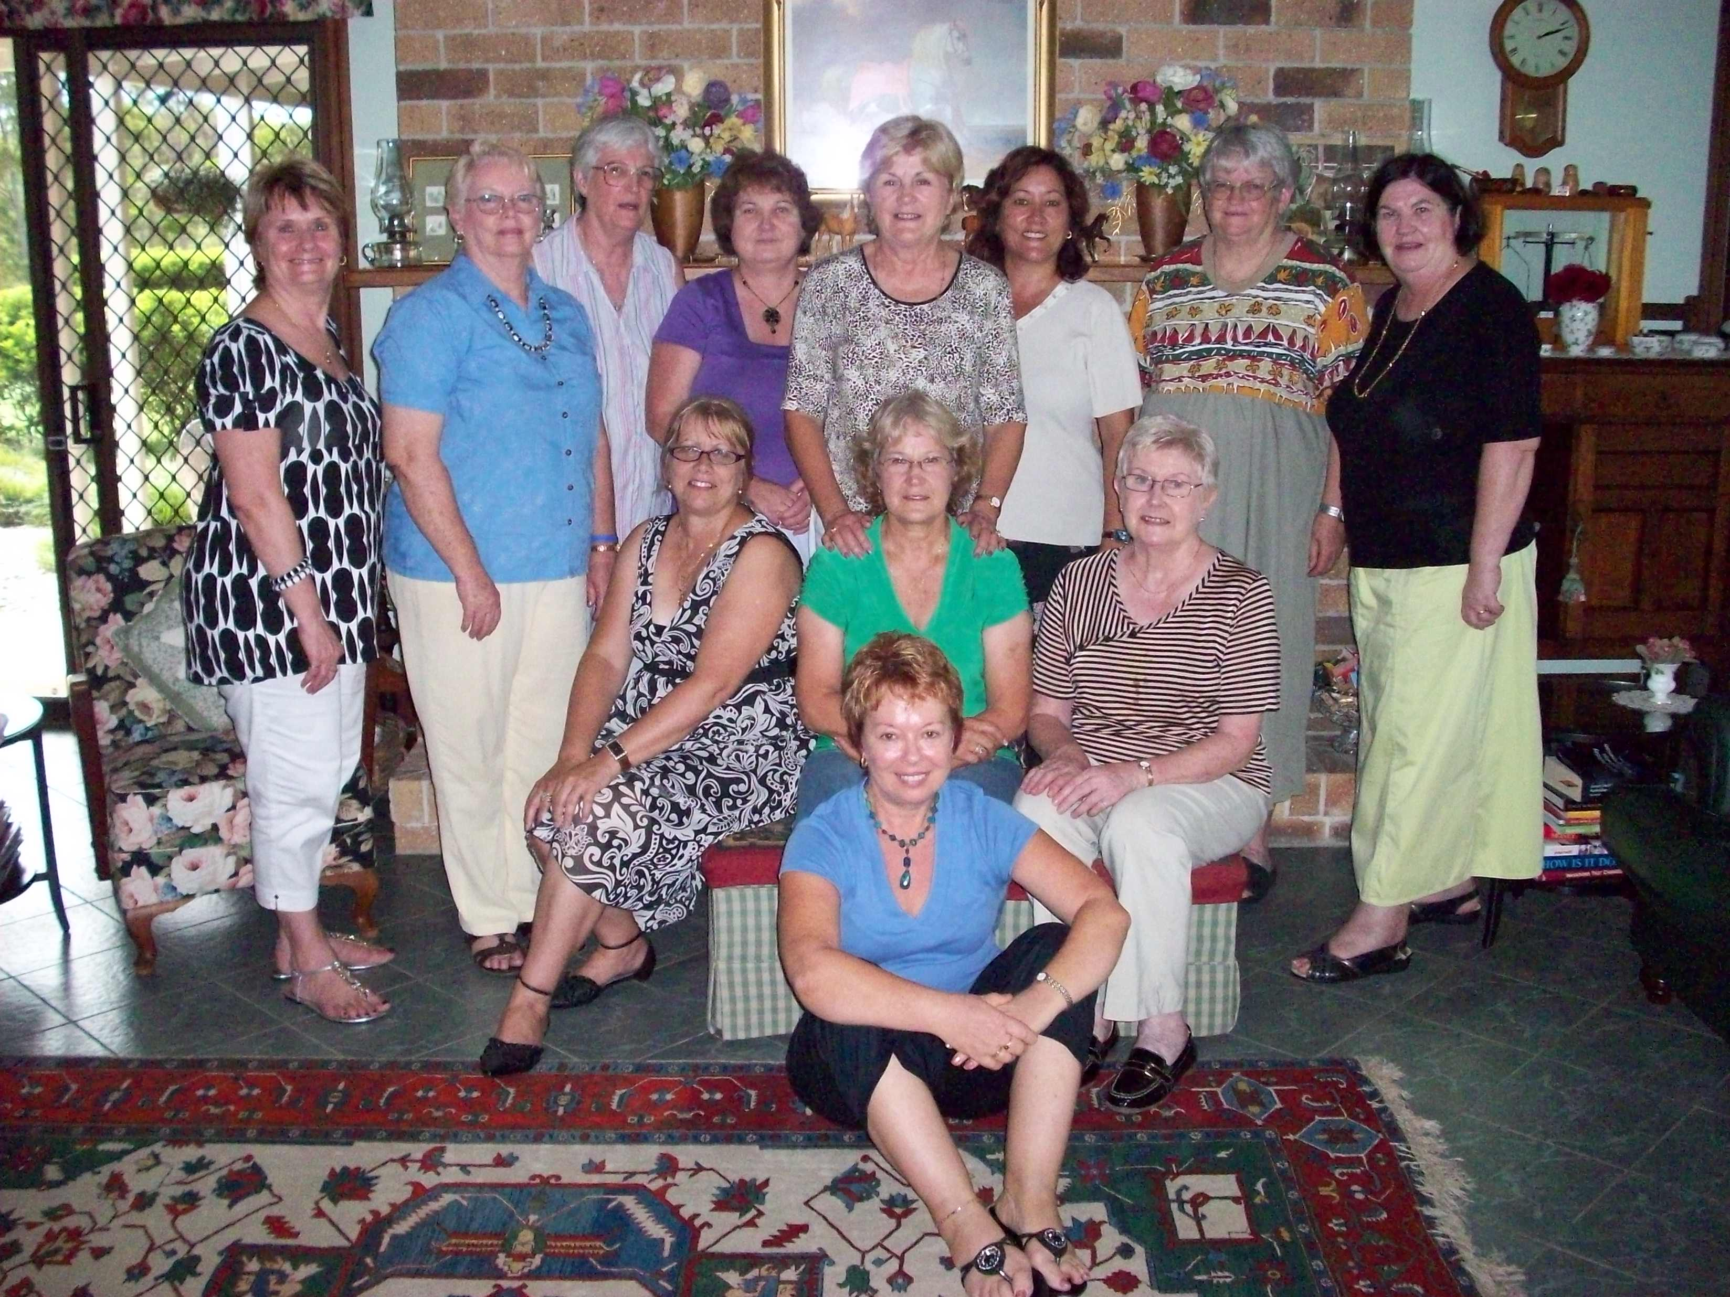
At Barbara’s farewell luncheon held at the Cooke Residence prior to her departure to Townsville.

Back Row – LR – Pam, Edith, Helene, Cathy, Sue, Sara, Shirley and Sandra.
Middle Row – LR – Glenda, Barbara (guest of honour), Marie Brady.
Front – Annette Belling

